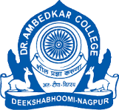DR. AMBEDKAR COLLEGE, NAGPUR
DEPARTMENT OF PHYSICS

REPORT ON

INDUCTION PROGRAMME
Academic Session 2026–27

DATE | 19 August 2026
SCHEDULED TIME | 11:00 AM
PROGRAMME STARTED | 11:20 AM
PROGRAMME CONCLUDED | 1:30 PM
ORGANIZED BY | Department of Physics
NO. OF ATTENDEES | 85
VENUE | Kumbhare Hall, Dr. Ambedkar College, Nagpur
ANCHORS | Mahakpreet Kaur & Vikas Shukla

A FORMAL RECORD OF THE INDUCTION PROGRAMME PROCEEDINGS, ACADEMIC GUIDANCE, ORIENTATION, LABORATORY AWARENESS, CAREER INTERACTION, STUDENT PARTICIPATION AND CONCLUDING ACTIVITIES

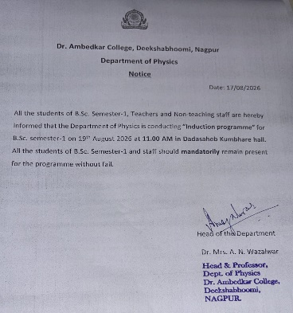

INDEX. Successive Events & Time Schedule
This index records the successive events in chronological order and gives the recorded duration wherever available. Unrecorded timings have not been estimated.
No. | Successive Event | Person / Speaker | Time / Duration
1 | Welcome and Opening | Anchors: Mahakpreet Kaur & Vikas Shuk | laProgramme began ~11
2 | Introduction: Purpose of the Induction Programme | Anchors / Department | Approx. 10–15 min
3 | Garland Ceremony – Lord Buddha & Dr. Babasahe | bFAacmublteyd/kdairgnitaries / students | Not separately recorde
4 | Principal's Address | Dr. Deepa Panhekar | Not separately recorde
5 | HOD's NEP / Department Presentation | Dr. Aarti Wazalwar | Approx. 40 min
6 | Orientation & Institutional Protocols | Dr. Namrata Pradyankar | Approx. 20 min
7 | Laboratory Protocols & Do's / Don'ts | Laboratory In-charge | Not separately recorde
8 | Career Opportunities & Pathways in Physics | Dr. Amit Bansod | Approx. 15 min
9 | College Journey Sharing | Ph.D. scholars & 3rd-year B.Sc. students | Within career session
10 | Vote of Thanks | 3rd-year B.Sc. student | Not separately recorde
11 | Annual Presidential Election Announcement | Anchors / Department | At conclusion
12 | Election / Student Voting Information | Three 3rd-year nominees; Google Form | At conclusion
13 | Faculty / Group Photograph Session | Faculty, students & anchors | At the end
14 | Programme Closure | Department of Physics | ~1:30 PM

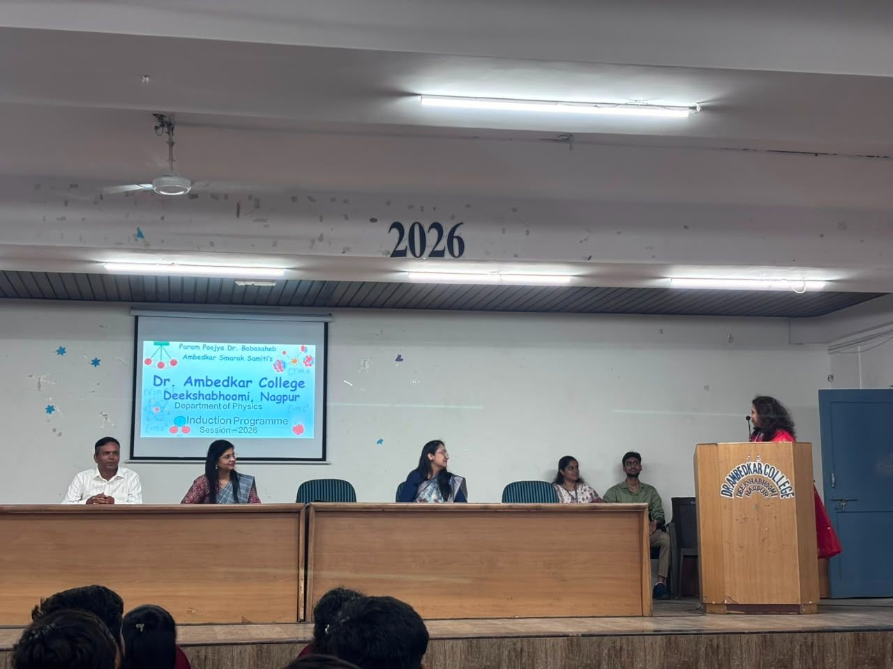

2 . Garland Ceremony – Lord Buddha & Dr. Babasaheb Ambedkar

Ceremonial Opening
As part of the opening of the induction programme, a garland ceremony was conducted in honour of Lord Buddha and Dr. Babasaheb Ambedkar. The ceremony formed an important part of the formal beginning of the programme and was conducted in the presence of the faculty members, staff and students. It provided a respectful and meaningful opening before the academic and orientation sessions commenced.

Significance within the Programme
The ceremony established a dignified atmosphere for the gathering and marked the beginning of the day's proceedings. It also connected the formal academic event with the values of knowledge, learning, social
As part of the opening of the induction programme, a garland ceremony was conducted in honour of Lord Buddha and Dr. Babasaheb Ambedkar. The ceremony formed an important part of the formal beginning of the programme and was conducted in the presence of the faculty members, staff and students. It provided a respectful and meaningful opening before the academic and orientation sessions commenced.
The ceremony established a dignified atmosphere for the gathering and marked the beginning of the day's proceedings. It also connected the formal academic event with the values of knowledge, learning, social responsibility and respect that are central to the educational environment of the institution.
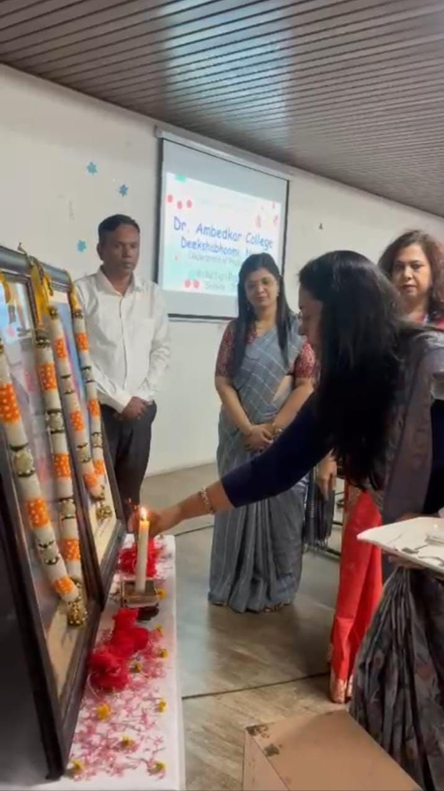
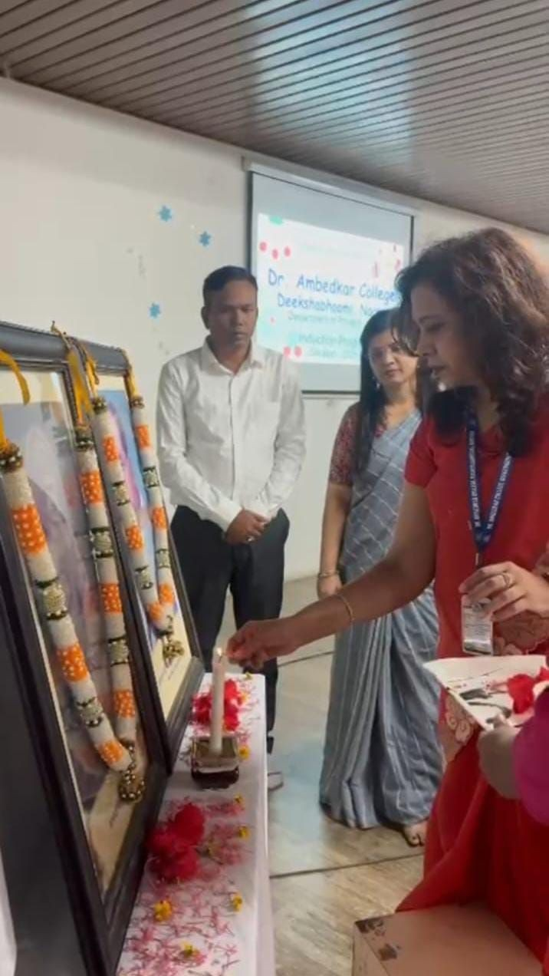
PHOTOGRAPH SPACE
Photograph: Garland ceremony of Lord Buddha
Insert / paste the actual photographere.

PHOTOGRAPH SPACE
Photograph: Garland ceremony of Dr.
Babasaheb Ambedkar
Insert / paste the actual photograph here.

3 . Programme Overview, Objectives & Participants

Introduction
The Department of Physics, Dr. Ambedkar College, Nagpur, organised the Induction Programme on 19th August 2026 at Kumbhare Hall at 11 am. The programme was designed to welcome students and provide a structured introduction to the academic environment, the Department of Physics and the responsibilities of college life. It also created opportunities for interaction among faculty members, senior students, Ph.D. scholars and newly admitted students.

Objectives
  - To welcome students and introduce them to the college and Department of Physics.
  - To familiarise students with the NEP-oriented academic structure and expectations.
  - To explain institutional, departmental and laboratory protocols.
  - To encourage participation in departmental activities and educational tours.
  - To provide awareness of academic, research and career pathways in Physics.
  - To encourage interaction with faculty, senior students and Ph.D. scholars.
  - To help students begin college with clarity, confidence and enthusiasm.

Participants and Faculty Presence
Principal Dr. Deepa Panhekar, HOD Dr. Aarti Wazalwar, Dr. Namrata Pradyankar, Dr. Amit Bansod, the laboratory in-charge, other professors and staff, Ph.D. scholars, senior B.Sc. students and students were present during the programme.

Address by Principal – Dr. Deepa Panhekar
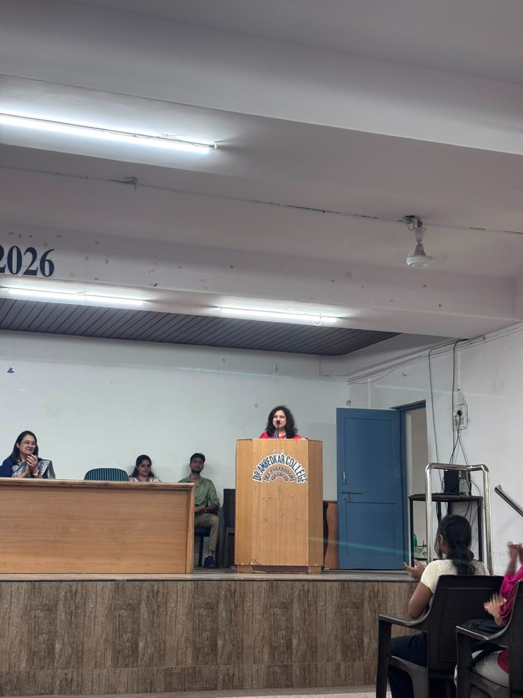

SESSION REPORT
PHOTOGRAPH SPACE
Principal Dr. Deepa Panhekar addressing the students
Insert / paste the actual photograph here.

To the formal Principal Dr. Deepa Panhekar addressed the students after the opening ceremony. She welcomed the students to the college and offered guidance for their academic journey. Her address emphasised hard work, sincere effort, discipline and making effective use of the opportunities available within the institution. She encouraged students to approach college life with a positive attitude and commitment to learning. Her address provided an encouraging beginning academic guidance.

Key points / significance
The session contributed to the induction process by providing students with guidance relevant to their academic transition, responsibilities and development.

Principal Dr. Deepa Panhekar addressing the students

Address by HOD – Dr. Aarti Wazalwar
Suggested caption: HOD Dr. Aarti Wazalwar addressing students through her presentation
Time / Duration: Approximately 40 minutes
SESSION REPORT
Dr. Aarti Wazalwar, Head of the Department of Physics, conducted a presentation-led session of approximately 40 minutes. She explained important aspects of the new NEP scheme and helped students understand the academic framework relevant to their programme. She highlighted departmental activities and educational tours and encouraged students to participate actively and use every opportunity to gain knowledge. The session served as both academic orientation and an introduction to the wider learning opportunities available through the department.
Key points / significance
The session contributed to the induction process by providing students with guidance relevant to their academic transition, responsibilities and development.
PHOTOGRAPH SPACE
HOD Dr. Aarti Wazalwar addressing students through her presentation
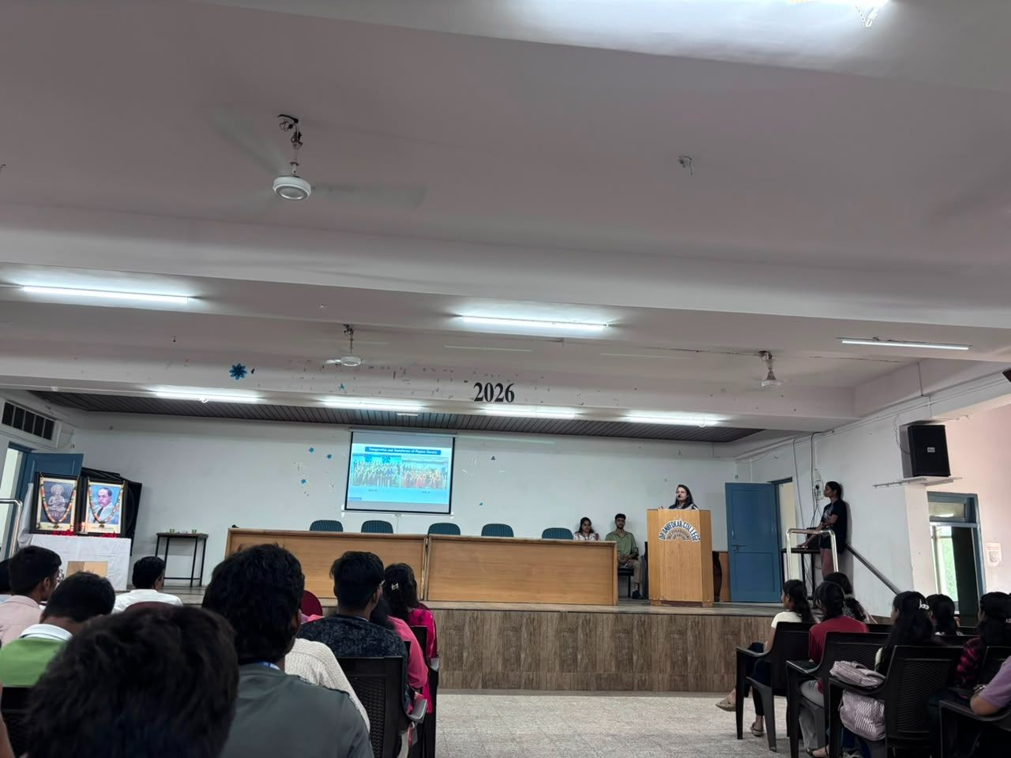

Insert / paste the actual photograph here.

Orientation & Institutional Protocols – Dr. Namrata Pradyankar
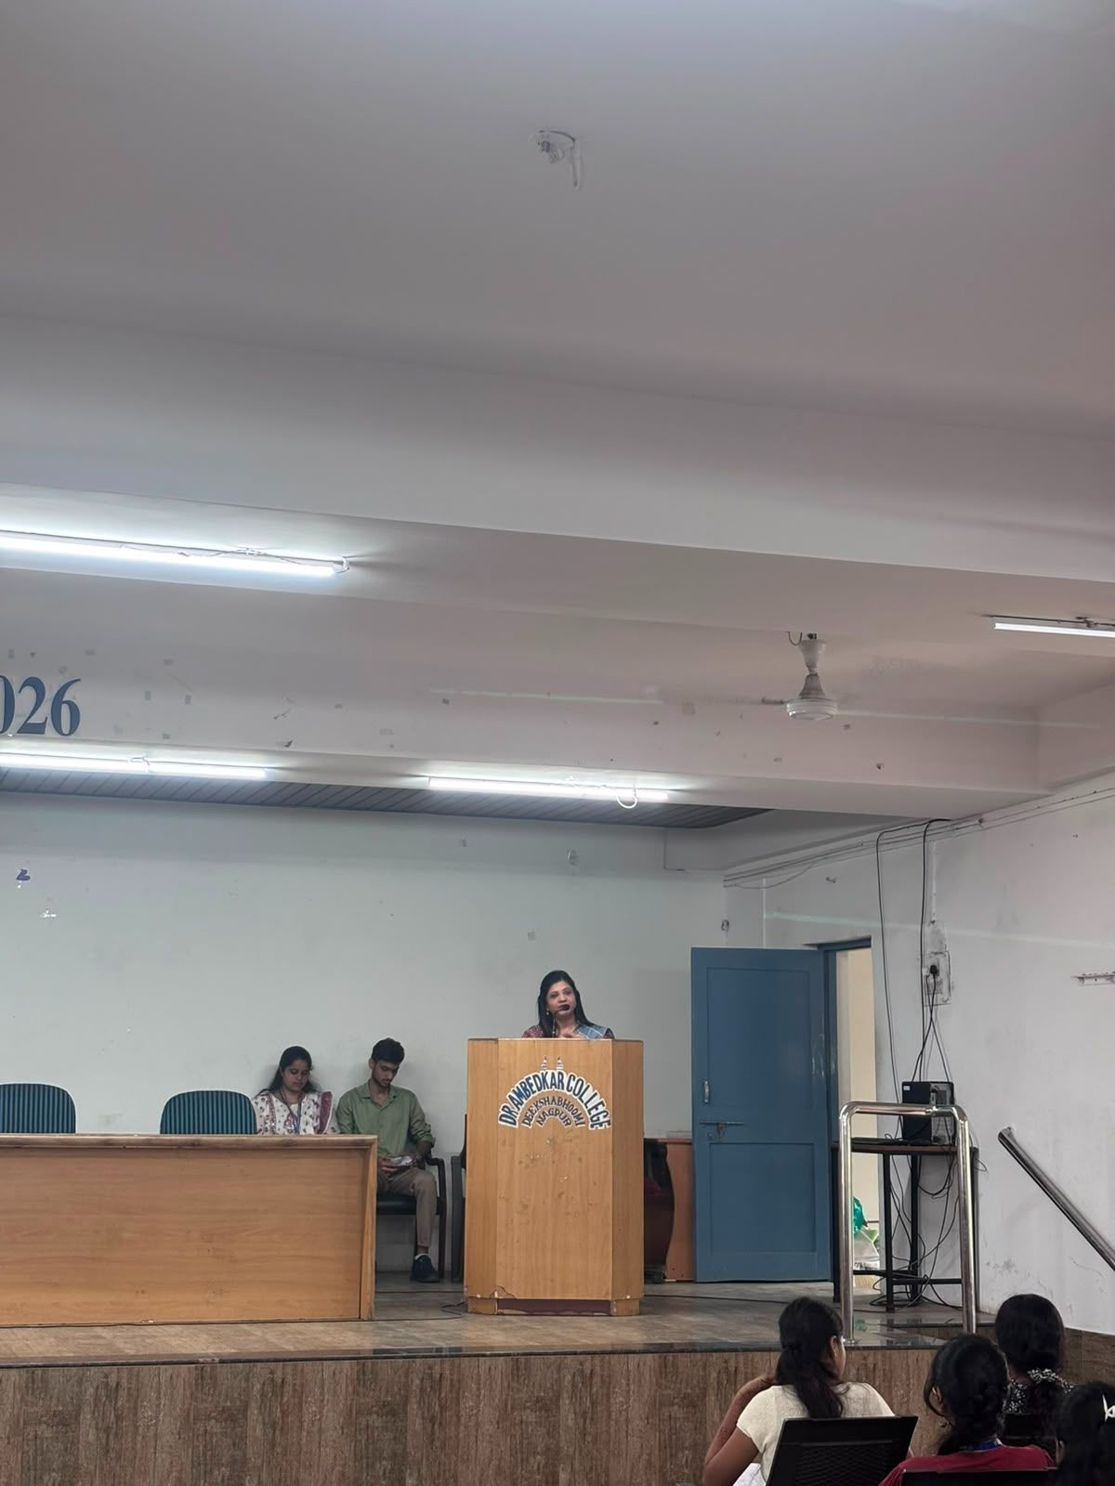

SESSION REPORT
PHOTOGRAPH SPACE
Dr. Namrata Pradyankar conducting the orientation session
Insert / paste the actual photograph here.

Dr. Namrata Pradyankar addressed the students for approximately 20 minutes regarding orientation, institutional protocols and matters connected with college life. Her session helped students become familiar with expected conduct and responsibilities within the institution. The guidance was intended to make the transition into college smoother and give students practical clarity regarding their role in the academic environment.

Key points / significance
The session contributed to the induction process by providing students with guidance relevant to their academic transition, responsibilities and development.

Laboratory Orientation – Laboratory In-Charge

SESSION REPORT
The laboratory in-charge addressed the students regarding laboratory protocols and the essential do's and don'ts to be followed while performing Physics experiments. The session emphasised responsible laboratory behaviour, careful handling of experimental work, following instructions and maintaining discipline during practical sessions. Students were introduced to the importance of observing precautions and following systematic experimental procedures.
Key points / significance
The session contributed to the induction process by providing students with guidance relevant to their academic transition, responsibilities and development.
PHOTOGRAPH SPACE
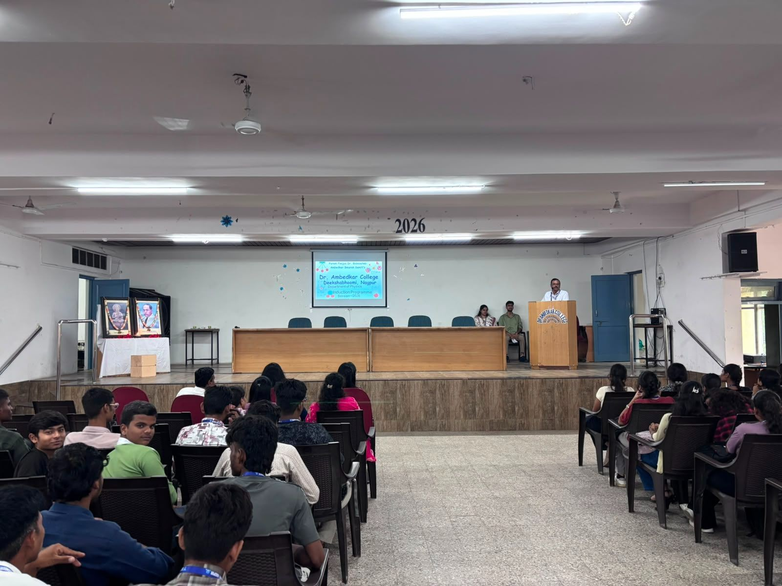
Laboratory in-charge explaining laboratory protocols and precautions
Insert / paste the actual photograph here.

Career Opportunities & Pathways in Physics – Dr.Amit Bansod
SESSION REPORT
Dr. Amit Bansod addressed the students for approximately 15 minutes on various career opportunities and academic pathways available in Physics. The session broadened students' awareness of possible directions beyond their immediate undergraduate curriculum. Ph.D. scholars were invited to share aspects of their college journeys, and third-year B.Sc. students also shared their experiences. These interactions gave newly admitted students practical perspectives on academic progression and possible future pathways.
Key points / significance
The session contributed to the induction process by providing students with guidance relevant to their academic transition, responsibilities and development.
Suggested caption: Dr. Amit Bansod addressing students on career opportunities in Physics
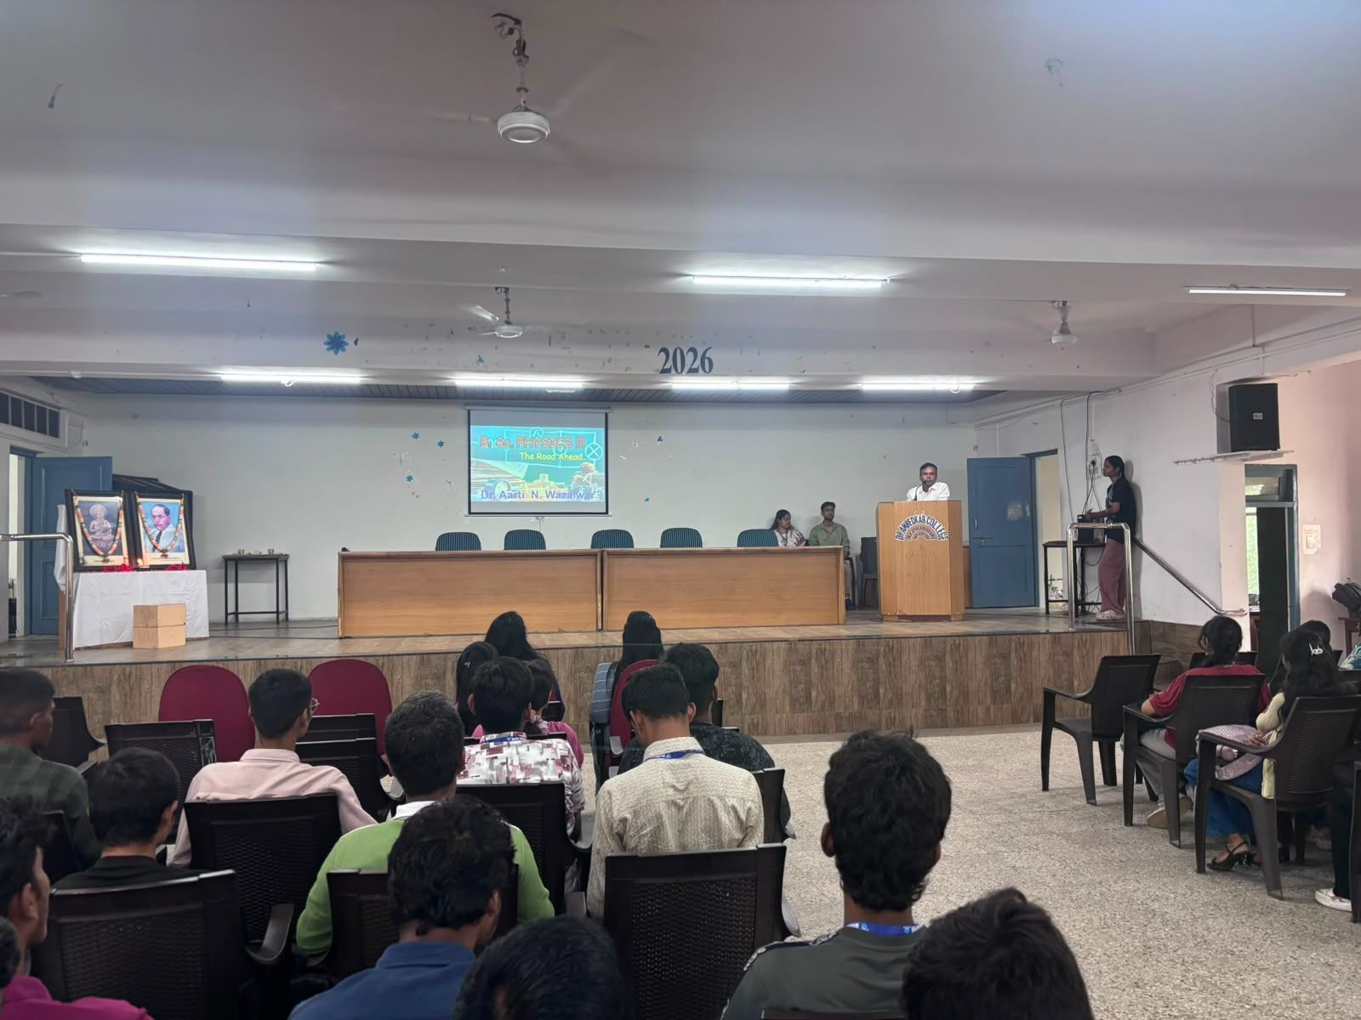

PHOTOGRAPH SPACE
Dr. Amit Bansod addressing students on career opportunities in Physics

Vote of Thanks
Before the final election announcement, a third-year B.Sc. student was invited to deliver the vote of thanks, expressing gratitude to the dignitaries, faculty, staff, students and all contributors to the programme.
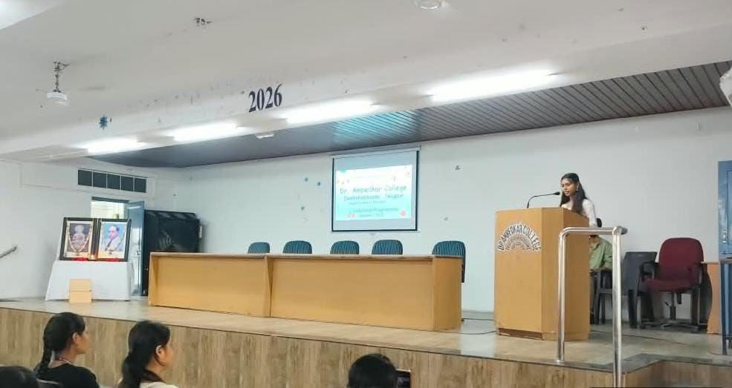

Overall Photographic Documentation
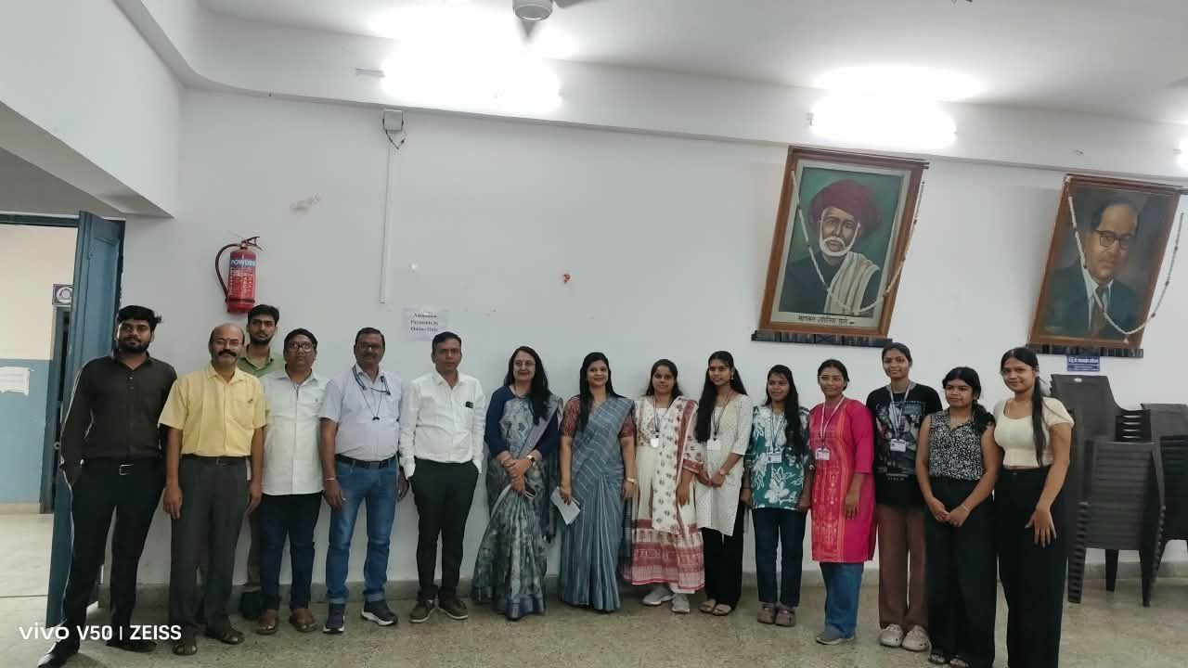
This page is reserved primarily for photographs. Insert the actual photographs from the programme here, including group photographs, faculty interactions, student participation, anchors with faculty members and the concluding photograph session.
PHOTOGRAPH SPACE
Overall programme photograph – students & faculty
Insert / paste the actual photograph here.

PHOTOGRAPH SPACE
Faculty / professors with student participants
Insert / paste the actual photograph here.

PHOTOGRAPH SPACE
Anchors with faculty members / dignitaries
Insert / paste the actual photograph here.

PHOTOGRAPH SPACE
Concluding group photograph / photograph session
Insert / paste the actual photograph here.

FEEDBACK
