
DEPARTMENT OF COMPUTER SCINECE
Report on
Induction Program under Deeksharambh
Date: 05-08-2026
Co-ordinator: Dr. Pankaj Nimbalkar (HoD)
Faculty Member: W. Anandpawar, V. Bondar, R. Uikey, A. Meshram.

Notice
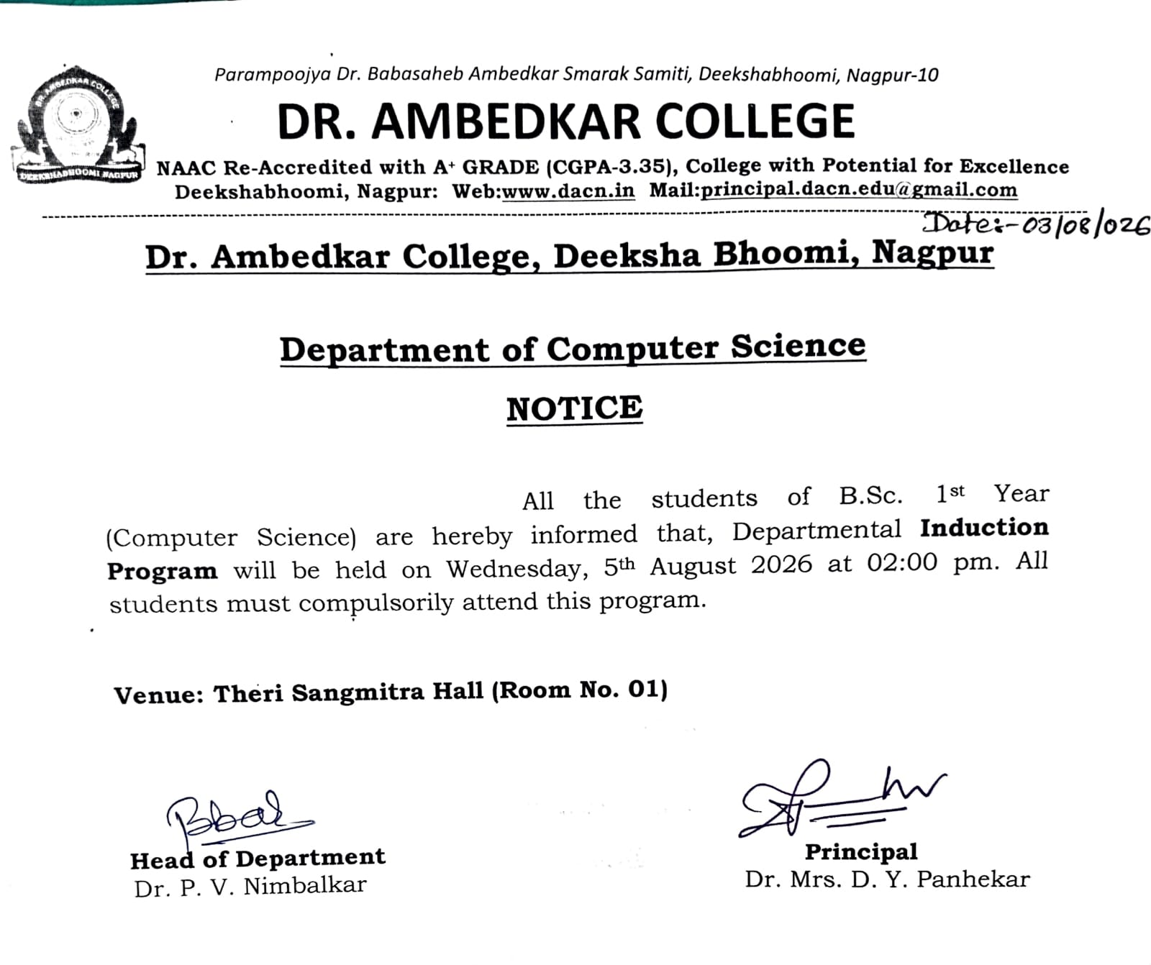

The Department of Computer Science conducted an Induction Program for B.Sc. Semester-I students of Computer Science, Electronics, Statistics, and Mathematics, along with Physics and Chemistry students associated with the PCoM and PCoC groups, on 5 August 2026 at 2:00 p.m. in Sangmitra Hall (Room No. 01). The program was organized as a mandatory induction activity for newcomers in accordance with the notification issued by the UGC. Dr. P. V. Nimbalkar, Head, Department of Computer Science, delivered a presentation highlighting the various academic and co-curricular programs conducted by the college, the different cells functioning in the college, and the B.Sc. NEP 3-2-1 pattern being implemented from the current academic session. He also discussed the college's academic timetable and related academic arrangements.
Prof. Winit Anandpawar spoke about the distribution of marks for activities under CC, the criteria for B.Sc. Fourth-Year Honours and Honours with Research, and various career opportunities available to students. Prof. Vitthal Bondar provided information about the teaching scheme and the university question paper pattern.
Faculty members of the Department, Prof. Rakesh Uikey and Mrs. Akansha Meshram, interacted with the students and addressed their queries regarding the college schedule and timetable. They also explained the various categories of subjects included in the curriculum.
The teaching and non-teaching staff members of the Department were present during the program. A total of 95 students from various subject groups associated with the Department of Computer Science attended the program.
Glimpses of Induction Program:
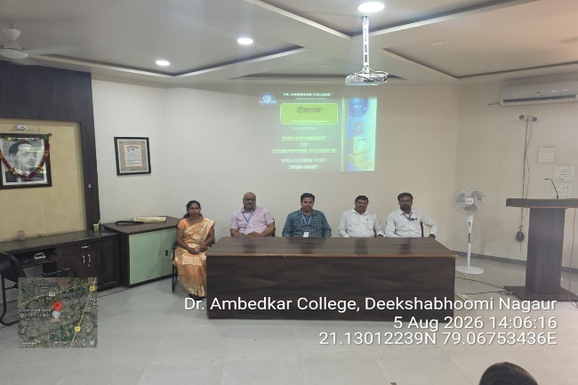 | 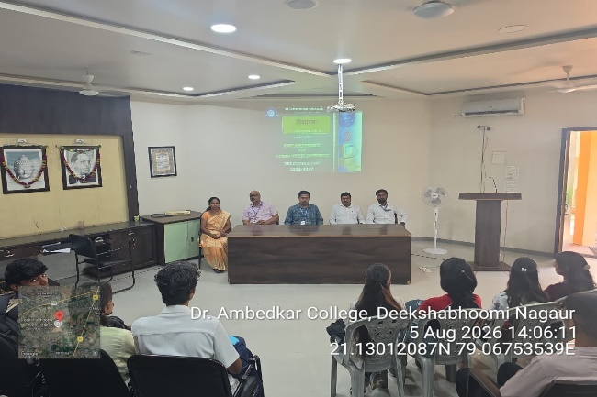
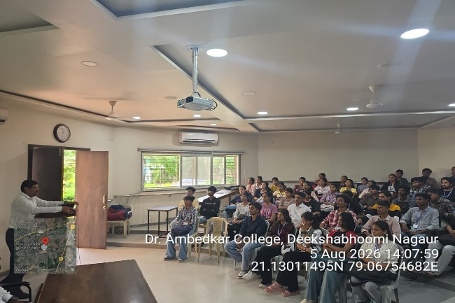 | 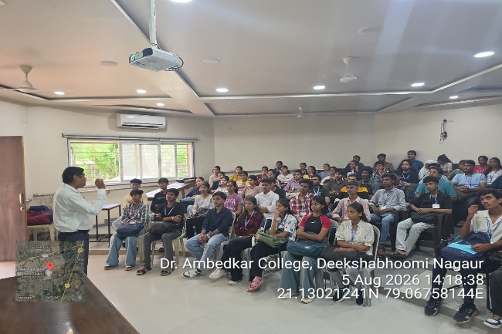
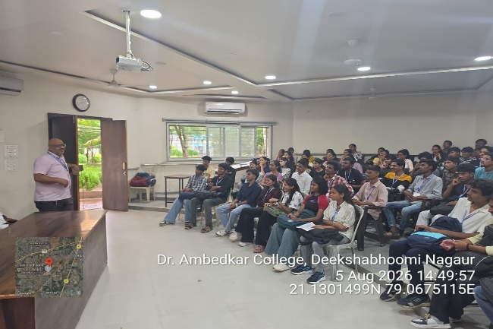 | 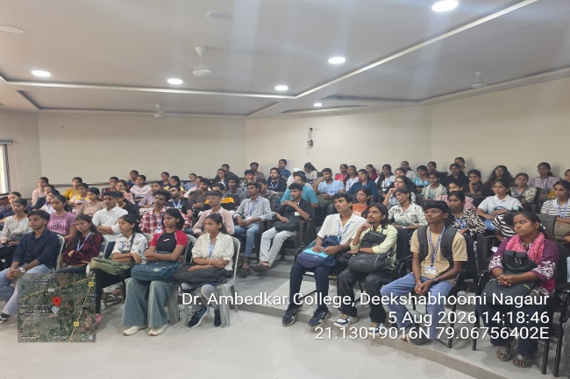
Attendance Record:
