One-Day Workshop on Research Methodology and Field Project for Undergraduate and Postgraduate Students
Department: Economics
Head of the Department: Prof. Priya Wankhede
Activity Name:- Research Methodology Workshop
Date : 10/10/2025
Time: 9.30 a.m.
Venue: Dr.Madhukarrao Wasnik PWS College of Arts,Commerce and Science
“Research should be value-based and honest. Students should be vigilant when choosing their research guide, and they must select a topic in which they have a genuine interest. Only then can one experience the true joy and satisfaction of research. Researchers should undertake their work with hard labour, not by adopting easy paths," stated Dr. Rajesh Biniwale, Senior Scientist, NEERI, Nagpur. He was speaking as the Chief Guest of the inaugural program at the one-day workshop organized by Dr. Madhukarrao Wasnik PWS College of Arts, Commerce, and Science.
This workshop was organized by the Department of Humanities of our college, in association with Dayanand Arya Kanya Mahavidyalaya and Dr. Ambedkar College, Dikshabhoomi, for undergraduate and postgraduate students as per the New Education Policy (NEP) on 10th October 2025 at college auditorium at 9:30am. The theme of the workshop was “Research Methodology and Field Project.”
The workshop was presided over by the college Principal, Dr. Pradnya Bagde. Dr. Vivek Diwan, Associate Dean, Faculty of Humanities, RTM Nagpur University, and Head of the Department of Political Science, R. S. Mundale College of Arts and Commerce, was invited as the Key-note Speaker. Dr. Babita Thul, Head of the Political Science Department, Dayanand Arya Kanya Mahavidyalaya, and Dr. Vipul, Dr. Ambedkar College, were also prominently present on the occasion.
While delivering his keynote address, Dr. Vivek Diwan said that the New Education Policy makes research projects and field projects mandatory in the curriculum to strengthen the research aptitude of undergraduate and postgraduate students, and to facilitate the understanding and resolution of various social problems through research. He further emphasized that research must be based on integrity and intellectual honesty. He frankly expressed his concern that the recent trend of declining research standards and the indiscriminate distribution of high marks at the university level would soon be curbed. In her presidential address, Dr. Pragnya Bagde stated that every research must have, and should have, the foundation of human welfare. Only then can research contribute to national and social development.
Dr. Kamlakar Tagde outlined the purpose and planning of the one-day workshop. Dr. Sushant Chimankar introduced the Chief Guest and Key Speaker to the audience. The inaugural session was conducted by Prof. Divya Parekar, and the vote of thanks was proposed by Dr. Durga Pali.

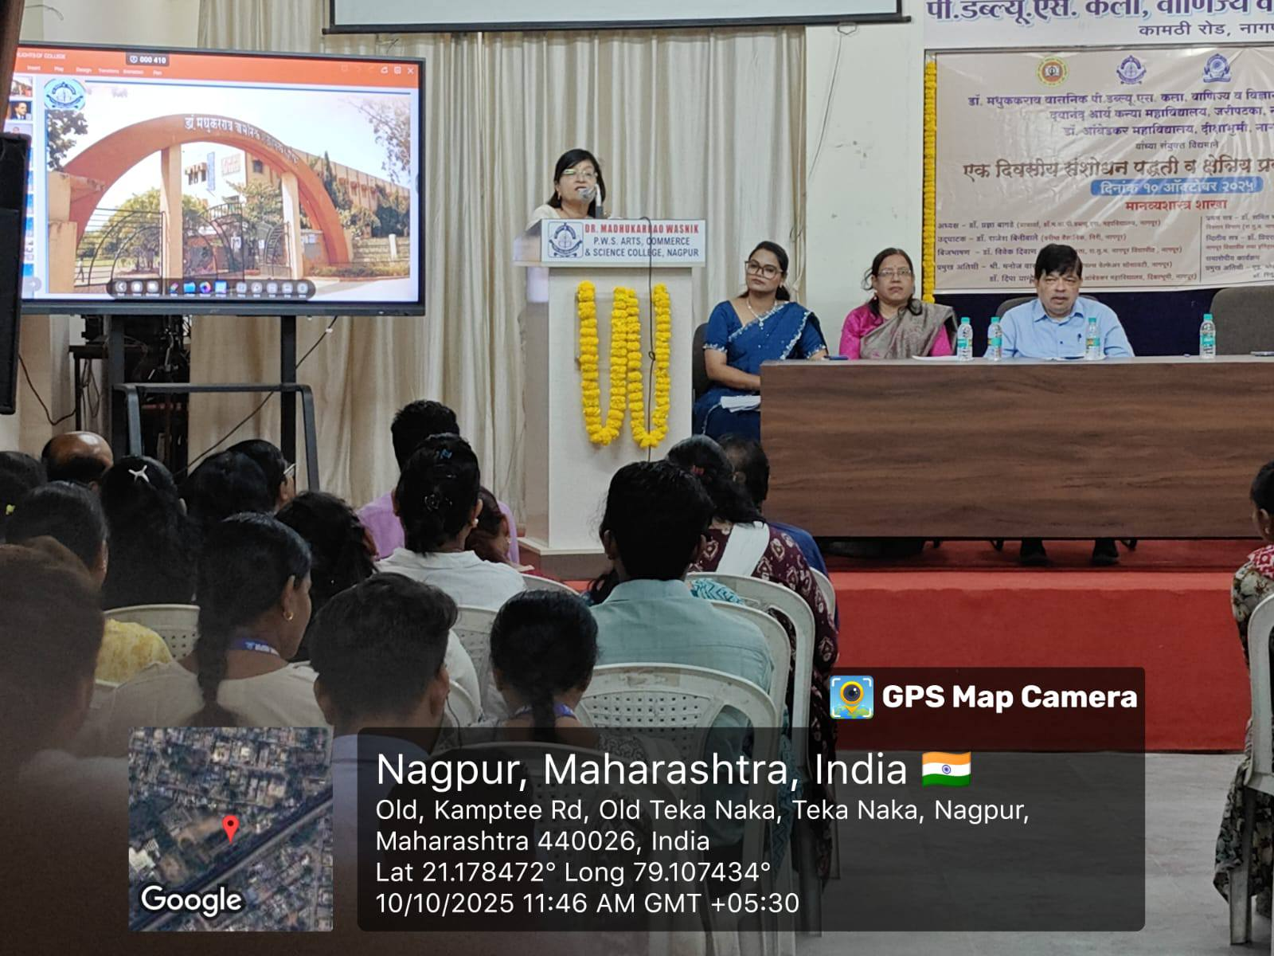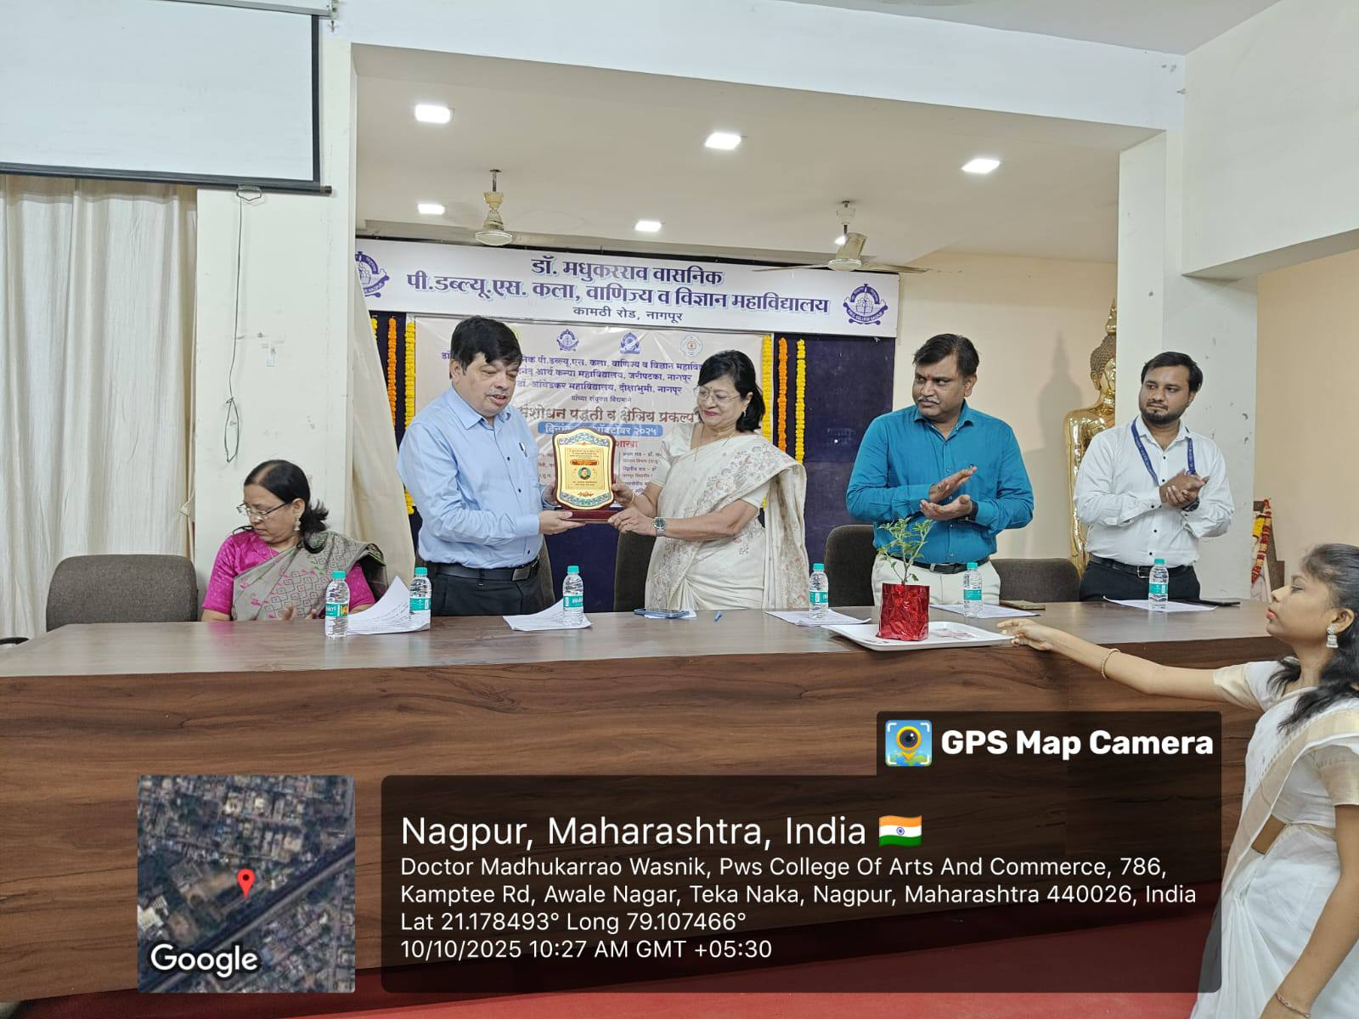
Dr. Bagade, Principal addressing the gathering and felicitating the Chief Guest, Dr. Rajesh Biniwale, a Scientist.
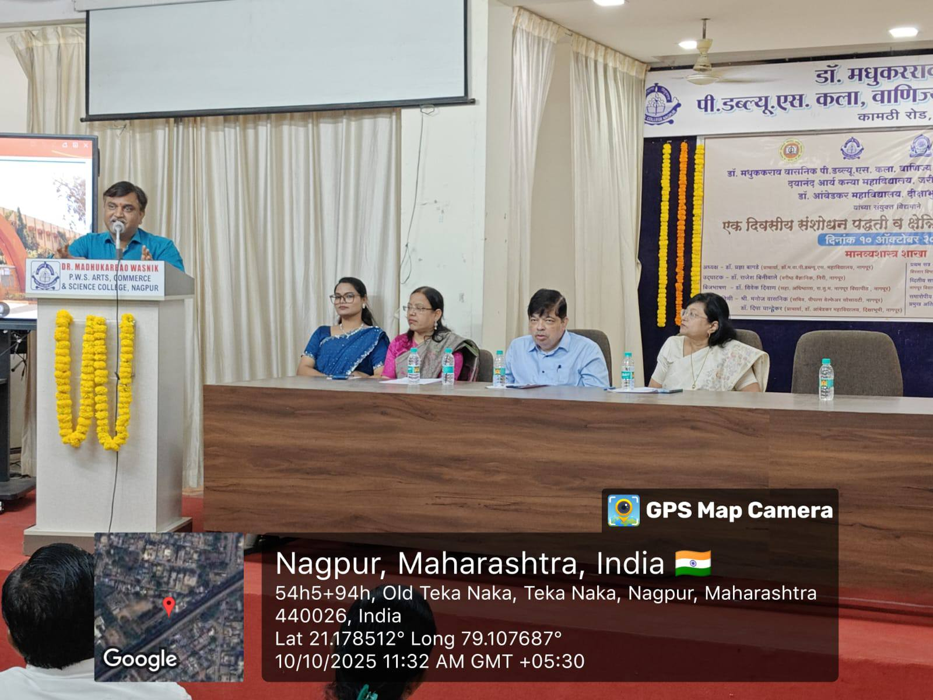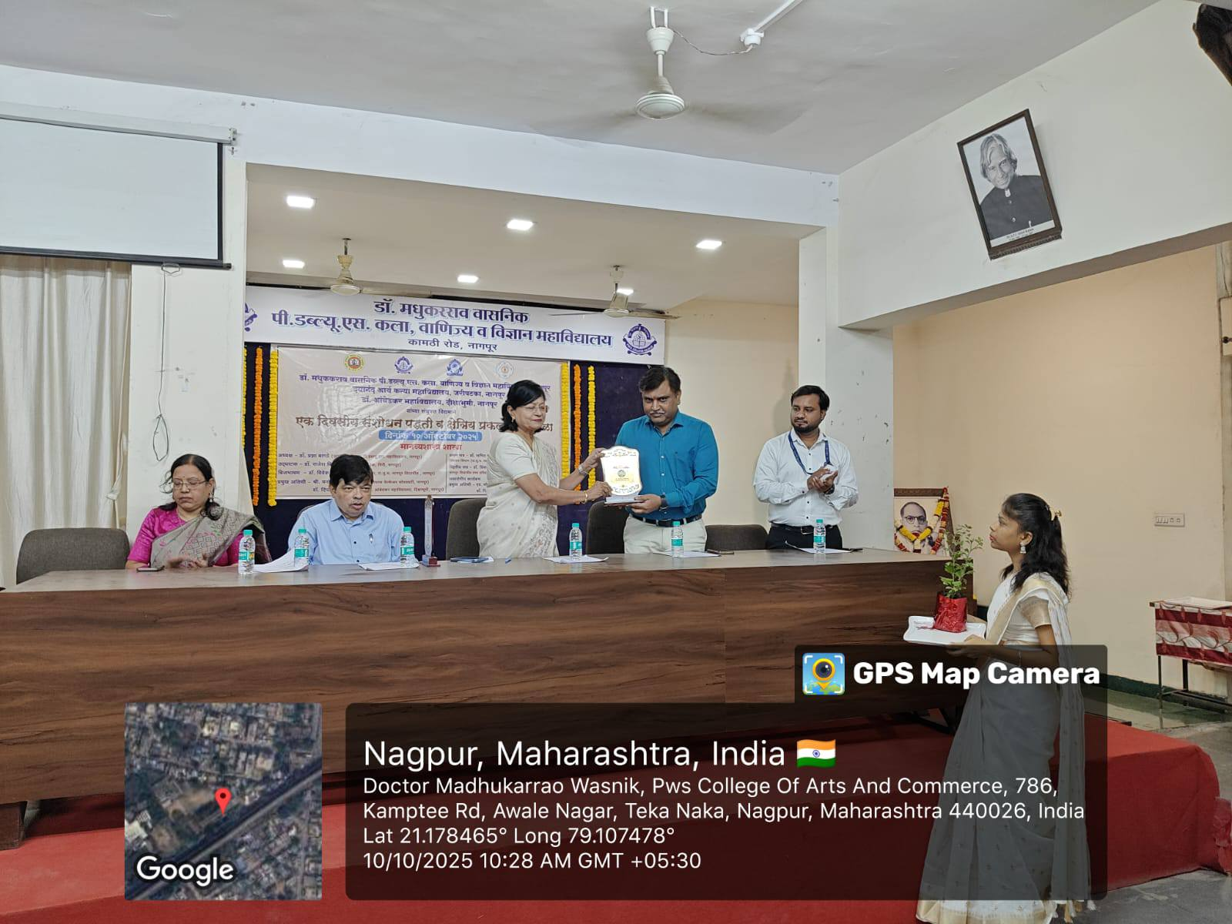
Dr. Vivek Diwan addressing the gathering at the inaugural session of the workshop
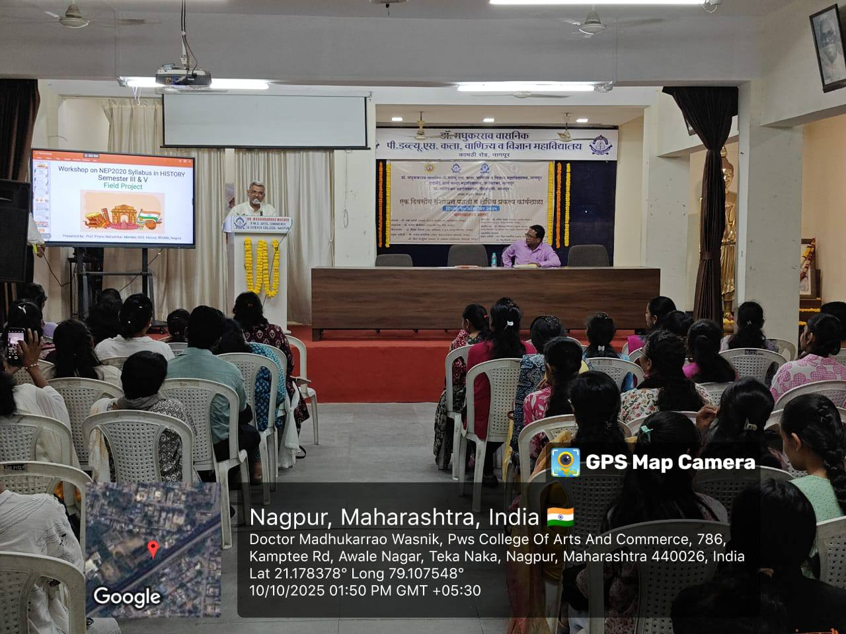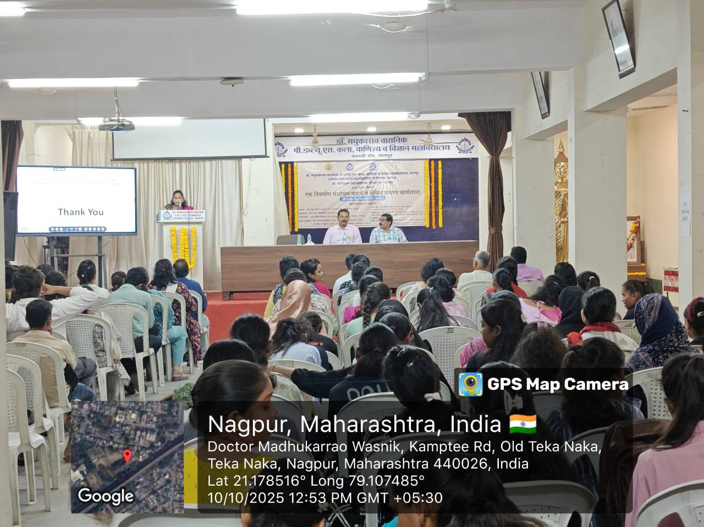

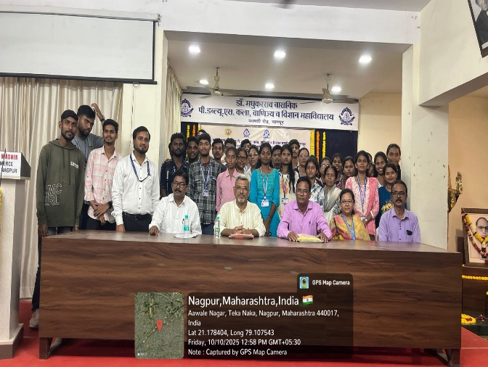
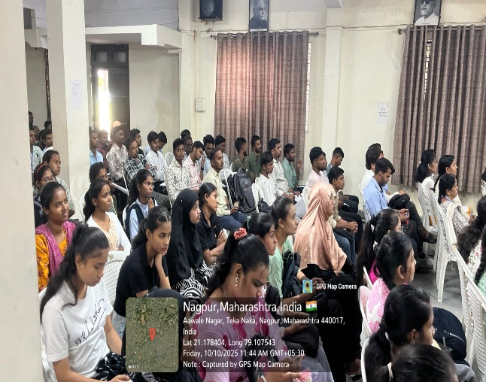

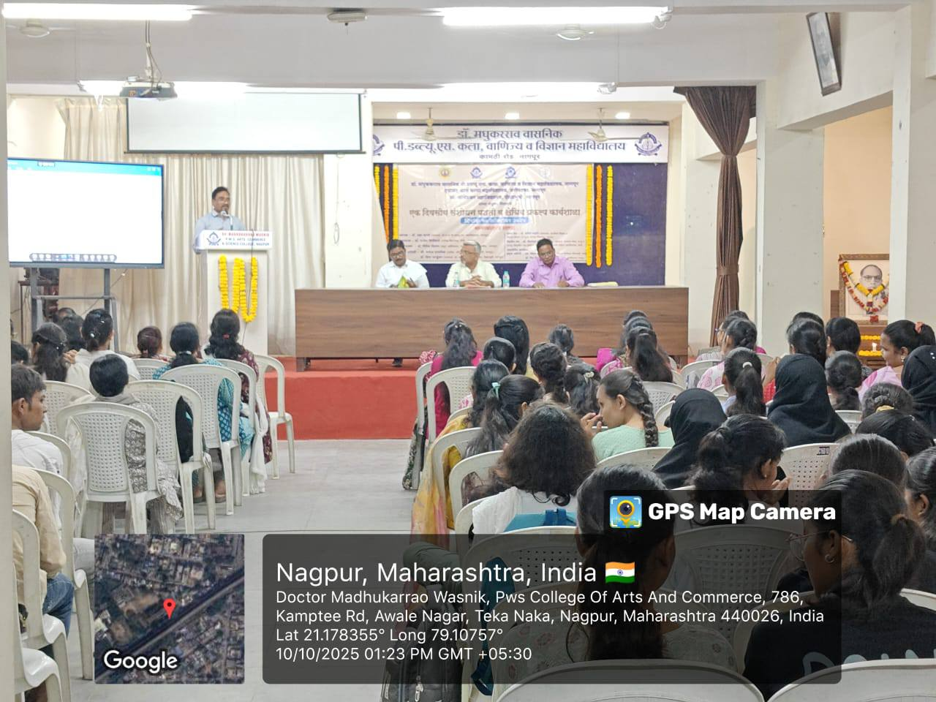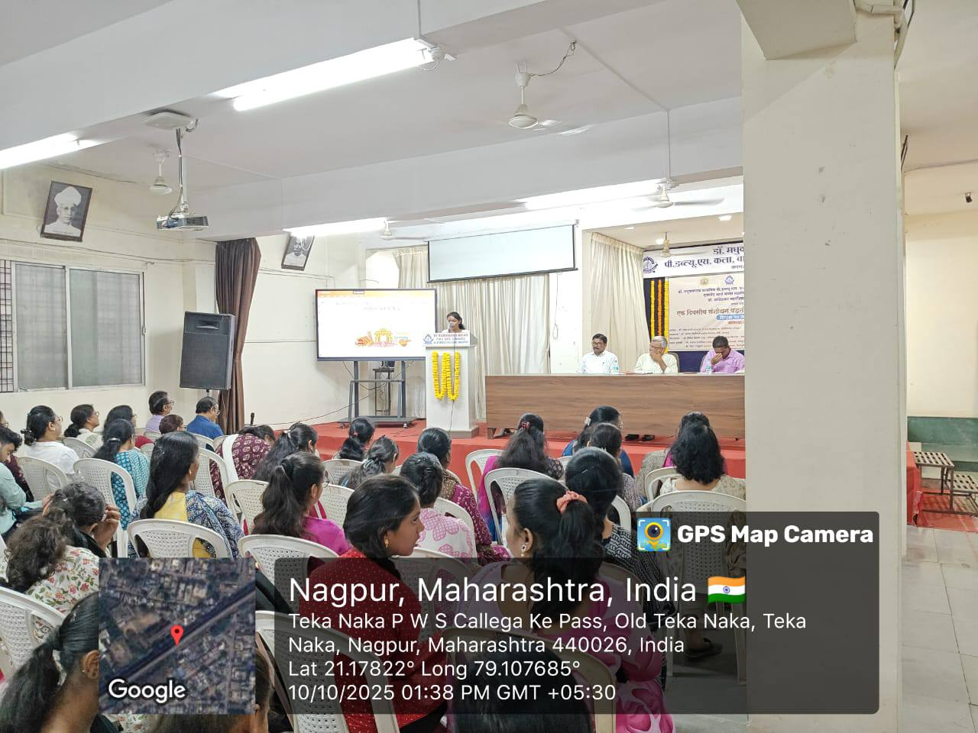
Participants speaking in the technical sessions
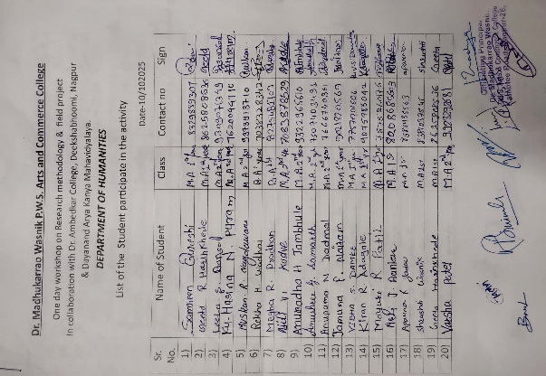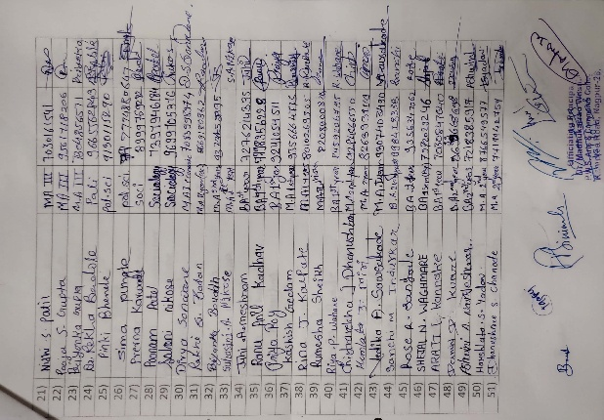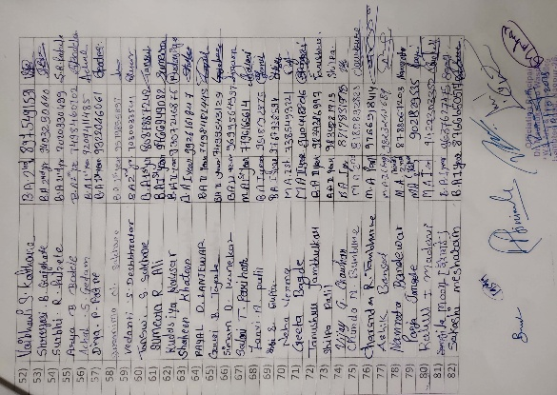

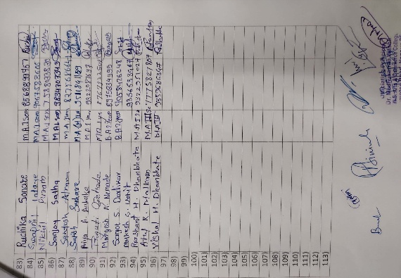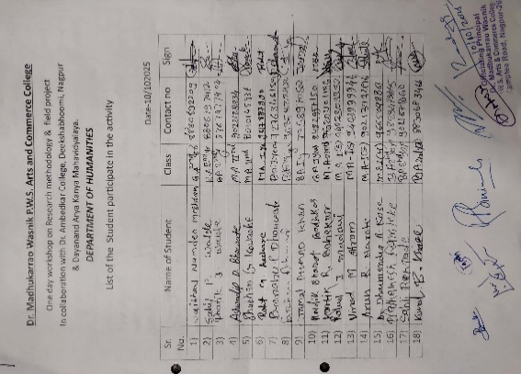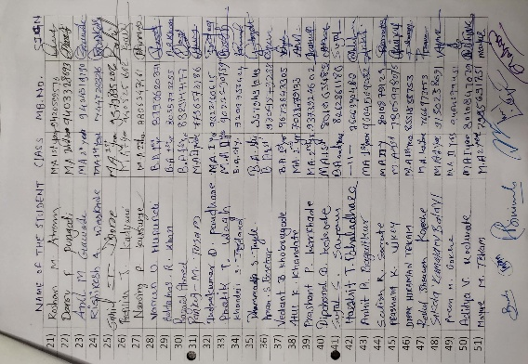
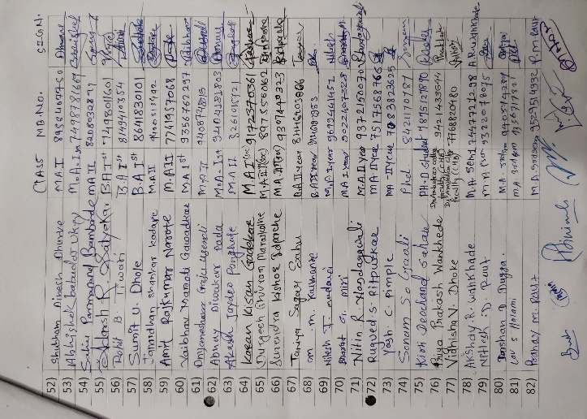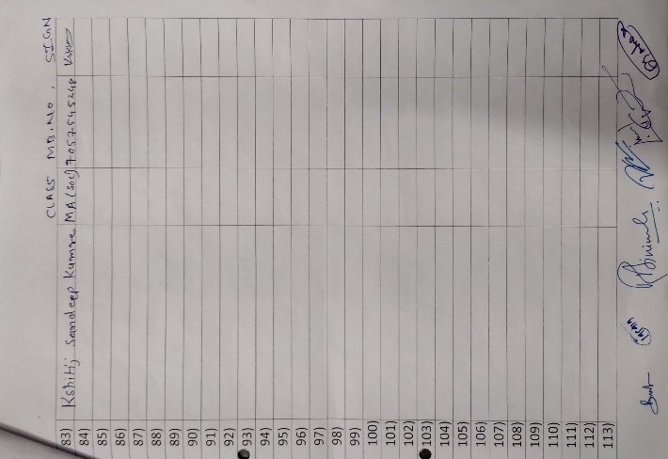

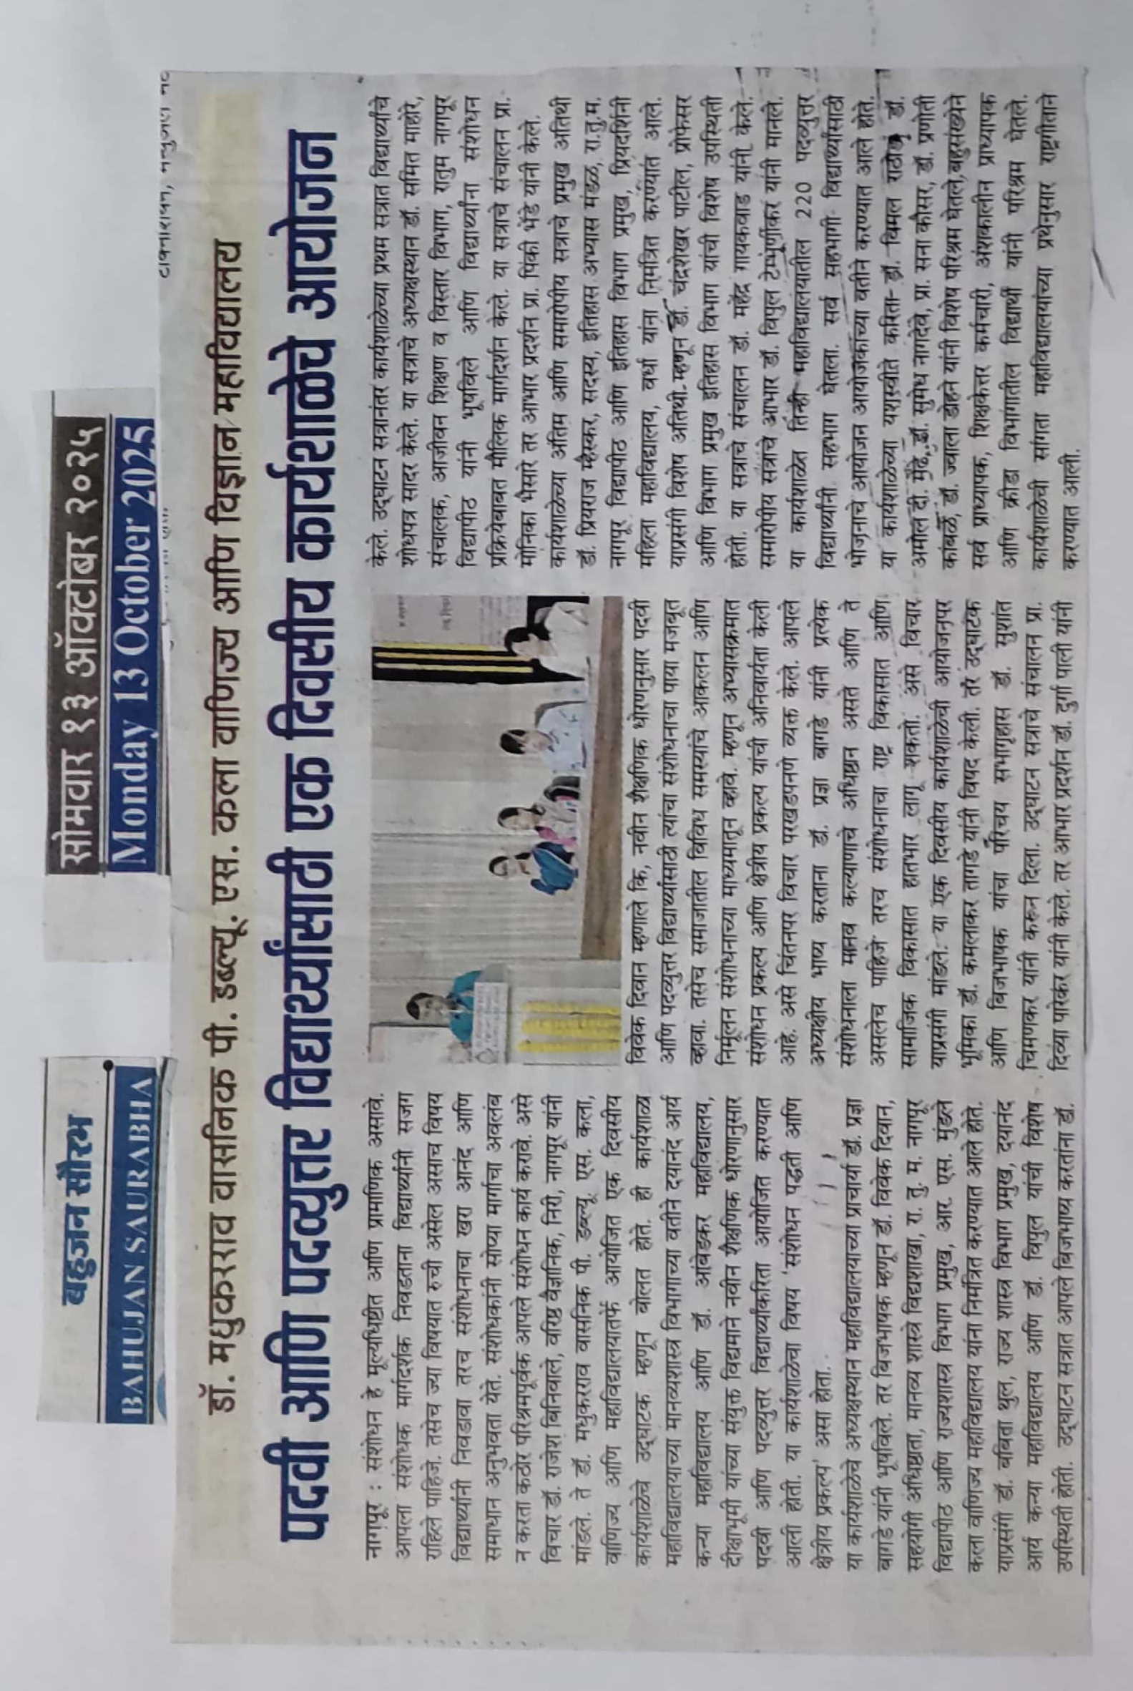

Certificate of participation in the workshop
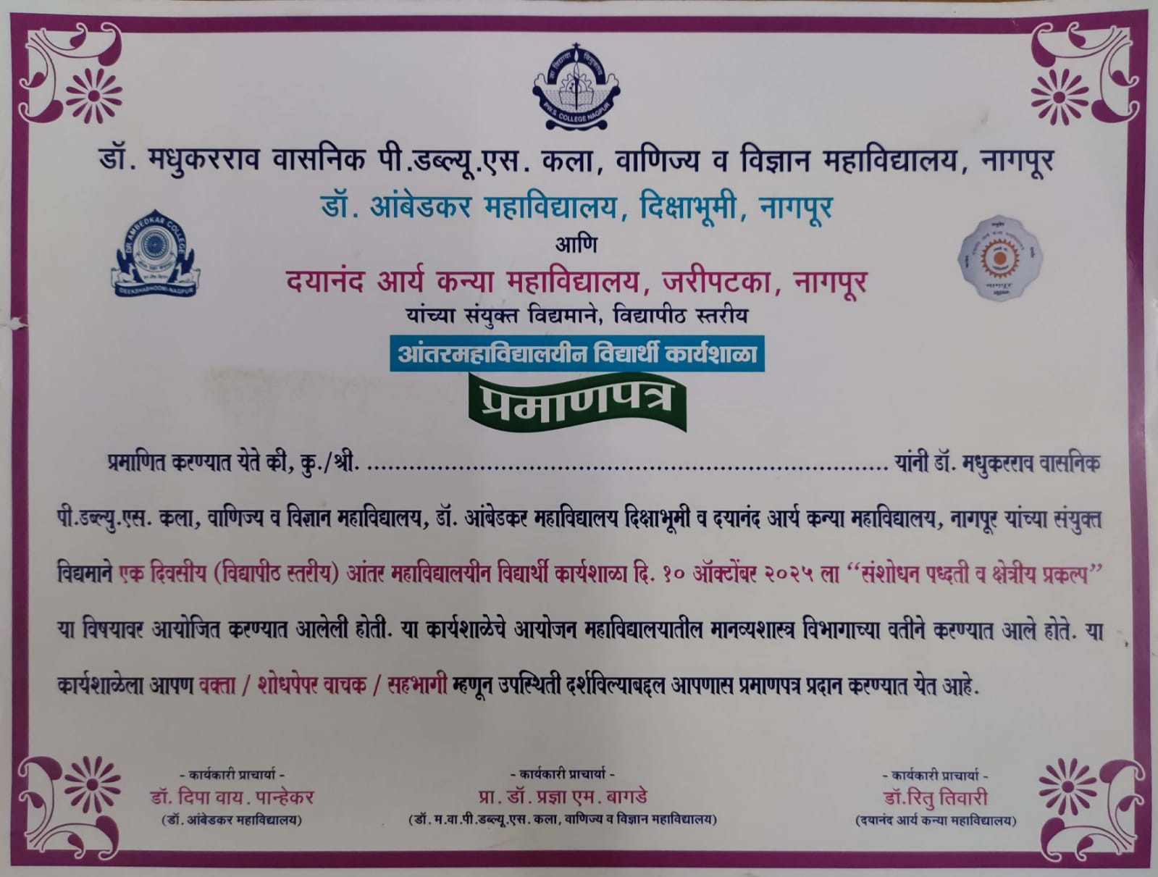

Submitted by:- Prof.Priya Wankhed


Department of Economics

