Report on
Campus Placement Drive by Fendahl Technology
Date:13 February 2026.
Venue: Dr. Ambedkar College Deekshabhoomi, Nagpur.
The Department of Computer Science (CS) and Computer Application (BCA), Dr. Ambedkar College, Deekshabhoomi, Nagpur, organized a Campus Placement Drive in collaboration with Fendahl Technology for the position of Junior Software Developer on 13 February 2026. The drive was conducted from 9:30 AM to 5:00 PM at the premises of Dr. Ambedkar College, Deekshabhoomi, Nagpur and provided an excellent opportunity for students to begin their professional careers in the field of software development.
The placement drive was conducted under the guidance of Principal Dr. Mrs. Deepa Panhekar Head of Department Dr. Pankaj Nimbalkar (CS) and Head of Department Dr. Prashant Yende (BCA). The event was organized by the BCA Department with the support of Mr. Javed Shah, Placement Coordinator, who facilitated communication between the company and the students and ensured the smooth conduct of the recruitment process. Mr. Rakesh Uikey, Coordinator from Computer Science Department help in smooth conduction of the recruitment process.
Students with knowledge of programming, Object-Oriented concepts, databases, and web technologies participated enthusiastically in the recruitment process. The selection process was conducted in multiple rounds to evaluate the technical knowledge, aptitude, and communication skills of the students.
The recruitment process was conducted as follows:
- Aptitude Test: 9:30 AM – 11:00 AM
- Technical / Programming Test: 11:30 AM – 1:30 PM
- HR Round with Personal Interview: 2:30 PM – 5:00 PM
After the technical/programming test, the following students were shortlisted for the HR round:
- Parikshit Kadam
- Geetanjali Singh
- Aman Kanojiya
- Alfiya Pathan
- Radhika Anwane
- Lalit Pandit
- Tanishk Jain
- Laxmi Chichmalkar
- Chetana Ghatole
After the final HR round and personal interviews, two students were successfully selected for placement in Fendahl Technology:
1. Lalit Pandit
2. Geetanjali Singh
The campus placement drive proved to be a valuable experience for the participating students, providing them exposure to the professional recruitment process and motivating them to enhance their technical and problem-solving skills. Such initiatives help bridge the gap between academic learning and industry requirements, enabling students to take their first step toward a successful professional career.

Glimpses of Placement Drive Fendahl Technology :
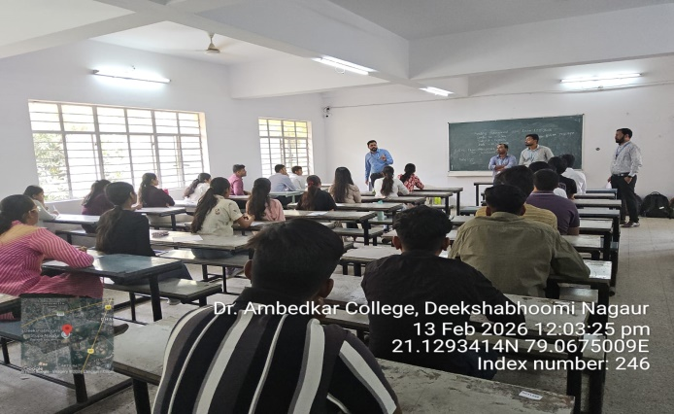 | 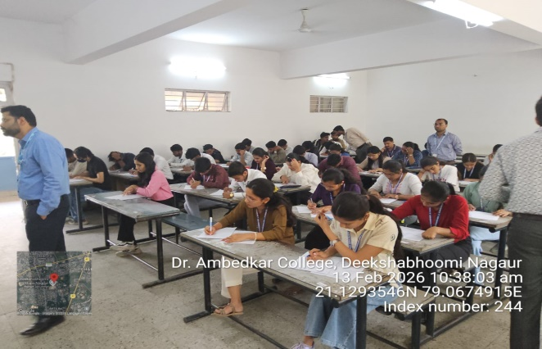
Fendahl Executive briefing about placement procedure | Students Engaged in Apptitute Test(Round-I) of Placement Drive
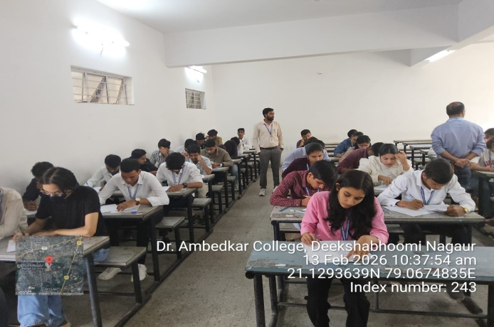 | 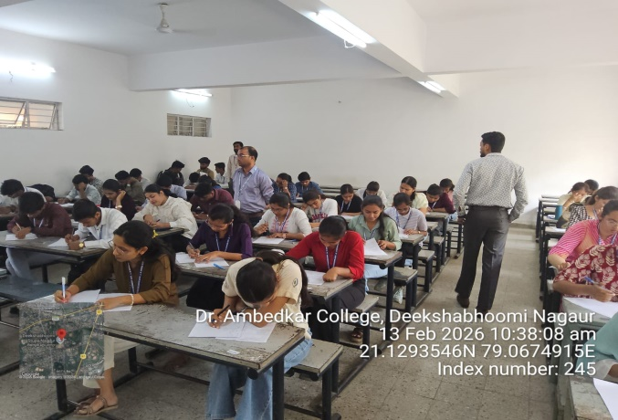
Students Appearing for Technical Round (Round-II) of Placement Drive
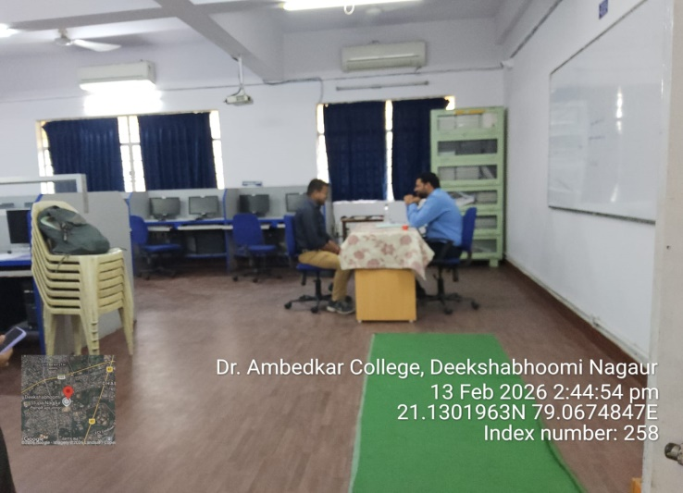 | 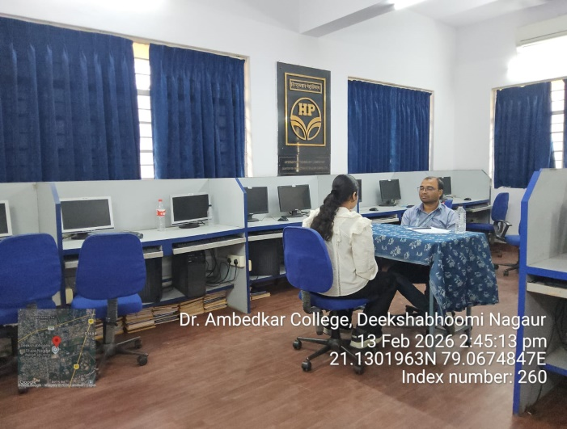
Students Appearing for HR and PI Round (Final Round) of Placement Drive

