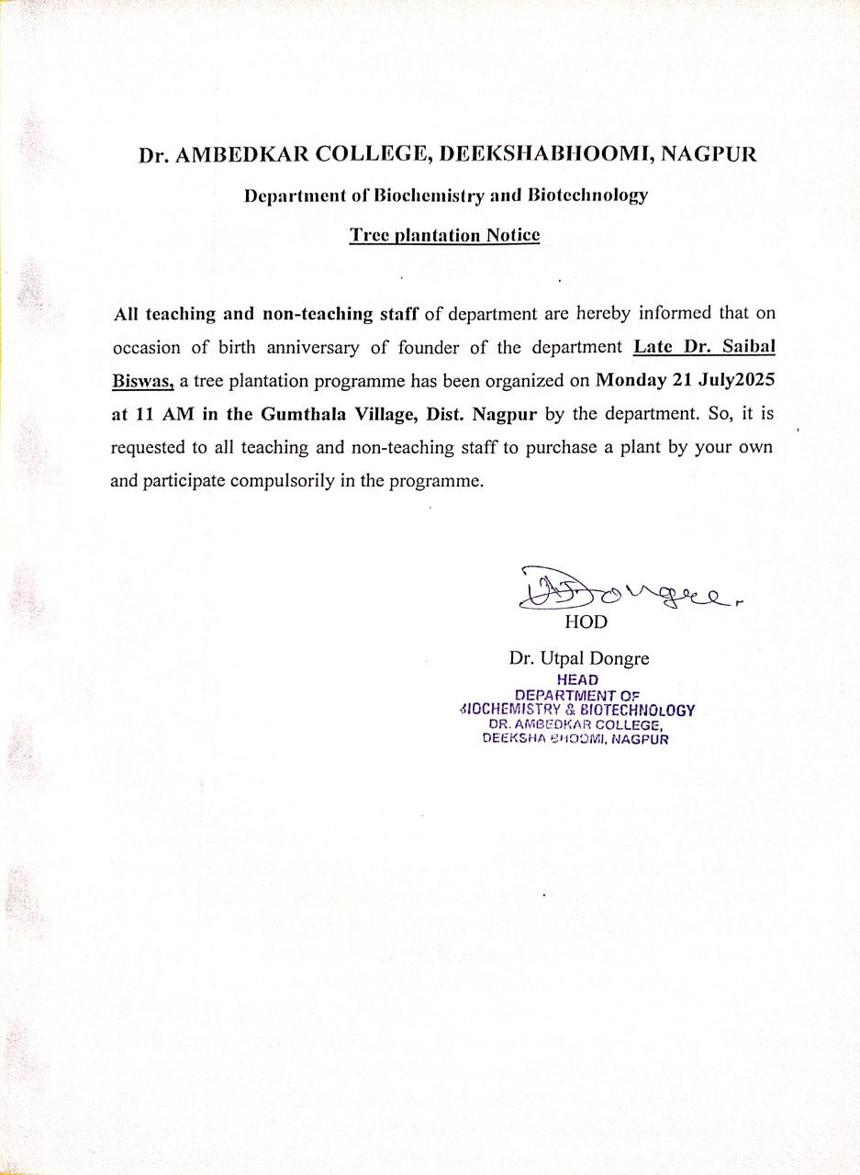

TREE PLANTATION IN THE MEMORY OF LATE Dr. S. K. BISWAS

Trees contribute to the environment by providing oxygen, improving air quality, climate amelioration, conserving water, preserving soil, and supporting wildlife. They also are important part of every community, our streets, parks, playgrounds and backyards when lined with trees create peaceful, aesthetically pleasing environment. They increase our quality of life by bringing natural elements and wildlife in the urban environment and this is acknowledged in the Governments Sustainable Development Strategy.

Throughout the world, about 900 million trees are cut down annually, Twenty nine million, eight hundred thousand trees (29,800,000) are cut down every day in the world. Annual tree mortality ranges from 1 to 3%, so approximately 14,000-45,000 of these trees will fall every year. About 50,000 trees should be planted every year in the study area to ensure that the city's tree cover does not fall below its current level.

In order to create awareness amongst youngsters, Dr. Ambedkar College, Deekshabhoomi, Nagpur has conducted tree plantation program in the memory of Late Dr. S. K. Biswas, former H.O.D of the department of Biochemistry and Biotechnology on 21 July 2025. All the faculty members, non-teaching staff members of the Department has participated enthusiastically in the programme and planted different flowering, medicinal and ornamental plants.

Valuable efforts has been taken to organize the above programme by Dr. Utpal Dongre, H.O.D, Department of Biochemistry and Biotechnology and all the teaching and non- teaching staff.

"WHEN ONE PLANTS A TREE ONE PLANTS THEMSELVES. EVERY ROOT IS AN ANCHOR, OVER WHICH ONE RESTS WITH GRATEFUL INTERESTS AND BECOME SUFFICIENTLY CALM TO FEEL THE JOY OF LIVING”

— JOHN MUIR

