Dr. Ambedkar College, Deekshabhoomi ,Nagpur.

Name of Program: INNOVISION 2026: Where Science Meets Enterprise
Guests: Mr. Abhitabh Meshram, Chairmen Prowess Group, Dr. Prajakta Gadkari, CA, Dr. H. M. Meshram, Senior Scientist IICT, Hydrabad
Date and Time of Program: 28/02/2026 at 10.00AM-3:00PM
No. of Students Present: 200
No. of Teachers Present: 10
Hosted by: IQAC, ED Cell, IIC, Career Katta, UNNATI cells of Dr. Ambedkar College, Nagpur
Convener: Dr. D. N. Begde

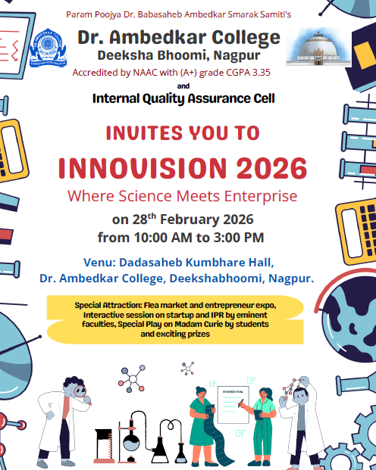

A

Report

on

INNOVISION 2026: Where Science Meets Enterprise
The INNOVISION 2026 program, held on 28th February 2026 at Dr. Ambedkar College, Nagpur, was a collaborative effort organized by the IQAC, ED Cell, IIC, Career Katta, UNNATI, and all college faculties. Hosted at the Dadasaheb Kumbhare Hall, the event was designed as a premier intersection of scientific research and entrepreneurial application, running from 10:00 AM to 3:00 PM. The primary goal of the program was to provide a platform for students to explore startups and Intellectual Property Rights (IPR) alongside technical exhibitions.
The event commenced with a formal Inauguration and Welcome ceremony between 10:00 AM and 11:00 AM. Under the leadership of Dr. Pratima Lokhande, Ms. Shazia Bari, and Mr. Manoj Andraskar, the committee welcomed the Chief Guest, Mr. Abhitabh Meshram, Chairman of the Prowess Group. The dignitaries, including Principal Dr. Mrs. Deepa Panhekar and the judging panel, were presented with saplings as a sustainable welcoming gesture. This session set the stage for the day's theme of growth and innovation.
Following the inauguration, the program transitioned into two high-impact Interactive Sessions focused on professional development. From 11:00 AM to 11:30 AM, Dr. Prajakta Gadkari delivered a session on Startup and Entrepreneurship, focused on the fundamentals of building a business. It also involved discussion on IPR and Patenting as a specialized part of the session which addressed the importance of Intellectual Property Rights in scientific research and commercialization. This session provided students with a theoretical and practical foundation for protecting and commercializing their scientific ideas.
The midday segment from 12:00 PM to 1:00 PM featured a hands-on Flea Market and Entrepreneur Expo, also known as the Anand Mela. Conducted in the shaded parking area, this market allowed students to showcase their business ventures and interactive products. This was coordinated by Dr. Vitthal Bondar, Ms. Priyanka Soitkar, and Mr. Chetan Dhande. Concurrently, the Model and Poster Exhibition took place in the Kumbhare Hall and department labs. Dr. Amit Bansod and Dr. Rahul Kamble oversaw the arrangement of static and working models and posters, which were evaluated by the panel of judges to determine the winners of the competition. The panel of judges included Dr. S. R. Somkuwar, Dr. Aarti Wazalwar, Dr. Utpal Dongre, and Dr. Harsha Pethe and they provided a comprehensive judgement through rigorous evaluation.
The afternoon continued with a cultural and educational highlight: a Science Play on Madam Curie. Performed by the students of Department of Physics between 1:00 PM and 2:00 PM, the play was coordinated by Dr. Namrata Pradnyakar. This performance aimed to humanize scientific discovery and inspire the student body through the dramatized life of one of history's most significant scientists.
The program concluded with the Valedictory Function and Prize Distribution from 2:00 PM to 3:00 PM was conducted jointly by Ms. Priyanka Soitkar, Dr. Namrata Pradnyakar, Ms. Karuna Shahani, and Mr. Manoj Andraskar. The committee announced the winners of the model and poster competitions. Ms. Aditi Hatwar from B.Sc. Biotechnology went on to grab the first prize in the model category wherein she demonstrated an innovative approach to produce fertilizer and electricity sourced from public urinals. Ms. Aasawari Moon from XI commerce Jr. college and Tashka Koche (Physics Dept) with Palak Rawande (Biochemistry Dept) won the second and joint third prize respectively in the model category. In the Poster category Ms. Prerna Choudhary, Pradnya Sahare and Selofiya Akare’s group won the first prize where their idea of producing functional food in the form of probiotic chocolate was considered superlative by the judges. Mr. Aryan Sapkal and Ms. Aliza Khan were declared as the second and third prize winners respectively in the poster presentation competition. Dr. H. M. Meshram, Senior Scientist IICT, Hydrabad was the chief guest for this session and Prizes were distributed amongst the winners at the hands of the chief guest and our Principal, Dr. Mrs. Deepa Panhekar. The event ended with a formal vote of thanks by Ms. Priyanka Soitkar, acknowledging the financial oversight provided by Dr. Akhil Ramteke and Mr. Winit Anandpawar and Dr. Rahul Kamble for the comprehensive support for the day's achievements.
