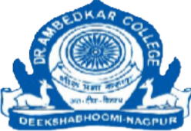

DR.AMBEDKAR COLLEGE, DEEKSHABHOOMI, NAGPUR DEPARTMENT OF LAW

REPORT ON ACTIVITIES CONDUCTED AS A PART OF SAMVIDHAN FESTIVAL – 2025
To commemorate the spirit of our Indian Constitution, Department of Law organised a series of engaging and insightful activities as a part of Samvidhan Mohotsav 2025 which aimed at fostering constitutional values among students. These initiatives were designed to deepen their understanding of the Indian Constitution, encourage active civic participation, and highlight the significance of fundamental rights and duties. Through collaborative, creative, and knowledge-based events, students were provided with meaningful opportunities to explore the spirit of the Constitution and appreciate its role in shaping a democratic society.
Following are the activities conducted-

Date | Activity conducted | Place | Conducted by | No. of  students
14.11.2025 | Legal awareness survey | Laxmi Nagar slum area and MMS college of social service | Dr. Pratima Lokhande  Adv. Akash Dhote | 07
On the Occasion of Constitutional Day, there are numerous celebrations and events across the country. As a part of Legal fraternity, it is a matter of pride to remember this date imprinted in the history that assures formal adoption of a documents which guarantees the citizens of their fundamental and constitutional rights. But a question arises whether if the citizens know about these provisions under the Constitution? How many people among general public are aware about the rights guaranteed under the constitution? So, to understand the awareness about the Constitution of India, the students of the Department of Law at Dr Ambedkar College, Deeksha Bhoomi, conducted a Socio-Legal Survey.
In this area specific survey, the students covered a slum rehabilitation to consider the awareness from the weaker section of the society. Then proceeding to the college premises of a Social Service College (M.S.S College of Social Service), the students conducted a survey from participants ranging from elder age group to younger fellow students. The students had a very unique experience while interacting with strangers from different parts of a society. This helped the students boost confidence and increase boldness to interact with strangers from different backgrounds.
Annexure:
- Sample Copy of the Questions of the Survey in Hindi.
- Survey Copies of the Students.

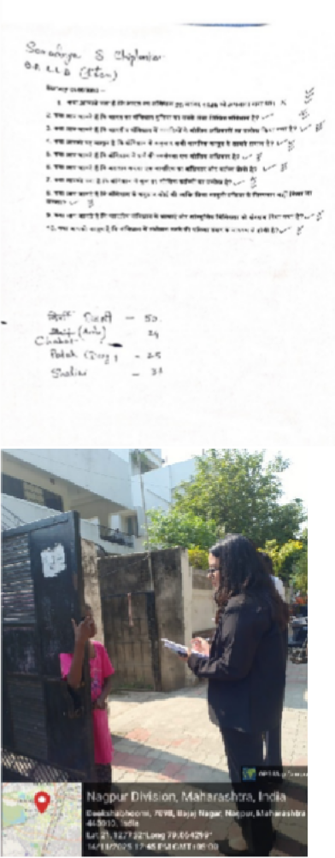
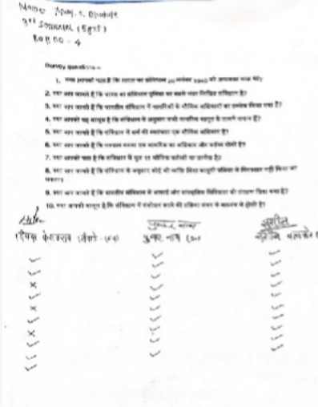 | 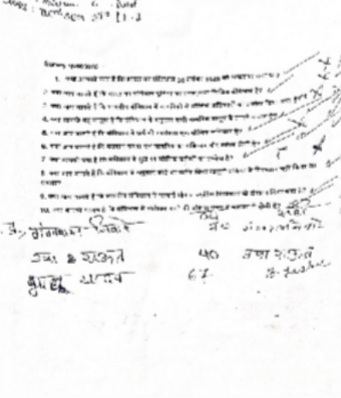
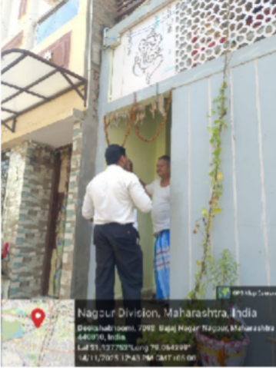 | 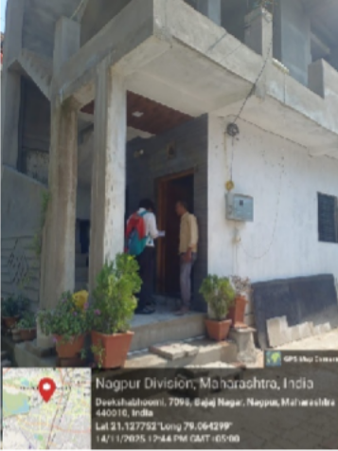

Date | Activity conducted | Conducted by | Classesinvolved
14.11.2025 | Book exhibition | Dr. Vaishali Sukhdeve, Mr. Sagar Tavar and Mrs. Navjyot Sethi | 3-Year LL.B. and 5-Year  B.A.LL.B. Students

A Library Visit was organised to mark “Sanvidhan Mahotsav – 2025” for the students ofthe 3-Year and 5-Year Law Programmes of Dr. Ambedkar College, Deekshabhoomi, Nagpur with the objective of familiarising them with the rich legal and constitutional resources available in the institutional library. A total of 31 students from the 3-Year Programme and 51 students from the 5-Year Programme enthusiastically participated in the Book Exhibition.
The exhibition featured an impressive display of eminent legal works, including Black’s Law Dictionary, The Transformative Constitution: A Radical Biography in Nine Acts, H.M. Seervai’s Constitutional Law of India, My Own Boswell by Justice M. Hidayatullah, among several other authoritative texts in the library.

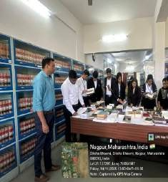
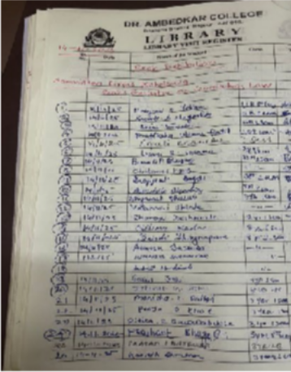
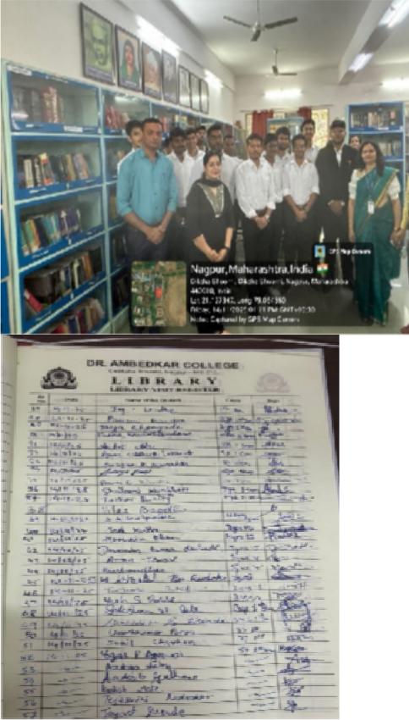
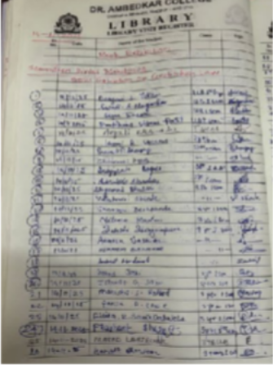
The visit aimed to introduce students to the library’s extensive collection of legal and constitutional literature, provide exposure to essential reference materials for Jurisprudence, Constitutional Law, and research-based learning, and encourage strong reading habits and scholarly inquiry among budding legal professionals. The students were also guided on how to effectively utilise library resources for their assignments, research papers, moot court preparation, and other academic projects in the future.
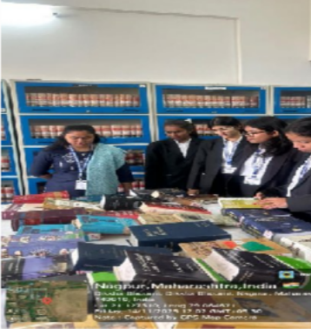

Date | Activity conducted | Topic | Conducted by | No. of  Students
15.11.2025 | Classroom Paper Presentation Activity | Constitution &Constitutional Issues | Ms. Ritu  Kaushik | 14

The Department of Law organized a Classroom Paper Presentation ActivityonNovember15, 2025, at Dr Ambedkar College, Deekshabhoomi, Nagpur. The programme focused on “Constitution & Constitutional Issues” and aimed to enhance students’ understanding of constitutional provisions, landmark judgments, and contemporary debates. Fourteen students participated in the activity, each presenting a paper for 6–8 minutes followed by a Question- and-Answer session. The objectives of the activity were to encourage independent research on constitutional law, help students develop presentation and academic communication skills, foster peer learning and constructive feedback, and connect theoretical learning with current constitutional issues.

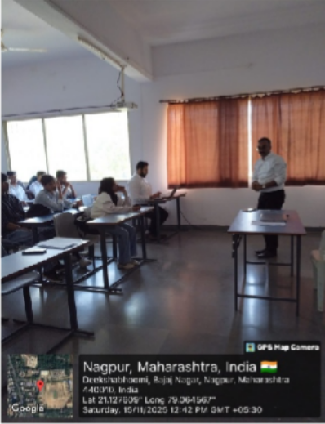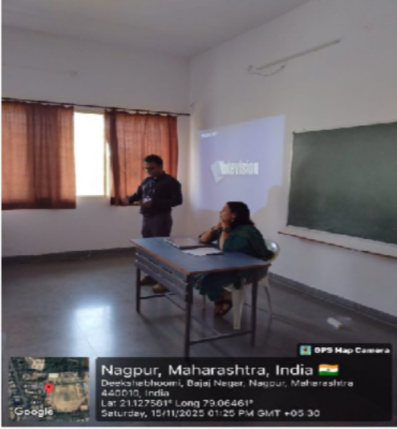

Date | Activity conducted | Conducted by | Classesinvolved
17.11.2025 | Extempore competition | Mr. Robin Kukde | 5-YearB.A.LL.B.Students

An extempore competition on key constitutional topics was conducted on 17 November,2025 for the BALL.B.1stSemester students as part of the Samvidhan Diwas Mahotsava.The event was conducted by Professor of History, Robin Kukde. Topics included Fundamental Rights, Right to a Clean Environment, Changing Reservation Policies, Need to Amend Fundamental Duties, and Lack of Scientific Temper(Article51A(h)).Students delivered one- minute speeches showcasing the understanding of constitutional principles and contemporary issues. The activity promoted legal awareness, critical thinking, and responsible citizenship. The event was successfully held by the Department of Law, contributing meaningfully to the celebration of the Indian Constitution.

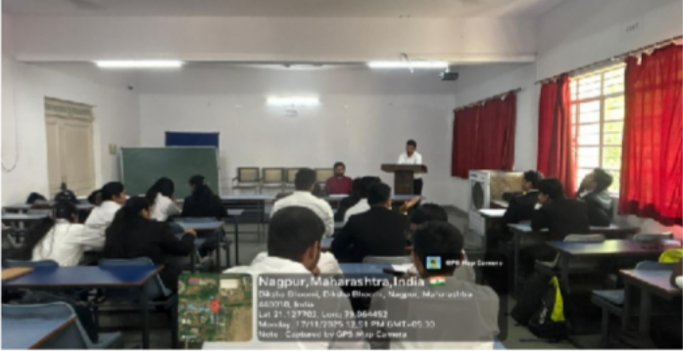

Date | Activity conducted | Conducted by | No. of students
18.11.2025 | Slogan writing Competition | - Dr.Pratima Lokhande  - Mrs.Apurva Bondre | 10

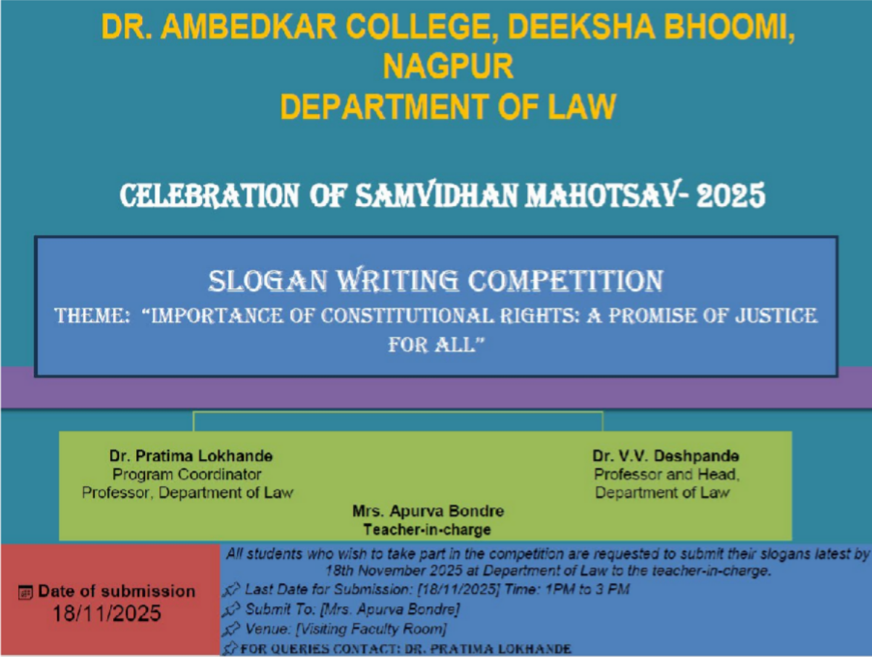

Report:
The Slogan writing competition was organized on 18th November 2025 on the occasion of Constitution Day 2025 by Department of Law. The theme of the event was “Importance of Constitutional Rights: A promise of justice for All”, aimed at sensitizing participants about the importance of Constitutional values in everyday life. A total of 10 students from various classes participated enthusiastically. Each participant was required to submit a slogan reflecting the theme. The slogans were judged on creativity, clarity, relevance to the theme, and overall impact. The Slogan-writing Competition successfully achieved its purpose of spreading awareness on Constitutional rights.

Photos:

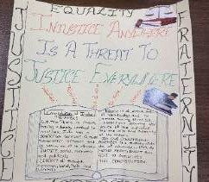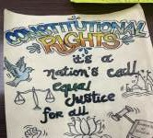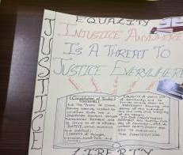

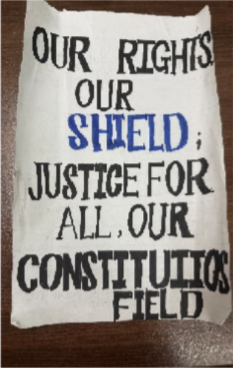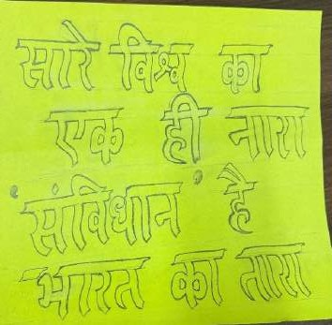

Date | Activity conducted | Conducted by | No. of students
18.11.2025 | Round table conference | Dr. Mrs. Sandhya Kalamdhad  Adv.Akash Dhote | 6

On the Occasion of Constitutional Day, there are numerous celebrations and events across the country. As a part of Legal fraternity, it is a matter of pride to remember this date imprintedin the history that assures formal adoption of a document which guarantees the citizens of their fundamental and constitutional rights. But a question arises whether if the provisions under the Constitution are being followed in the independent India? How many pillars of the democracy under the constitution are working efficiently and independently? So, to understand this aspect about the Constitution of India, the Department of Law at Dr Ambedkar College, DeekshaBhoomi, conducted a Round-Table Conference. In this conference, the students covered a topic related to the autonomy and functioning of the Election Commission of India. Students discussed the case of 'Anoop Banarwal Vs. Union of India' and different other legislations in this regard. The students also pointed out the unsatisfactory outcomes of the Anti-Defection laws in different states of India. The students hadaveryuniqueexperiencewhilediscussingarecentcontroversialissuedwellinginthe

country. This helped the students boost confidence and increase boldness to express their opinion on legal matters in a scholarly discussion.
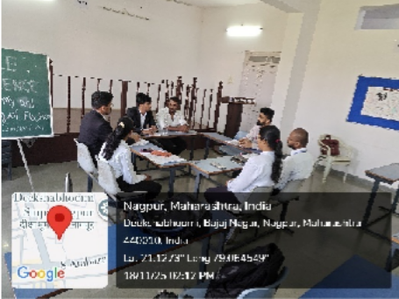
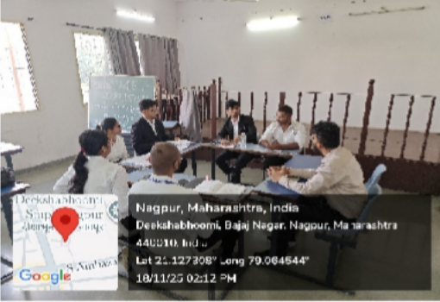

Date | Activity conducted | Conducted by | No. of students
18.11.2025 | Group Discussion Activity | Ms.Ashwini Kulkarni, Ms. Poonam Ingolay | 28

The Department of Law, Dr. Ambedkar College, Nagpur conducted a group discussion for first-semester BA.LL.B. students to enhance their analytical, communication, and public- speaking skills. The activity aimed to connect sociological concepts with Constitutional Law and encourage logical expression of ideas. Students were divided into groups and discussed topics such as freedom of speech, untouchability, rural transformation, family and constitutional law, and civil society. Guided by Assistant Professors Ms. Ashwini Kulkarni and Ms. Poonam Ingole, participants supported their views with constitutional provisions, judicial precedents, and social reasoning. The session helped students improve their research abilities, legal reasoning, and confidence. Overall, the activity successfully fostered socio- legal awareness and critical thinking among the students, reflecting their enthusiasm for learning and professional growth.
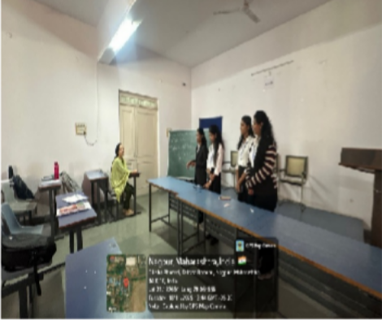
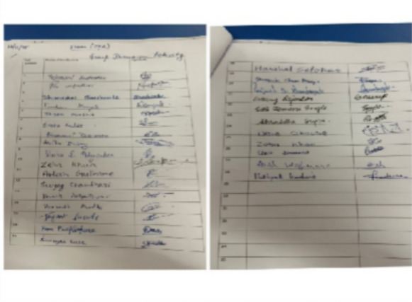

Date | Activity conducted | Conducted by | No. of students
20.11.2025 | Poster Making Competition | Dr.Shilpa Rathod | 2

The Department of Law successfully organized a Poster Making Competition as a part of the Sanvidhan Diwas Mahotsav, commemorating Constitution Day (26th November). The primary objective of the competition was to actively engage students of the LL.B. 3-Years and LL.B. 5-Years Courses and encourage a deeper, visual understanding of the core principles and values enshrined in the Indian Constitution. The event was conducted under the efficient coordinator ship of Dr. Shilpa Rathod.
To provide a wide scope for creative and intellectual expression, participants were invited to choose themes closely related to the Constitution. The suggested themes were:
  - Preamble: The Soul of the Constitution
  - Fundamental Rights and Duties
  - Directive Principles of State Policy(DPSP)
  - Federalism in India
  - Role of the Judiciary and Judicial Review
  - Constitutional Values: Liberty, Equality, Fraternity, Justice
The notice was circulated to all eligible students, inviting their enthusiastic participation. The deadline for the submission of the creative posters was 12:00 PM sharp on November 20, 2025.
The competition saw participation from two dedicated students . Ms. Sayalee Ghatole for I Sem LLB 3 years and Ms Rakesh Gajbhiye from V Sem LLB 5 years, who prepared insightful and visually compelling posters reflecting the constitutional themes. Though the number of participants was limited, the quality and effort invested in the submitted entries were commendable, demonstrating a sincere appreciation for the values of the Constitution.
The Poster Making Competition successfully achieved its goal of fostering engagement with constitutional principles ahead of Constitution Day. Dr. Shilpa Rathod, the coordinator, managed the collection and initial review of the submitted entries effectively.

The Department of Law extends its sincere appreciation to Dr. Shilpa Rathod for her meticulous coordination and thanks the two participants for their creative contributions to the Sanvidhan Diwas Mahotsav celebration.
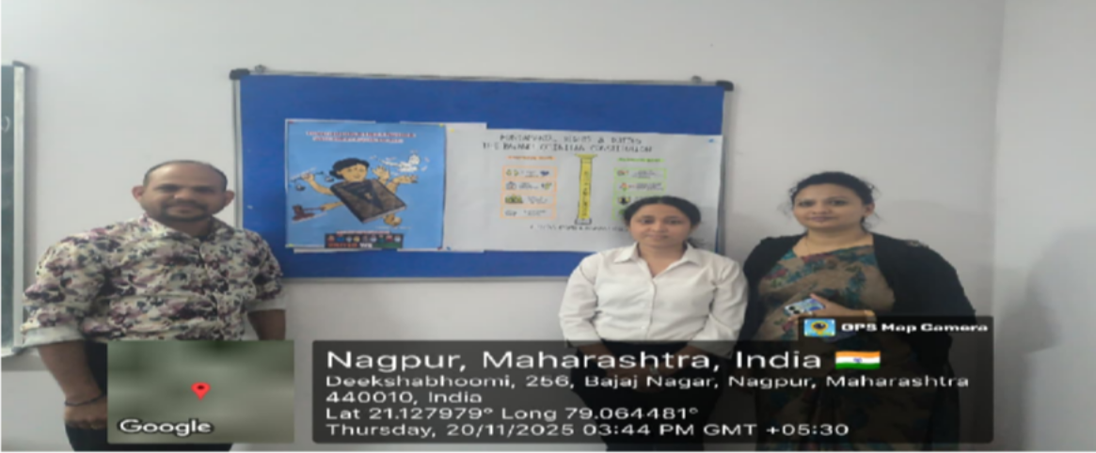

Date | Activity conducted | Conducted by | Classesinvolved
21.11.2025 | Know your Constitution | Ms. Shazia Bari, Assistant Professor | BCA and Biotechnology Students
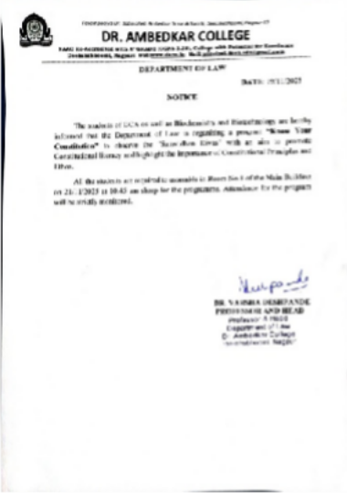

Dr. Ambedkar College, Department of Law, Deekshabhoomi, Nagpur had Organized the program “Know your Constitution” as a part of “Samvidhan Mahotsav” to mark the Constitution day. The program was organized on 21st November, 2025 through the Centre for Constitutional Law and Public Policy debate, Department of Law. It was conducted in collaboration with the BCA Department and the Department of Biochemistry and Biotechnology of the College. The program started by invoking the blessings of Lord Gautam Buddha and Dr. B.R. Ambedkar. Prof. Dr. Varsha Deshpande, Head of the Department(Law) delivered the introductory remarks. Dr. Deepa Panhekar, Officiating Principal addressed the gathering and applauded the organizers of the event.
This unique initiative was taken by the Department of Law to promote Constitutional literacy and to highlight the importance of Constitutional values, principles and ethos. In this program, Ms. Harshal Bajaj, LL.M. student from the Department of Law gave a presentation on the topic “Know your Constitution” in which she covered the Constitutional history, Preambular goals, fundamental rights and fundamental duties. The presentation was followed by the question- answer session.
Approximately 46 students attended the program. The event was co-ordinated by Ms. Shazia Bari, Assistant Professor& Co-coordinator of the Centre. Dr. Harshala Pethe, Assistant Professor (BCA) and Mr. Rohan Thaware, Assistant Professor (Biotechnology) rendered valuable support in organizing the program.

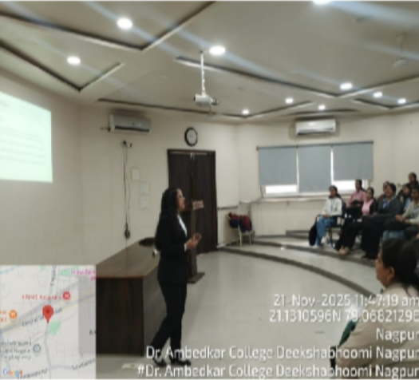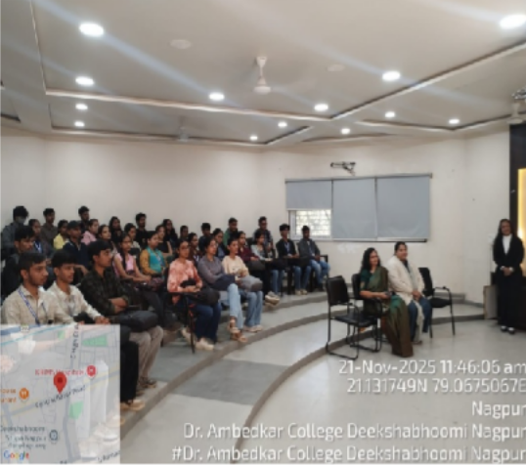

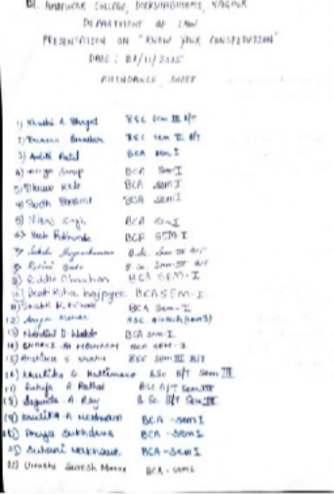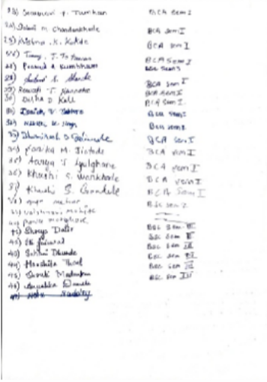

NAMEOFTHEPROGRAMME: | PREAMBLERECITATIONCOMPETITION
DATEANDDAY: | 21STNovember2025
TIME: | 1.00 PM
VENUE: | Moot court HallA, First floor, DepartmentofLaw
PROGRAMME CO-  ORDINATOR: | Dr. Mrs. Vaishali A. Sukhdeve

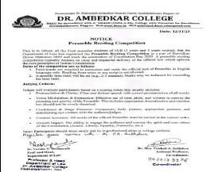
The Department of Law had organized the Preamble Reciting Competition on 21st November 2025 as a part of Sanvidhan Diwas Mahotsav 2025 and mark the celebration of Constitution Day 2025. A preamble reciting competition typically focused on clear and impactful delivery of the official text which upholds the core principles of Indian Constitution. By engaging in the act of reciting the Preamble, participants are encouraged to reflect on its meaning and apply its guiding principles to their lives and the broader community. The objectives of the preamble are to secure justice, liberty, and equality for all citizens and to promote fraternity among them, which includes assuring the dignity of the individual and the unity and integrity of the nation. These principles form the foundation of the Indian Constitution and guide its framework for governance. Total 09 participants registered for the competition. They were judged on basis different criterions like Pronunciation & Clarity, Voice Modulation & Expression, Confidence & Stage Presence, Overall Impact wherein the ability to engage the audience and convey the spirit and core values of the Constitution like Justice, Liberty, Equality, Fraternity, etc. All the participants

recited the Preamble with complete zeal and enthusiasm. Ms.Disha Choube became the winner of the competition by securing highest marks.

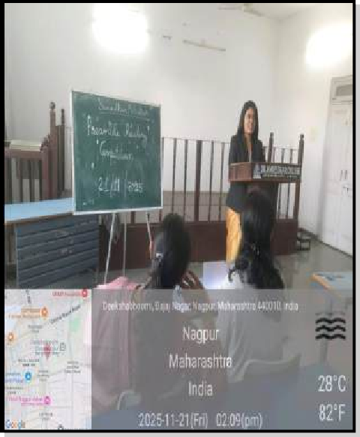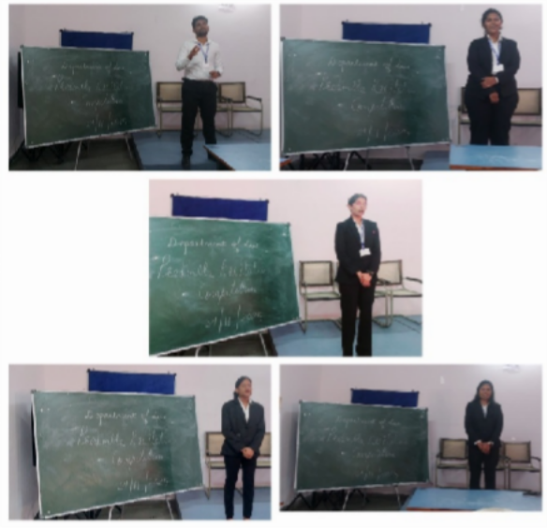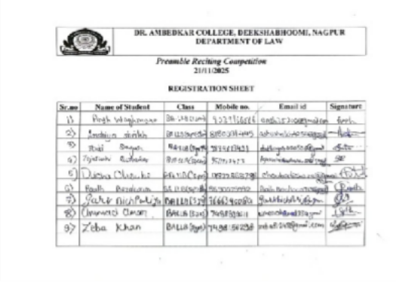

Date | Activityconducted | Conducted by | No. of students
21.11.2025 | Mock Parliament | Prof. Pratima R. Lokhande | 40

The Mock Parliament was organised on the occasion of Samvidhan Mahaostav- 2025 by Department of Law of Dr. Ambedkar College, Deekshabhhomi, Nagpur on 21 November, 2025. The Mock Parliament commenced at 10.30 am. The session began with invoking the blessings of Taathagat Gautam Bhuddha and Dr. B.R. Ambedkar. Prof. Dr. Deepa Panhekar, Principal felicitated the Judge Ms. Pragya Chhabra, Journalist Lokmat by offering sapling. Dr.V.V. Deshpande, HOD of Law

was present and expressed her best wishes for the successful organization of programme.
The judge Ms. Pragya Chhabra, Journalist Lokmat inaugurated the event bybangingthe gavel and also appreciated the efforts taken by the staff and thestudents for organizing Mock Parliament. She had appreciated the organizers for promoting awareness, interest and a democratic value system among the students. She thanked the College administration for the conduct of the Mock Parliament. The Mock Parliament received tons of appreciation from the students and the teacher alike.40+ participants participated in the event.
The vote of thanks was given by Student Ms. Gayatri. The session ended successfully at 4.00 pm with huge number of participants and remarkable feedback given by them. The Mock Parliament was organised under the guidance of and Dr. Pratima Lokhande (Program Coordinator). Dr. Vaisahli Sukhdeve from Department of Law was also present to encourage the students.
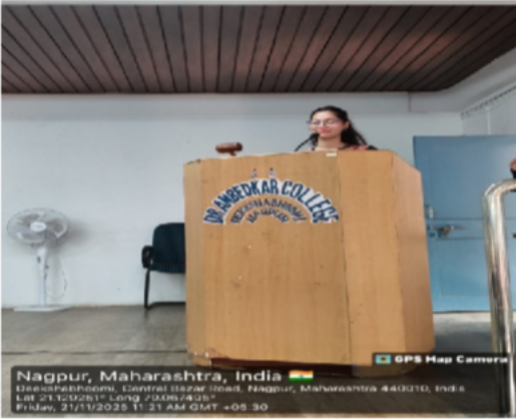
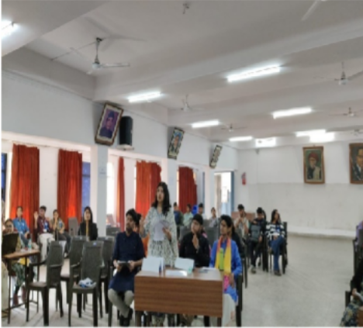

Date | Activity conducted | Conducted by | No. of students
22.11.2025 | Treasure Hunt Activity | Dr.Mrs.Varsha Deshpande Ms. Anusha Patre  Ms. Ashwini Kulkarni, | 12

The Department of Law organised a Constitution-Themed Treasure Hunt as a part of Constitution day celebrations. It also helped to promote interactive learning and enhance students’ understanding of fundamental rights, landmark cases, and constitutional principles. Teams enthusiastically navigated various locations across the campus—including the library, podium, canteen, garden, and legal aid board—by solving clues inspired by cases such as Shreya Singhal, Parmanand Katara, etc. The activity encouraged teamwork, critical thinking, and quick problem-solving, while making constitutional law engaging and enjoyable. The event was coordinated by Head of the Department Prof.Dr.Varsha Deshpande,Assistant

Professors Ms. Anusha Patre and Ms. Ashwini Kulkarni. The activity concluded successfully with positive feedback from the participants, marking it as an enriching and innovative learning experience.





