
Dr. Ambedkar College Deekshabhoomi Nagpur.

Title : Report on visit to Regional Meteorological Department
Nagpur.
Place : Nagpur.
Date : 02/12/2025
Report by : Namrata Pradnyakar (Asst. Prof. Physics), Harshala Gawate (B. Sc. Physics Sem 3)

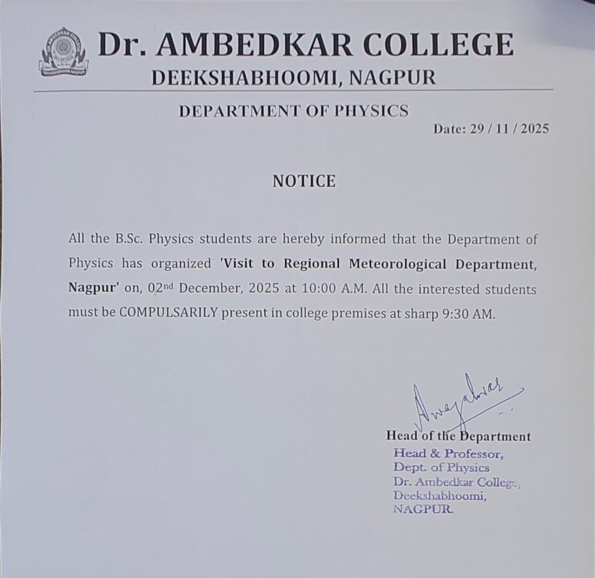

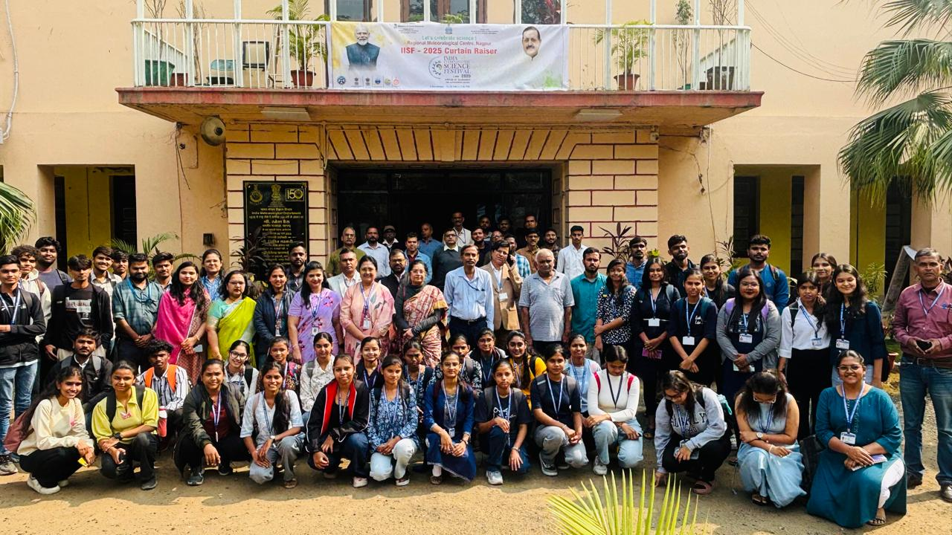

Introduction of Regional Meteorological Department :
The Regional Meteorological Centre (RMC), Nagpur, established in 1954, is one of the major operational units of the India Meteorological Department (IMD). The centre plays a crucial role in weather monitoring, forecasting, and climate services for the regions of Madhya Pradesh, Chhattisgarh, and the Vidarbha region of Maharashtra. Headed by a Deputy Director General of Meteorology, RMC Nagpur operates an advanced observation and forecasting network that includes Doppler Weather Radars, surface observatories, upper-air observatories, and satellite-based monitoring systems. The centre provides a range of services including 5-day weather forecasts, agro-meteorological advisories, aviation weather updates, and early warning alerts for extreme weather events. RMC Nagpur also supports disaster preparedness and decision-making for sectors such as agriculture, transportation, public safety, and administration. The regional forecasting responsibilities are further strengthened through meteorological subdivisions operating in Bhopal and Raipur, making RMC Nagpur a vital node in India’s weather and climate monitoring infrastructure.
The Department of Physics organized an educational visit to the Regional Meteorological Department (IMD), Nagpur, on 2nd December 2025, where 46 students, accompanied by teaching and non-teaching staff, attended the India International Science Festival (IISF) curtain-raiser program hosted by the centre. The event began with a lamp-lighting ceremony, symbolizing the spirit of knowledge and scientific inquiry. This was followed by an insightful lecture delivered by Dr. Rizwan Ahmad, who highlighted that the primary objective of the program is to inspire and motivate students and researchers in the fields of science and technology.
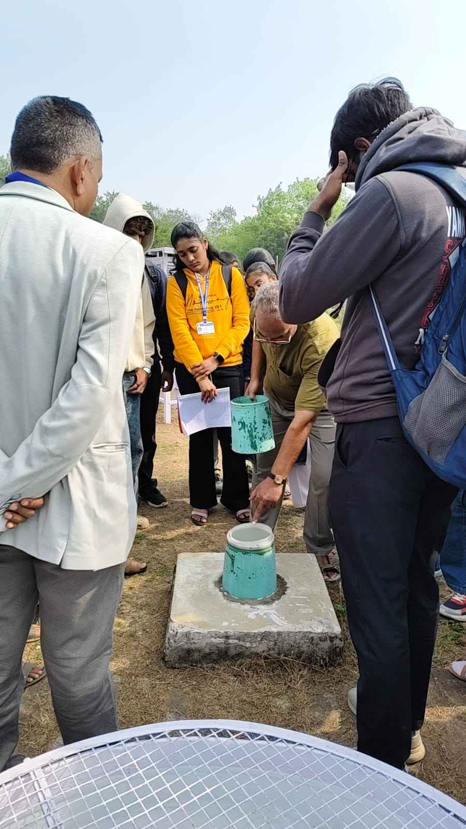
- Rain Gauge :
Rain Gauge is a type of instrument used by meteorologist to measure the amount of liquid precipitation.
He then explained that this is the standard rain gauge means non – recording rain gauge. It consist collecting funnel, measuring cylinder, outer shell and measuring stick. The funnel at top collects the water, the measuring cylinder located below the funnel that receives the collected water, the outer shell surrounding the measuring cylinder is to catch any excess water that overflows during heavy rainfall. A stick is used to measure the depth of water in the measuring tube.
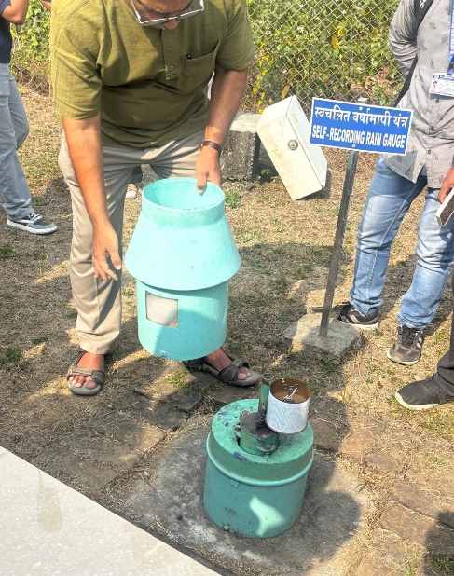
- Self – Recording Rain Gauge :
A Self-Recording Rain Gauge (SRRG), a meteorological instrument used to automatically measure and record the rate and duration of rainfall.
It consist turquoise-colored outer casing or collector funnel, which channels the rain into the internal mechanism. Revealed inside the lower section is the recording drum, which holds a calibrated chart paper and is rotated by a clockwork mechanism. As rain falls, an internal system (often a float or tipping bucket) moves a pen across the chart, creating a continuous trace of accumulated precipitation over time.

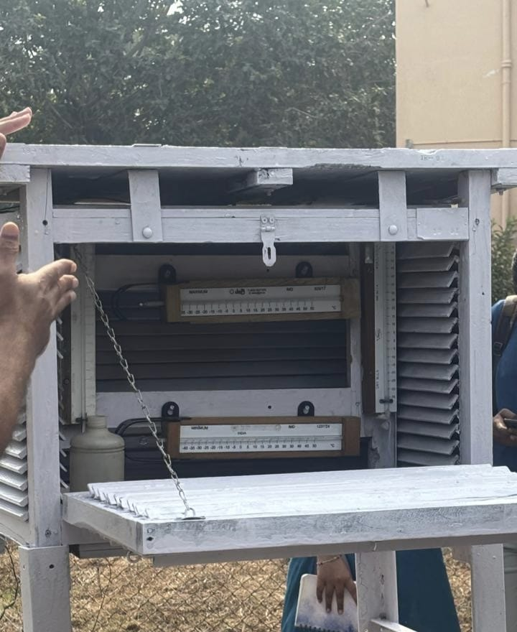
- Single Stevenson Screen :
A single Stevenson screen is a standardized, louvered wooden shelter that protects meteorological instruments like thermometers and hygrometers from direct sunlight and precipitation while allowing for free air circulation.
It consist of :
- Dry-bulb thermometer: Measures the actual air temperature.
- Wet-bulb thermometer: Used in conjunction with the dry-bulb thermometer to measure humidity and dew point. Together, they form a psychrometer.
- Maximum and minimum thermometers: These record the highest and lowest temperatures reached over a period, like 24 hours.

- Thermograph :
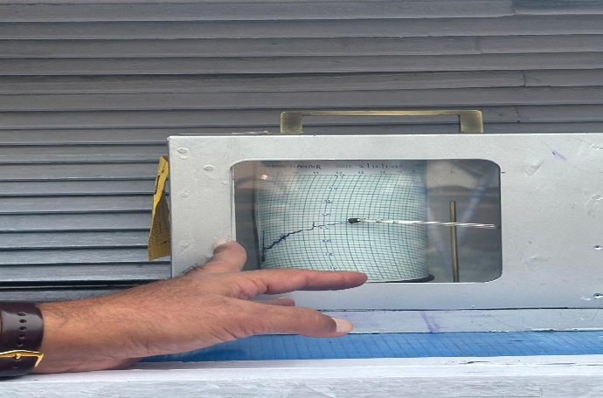
A thermograph continuously traces a graph of temperature against time, providing a complete and detailed record of temperature fluctuations.
As the temperature changes, the pen moves vertically across the chart paper wrapped around a clockwork-driven recording drum.

- Open Pan Evaporimeter.
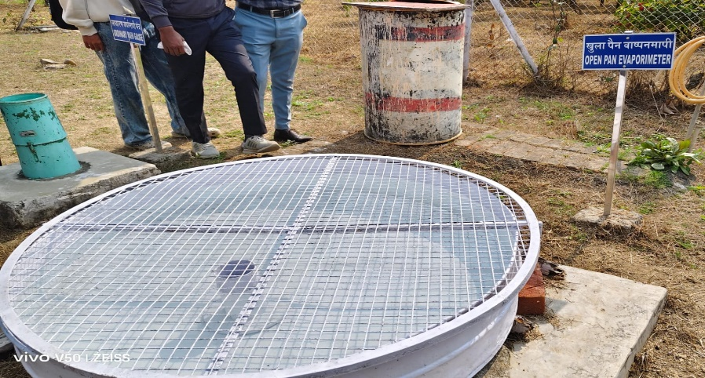
An Open Pan Evaporimeter, sometimes called an atmometer, is a meteorological instrument used to measure the rate of evaporation of water into the atmosphere.
Pan: It is a large, circular, cylindrical reservoir, typically made of copper or galvanized iron sheets, that holds the water.
For the ISI Standard, the pan is about 122 cm (1.22 m) in diameter and 25.5 cm deep.
Fixed-Point Gauge: A small brass tube is placed near the center of the pan to provide a calm, undisturbed water surface for measurement. Inside the stilling well is a fixed-point gauge (a brass rod ending in a tapered point) that serves as the reference level for the water surface.
Measuring Cylinder: A calibrated measuring cylinder is used to accurately add or remove water.
Wire Mesh Cover: The pan is often covered with a wire mesh or screen of standard mesh to prevent water loss from being consumed by birds or animals.
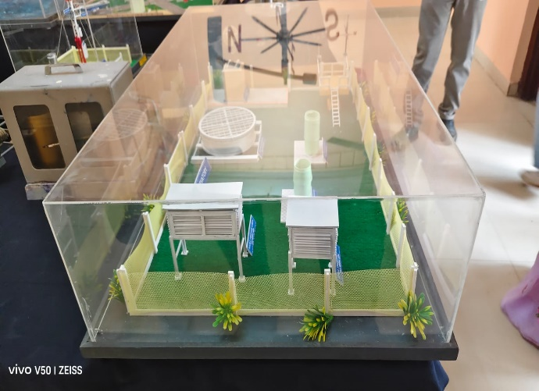
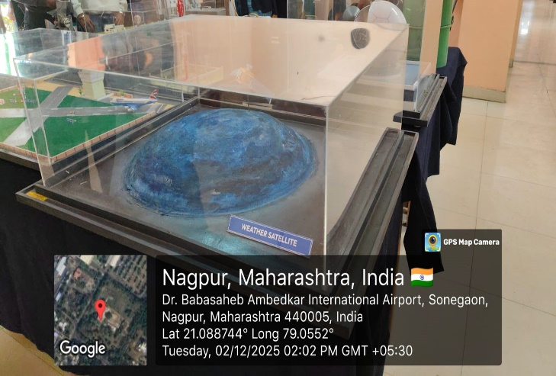

Attendance:
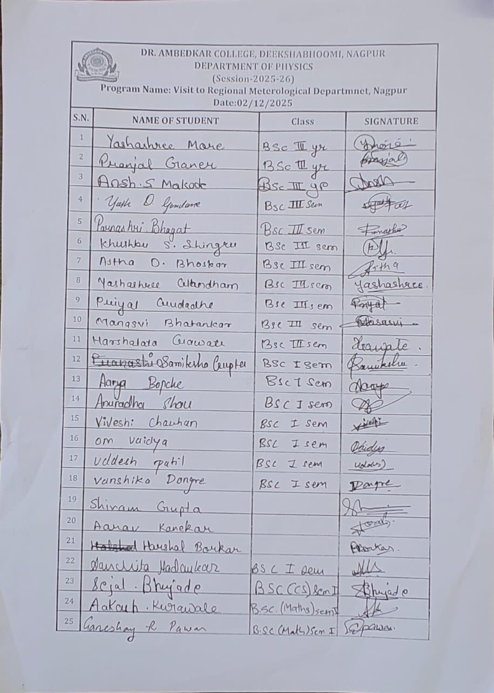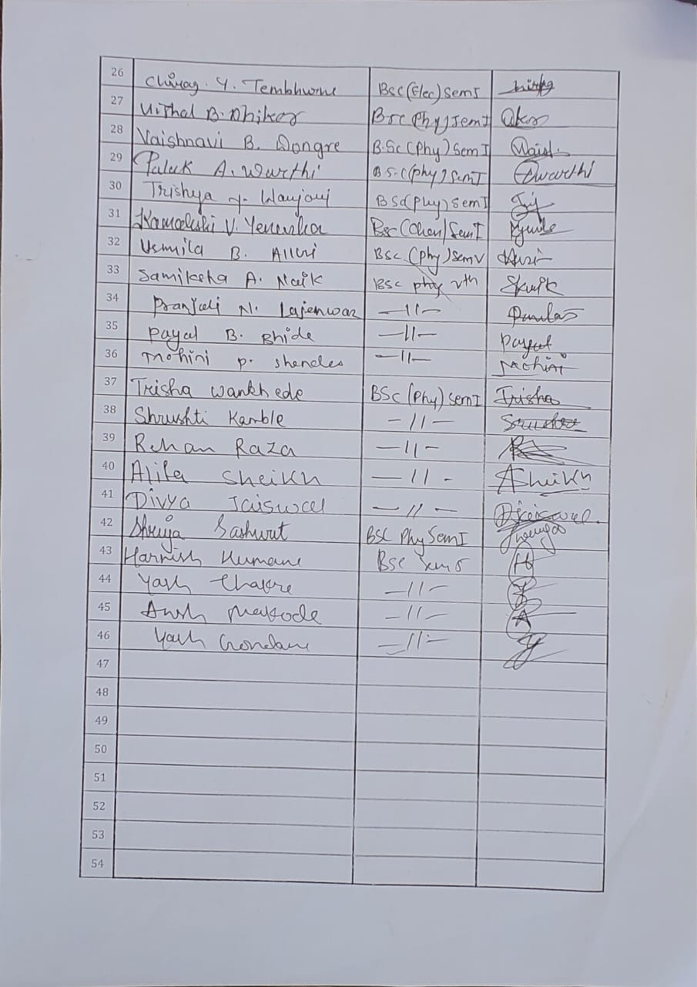

Feedback:

