
Dr. Ambedkar College Deekshabhoomi Nagpur.

Title : Report on Guest Talk of Scientists of Regional Meteorological Department
Nagpur.
Place : Nagpur.
Date : 02/12/2025
Report by : Namrata Pradnyakar (Asst. Prof. Physics), Harshala Gawate (B. Sc. Physics Sem 3)

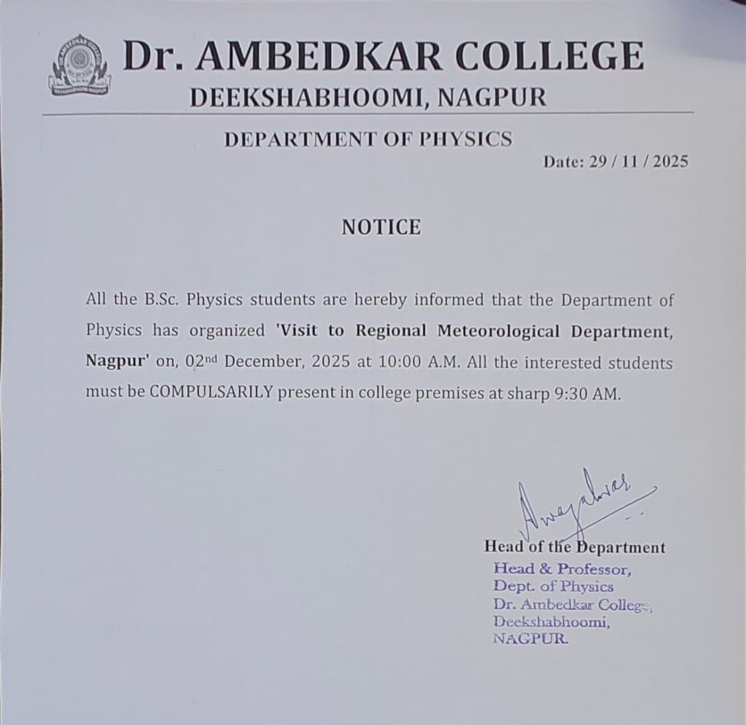

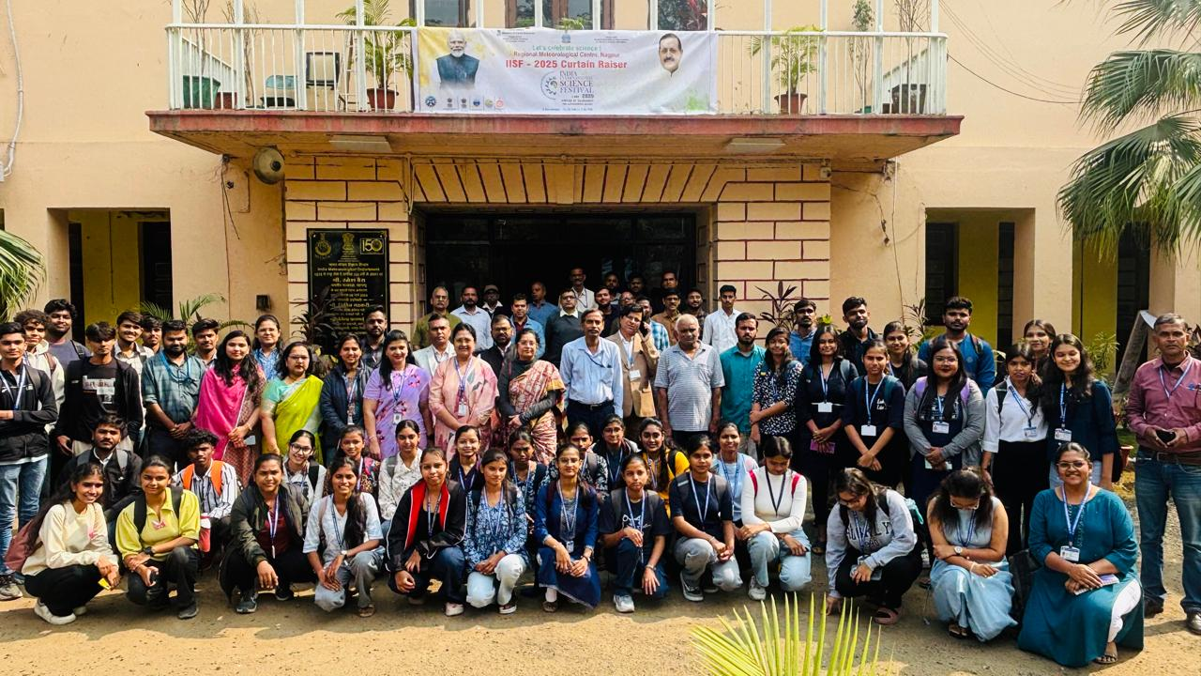

The Regional Meteorological Centre (RMC), Nagpur, established in 1954, is a key unit of the India Meteorological Department. It provides weather monitoring, forecasting, and climate services for Vidarbha, Madhya Pradesh, and Chhattisgarh using advanced systems like Doppler radars, observatories, and satellites. RMC Nagpur issues weather forecasts, advisories, and early warnings, supporting agriculture, aviation, disaster management, and public safety.
The Department of Physics organized an educational visit to the Regional Meteorological Department (IMD), Nagpur, on 2nd December 2025. A total of 46 students, along with teaching and non-teaching staff, attended the IISF curtain-raiser program. The event began with a lamp-lighting ceremony, followed by an informative lecture by Dr. Rizwan Ahmad, who emphasized inspiring students and researchers in science and technology.
Dr. Ahmad highlighted that the festival offers a platform to discuss current scientific progress, identify research gaps, and plan future strategies. He explained the legacy of the 150-year-old India Meteorological Department and its role in advanced weather forecasting. He noted that improved forecasting has reduced cyclone-related casualties to below 100, despite an increase in severe cyclones due to climate change. The visit inspired curiosity, scientific temperament, and research interest among students. Further, Shri R. R. Balasubramanyam, Scientist F and Head of RMC Nagpur, was invited to provide an overview of the India International Science Festival (IISF). He presented a detailed session on IISF 2023, scheduled to be held from December 6th to 9th at Panjab University, Chandigarh, and explained the significance of this national science event.
He highlighted that IISF, initiated in 2015, is a joint collaboration of the Ministry of Science & Technology, the Ministry of Earth Sciences (MoES)—under which the India Meteorological Department (IMD) operates—and Vijnana Bharati (VIBHA). The primary objective of the festival is to create widespread awareness among the public, students, and the socio-technical community about innovations and developments in science and technology.
Shri Balasubramanyam emphasized the crucial role of IMD under MoES. He clarified that IMD is not merely a research organization but a public weather service provider responsible for real-time weather forecasting and warnings. IMD’s operations rely on a vast observational network that includes over 9,000 manual rain gauges, surface observatories, Doppler Weather Radars, satellite observations, and upper-air measurements, including the daily release of hydrogen-filled balloons that ascend up to 30 km.
This extensive data network feeds into global numerical weather prediction models, enabling the issuance of accurate forecasts and early warnings.
He also stressed the importance of youth participation in scientific and technological development, referring to India’s rapid progress in fields such as drone technology and the nation’s advancement during the “Amrit Kaal” period, with the vision of becoming a developed country by 2047.
Additionally, he discussed the unique and challenging rainfall patterns of Maharashtra, arising from its diverse geography—ranging from the heavy rainfall zones of Konkan, to rain-shadow regions, and the variable rainfall conditions in Vidarbha. He also highlighted various weather-related mobile applications such as the Mausam App, which provide user-friendly access to forecasts, warnings, and climate information.
Then Dr. Praveen Kumar, Scientist-C and Forecasting Officer, ORMD Simhapur, delivered a presentation on the services provided by the IMD. He explained that the India Meteorological Department was established on January 15, 1875, in Bombay, following a series of severe weather events—including an unexpected cyclone in Calcutta in 1864 and major monsoon failures in 1866 and 1871—which highlighted the urgent need for a national weather service.
He emphasized that the IMD operates 24×7, continuously providing observations, forecasts, and advisories. These not only warn the public about events like heavy rain, cold waves, or heat waves but also help various sectors prepare in advance and reduce potential damage.
He highlighted how IMD’s services are crucial for many stakeholders:
- Defense: Weather information supports military planning, deployment, and operations.
- Agriculture: Farmers use weather forecasts for irrigation scheduling—postponing watering if rain is expected to avoid over-saturation and crop loss.
- Water Resources: Dam authorities rely on IMD’s Quantitative Precipitation Forecasts (QPF) to manage reservoir storage and controlled water release and prevent flooding.
- Aviation: IMD units at every airport provide essential data for safe takeoff and landing decisions.
- Traffic Management: Weather advisories guide traffic authorities in planning diversions and ensuring road safety during severe weather.
After this session, the Chief Guest, Smt. Hema Mayuresh Deshpande, addressed the gathering. She is an Environmental Professional with over 25 years of experience in the Maharashtra Pollution Control Board (MPCB), specializing in the implementation and enforcement of environmental laws. Her work spans environmental management, impact assessment, pollution prevention, monitoring networks, resource conservation, and public awareness initiatives. She has also taught at graduate and postgraduate levels and provided industrial consultancy. She holds an M.Sc. in Environmental Science (First Class) and currently serves as Regional Officer, MPCB, Nagpur.
In her address, she explained that the very foundation of life on Earth is the protective atmosphere and stable climate, making meteorology and the survival of life deeply interconnected. She also emphasized the importance of maintaining a clean and sustainable environment and encouraged the initiation of environmental programs through collective efforts of students, teachers, and citizens.
The program concluded with the National Anthem.
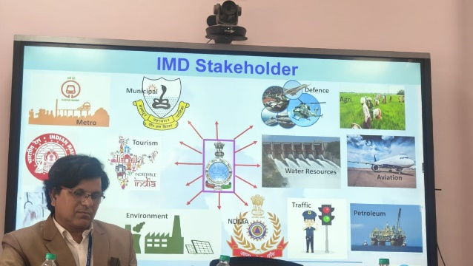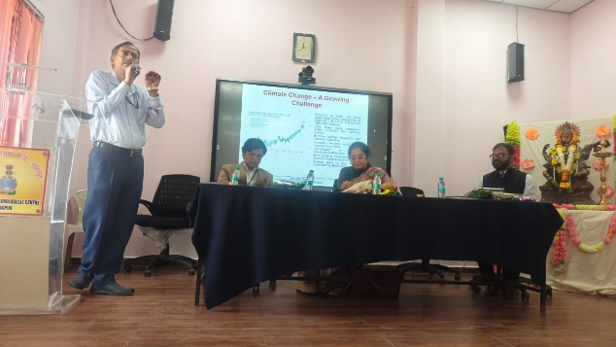
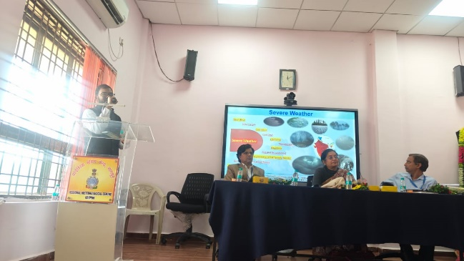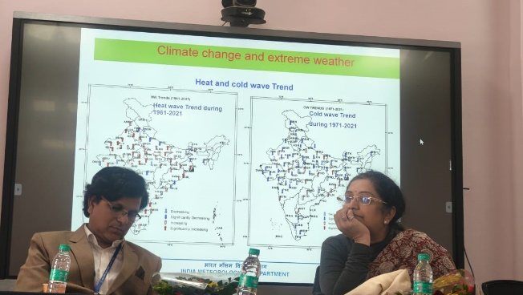

Attendance:
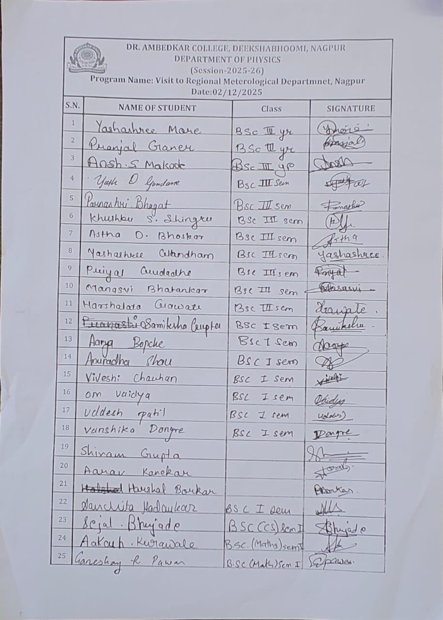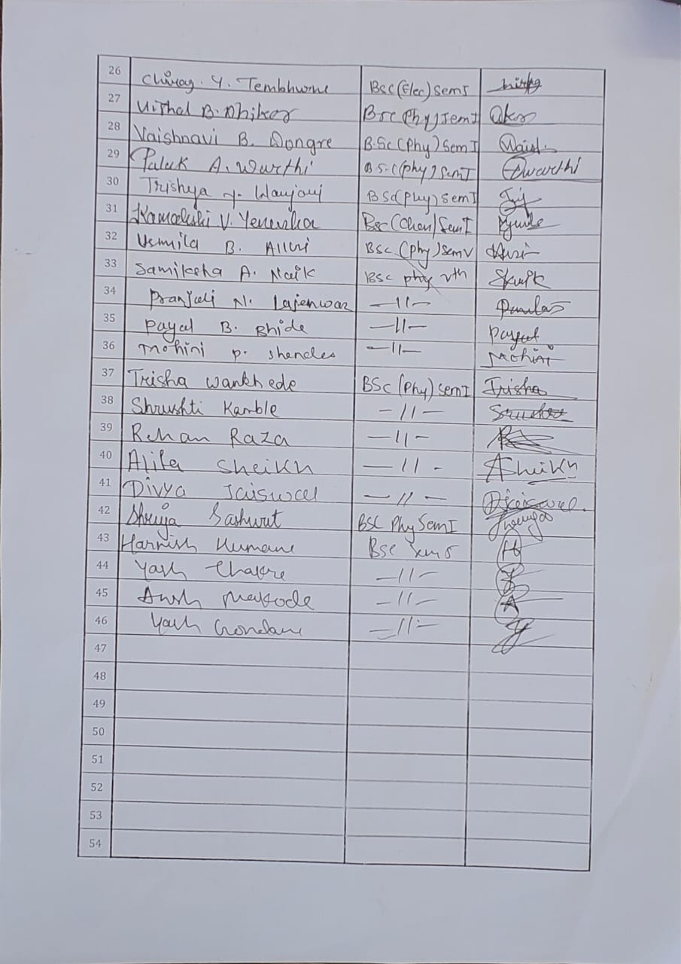

Feedback:

