DEPARTMENT OF COMPUTER SCIENCE
Report on
Workshop on “UI/UX Fundamentals ”
Date: - 29-08-2025 Number of students:70
Resource Person: -
- Mr. Subham Dhapodhkar, Director, Mastcore Digital Services, Nagpur.
- Mr. Subodh Nimje, Mastcore Digital Services, Nagpur.
NOTICE
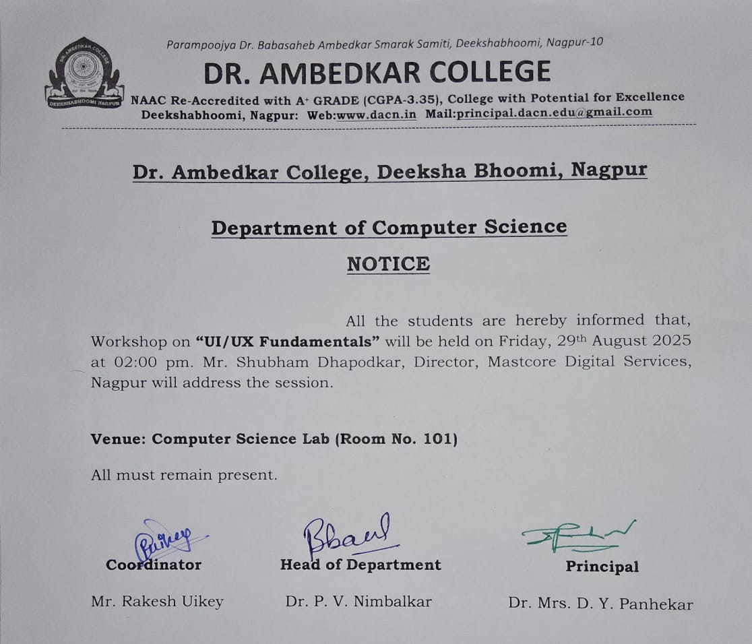

Report
On August 29th, 2025, the Department of Computer Science successfully hosted the Workshop on “UI/UX Fundamentals”. The event was graced by the presence of eminent resource persons, Mr. Shubham Dhapodhkar and Mr. Subodh Nimje, along with HoD and the esteemed faculty members, students, and distinguished guests.

The program began with a warm and enthusiastic welcome by Mr. Rakesh Uikey, the host of the event. The ceremonial lamp was lit in the presence of esteemed dignitaries to honor Tathagat Gautam Buddha and Bharat Ratna Dr. Babasaheb Ambedkar, symbolizing knowledge, peace, and enlightenment. Guests were felicitated with saplings as a gesture of growth and respect.
The event was conducted under the able coordination of Mr. Rakesh Uikey, Assistant Professor, Department of Computer Science, and Dr. Pankaj Nimbalkar, Head of Department of Computer Science, who guided and supported the smooth execution of the program.

Guest Introduction:

- Mr. Subham Dhapodhkar, Director, Mastcore Digital Services, Nagpur, is a full stack developer specializing in web development, UI/UX, and Digital Solutions. Passionate about teaching and empowering individuals with practical tech skills for career growth.

- Mr. Subodh Nimje, a software developer at Mastcore Digital Services, Nagpur. is a full stack developer specializing in web development, and Digital Solutions. Passionate about teaching and empowering individuals with practical tech skills for career growth.

Workshop Highlights:
The workshop covered the following topics in depth.
1. Basics of Web Development (HTML, CSS, Bootstrap)
2. Introduction to UI/UX Design
3. Insights into IT Culture
4. Introduction to Front-End Frameworks
5. Building Grid Structures Using CSS
6. Agile Methodology
7. Responsive Website

Students got exposure to various IT-Industry trends including-
- Industry-Relevant Skills: Exposure to web technologies and best practices.
- Career Development: Insights into job opportunities and entrepreneurial prospects.
- Practical Learning: Hands-on experience with real-world applications.
The program concluded with a heartfelt vote of thanks by Mr. Rakesh Uikey, who expressed gratitude to all dignitaries, faculty, students, and guests for their presence and support in making the event successful.
The ceremony ended with group photographs and refreshments, leaving behind smiles, inspiration, and a sense of accomplishment.
Event Glimpses
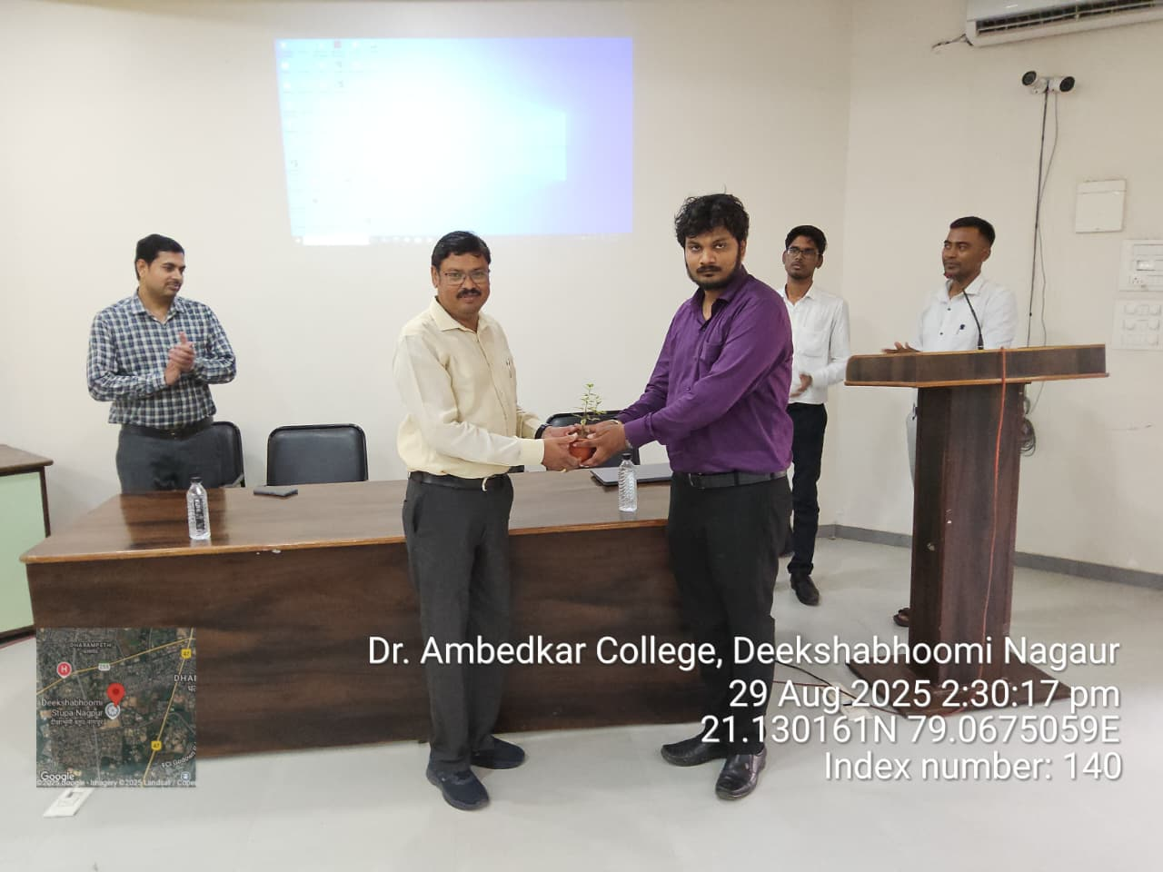
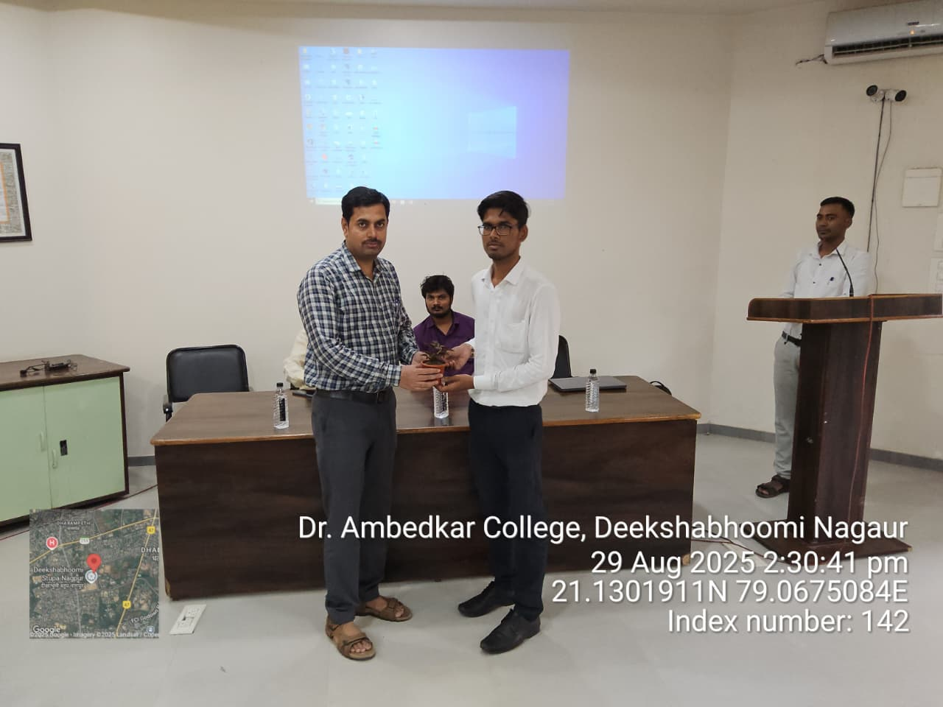
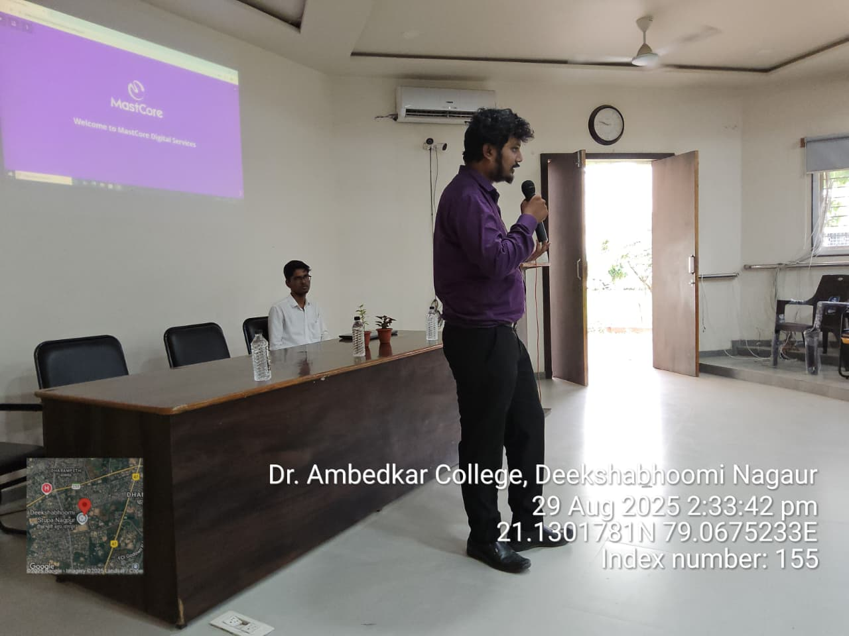
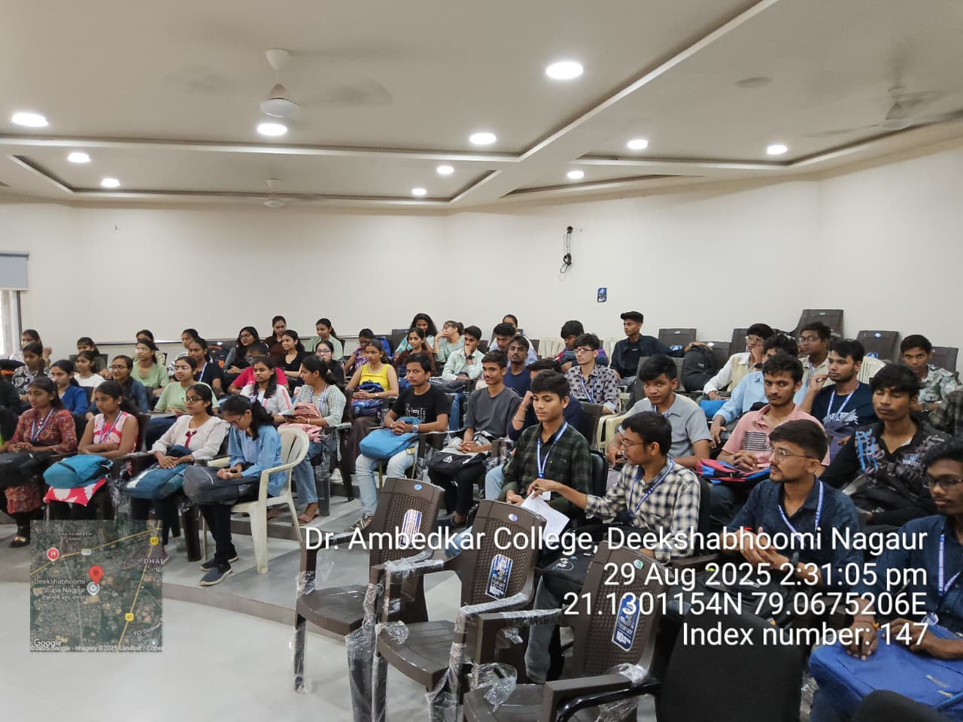
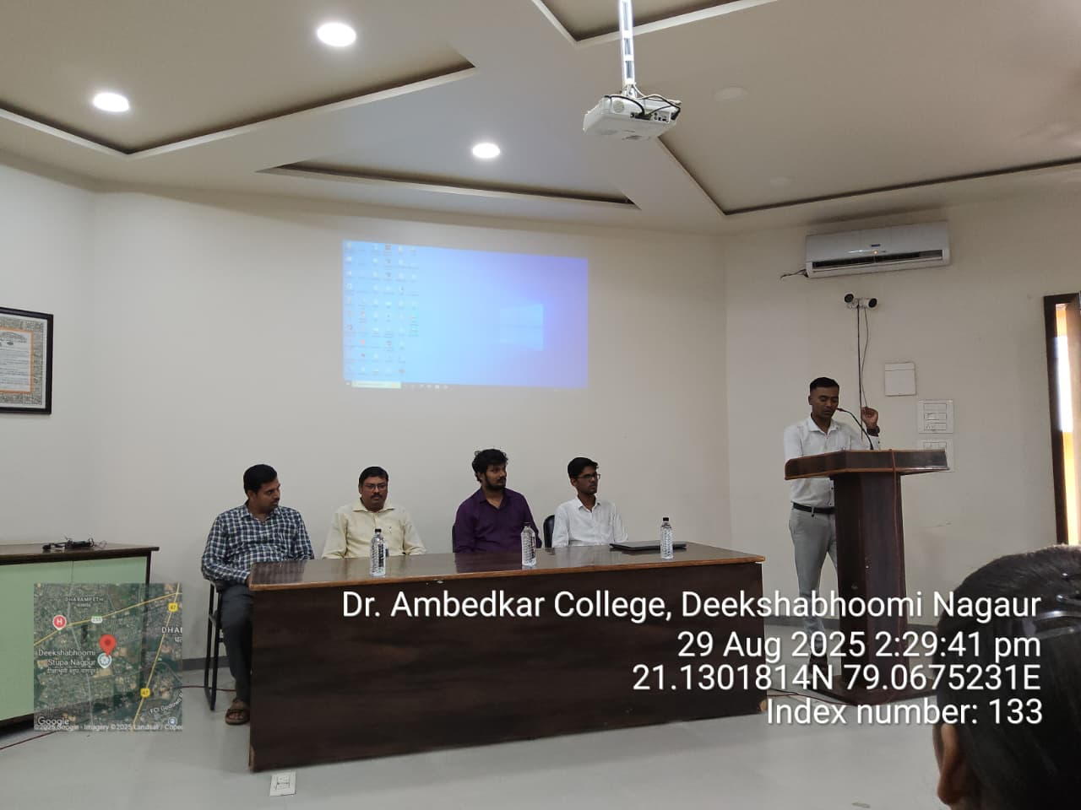
Attendance

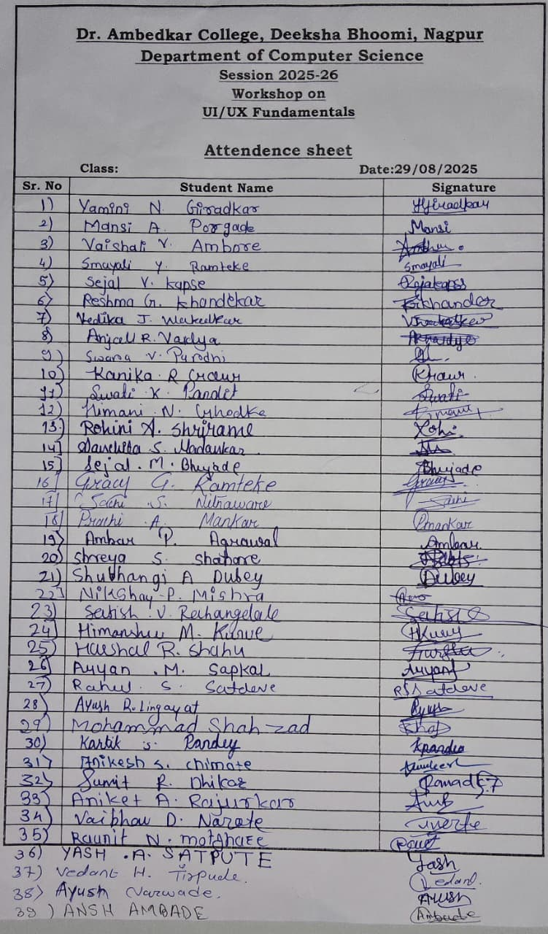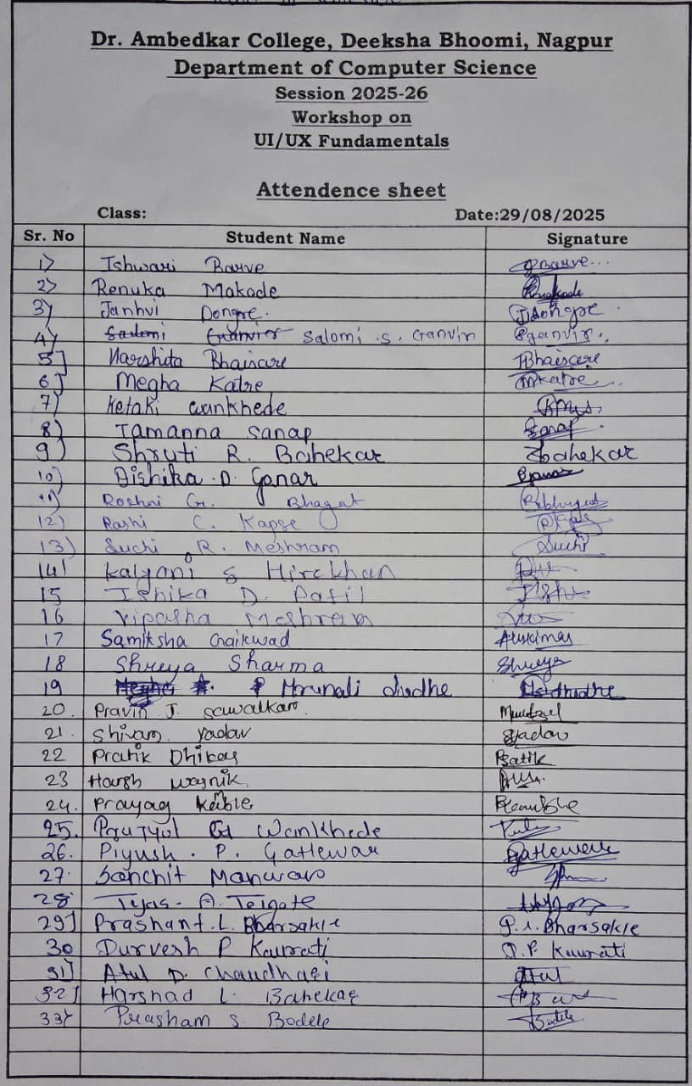
Feedback
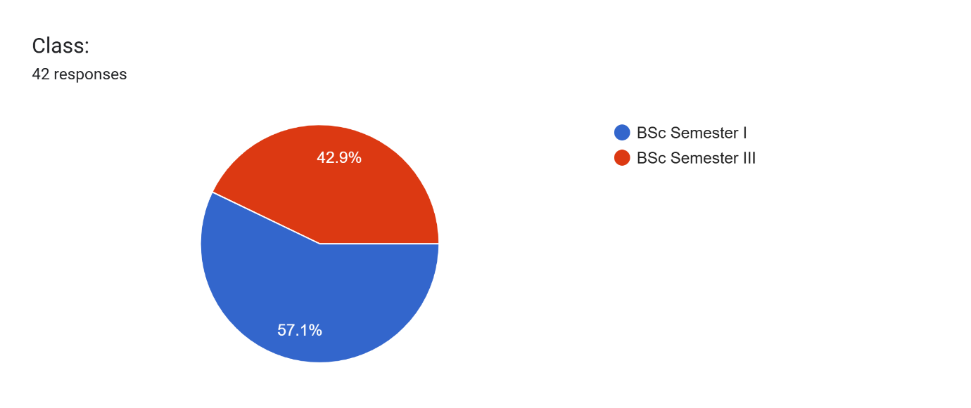
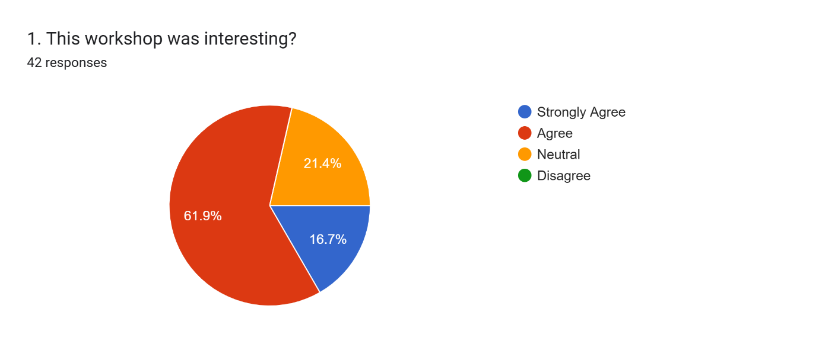
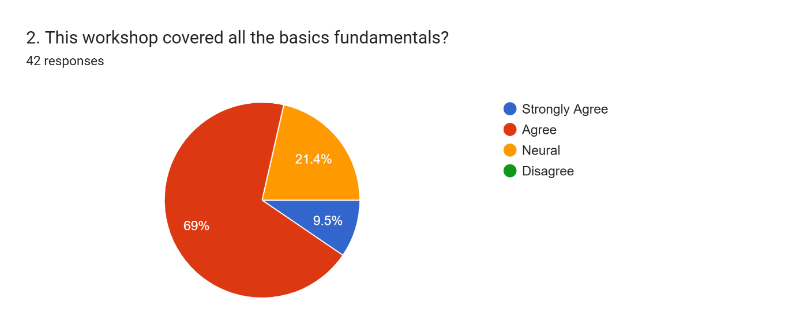
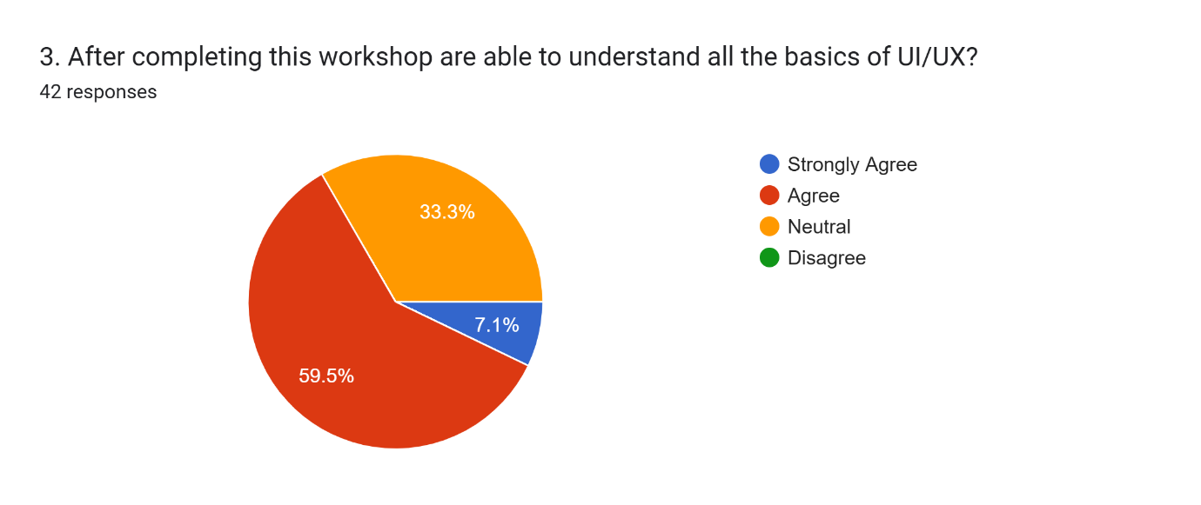
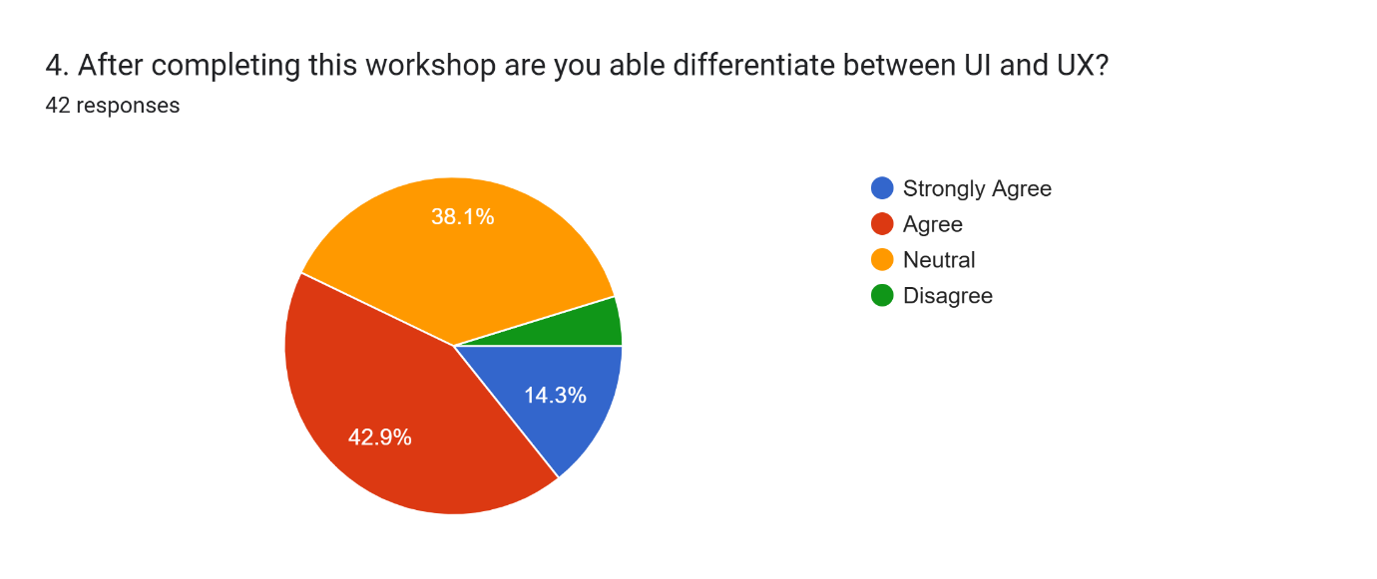
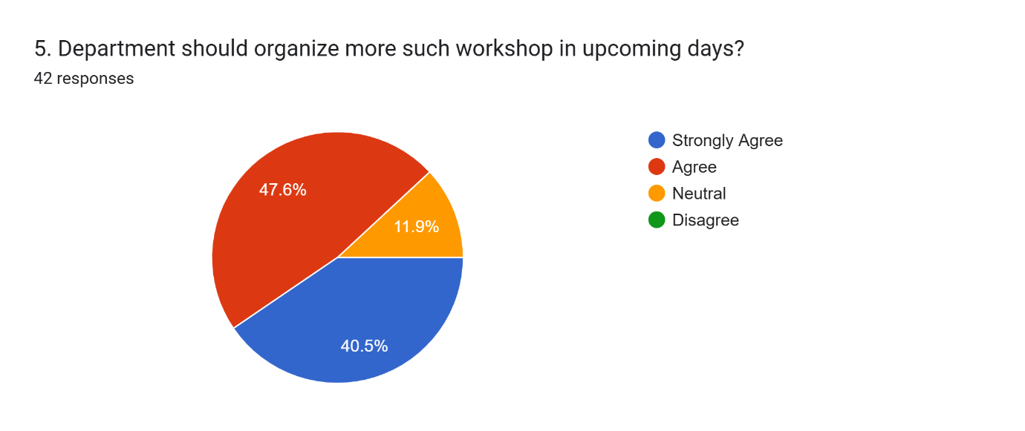

Certificate
