NAME OF THE PROGRAM | DATA PROTECTION AND DATA PRIVACY
ORGANISING DEPARTMENT/ NAME THE CELL | NOUVEAU CORPORATES CLUB  DEPARTMENT OF LAW
COMMITTTEE CHAIR Of THE NOUVEAU CORPORTES CLUB | DR. VARSHA DESHPANDE
VICE CHAIR Of THE NOUVEAU CORPORTES CLUB | DR. PRATIMA LOKHANDE
ACTING CHAIR OF NOUVEAU CORPORTES CLUB | MS. ANUSHA PATRE  MR. AKASH DHOTE
DATE | 19th July 2025
RESOURCE PERSON | MR. NIKHIL APARAJIT, TECH CONSULTANT
NUMBER OF STUDENTS | 50
TIME | 11.00 am
VENUE | SEMINAR HALL
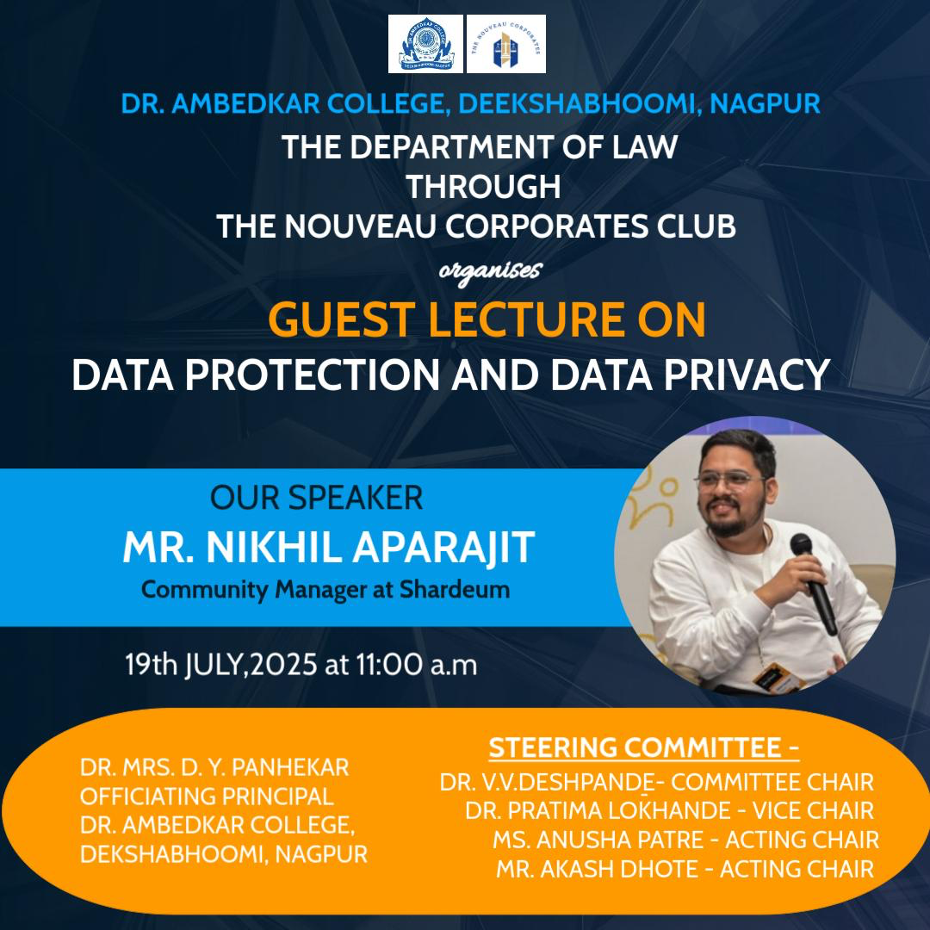

REPORT ON GUEST LECTURE

On 19th July 2025, The Nouveau Corporates Club of the Department of Law, Dr. Ambedkar College, Deekshabhoomi, Nagpur organised a Guest Lecture on the topic “Data Protection and Data Privacy.” The lecture was delivered by Mr. Nikhil Aparajit, a well-known tech consultant dealing with DPDP Act. The session was presided over by officiating Principal Dr. D.Y. Panhekar, Head of Department and The Committee Chair Dr. V.V. Deshpande, Dr. Pratima Lokhande Professor and The Vice Chair, Miss Anusha Patre Assistant Professor and The Acting Chair, along with other faculty members whose presence added academic depth to the event.

The lecture aimed to introduce students to the growing significance of personal data security in the digital age and how it intersects with legal frameworks. Mr. Aparajit began by highlighting how digital platforms, though apparently free, often operate on business models that profit by collecting and analysing user data. Tools such as Google Analytics and Facebook Pixel were explained in simple terms to demonstrate how users are profiled based on their behaviour. He elaborated on the concept of metadata, stating that even information that does not directly reveal content—such as location, device usage, and time stamps—can still be used to identify and exploit individuals. A key quote that resonated with the audience was, “If you use something for free, then you are the product,” reminding everyone of the hidden costs of digital convenience.

Mr. Aparajit further discussed the landmark 2017 Supreme Court judgment in the Justice K.S. Puttaswamy v. Union of India case, where the Right to Privacy was upheld as a fundamental right under Article 21 of the Indian Constitution. He then provided an overview of the newly enacted Digital Personal Data Protection (DPDP) Act, explaining its emphasis on user consent, data transparency, and the accountability of data processors. The lecture successfully bridged the gap between constitutional rights and contemporary digital law.

He also offered several practical suggestions to protect one’s data in everyday life. These included using strong passwords, enabling two-factor authentication (2FA), staying alert to phishing scams, avoiding oversharing on social media, and regularly updating the privacy settings on mobile applications and electronic devices. The session was not only informative but also interactive.

During the question-and-answer round, students raised thoughtful concerns about Data mining and deletion, misuse of biometric data, and safety measures important for an individual to take for day-to-day data protection. Mr. Aparajit stressed the importance of digital literacy and urged future legal professionals to remain well-informed about evolving cyber laws and data protection policies.

Overall, the lecture was highly enlightening and helped students develop a deeper understanding of data privacy and the role of law in safeguarding it. The session encouraged legal awareness and responsible digital conduct, leaving the attendees better informed about their rights and the risks associated with the digital world. It was a successful event that highlighted the urgent need for law students to be proactive in adressing legal issues in the digital era.

LIST OF STUDENTS:
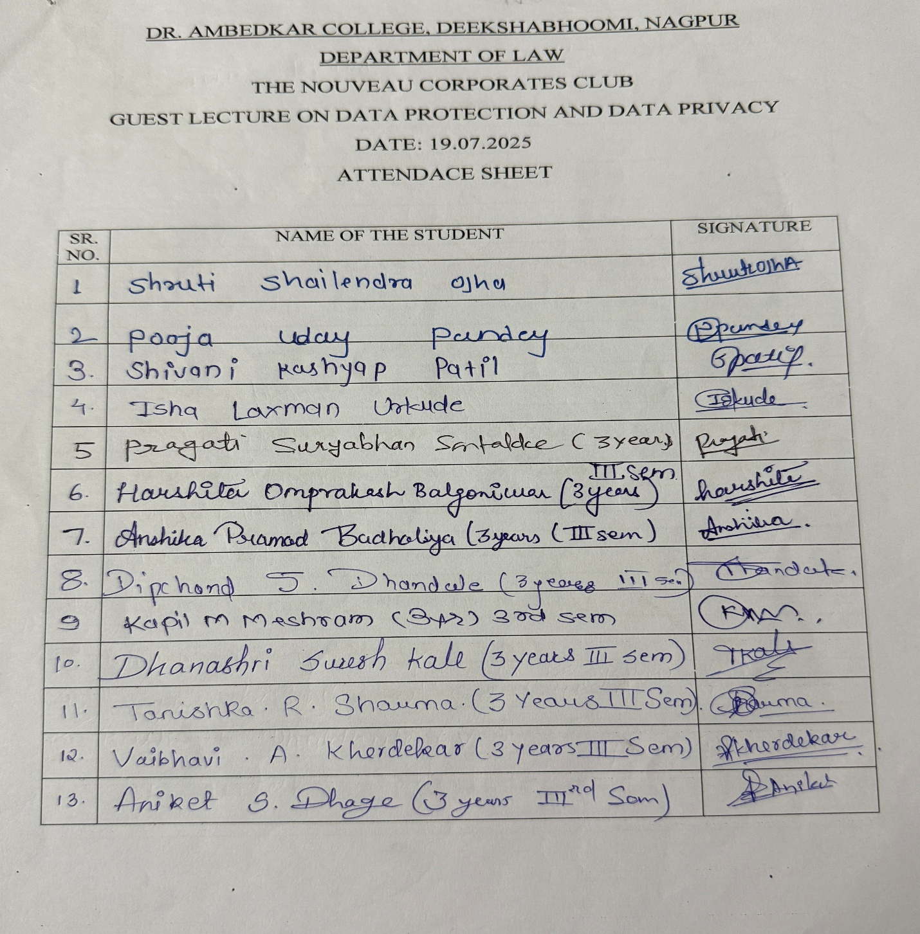
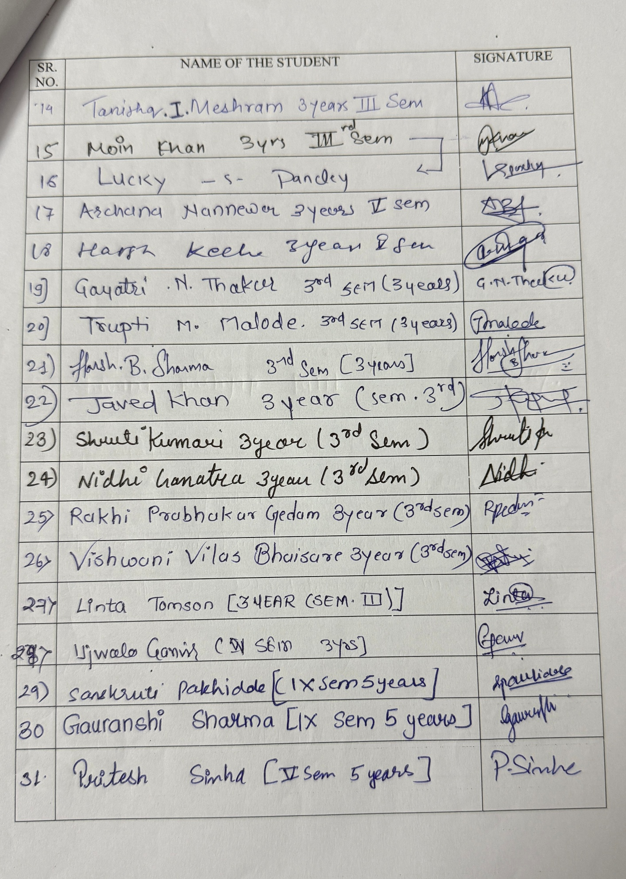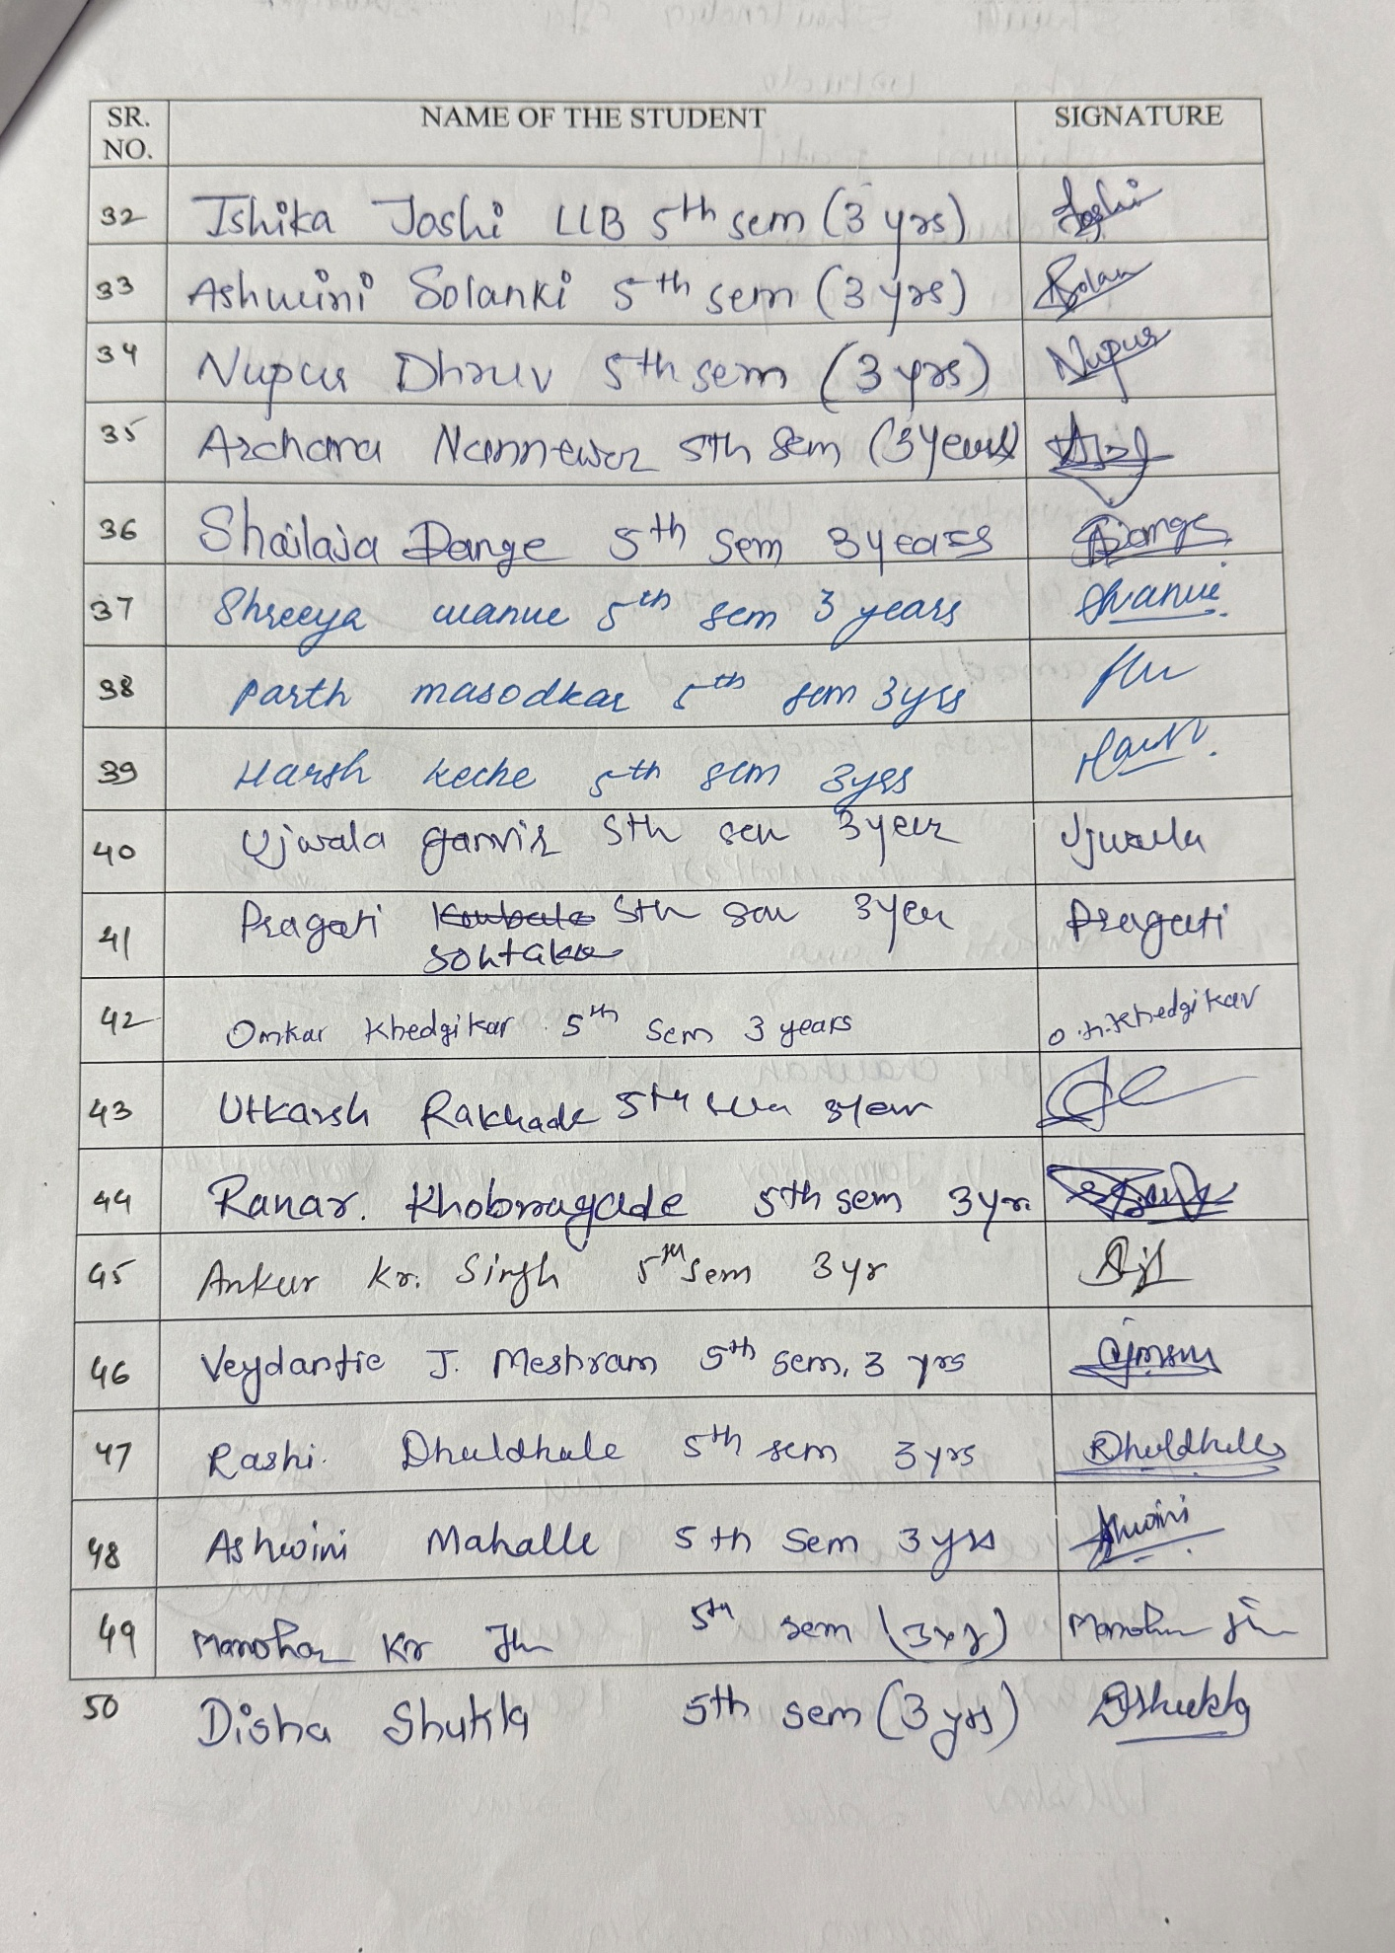
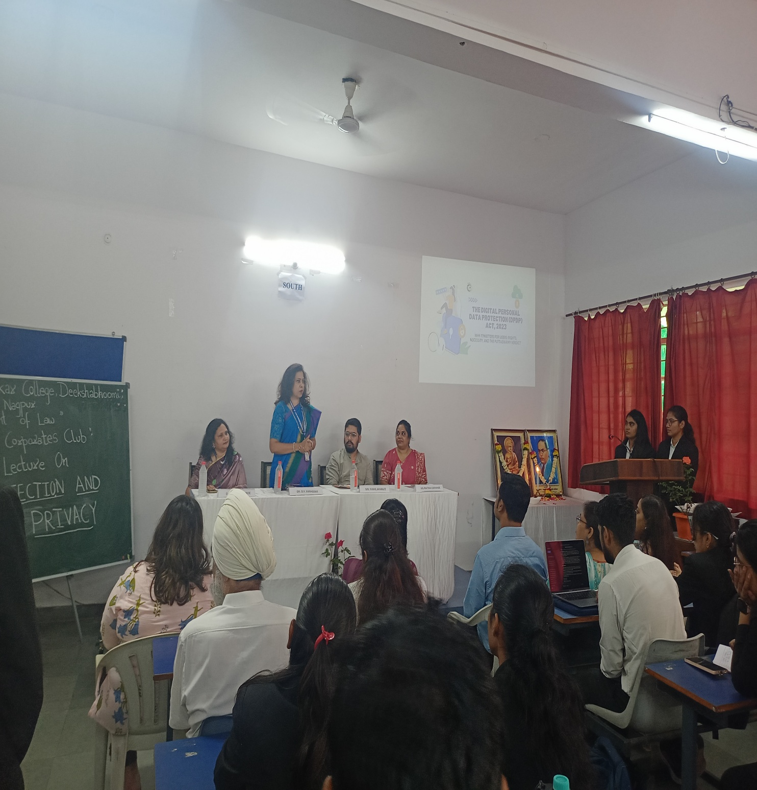
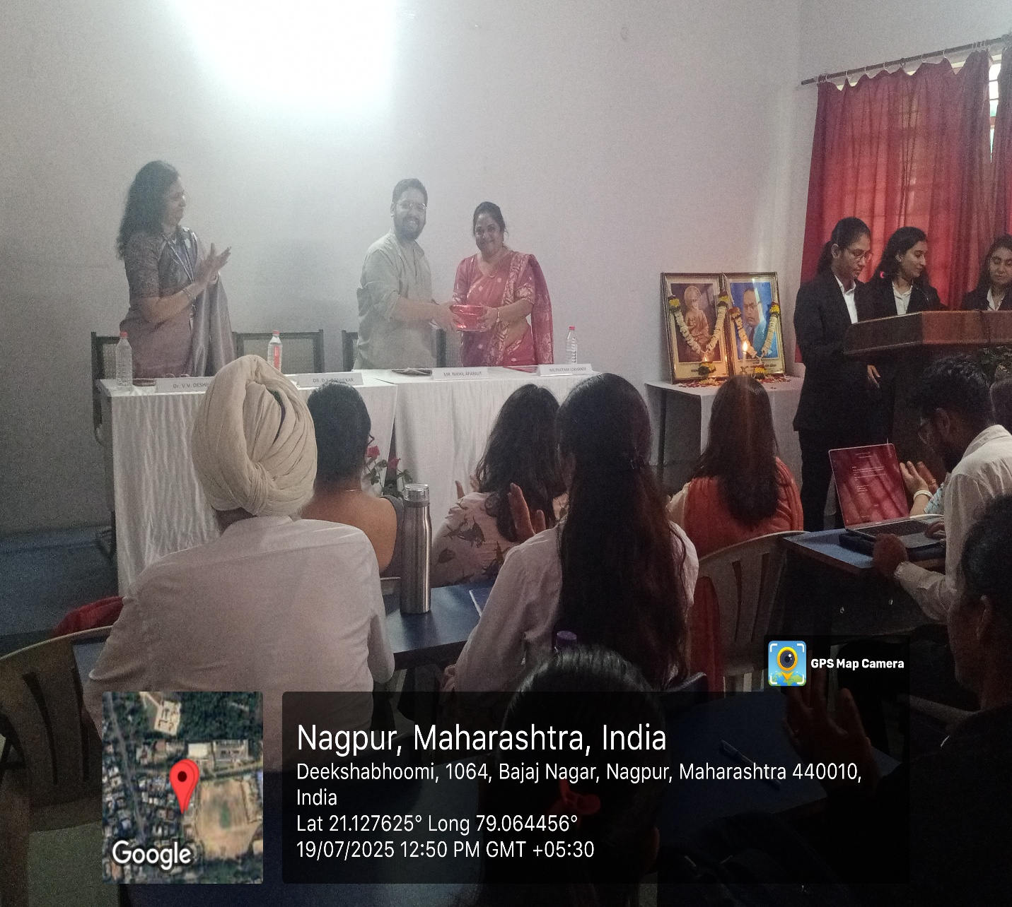
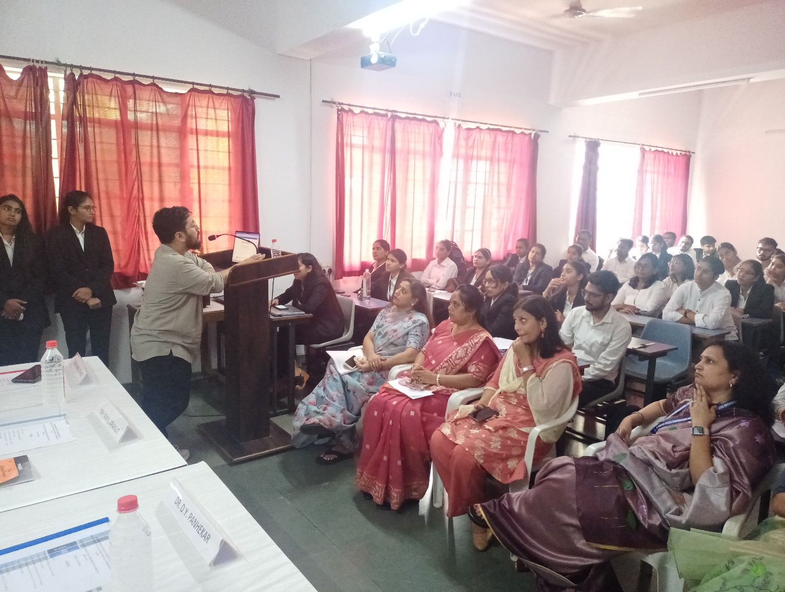
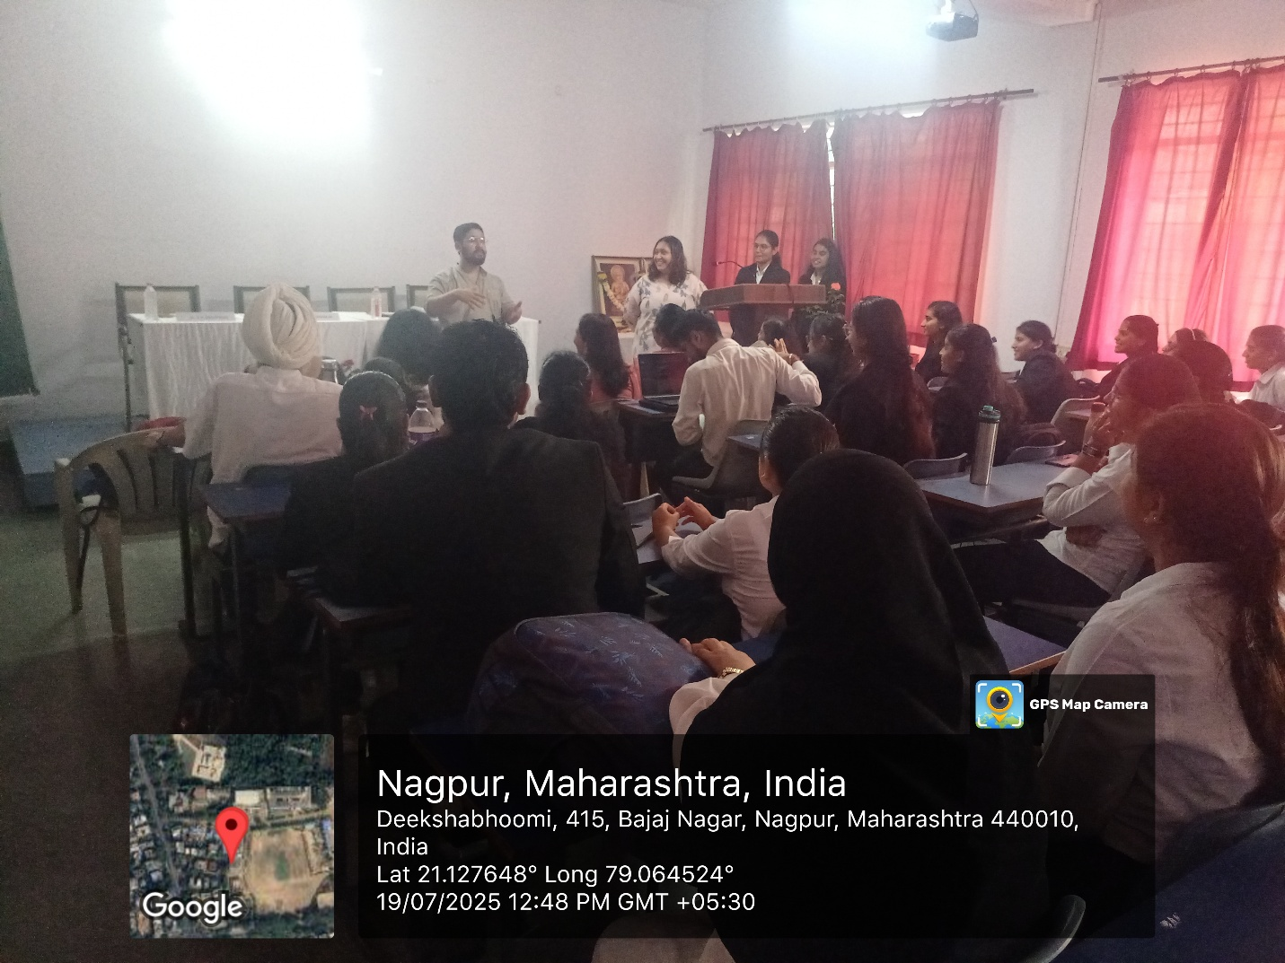
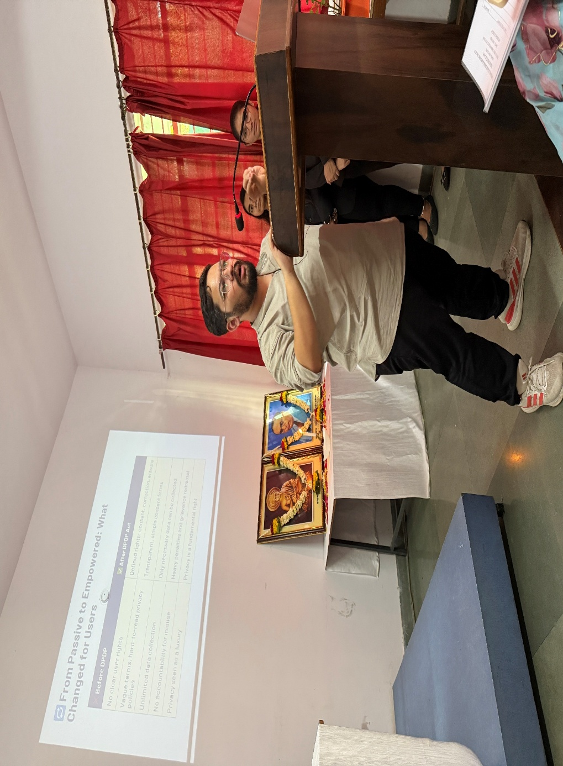

NEWSPAPER COVERAGE
