REPORT
DR. AMBEDKAR COLLEGE, DEEKSHA BHOOMI,
DEPARTMENT OF LAW
INDUCTION PROGRAMME
DATE: 06TH OCTOBER 2025
NAME OF THE PROGRAM: INDUCTION PROGRAMME
PROGRAM COORDINATOR: PROF. DR. MRS. SANDHYA P. KALAMDHAD
PROF. DR. PRATIMA LOKHANDE
NUMBER OF ATTENDEES: 120
NAME OF THE VENUE: DR. AMBEDKAR COLLEGE DEEKSHABHOOMI NAGPUR DEPARTMENT OF LAW.

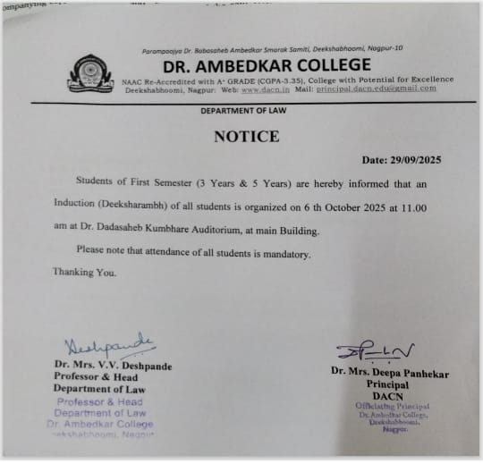

The Department of Law, Dr. Ambedkar College, Deekshabhoomi, Nagpur, organized an Induction Programme to warmly welcome the newly admitted students and acquaint them with the department’s vision, achievements, and academic culture. The event was held in the Main Building Auditorium in the gracious presence of faculty members, senior students, and the new batch of aspiring law students. The primary objective of the program was to help students understand the ethos of the department, its functioning, and the diverse opportunities available for their holistic academic and professional growth.

The program commenced with an inaugural ceremony, where Principal Dr. Deepa Panhekar and Head of Department Dr. Varsha Deshpande lit the ceremonial lamp and offered gratitude to Dr. Babasaheb Ambedkar and Thathagat Gautam Buddha , symbolizing enlightenment, wisdom, and justice — the guiding principles of the institution. Following this, Prof. Dr. Pratima Lokhande delivered a warm welcome address , extending heartfelt greetings to the freshers and introducing them to the rich academic and social legacy of Dr. Ambedkar College.

A comprehensive presentation on the history, vision, and mission of the Department of Law was given by Prof. Dr. Sandhya Kalamdhad, who highlighted the department’s significant contributions the legal education, research, and social reform. The presentation showcased the department’s academic excellence, achievements in moot court competitions, legal aid initiatives, and faculty research work. She also emphasized the success of the department’s distinguished alumni , who have excelled in the judiciary, legal practice, and academia, bringing pride to the institution.

The program also spotlighted several key initiatives undertaken by the department to enhance students’ learning experiences. These included the Legal Aid Cell , which offers free legal assistance to the underprivileged; the Moot Court and Debate Clubs, which strengthen advocacy and communication skills; and the Internship and Placement Guidance Cell, which helps students connect with professional opportunities. The department also regularly conducts workshops, seminars, and guest lectures on contemporary legal issues, alongside community outreach programs promoting legal awareness and social justice.
In her address to the students , Head of Department Dr. Varsha Deshpande inspired the audience with her encouraging words, emphasizing that law is not merely a profession but a noble responsibility towards society. She urged students to uphold the ideals of justice, integrity, and equality in every endeavor. The Principal, Dr. Deepa Panhekar, in her motivating remarks, applauded the students’ decision to pursue law and encouraged them to strive for excellence with confidence and dedication. Her words instilled enthusiasm and optimism among the young entrants.

An interactive session followed, during which new students had the opportunity to engage with faculty members and seniors. Queries regarding academic structures, examination patterns, and extracurricular activities were addressed, helping students gain a clearer understanding of departmental life. The program ended with a heartfelt Vote of Thanks delivered by Ms. Khwaish Bhagwani, who expressed gratitude on behalf of the department to the Principal, faculty members, guest speakers, and student organizers for their invaluable contributions to the success of the event. She also extended appreciation to the new students for their active participation and enthusiasm, wishing them a fruitful and enriching journey ahead in the field of law.
Overall, the Induction Program was a grand success, marking an inspiring beginning to the academic journey of the new batch. It effectively achieved its goal of introducing students to the department’s values, achievements, and initiatives, while fostering a spirit of belonging, curiosity, and commitment among them. The event truly reflected the Department of Law’s dedication to nurturing competent, ethical, and socially responsible legal professionals , committed to the ideals of justice and humanity.

Glimpse of the Event
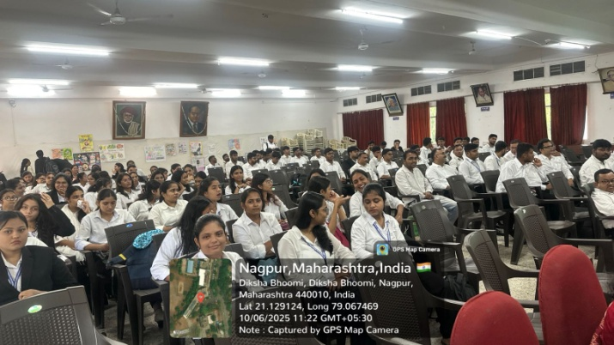

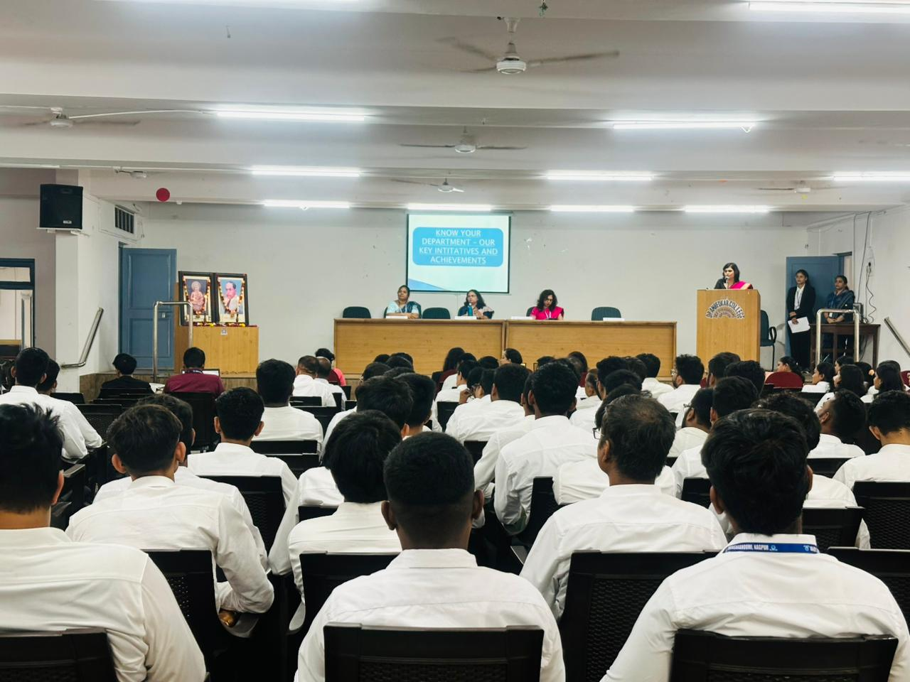

Attendance list
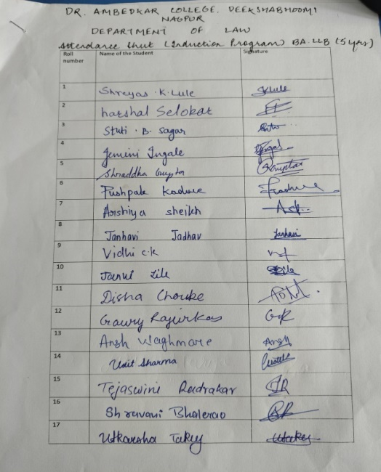 | 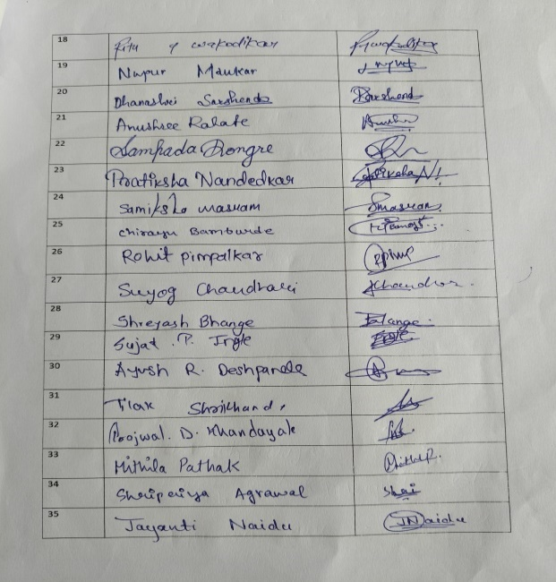
 | 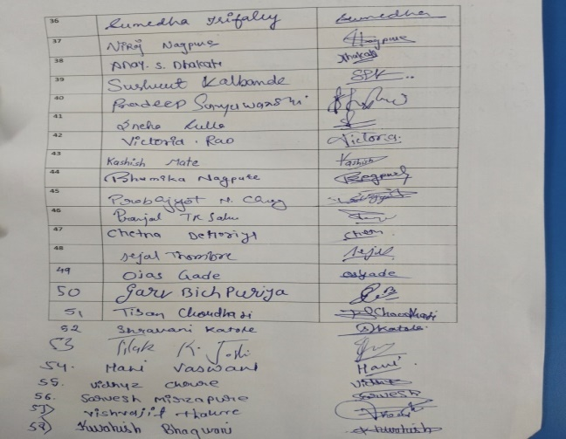

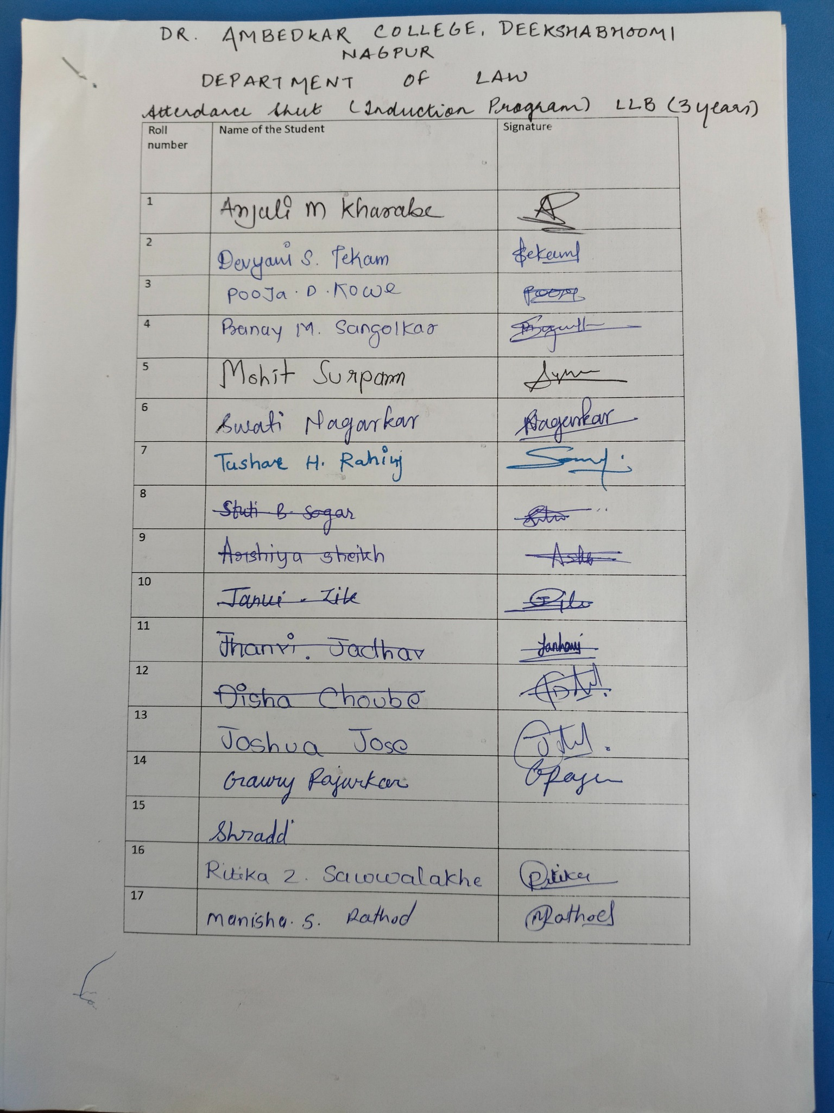 |  | 