DR. AMBEDKAR COLLEGE, DEEKSHABHOOMI, NAGPUR
DEPARTMENT OF LAW
CRIMINAL LAW CLUB

NAME OF THE PROGRAM: Debate competition : The compulsive use of regional languages in the states is an attack on the Indian Constitution.
DAY: 7TH August 2025
TIME: 11.30 - 4.00
NAME OF CELL : CRIMINAL LAW CLUB
PROGRAM COORDINATOR: PROF. DR. MRS. SANDHYA P. KALAMDHAD
MS.SHAZIA BARI (ASSISTANT PROFESSOR )
MS.RITU KAUSHIK (ASSISTANT PROFESSOR )
MS.KHUSHI BAJAJ (ASSISTANT PROFESSOR )
STUDENTS: 24 ( 8 teams : 3 students in a team)

REPORT ON
DEBATE COMPETITION: The compulsive use of regional languages in the states is an attack on the Indian Constitution.

A thought-provoking debate competition was organized on 7th August 2025 . The topic for the debate was “The Compulsive Use of Regional Language in the States is an attack on the Indian Constitution” which was held in the premises of Dr. Ambedkar College of Law Deekshabhoomi, Nagpur . The event aimed to encourage critical thinking among students on the balance between linguistic diversity and constitutional rights.
The event began with garlanding the portraits of Parampujya Dr. B.R.Ambedkar and Tathagat Gautam Buddha. The competition saw enthusiastic participation from students of law department , each presenting strong arguments either in support or against the motion. The debate was judged by a panel of experts Ms. Priyanka Khandelwal and Ms. Lekha Thakkar, who assessed the participants based on content, clarity, presentation, and rebuttal skills.

The debate concluded on a powerful note, leaving the audience with a deeper understanding of India’s linguistic framework and constitutional responsibilitie and was addressed by Principal Dr.Deepa Panhekar by her incredible motivational words.
The winners were :
- Best speaker opposition team : Nishta Singh
- Best speaker proposition team: Ayushi Chaourasia
- Opposition winning team : (Team comprising of ): (a)Aman Bhandarkar (b)Nishta Singh (c)Saumya Bhansal
- Proposition winnig team : (Team comprising of ) : (a) Ayushi Chaourasia (b) Victoria Rao (c)Khwaish Bhagwani
- Best Speakers : (a) Ankit Chandrakar (b) Abhiram Gurjalwar
The event successfully met its objective of creating an informed and respectful dialogue on a sensitive constitutional issue. The Vote of Thanks was given by Bhakti Meher to the debators, judges, winners and all the organizers for making the event a success and encouraged more such intellectual engagements in the future.

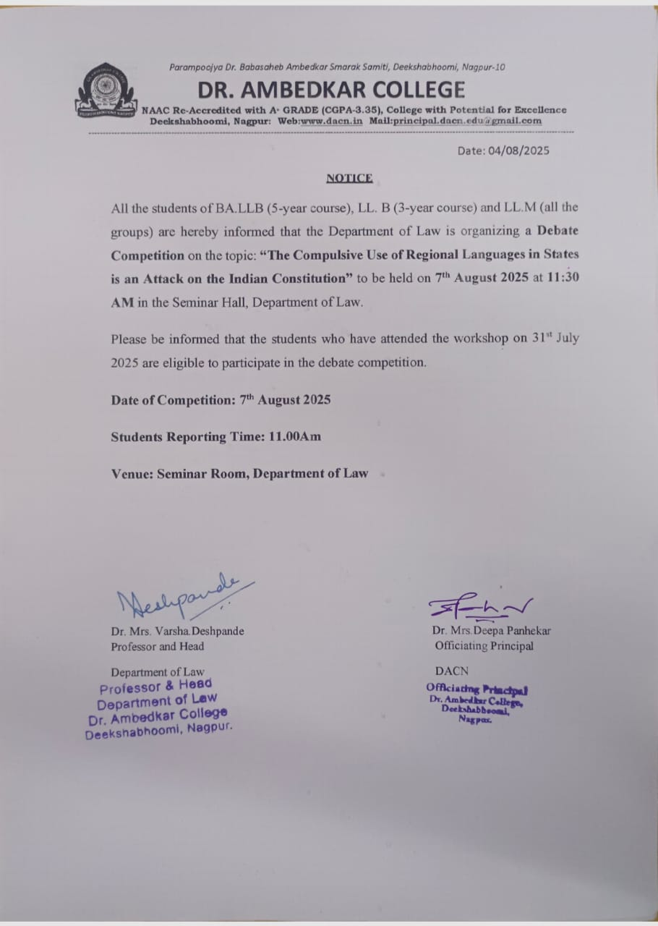

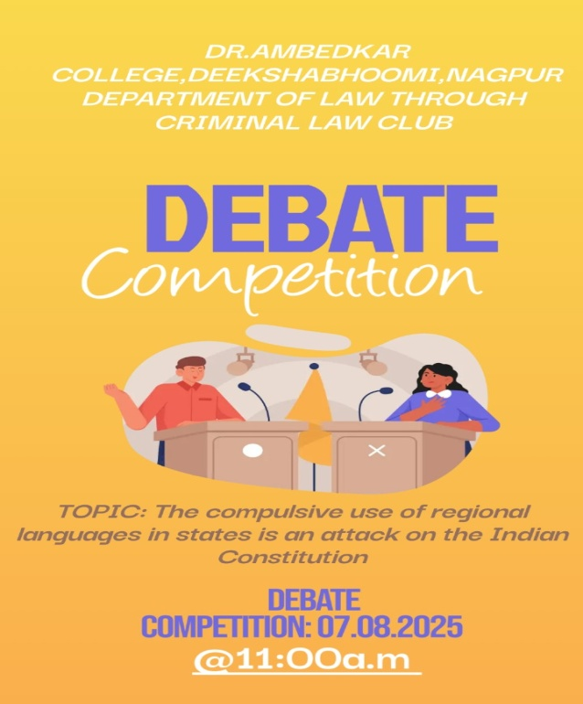

GLIMPSES OF THE EVENT

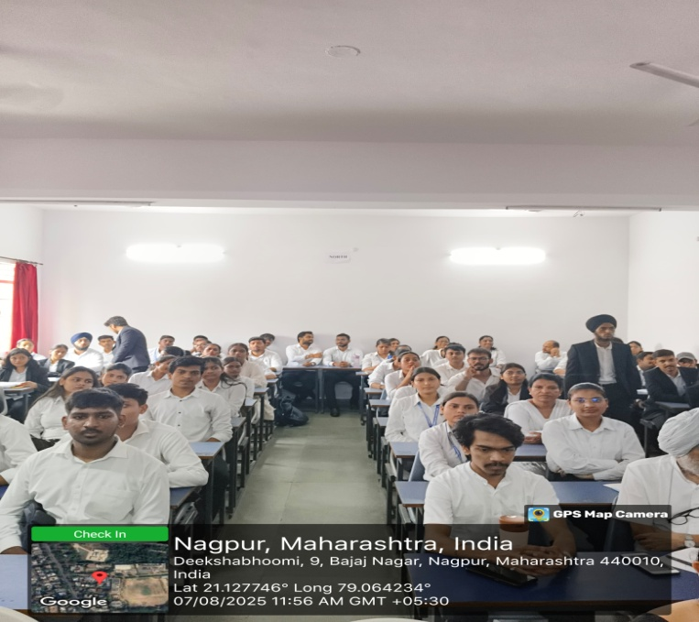
Audience present on the debate competition

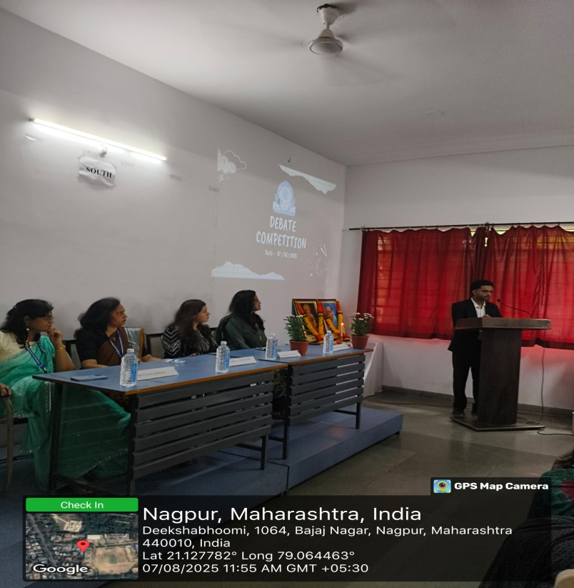
Inaugration of the program

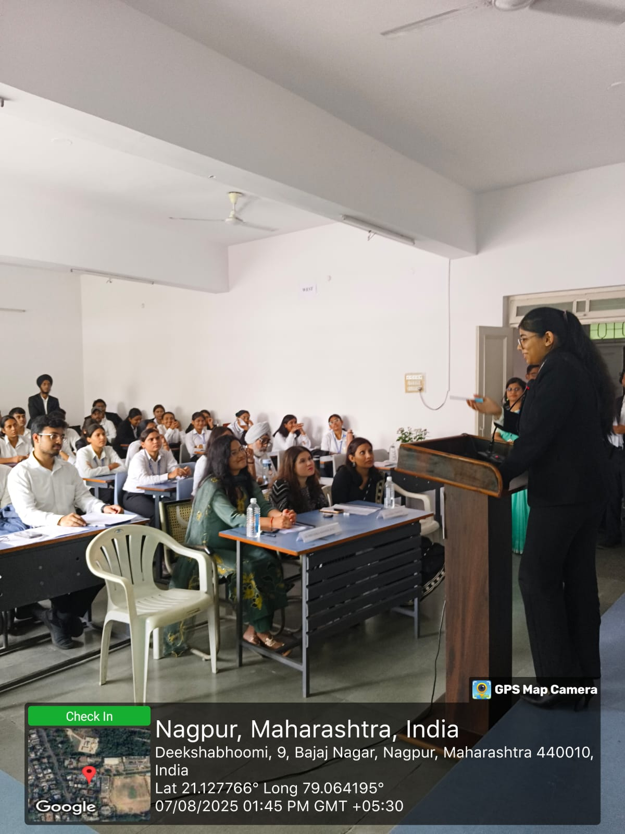
Students debating fiercely on the topic.
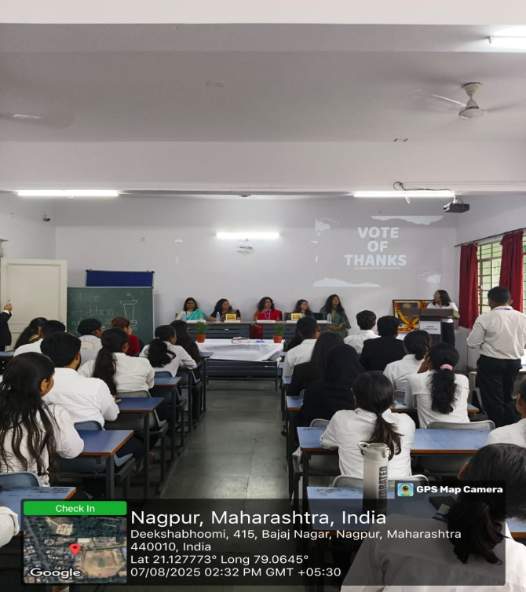
Vote of thanks given by Bhakti Meher

Attendees on Debate Competition

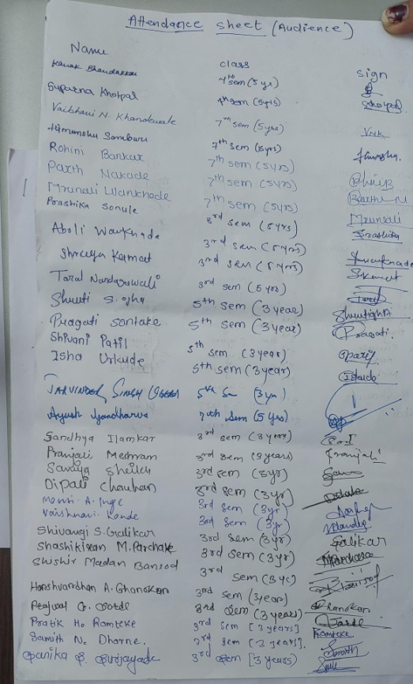
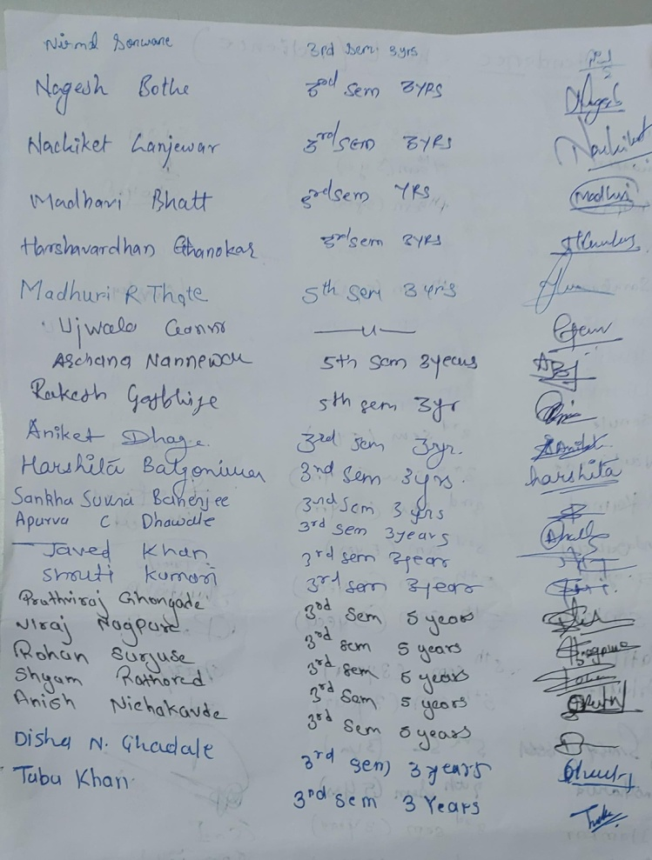

Feedback Forms

