REPORT
DR. AMBEDKAR COLLEGE, DEEKSHABHOOMI, NAGPUR
WORKSHOP ON CRIME SCENE INVESTIGATION
DEPARTMENT OF LAW NAGPUR IN COLLABORATION WITH CODEF SOLUTIONS PVT. LTD. NAGPUR
DATE: 13th September 2025
NAME OF THE PROGRAM: Workshop on Crime Scene Investigation.
PROGRAM COORDINATOR: PROF. DR. MRS. SANDHYA P. KALAMDHAD
SHREE SHUBHAM SHAHU (CODE F SOLUTIONS)
MS. ANUSHA PATRE (ASSISTANT PROFESSOR )
MS. ASHWINI KULKARNI (ASSISTANT PROFESSOR )

NUMBER OF ATTENDEES: 70 PARTICIPANTS.
NAME OF THE VENUE: DEPARTMENT OF LAW - DR. AMBEDKAR COLLEGE DEEKSHABHOOMI NAGPUR.
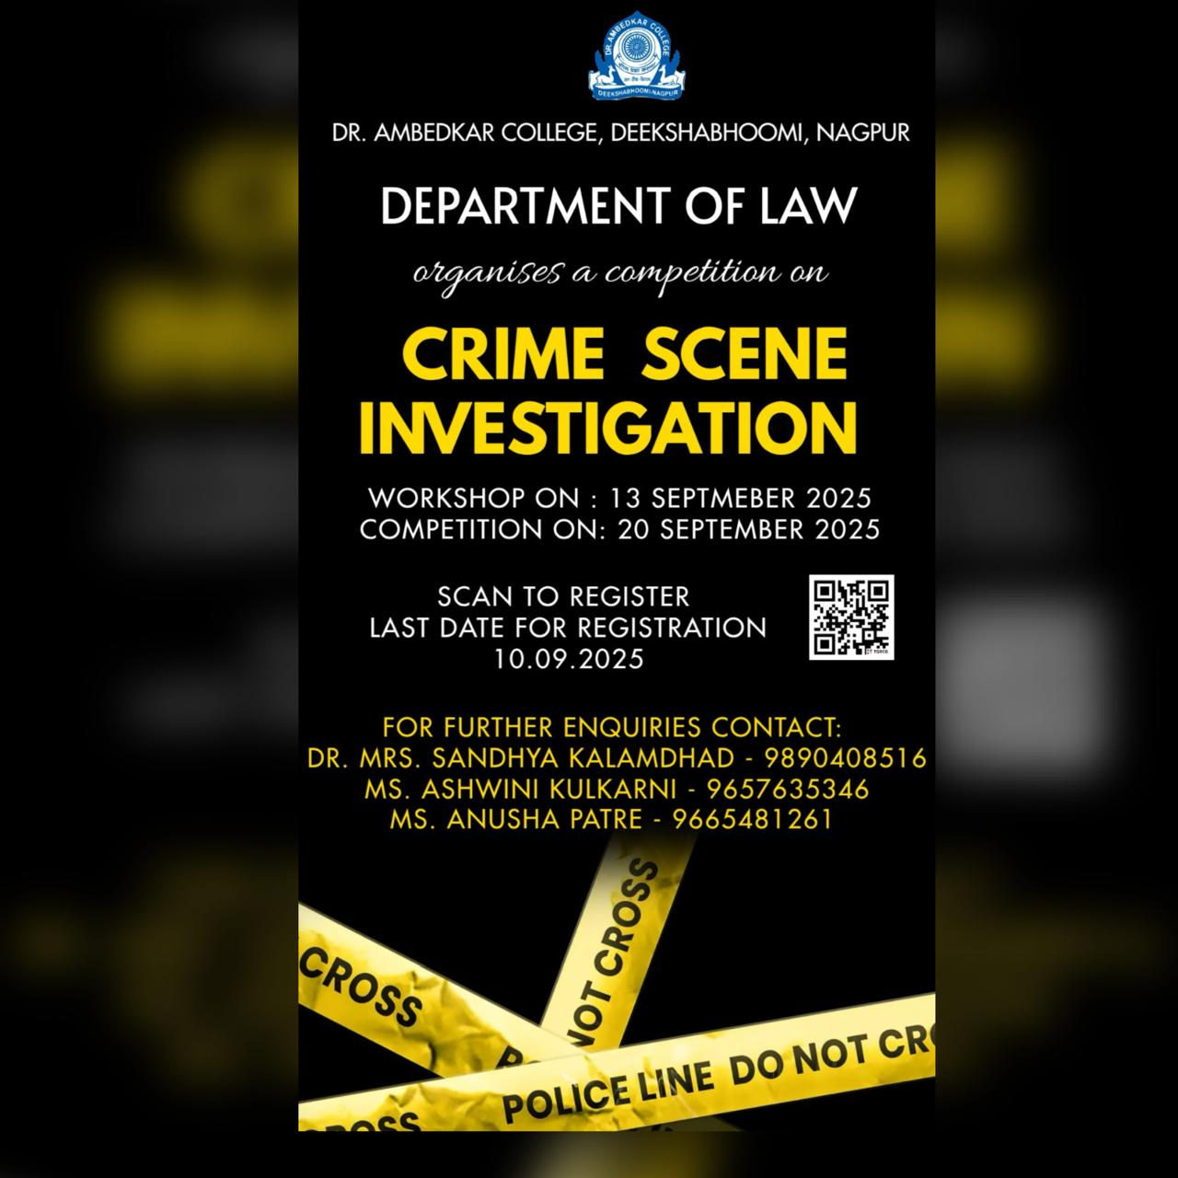

The Criminal Law Club of the Department of Law, Dr. Ambedkar College, Deekshabhoomi, Nagpur, in collaboration with Code F Solutions Pvt. Ltd., Nagpur, organized a Workshop on Crime Scene Investigation on 13th September 2025. The primary objective of the workshop was to provide law students and participants with a practical orientation towards forensic science and its applications in the criminal justice system.
The workshop commenced with the lighting of candles and offering gratitude to Thathagat Gautam Buddha and Dr. Babasaheb Ambedkar, symbolizing wisdom and justice. The first session was conducted by Mr. Shubham Shahu, Founder and Director of Code F Solutions Pvt. Ltd., accompanied by forensic experts Ms. Trisha Dey (Forensic Analyst) and Ms. Sharon Gautam (COO). Mr. Shahu emphasized the growing role of technology in modern investigative processes, highlighting the basic definition of crime, the steps involved in investigation, and the reasons behind criminal behavior. Ms Dey elaborated on the intersection of forensic science and law, stressing the importance of scientific evidence in ensuring fair trials.
Further, Ms. Sharon Gautam explained the different crime scene searching methods and their practical significance. The most engaging part of the workshop was the live demonstration, where participants observed and practiced: (i)Securing and documenting a crime scene. (ii)Fingerprint lifting and preservation. (iii) Collection of biological samples (blood, hair, and fibers). (iv) Use of digital forensic tools for analysis.
Participants were encouraged to interact with the experts through a Q&A session and by engaging in simulated crime scene scenarios, which allowed them to apply their theoretical knowledge to practical investigative tasks. This hands-on experience not only enhanced their learning but also bridged the gap between law and forensic science.
The workshop proved to be a highly informative and enriching experience for the participants. By blending legal studies with practical forensic applications, it helped students understand the critical role of scientific investigation in the administration of justice. The interactive sessions and live demonstrations fostered analytical thinking, attention to detail, and problem-solving skills among budding legal professionals.
Such initiatives by the Criminal Law Club highlight the importance of interdisciplinary learning in today’s era, where technology and science are indispensable to the pursuit of justice. The workshop successfully instilled in participants the idea that effective crime investigation is the foundation of a fair criminal justice system and inspired them to carry forward this knowledge in their future academic and professional pursuits.

Glimpses of the Workshop
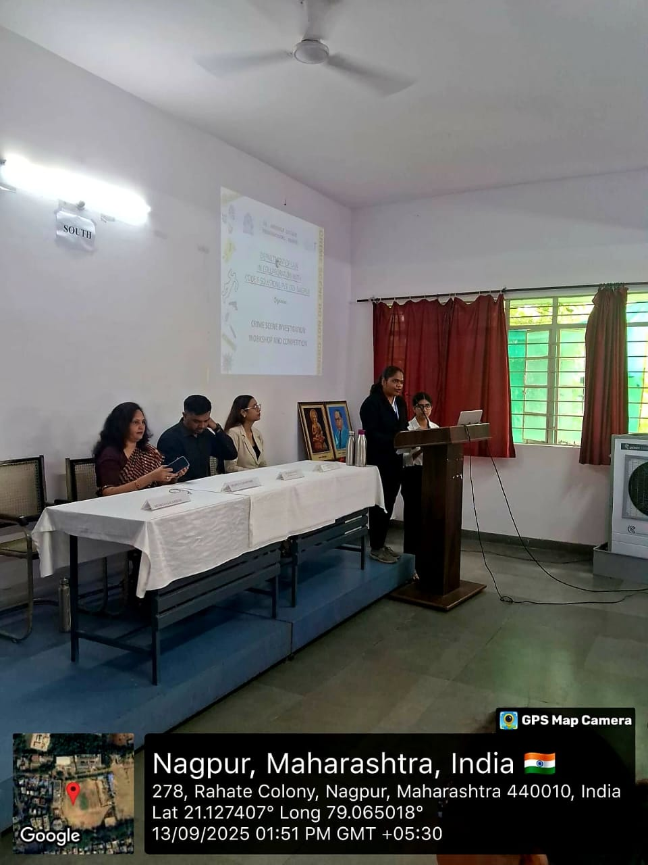
Inaugration of the workshop by welcoming the guests.

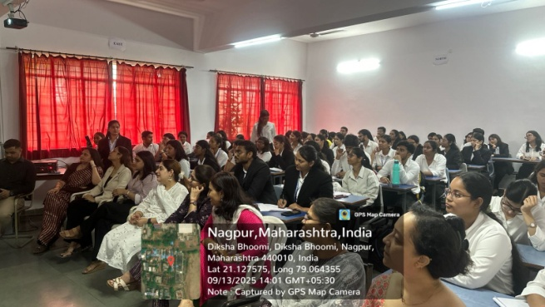
Participants and Volunteers engaged in the session with experts.

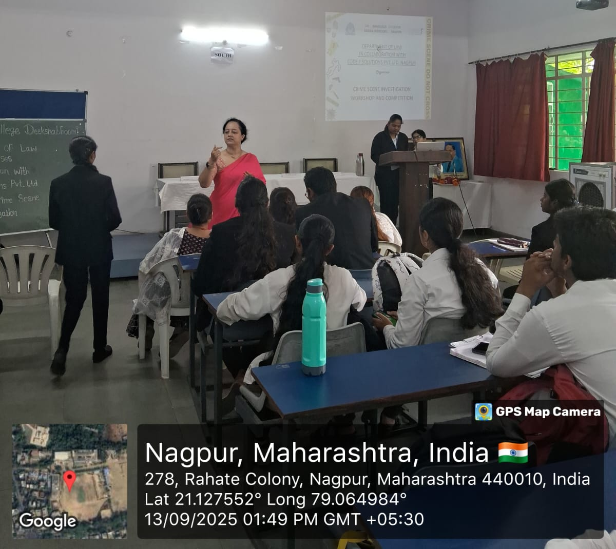
Ms.Ashwini Kulkarni Ma’am addressing the queries of the students.

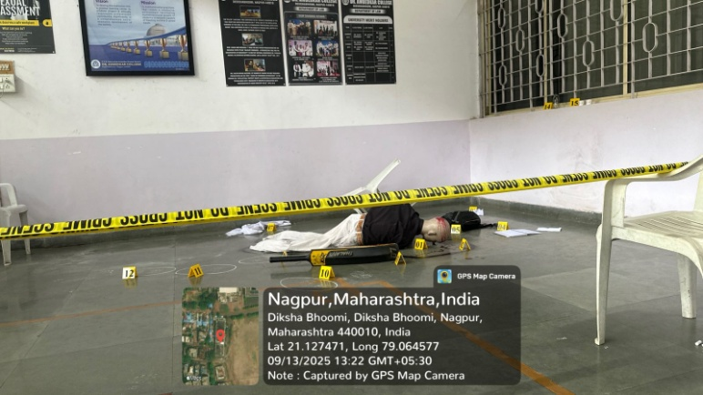
Dummy crime investigation scene made by CODEF solutions pvt.ltd.

Attendees Of the Workshop

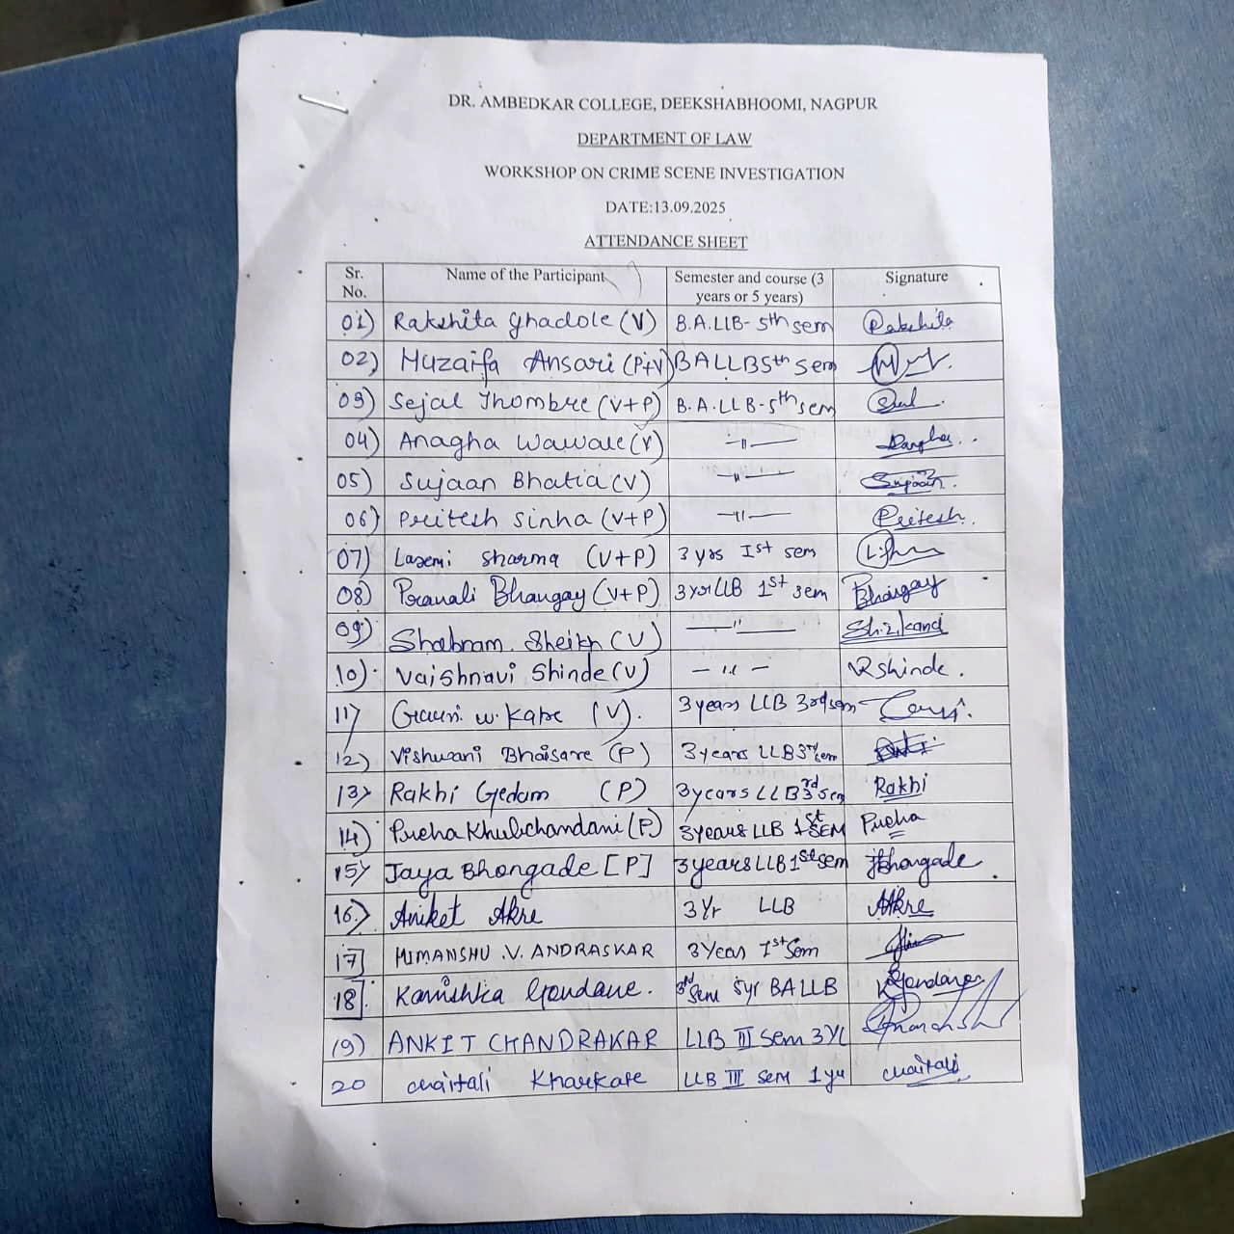

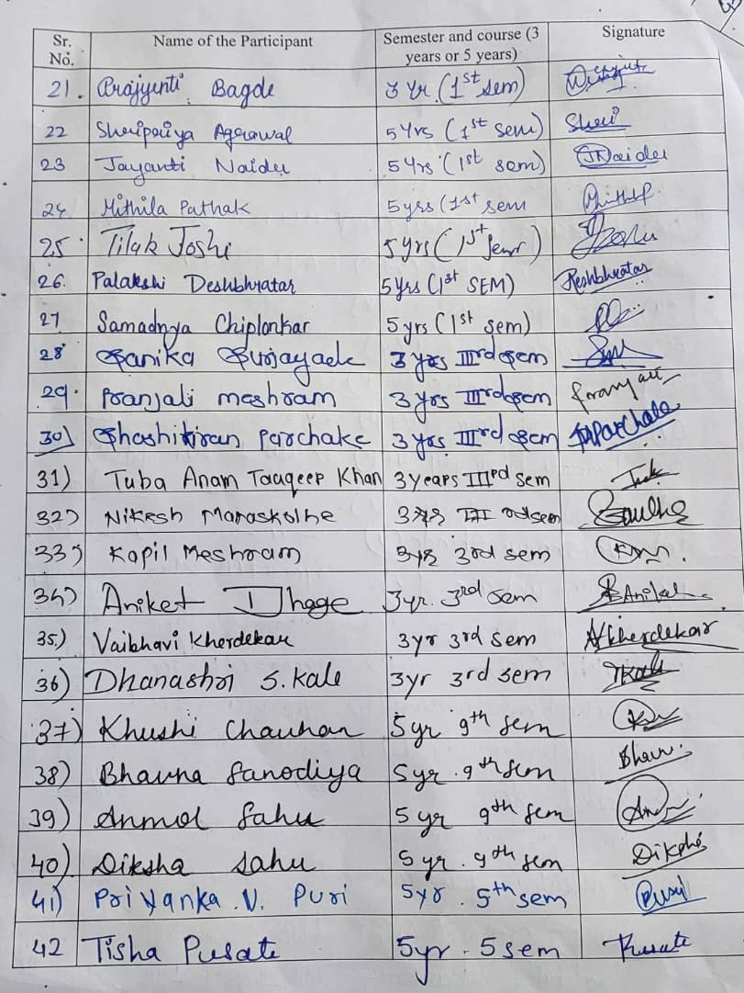

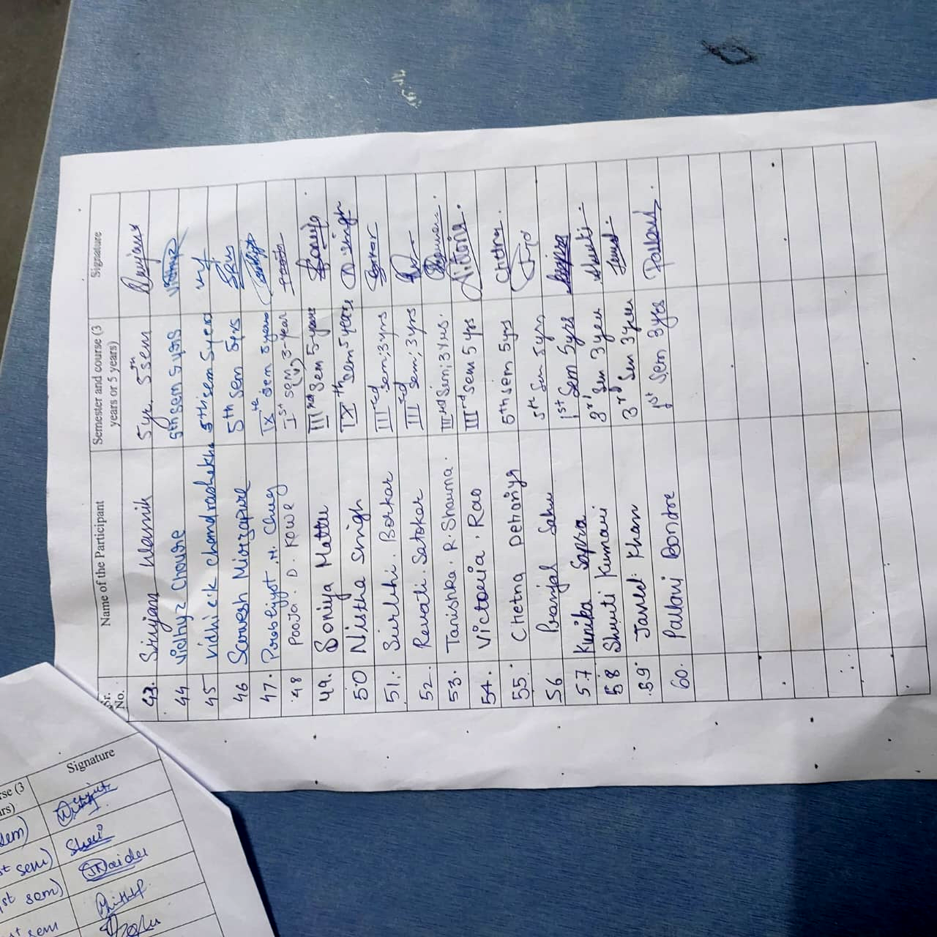

Feedback Responses

