REPORT
CRIME SCENE INVESTIGATION COMPETITION
THE DEPARTMENT OF LAW in Collaboration with CODE F SOLUTIONS PVT. LTD. NAGPUR
DATE: 20TH SEPTEMBER 2025
NAME OF THE PROGRAM: CRIME SCENE INVESTIGATION COMPETITION
PROGRAM COORDINATOR: PROF. DR. MRS. SANDHYA P. KALAMDHAD
SHREE SHUBHAM SHAHU (CODE F SOLUTIONS)
MS. ANUSHA PATRE (ASSISTANT PROFESSOR )
MS. ASHWINI KULKARNI (ASSISTANT PROFESSOR )

NUMBER OF ATTENDEES: 52 PARTICIPANTS .(10 TEAMS)
NAME OF THE VENUE: DR. AMBEDKAR COLLEGE DEEKSHABHOOMI NAGPUR, DEPARTMENT OF LAW.

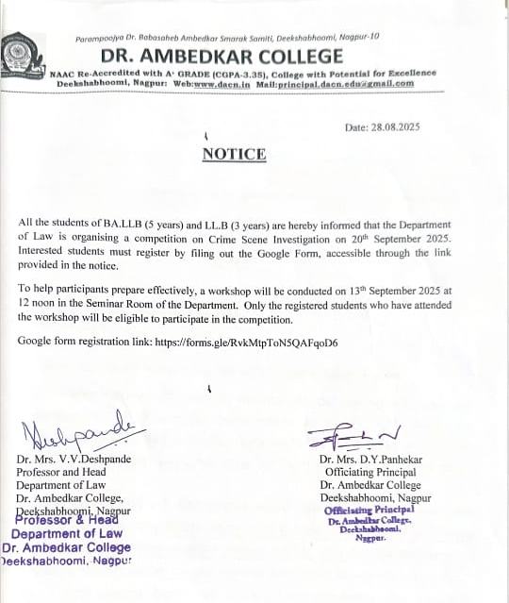 | 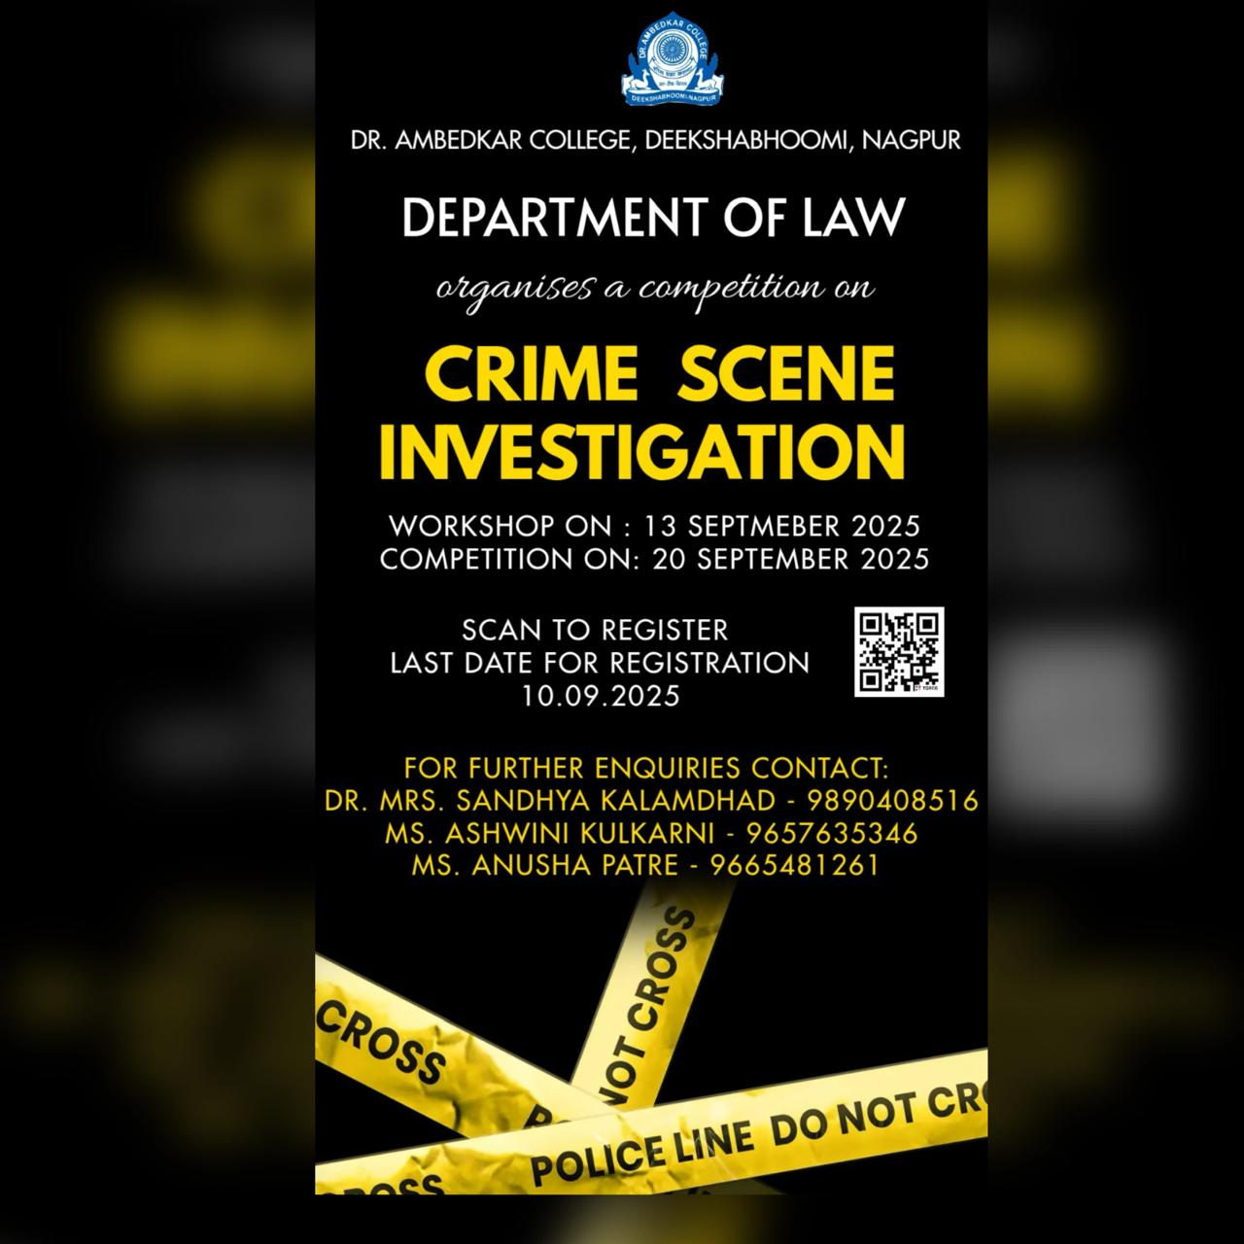

The Department of Law, Dr. Ambedkar College, Deekshabhoomi, Nagpur, in collaboration with Code F Solutions Pvt. Ltd., Nagpur, successfully organized the Final Round of the Crime Scene Investigation Competition on 20th September 2025. This event was a culmination of the Crime Scene Investigation Workshop Series, aimed at providing law students with practical exposure to forensic science and its role in the criminal justice system.
The competition comprised of three crime scenes. First, dowry death scene, second was honour killing scene and third was sexual assault scene. The judges of the competition were Adv. Kritika Shekhar, Adv. Vishwajeet Uberoi, Adv. Vivek Awchat, Ms. Sharon Gautam, Ms. Shubhangi Nikhare and Ms. Trisha Dey. In the final competition, shortlisted teams were presented with a simulated crime scene, designed to test their investigative, analytical, and teamwork skills. Participants were required to:
1. Secure and document the crime scene using standard forensic protocols.
2. Identify, collect, and preserve physical and biological evidence such as fingerprints, blood samples, and fibers.
3. Analyze digital and trace evidence using forensic tools.
4. Prepare a detailed crime scene report and present their findings before the panel of experts.
Each team demonstrated impressive coordination and application of the techniques learned during the workshop sessions. The judges evaluated the participants on parameters such as accuracy of evidence collection , methodology, report presentation, and clarity of reasoning behind their conclusions. The competition provided an engaging platform for students to apply theoretical legal knowledge to realistic forensic problem-solving scenarios. It encouraged critical thinking, attention to detail, and a scientific approach to criminal investigation — essential qualities for aspiring legal professionals.
The winners were according to the three crime scene set up :
Crime Scene 1 (dowry death): Team E
- Laxmi Sharma
- Anay Dakate
- Bhumika N
- Ojas Gade
- Himanshu Andraskar
Crime Scene 2 (honour killing): Team H
- Prabhjyot Chug
- Nishtha Singh
- Prehna
- Shripriya
- Shreyash Wankhade
Crime Scene 3 (sexual assault) : Team J
- Rakshita Ghadole
- Shyam Rathod
- Rohan Surjuse
- Anish Michkawade
- Vishwajeet Thakre
- Moin Khan
Artist of Justice Award - Chetana Dehariya
Legal Eye Award - Samadnya and Diksha
Best Detective Award - Nishtha Singh
Motivational Award - Nagesh Bothe
Spirit of Participation Award - Team B: Jayanti naidu, mithila pathak, bhakti mehar, pritesh sinha, huzefa Ansari
The Crime Scene Investigation Final Competition proved to be an enriching and educational experience, bridging the gap between law and forensic science. It not only enhanced students’ understanding of the investigative process but also reinforced the idea that scientific investigation is the cornerstone of a fair and just legal system. The Department’s continued efforts in organising such interdisciplinary events demonstrate its commitment to nurturing practically skilled and ethically aware legal professionals, ready to uphold justice through knowledge and scientific reasoning.

Attendees
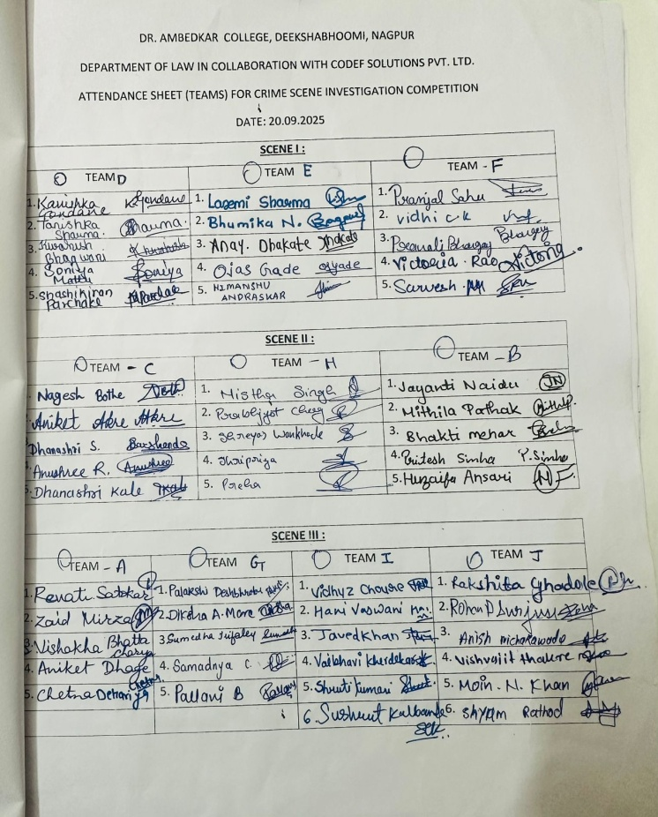

Glimpse of Events
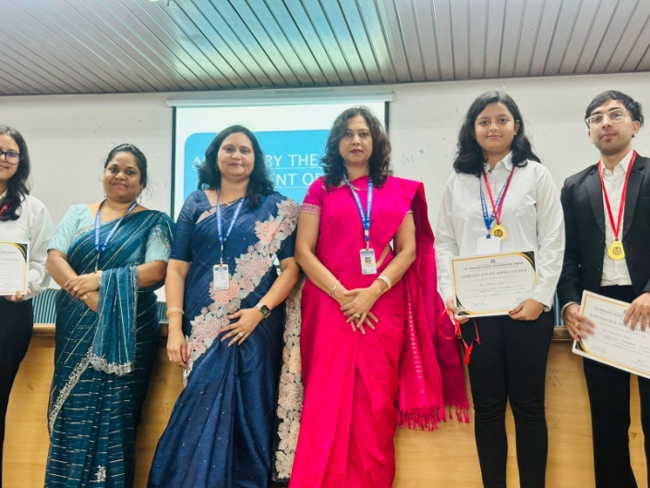 | 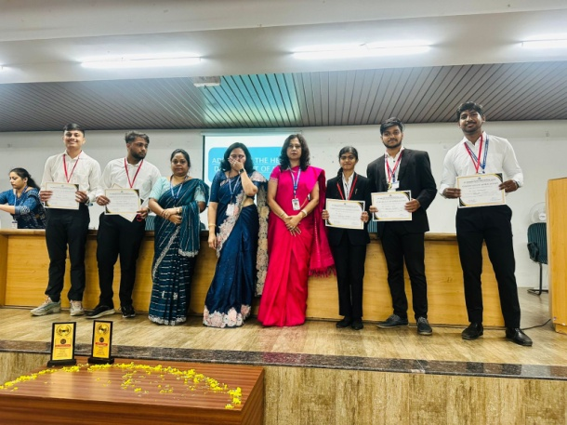
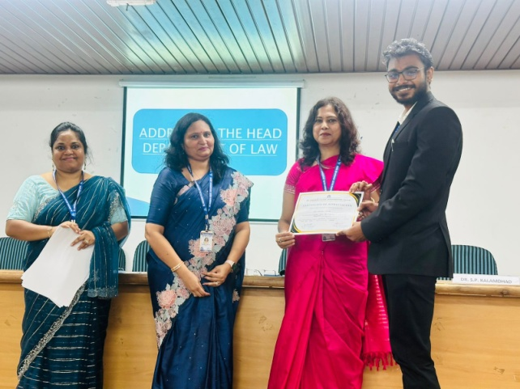 | 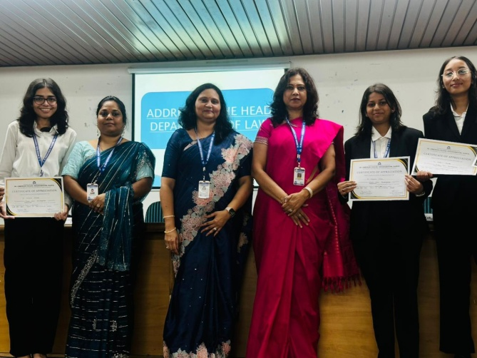

FEEDBACK OF THE STUDENTS
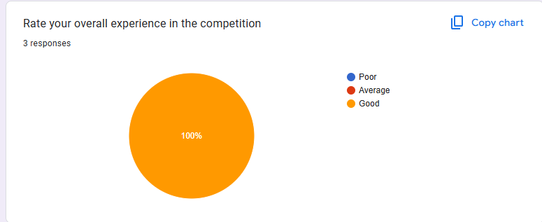 | 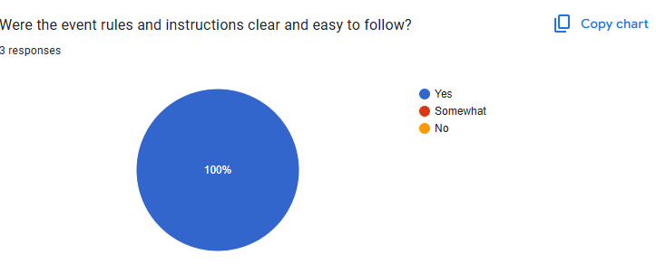
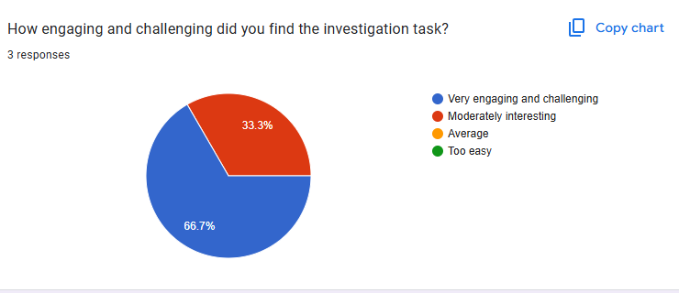

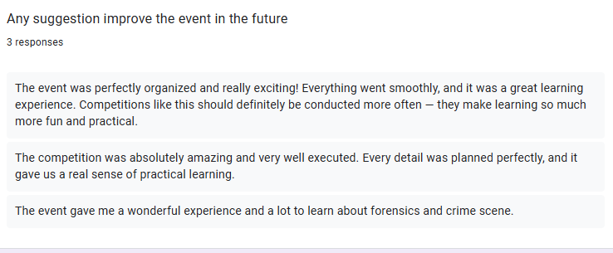

CERTIFICATE
