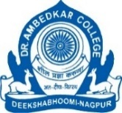
Dr. Ambedkar College, Deekshabhoomi, Nagpur
Department of Physics

Date of Program : 18/06/2025
No. of Students Present : 30
Hosted by : Department of Physics
Name of Program : Placement Drive of STEM

NOTICE
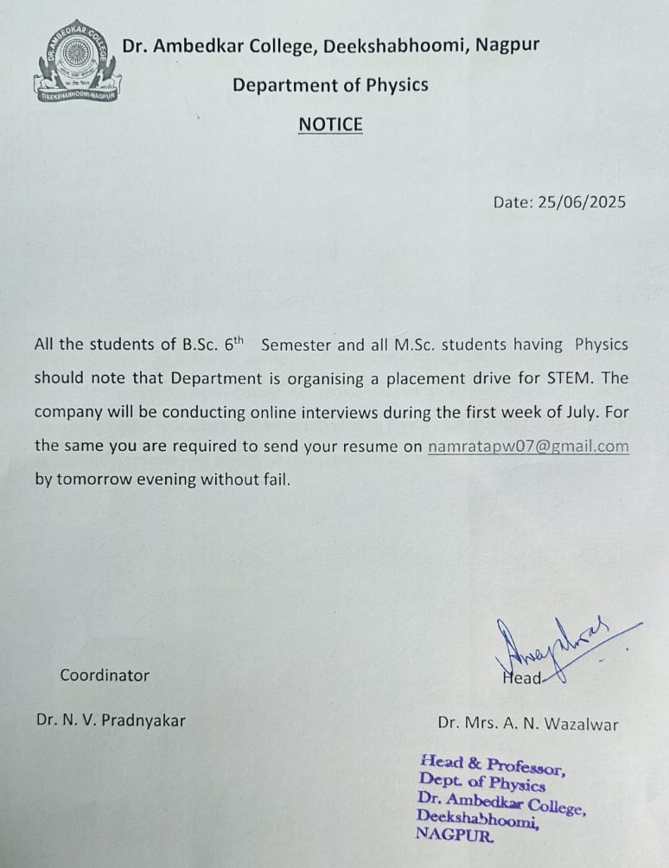

The Department of Physics, Dr. Ambedkar College, Deekshabhoomi, Nagpur, successfully organized an online placement drive for its students on 18/06/2025. The initiative was taken by Dr. Aarti N. Wazalwar, Head of department and coordinated by Dr. Namrata Pradnyakar, Asst. Prof., Dept of Physics. Department approached An mafatlal Group Company to hire the departmental students under thetir program STEM. This was aimed to provide meaningful career opportunities for both undergraduate and postgraduate students in the fields of STEM, Physics and Artificial Intelligence (AI).
A total of 30 students participated, including 26 undergraduate and 04 postgraduate candidates. The placement process was conducted virtually and included screening rounds followed by interaction sessions with recruiters. The recruiting organization, GSL, offered a unique opportunity for selected candidates to work as STEM & AI trainers in schools. Initially in the month of May 25 the interest of students for appearing to the interview was taken through Google form. Later till the month of July many other students had also shown their readiness.
The placement drive was well received by both students and the recruiting team. Students appreciated the chance to combine their subject knowledge with practical teaching opportunities in STEM and AI, while also contributing to school-level education. The department expressed satisfaction with the active participation of students and the professional approach of GSL.
The online placement drive organized by the Physics Department proved to be a valuable career-building platform for the students of Dr. Ambedkar College. It not only opened doors for employment but also encouraged students to engage with the growing fields of STEM and AI education, thereby aligning with national priorities in skill development and technological innovation. A student of M. Sc. Physics, Ms. Smriti Mankar received agreement/offer letter by STEM.
