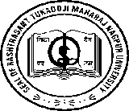
DEPARTMENT OF POLITICAL SCIENCE
RASHTRASANT TUKADOJI MAHARAJ NAGPUR UNIVERSITY, NAGPUR
(Established by Government of Central Provinces Education Department by Notification
No.513 dated the 1st of August, 1923 & presently a State University governed by the
Maharashtra Public Universities Act, 2016 (Mah.Act. No.VI of 2017)
Re-accredited by NAAC ‘A’ Grade

No. RTMNU/PS/2025/ Date:

Name of Program : Summer Workshop on Key Concept in Political Science
Date : 09/06/2025 to 14/06/2025.
No. of Students : 20
Name of Organizing institution:
- The Department of Political Science (Autonomous), Rashtrasant Tukadoji Maharaj Nagpur University, Nagpur.
- Dr. Ambedkar College, Deekshabhoomi, Nagpur
Convenor: Dr. Vikas Jambhulkar
Coordinator: Dr. Vidya Chourpagar: Associate Prof & Sachin Chapke
Name of the Resource Persons:
- Dr. Vikas Jambhulkar
- Assit. Prof. Pradyanand Mate
- Dr. Vidya Chourpagar
- Assit. Prof. Sachin Chapke

Report on Summer Workshop on Key Concept in Political Science
A key concept in political science is power, the ability to influence or control the behaviour of people and institutions. It forms the backbone of political interactions, shaping governance, policy, and societal structures.

Aim:
To influence the students to shape their understanding of societal structures, decision-making, and their role in civic life

Objectives:
To explore practically the Key concepts in political science like State, Democracy, Liberty, Equality and Rights.

The Department of Political Science (Autonomous) of Rashtrasant Tukadoji Maharaj Nagpur University and Dr. Ambedkar College, Deekshabhoomi, Nagpur jointly organized 5 Days Special Summer workshops on the theme “Important Concepts in Politics” from 9th June to 13th June 2025. In the Five days’ Workshop, students got explored with various aspects of the concepts like State, Democracy, Freedom, Equality and Freedom through various activities like dialogues, Group discussions and Debates. A review of Literature in theoretical and practical concepts in various governance systems in Indian and global societies, and its variations and resolutions in the course of time was discussed and reviewed. The students expressed their views on the importance, relevance and challenges of these concepts in the present day.

Schedule of Workshop:

Day | Date | Time | Name of Topic | Name of Resource Person
01 | 09/06/2025 | 11 a.m to 2.00 p.m. | Key Concepts of Political Science in State | Dr. Vikas Jambhulkar
02 | 10/06/2025 | 11 a.m to 2.00 p.m. | Key Concepts of Political Science in Democracy | Dr. Vikas Jambhulkar
03 | 11/06/2025 | 11 a.m to 2.00 p.m. | Key Concepts of Political Science in Rights | Assit. Prof. Pradyanand Mate
04 | 12/06/2025 | 11 a.m to 2.00 p.m. | Key Concepts of Political Science in Equality | Dr. Vidya Chourpagar
05 | 13/05/2025 | 11 a.m to 2.00 p.m. | Key Concepts of Political Science in Liberty | Assit. Prof. Sachin Chapke

Day 01, Session 1 (Dt. 09/06/2025)
The first session was conducted on 9th June 2025 from 11. a.m. to 2.00 p.m. The Session was conducted by Dr. Vikas Jambhulkar, Head Dept. of Political Science, PG DT, RTMNU, Nagpur. Dr. Jambhulkar conducted the session on the topic “Key Concepts of Political Science in State”. In his invaluable workshop Dr. Jambhulkar Defined the concept of State as a political entity with a defined territory, a permanent population, a government, and sovereignty. He gave the example of Max Weber’s definition which defined State as an entity that holds a monopoly on the legitimate use of physical force within a given territory. He focused on different types of States that include Nation-State, Multinational State, Failed Stat and Authoritarian vs. Democratic States. Various Functions and theories of State were briefly elucidated and explained with lively and practical examples.

PHOTOS OF DAY 01 ON 09/06/2025
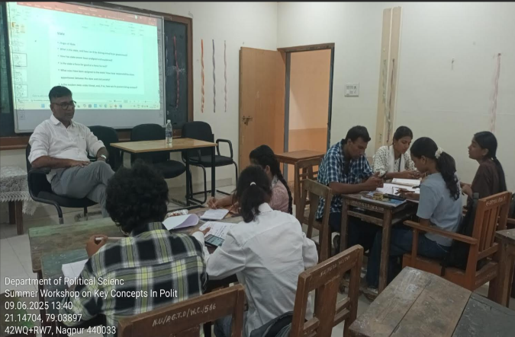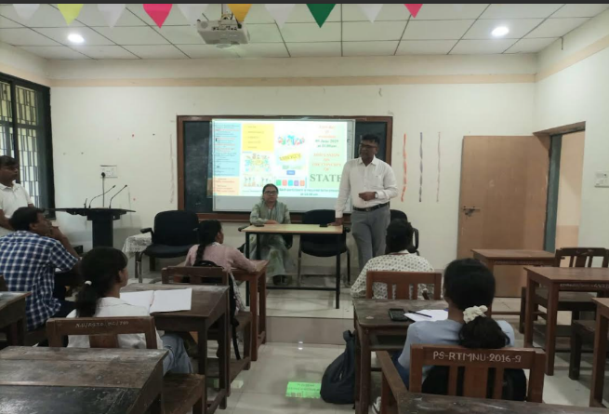

Day 02 , Session 2. (Dt. 10/06/2025)
The second session was conducted on Dt. 10/06/2025 from 11.00 a.m. to 2.00 p.m. by Dr. Vikas Jambhulkar. He conducted the session on the topic “Key Concepts of Political Science in Democracy”. Dr. Jaambhulkar in his influential workshop enlightened the students on the key aspects of Democracy by explaining that Democracy is a foundational pillar of political science, emphasizing governance based on the will of the people. It involves principles, institutions, and practices that ensure participation, accountability, and representation. He defined briefly the definition of Democracy which is a system of government where power is vested in the people, who exercise it directly or through elected representatives. He dealt with the Core Principles of Democracy which included Popular Sovereignty, Political Equality, Majority Rule, Minority Rights, Rule of Law and Individual Liberties.

Photos of Day 02 on 10/06/2025
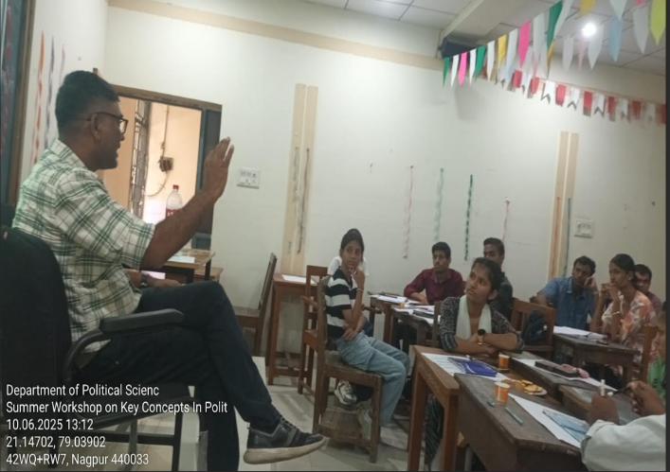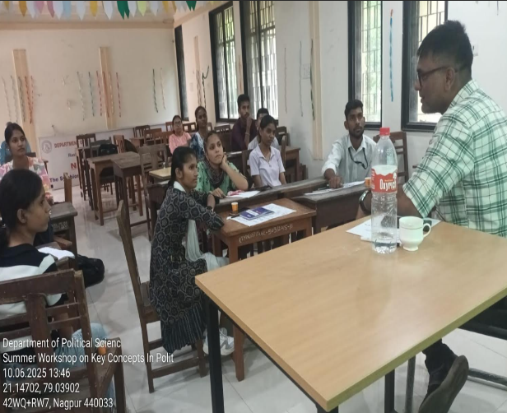

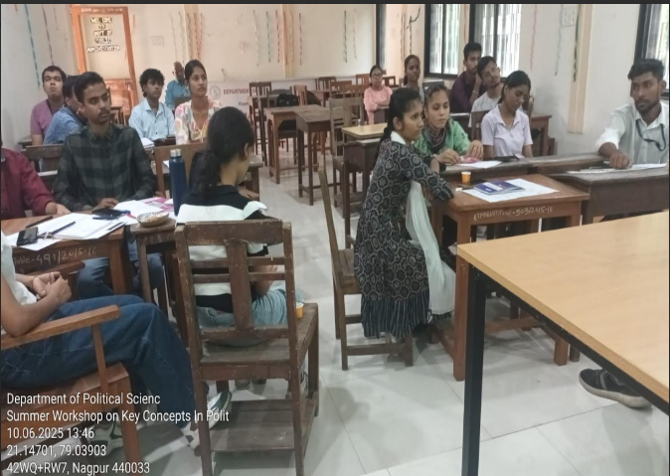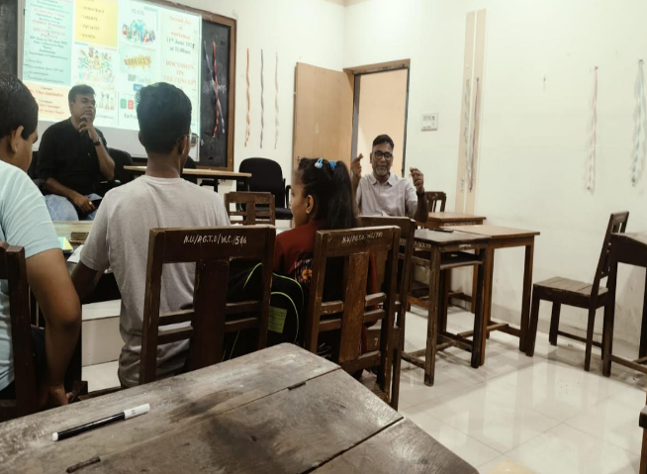

Day 03 , Session 3. (Dt. 11/06/2025)
The Third session was conducted on Dt. 11/06/2025 from 11.00 a.m. to 2.00 p.m. by Assist. Prof. Pradyanand Mate. He conducted the session on the topic “Key Concepts of Political Science in Rights”. The Resource Person began his workshop by explaining in brief the concept of rights is fundamental to political science, shaping the relationship between individuals, the state, and society. He elaborated briefly about various types of Rights that include Natural Rights, Legal Rights, Human Rights, Civil Rights, Political Rights and Social/Economic Rights. He talked about the difference between Positive vs. Negative Rights, Individual vs. Collective Rights, Rights and Duties and Rights and Power. The Session was very interactive. Students asked various questions relating to the aspect of Rights.

PHOTOS OF DAY 03 ON 11/06/2025
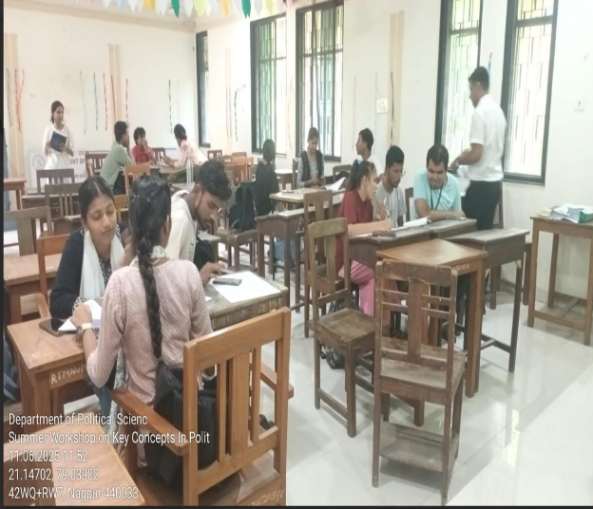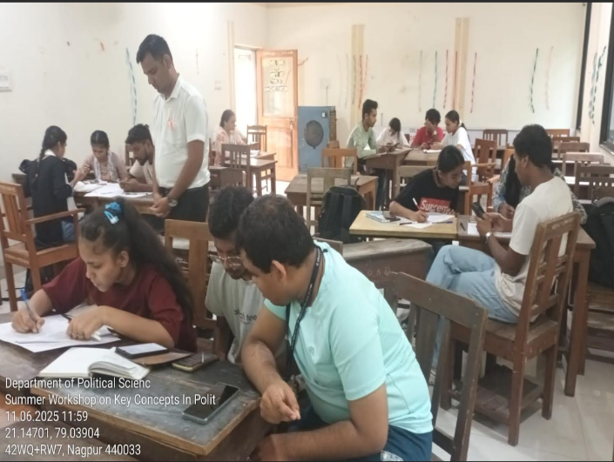

Day 04 , Session 4. (Dt. 12/06/2025)
The Fourth session was conducted on Dt. 12/06/2025 from 11.00 a.m. to 2.00 p.m. by Dr. Vidya Chourpagar. She conducted the session on the topic “Key Concepts of Political Science in Equality”. The Resource Person in her invaluable address gave a brief insight on the concept of equality explaining that Equality is a cornerstone of political science, addressing the distribution of rights, opportunities, and resources within a society and the principles guiding fair treatment. In her presentation, she explored on the core concepts of Theoretical Foundations of Rights that include Liberalism, Socialism/Marxism, Feminism and Egalitarianism. A practical activity was conduced on the Contemporary Issues of Rights that comprised of Affirmative Action, Digital Divide: Climate Justice: and Intersectionality. The students took active part in the practical approach of the key aspects of Rights. They were enlightened with the knowledge about the Rights and Privileges of the Constitution.

PHOTOS OF DAY 04 ON 12/06/2025
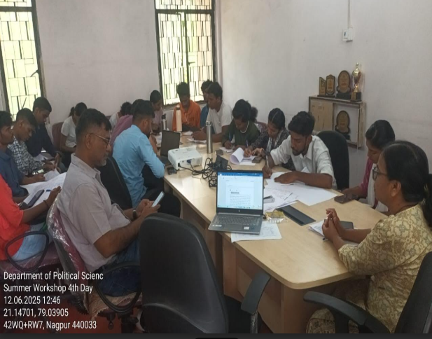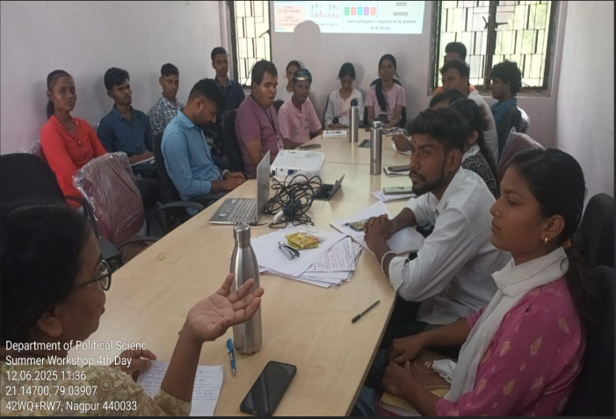

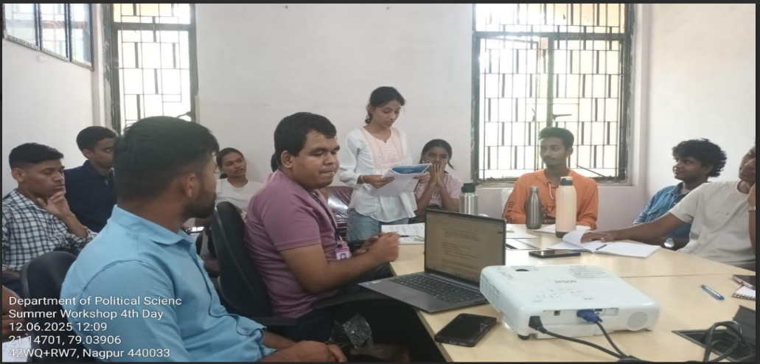

Day 05 , Session 5. (Dt. 13/06/2025)

The Fifth session was conducted on Dt. 13/06/2025 from 11.00 a.m. to 2.00 p.m. by Assit. Prof. Sachin Chapke. He conducted the session on the topic “Key Concepts of Political Science in Liberty”. Prof. Sachin Chapke in his workshop enlightened the students on the concept of liberty which is a cornerstone of political science, focusing on the freedom of individuals and groups to act, think, and live without undue constraints, while balancing the needs of society and the state. He talked about Sources of Liberty that include Natural Law, Constitutional Protections and Social Movements. The resource person conducted a practical approach on philosophical debates, practical protections, and contemporary challenges in which the students took active participation and understood the pros and cons of the Sailent Features of Liberty.
In order to encourage the students to think and to create a lively discussion. All the professors conducted the daily workshops by using various techniques. As a result, the students expressed themselves with great interest and ease. The students participated in the workshop in a playful atmosphere for five days.

In the concluding session, Head of the Department Dr. Vikas Jambhulkar explained how the basic concepts of politics affect everyone's daily life on a theoretical and practical level. He also guided the students on what to do to understand these concepts in more depth, which books to read. The students expressed their views on the usefulness of these five special workshops. Prizes and certificates were distributed to the participating students. Students from various branches of various colleges after 12th participated in the workshop. The objective of organizing this workshop was to create political awareness among the students who are pursuing higher education and to connect the students of various colleges with the university. Under the guidance of Dr. Vikas Jambhalukar, Dr. Vidya Chorpagar, Prof. Pragyanand Mate, Dr. Atlu Manu, Dr. Rai Mahajan, Dr. Bhapundar Gharat, Prof. Savchan Chapke, Vikas Raghote, Sanjay Vinkhare, Ivishka Vimpalkar and Pankaj Somkuwar contributed to the organization and planning of the workshop.

PHOTOS OF DAY 05 ON 13/06/2025
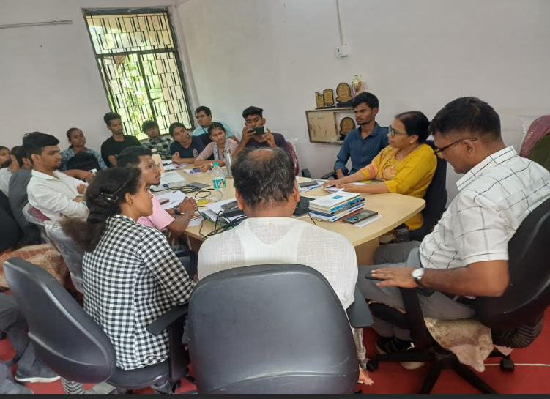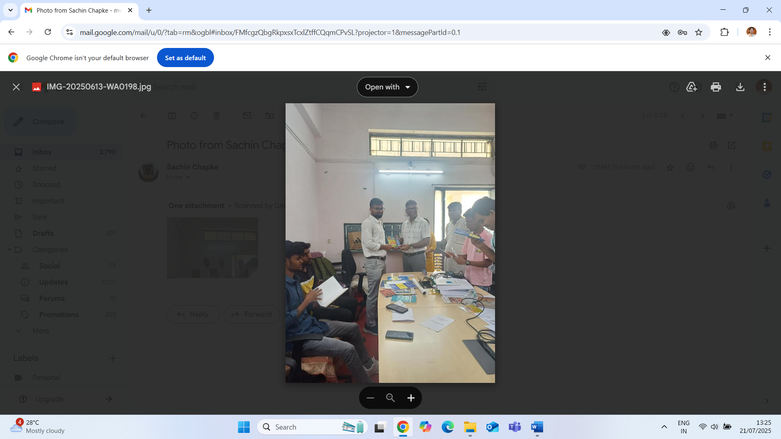

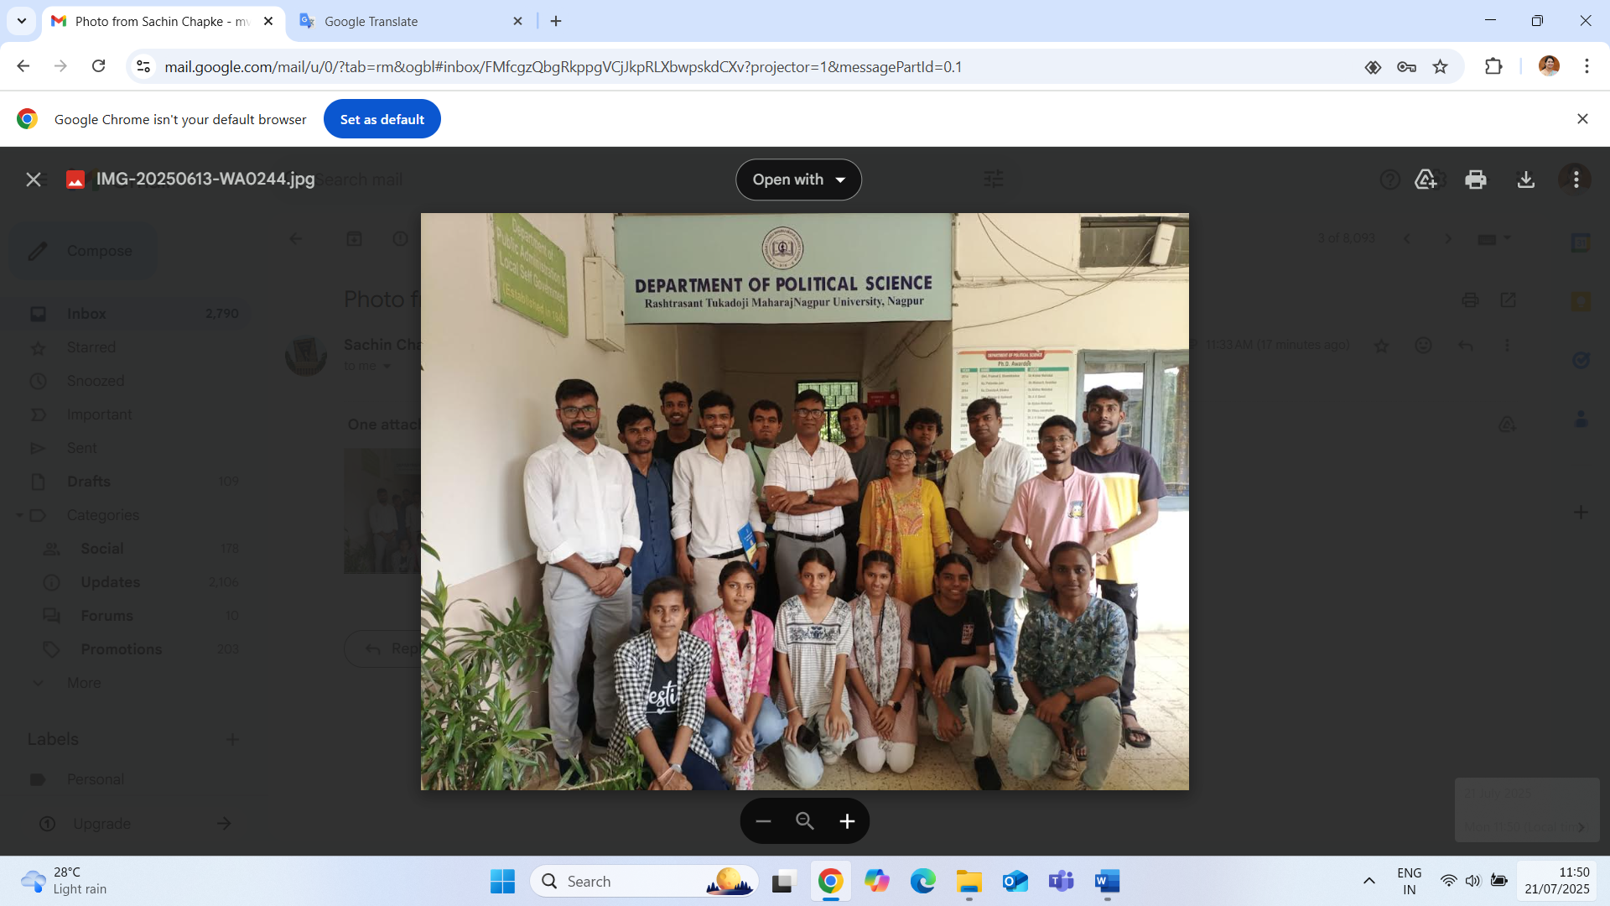

BROCHURE OF WORKSHOP
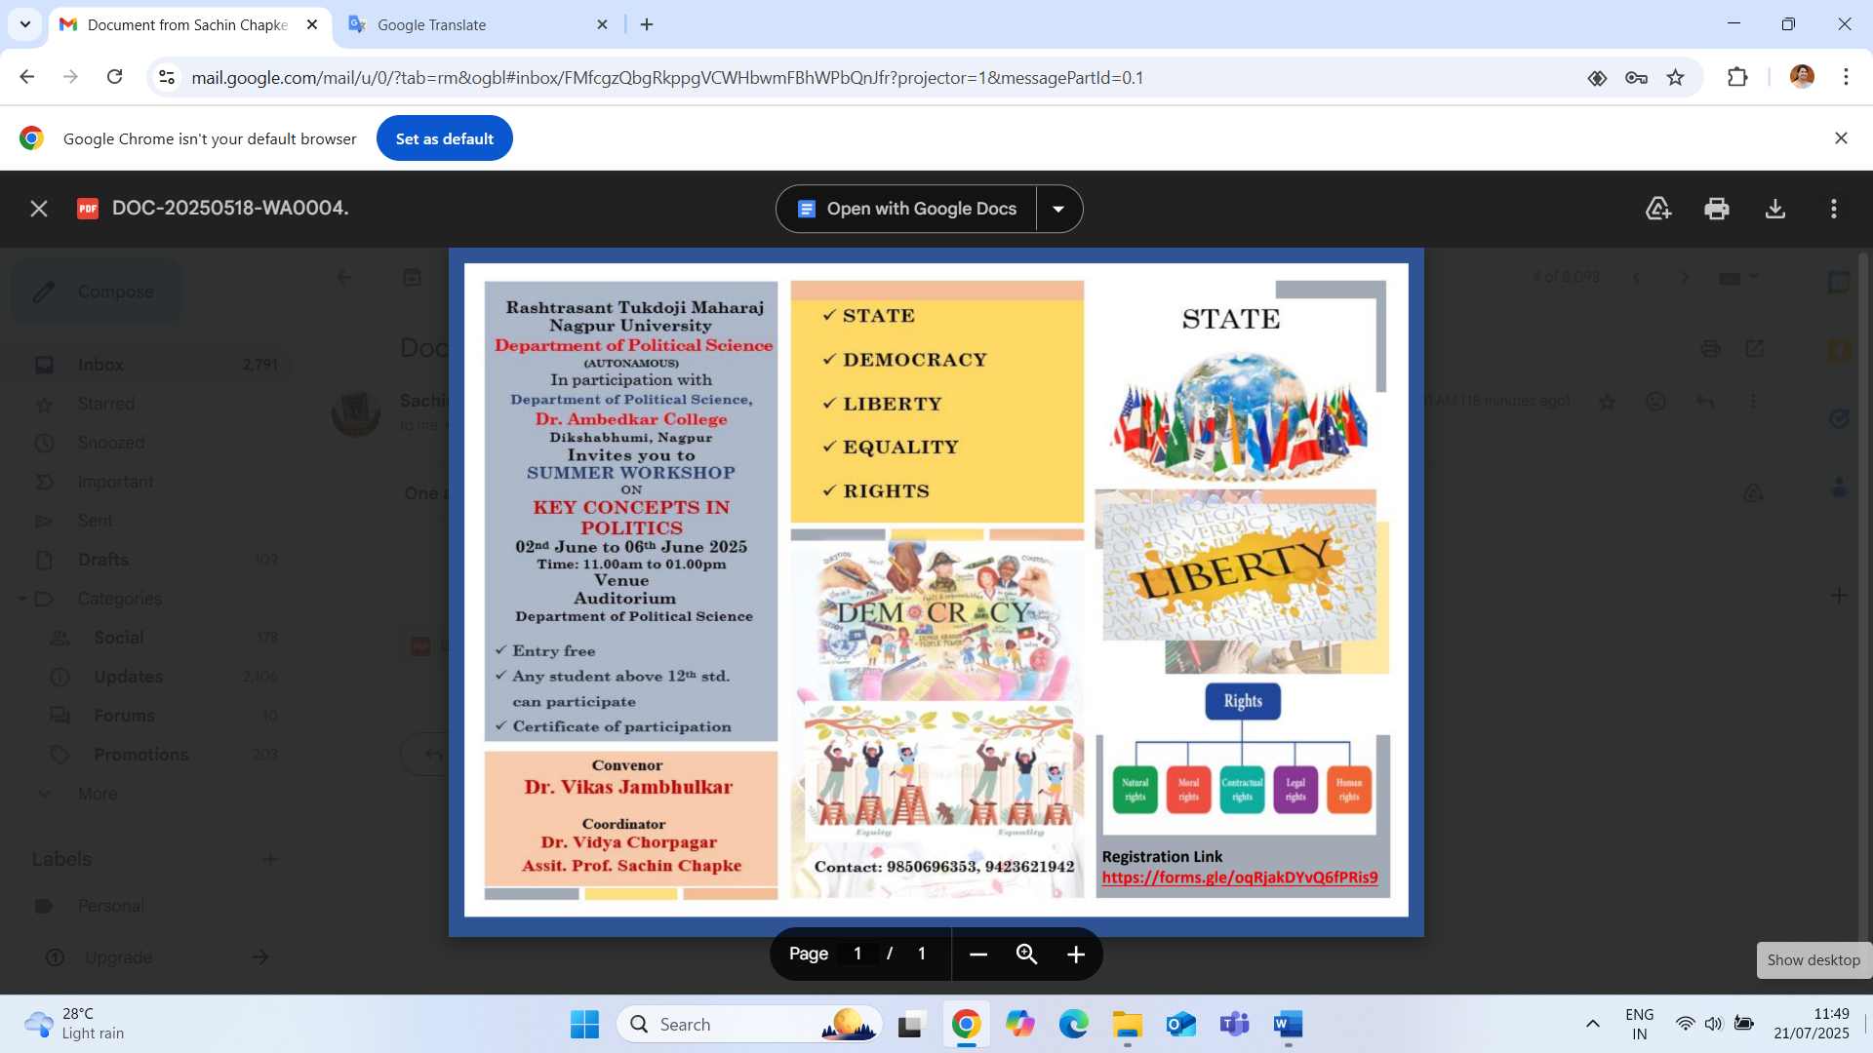

PRESS NOTE ON INAUGURATION SESSION
ON 09/06/2025

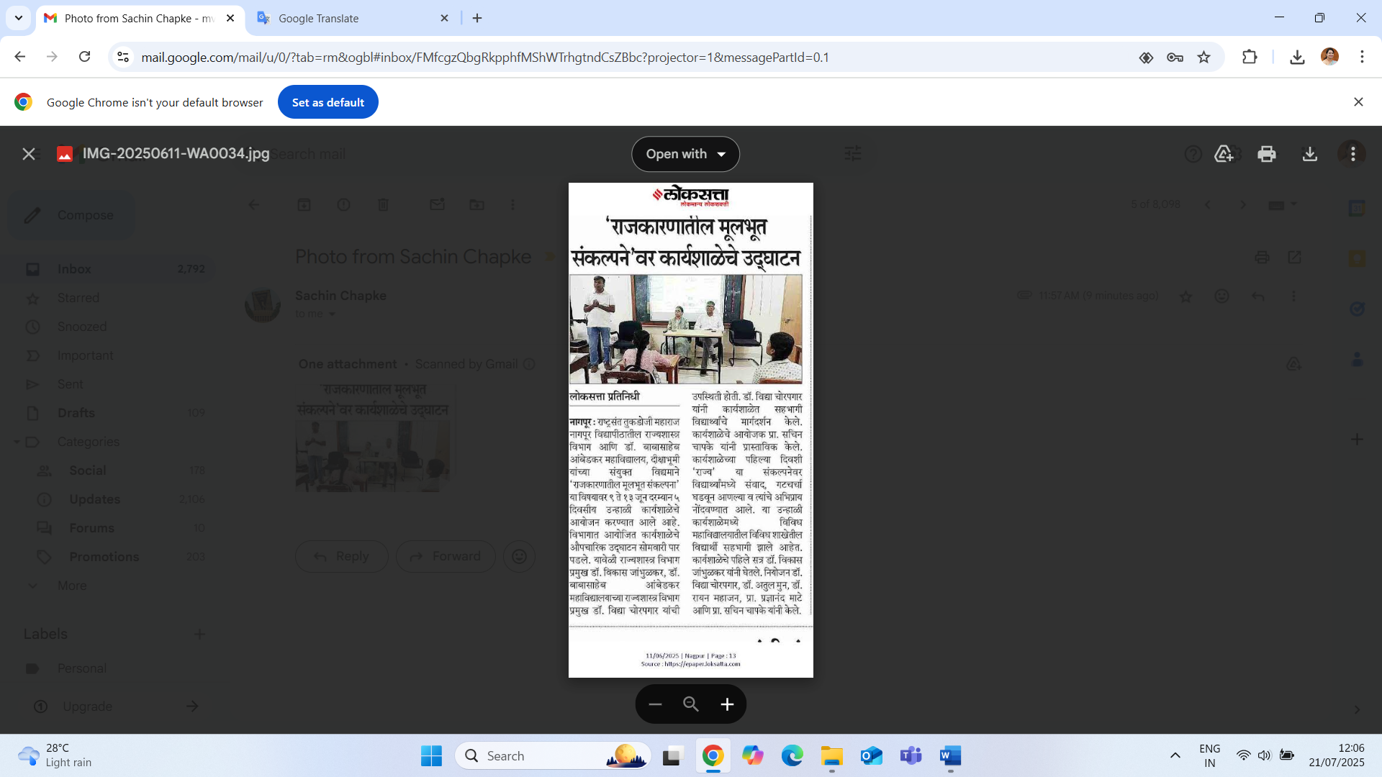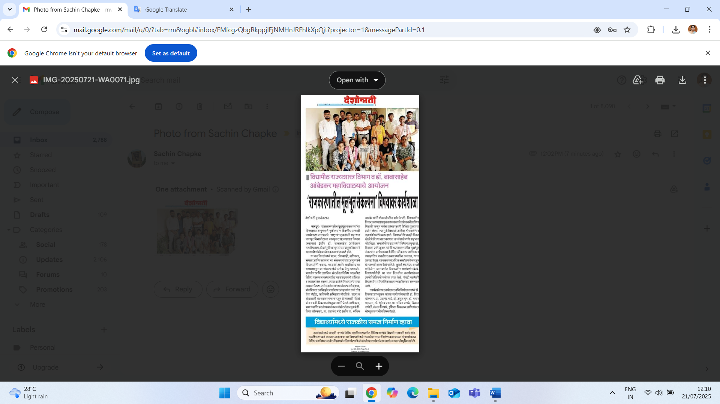

CERTIFICATE OF PARTICIPATION
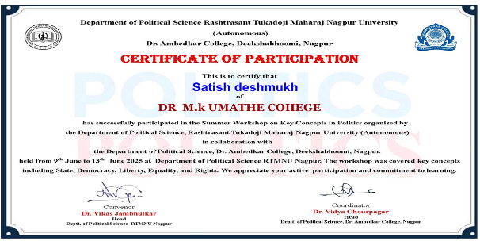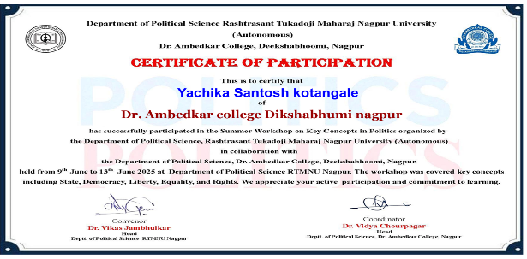
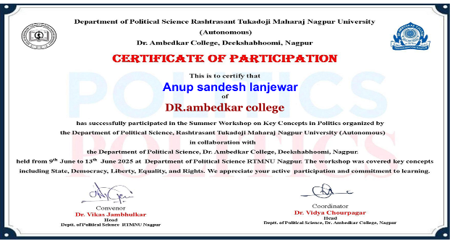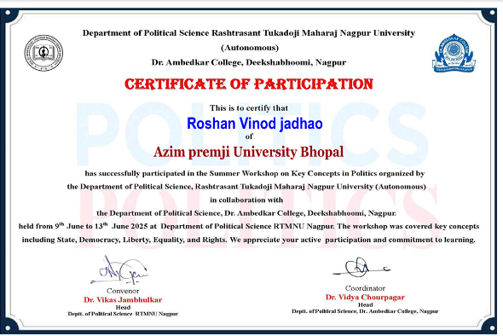

ATTENDANCE SHEET
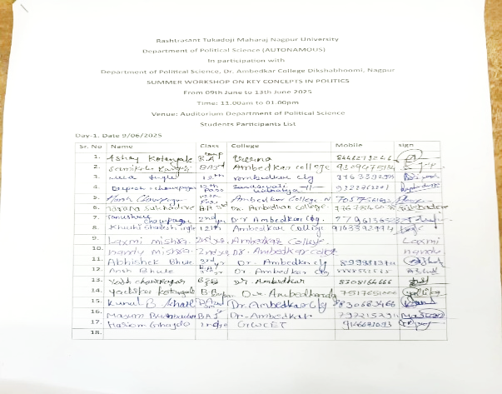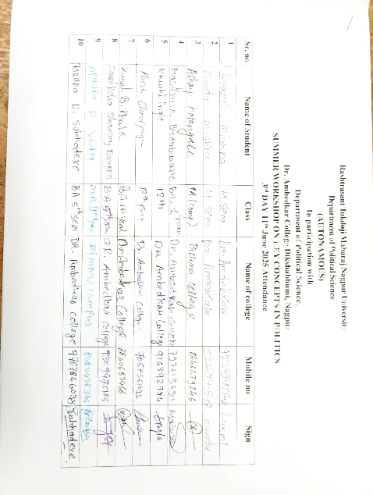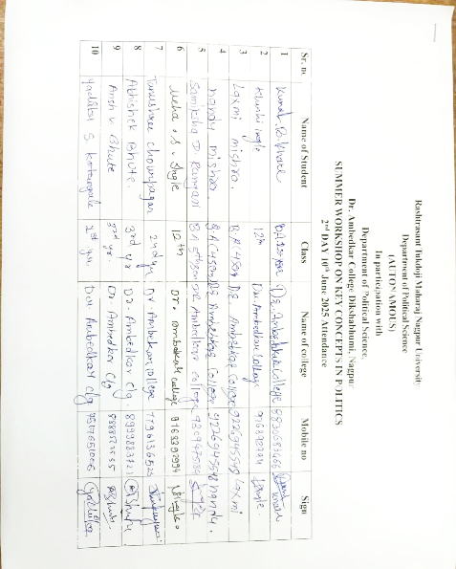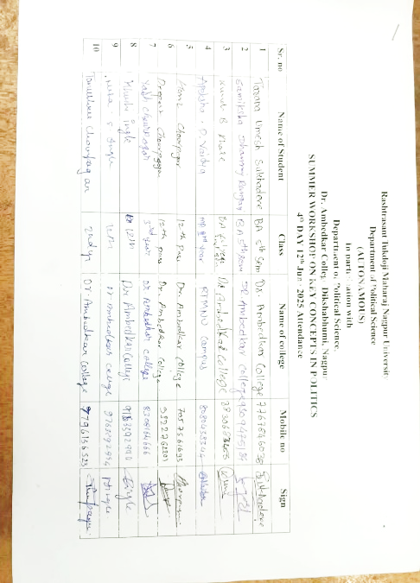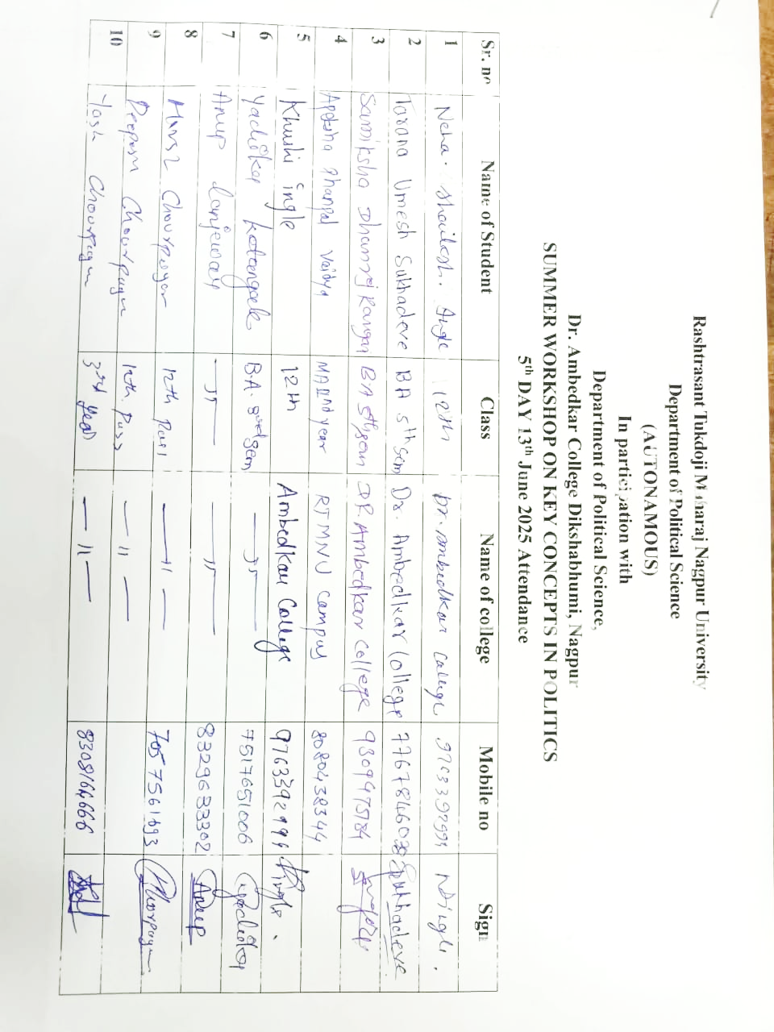

REGISTRATION RESPONSES OF STUDENTS
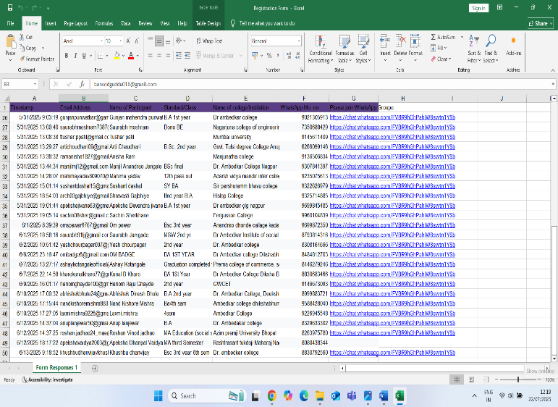

FEEDBACK RESPONSES OF STUDENTS

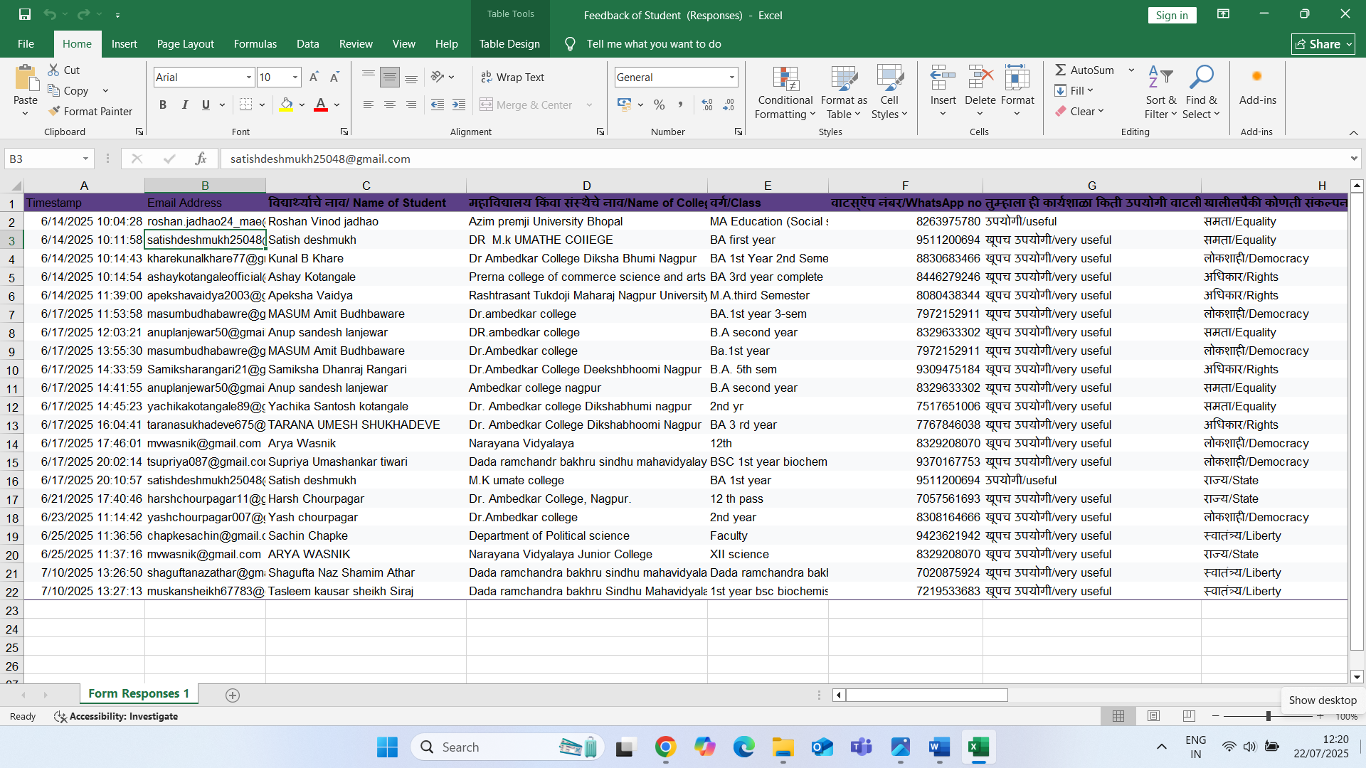

SUMITED BY
DR. VIDHYA CHOURPAGAR
ASSOCIATE PROFESSOR
DEPT. OF POLITICAL SCIENCE

