DR. AMBEDKAR COLLEGE, DEEKSHABHOOMI NAGPUR

DEPARTMENT OF LAW

CRIMINAL LAW CLUB

NAME OF THE PROGRAM: WORKSHOP ON PUBLIC SPEAKING FOR LEGAL PROFESSIONALS ON DEBATE SKILLS

DATE: 31st July 2025

NUMBER OF STUDENTS: 24

NAME OF CELL : CRIMINAL LAW CLUB

PROGRAM CO-ORDINATOR:
- Prof. Dr.Mrs. S.P. Kalamdhad
- Ms. Shazia Bari (Faculty Coordinator)
- Ms. Ritu Kaushik (Faculty Coordinator)
- Ms. Khushi Bajaj (Student Coordinator)

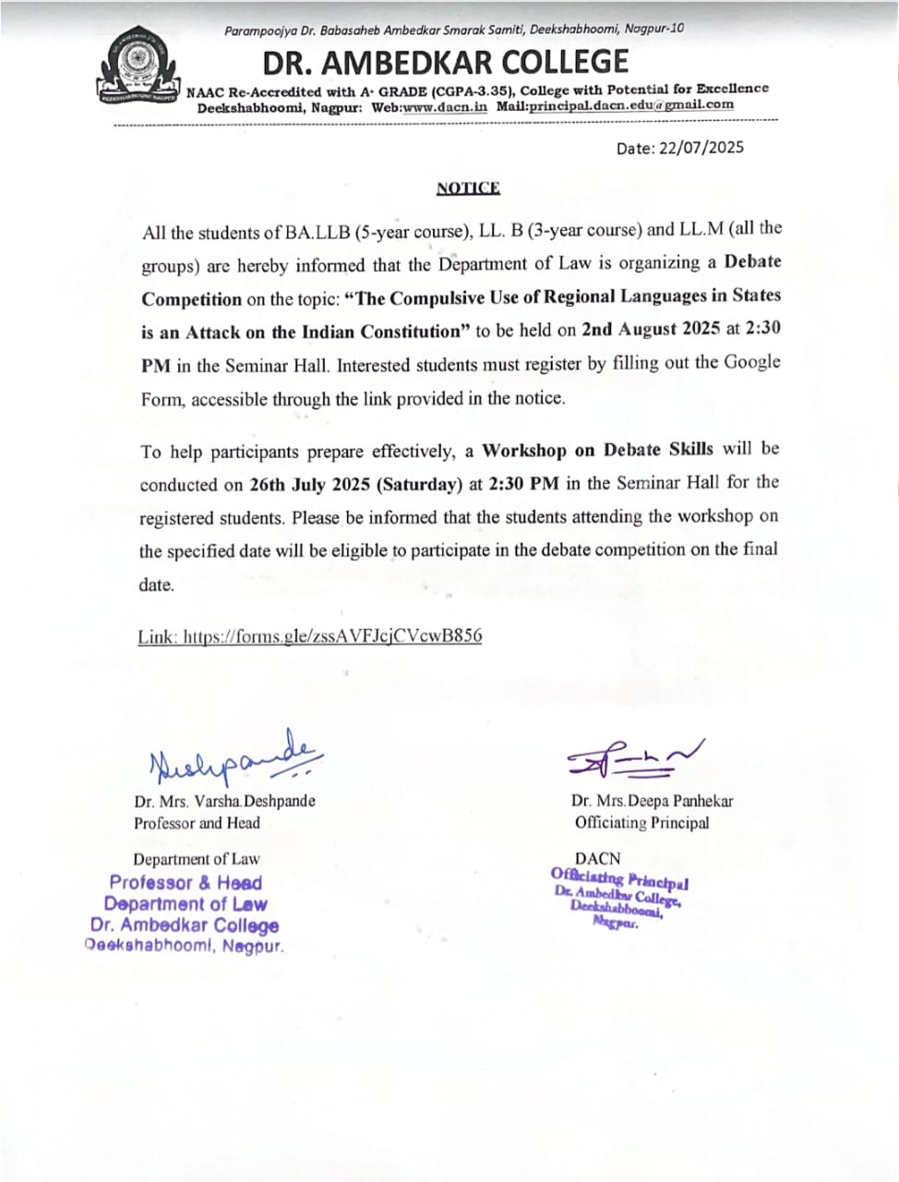

REPORT ON

WORKSHOP ON PUBLIC SPEAKING FOR LEGAL PROFESSIONALS ON DEBATE SKILLS

The Department of Law, of Dr. Ambedkar College Deekshabhoomi, Nagpur, organized an interactive workshop on “Public Speaking for Legal Professionals on debate skills” on 31st July 2025. The program aimed to enhance law students’ communication, debate, and argumentation skills with a focus on body language, counter-arguments, and debate preparation.

Students participated in mock debates, quick rebuttal rounds, and role-play exercises, learning techniques for voice modulation, structuring arguments, and anticipating opposing views. Faculty mentors provided guidance on research, evidence use, and stage confidence. Conducted by Ms. Khushi Bajaj with the help of Ms.Ritu Kaushik.

The workshop strengthened students’ debate skills, training them to present persuasive arguments, handle counterpoints effectively, and think quickly under pressure—abilities crucial for success in moot courts, competitions, and the legal profession.

Attendees of the workshop on public speaking skills.

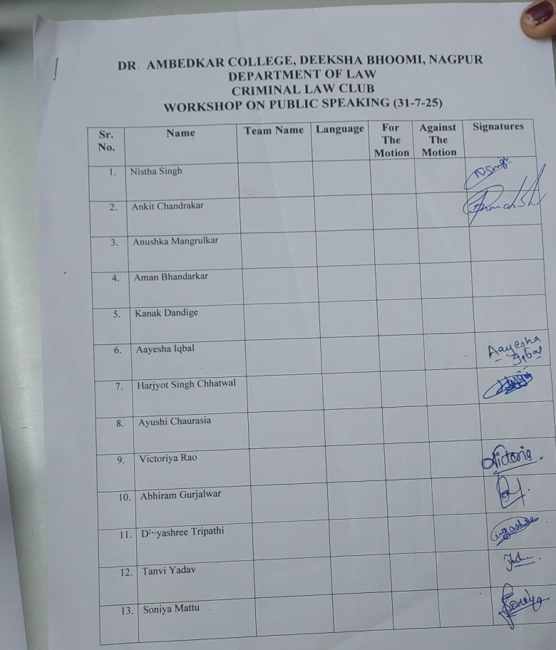
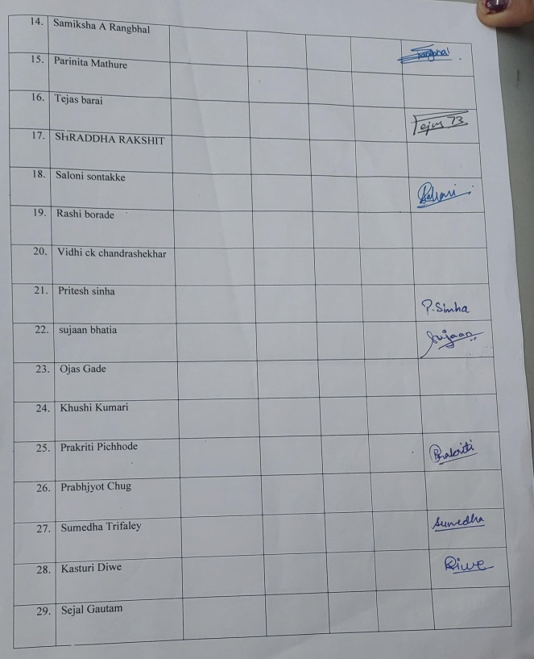

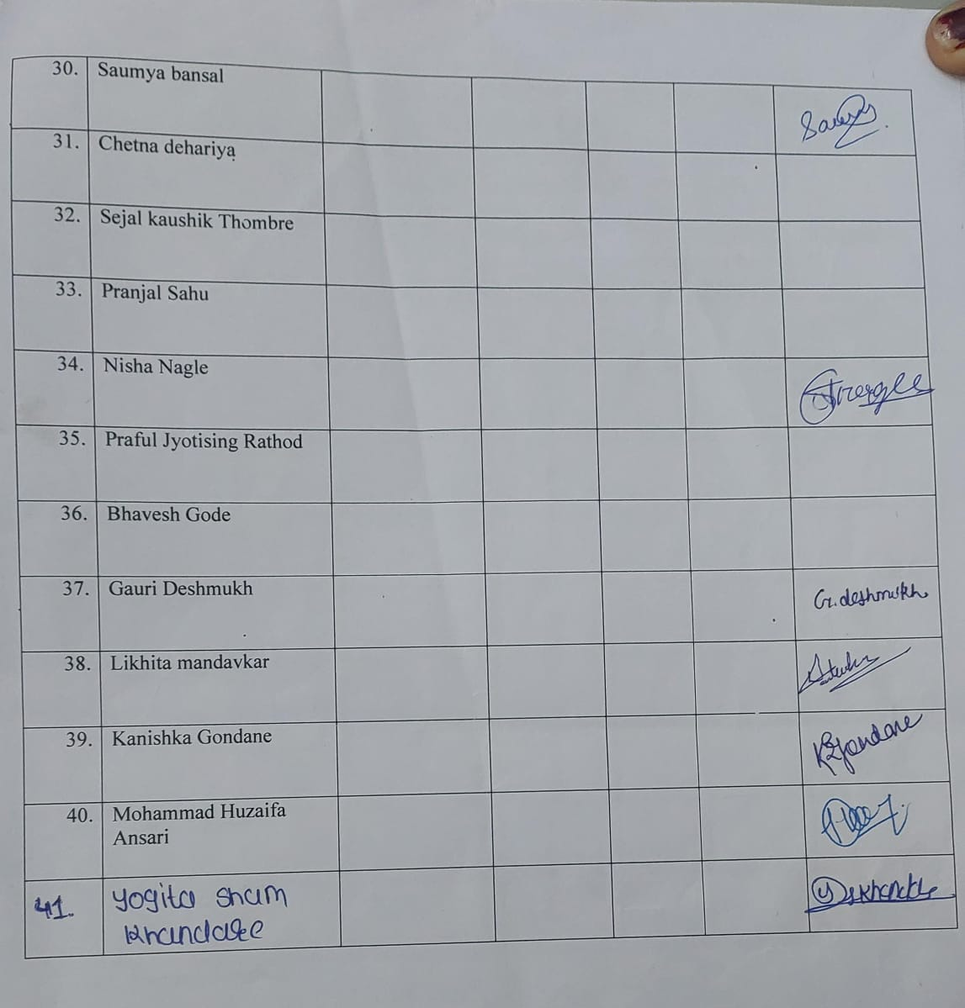

Glimpses of workshop

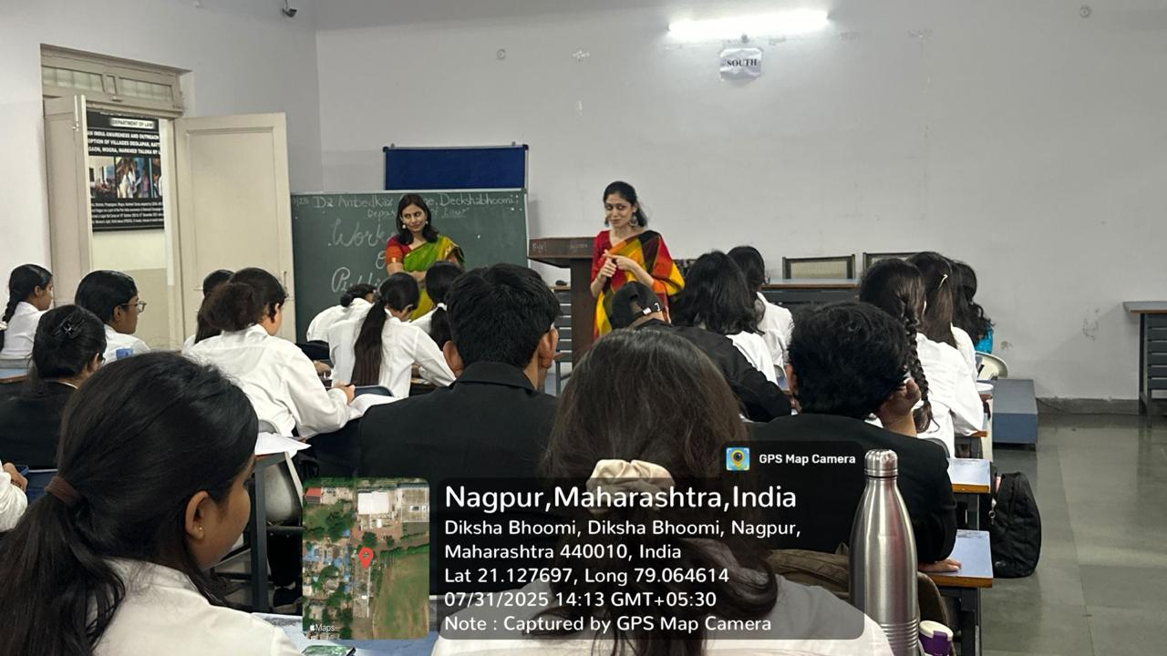
Ms. Khushi Bajaj Ma’am guiding the participants.

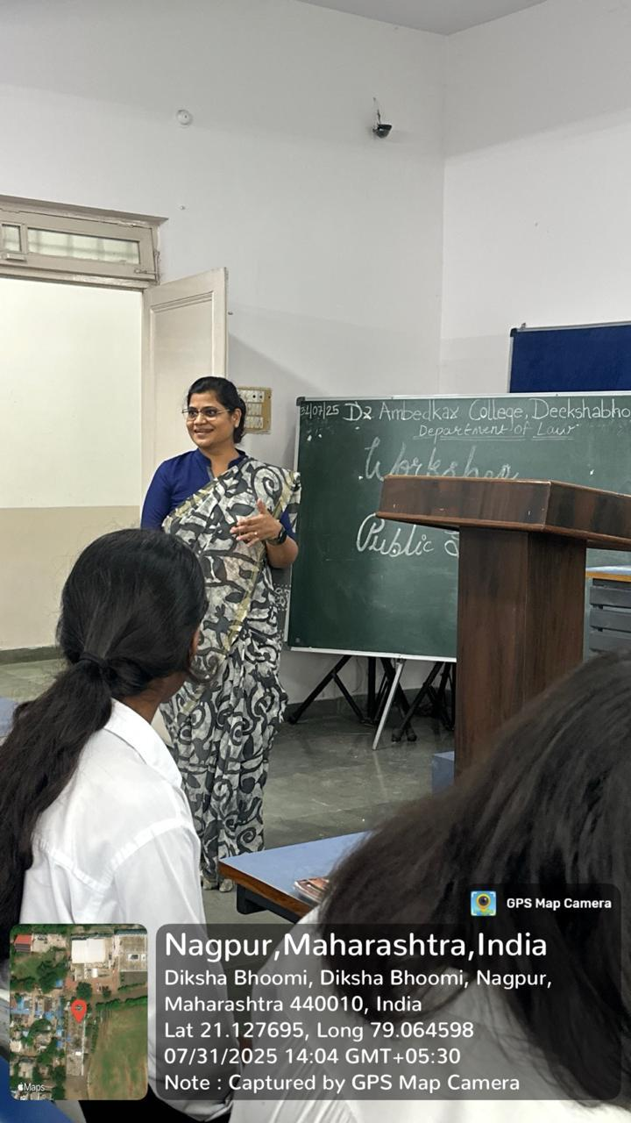
Prof.Dr.Mrs.S.P.Kalamdhad giving introduction to the participants
FEEDBACK
