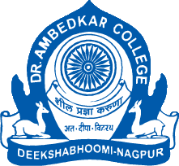 **Dr Ambedkar College Deekshabhoomi, Nagpur**

**Guest Lecture on AI and Its Impact on IT Jobs Held at Dr. Ambedkar College, Nagpur**

**Nagpur, August 22, 2025**

**Name of Program: Guest Lecture on AI and Its Impact on IT Jobs**

**Guest Speaker: Mr Shekhar Patankar, Vice-President, Persistent Systems, Nagpur**

**Date and Time of Program : 22/08/2025 at 11.00AM**

**No. of Students Present : 250**

**No. of Teachers Present : 10**

**Hosted by : The IQAC Cell of Dr. Ambedkar College, in collaboration with the Indian Women Scientists’ Association (IWSA), Nagpur Chapter**

**Organized by : Dr Aarti Wazalwar**

**NOTICE**

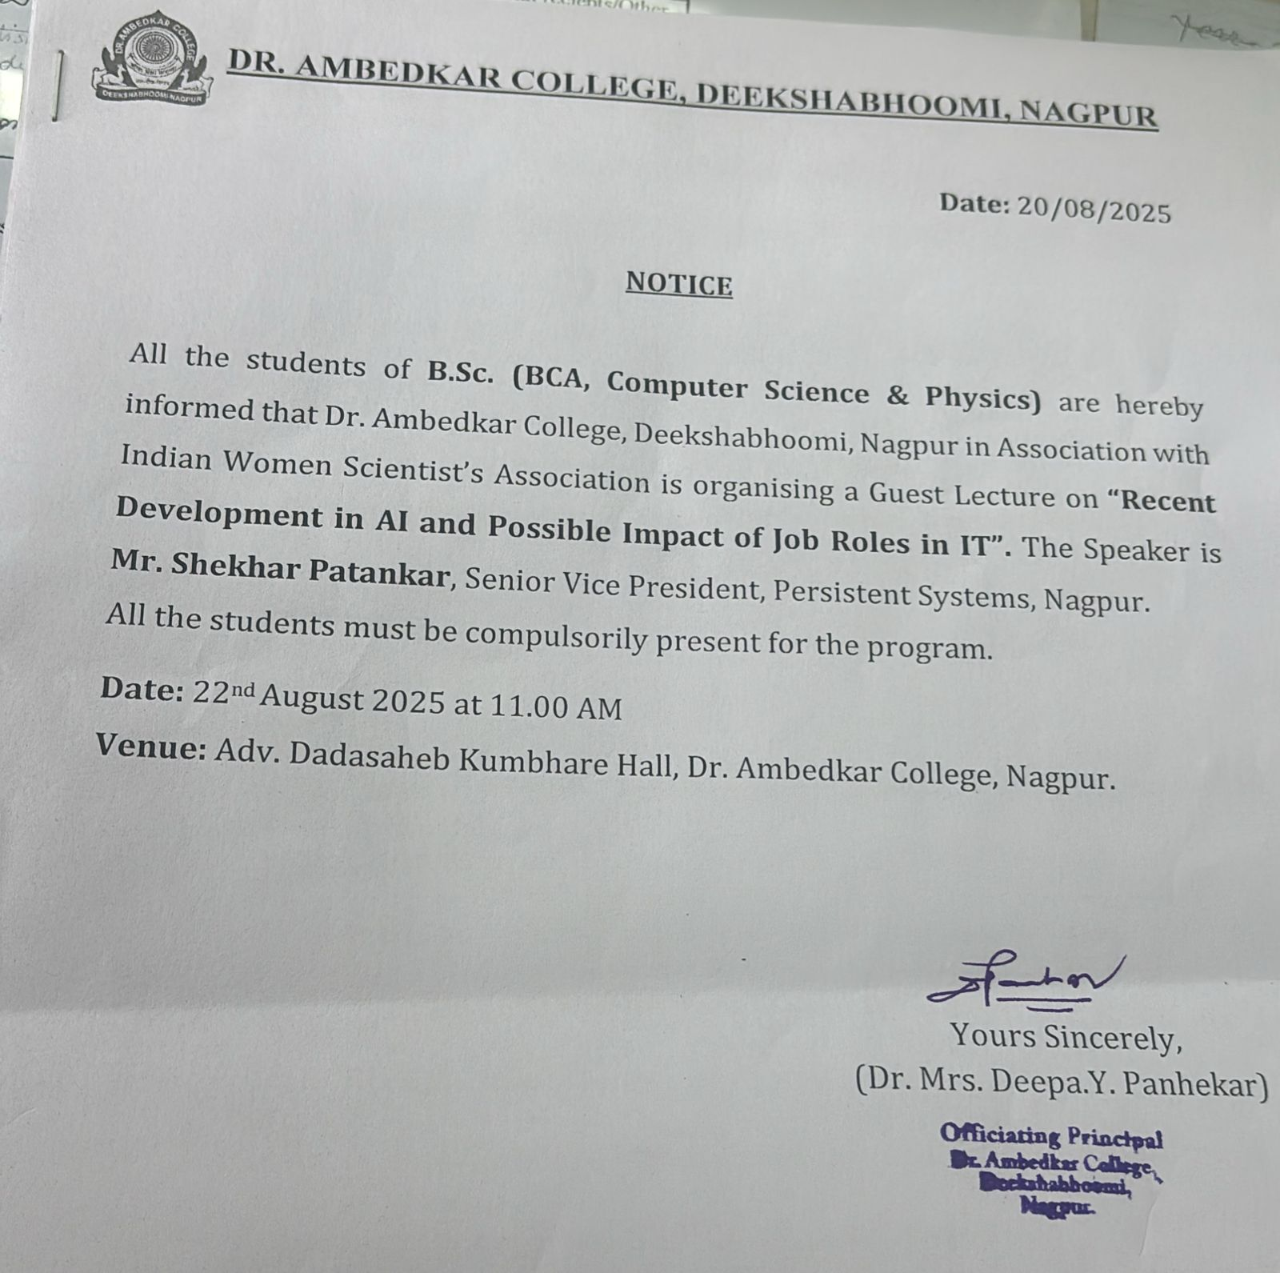

The IQAC Cell of Dr. Ambedkar College, Deekshabhoomi, Nagpur, in collaboration with the Indian Women Scientists’ Association (IWSA), Nagpur Chapter, organized a highly engaging guest lecture on *“****Recent Developments in AI and Possible Impact on Job Roles in IT****”* on Friday at 11:00 AM in the college auditorium.

The speaker, **Mr. Shekhar Patankar**, Vice-President, Persistent Systems, Nagpur addressed a packed auditorium comprising students, faculty, and professionals. The session aimed to provide insights into the latest advancements in AI and how they are reshaping the IT job landscape.

Mr. Patankar highlighted cutting-edge developments in areas like machine learning, generative AI, automation, and data science. He discussed how these innovations are leading to a transformation in IT roles—reducing demand for some traditional functions while creating new opportunities in AI ethics, data annotation, model tuning, and human-AI collaboration.

"The future belongs to those who can adapt quickly, learn continuously, and integrate creativity with technology," Mr. Patankar said during his talk. He emphasized how AI affects daily life and the responsibility and opportunity to use AI for future development.

He mentioned of entry-level IT job roles, including the need to conceptualize, design, code, build, monitor, test, operate, maintain, and upgrade. Python and Java were highlighted as important scripting and object-oriented languages for building code.

He summarized by saying that IT jobs are going to change significantly so mastery in ones skills is more important.

The event concluded with an interactive Q&A session where participants engaged in lively discussions on AI's real-world applications and career prospects in the age of automation.

The program was well-received and marked another successful initiative by the IQAC Cell and IWSA Nagpur Chapter towards fostering innovation and awareness among young minds.

Principal of the college, Dr Deepa Panhekar motivated the students in her welcome address.

The program was well coordinated by Dr Aarti Wazalwar and conducted by Dr Namrata Pradnyakar. Vote of thanks was proposed by Dr Prachi Lakhe.

Dr Anuradha Gadkari, Dr Seema Somalwar and Dr Pradnya Bhalerao were prominently present for the program.

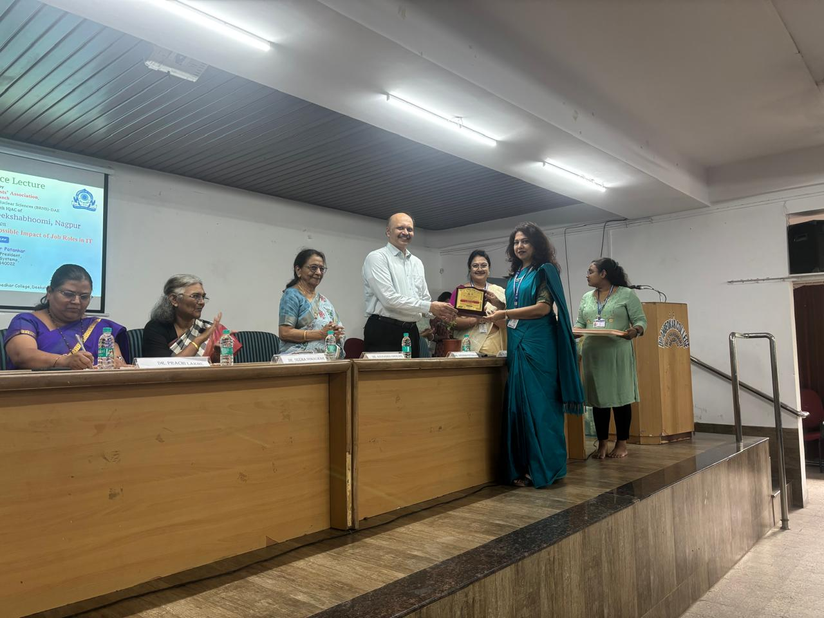

Mr Shekhar Patankar, Dr Deepa Panhekar, Dr Anupama Gadkari, Dr Seema Somalwar, Dr Prachi Lakhe and Dr Aarti Wazalwar

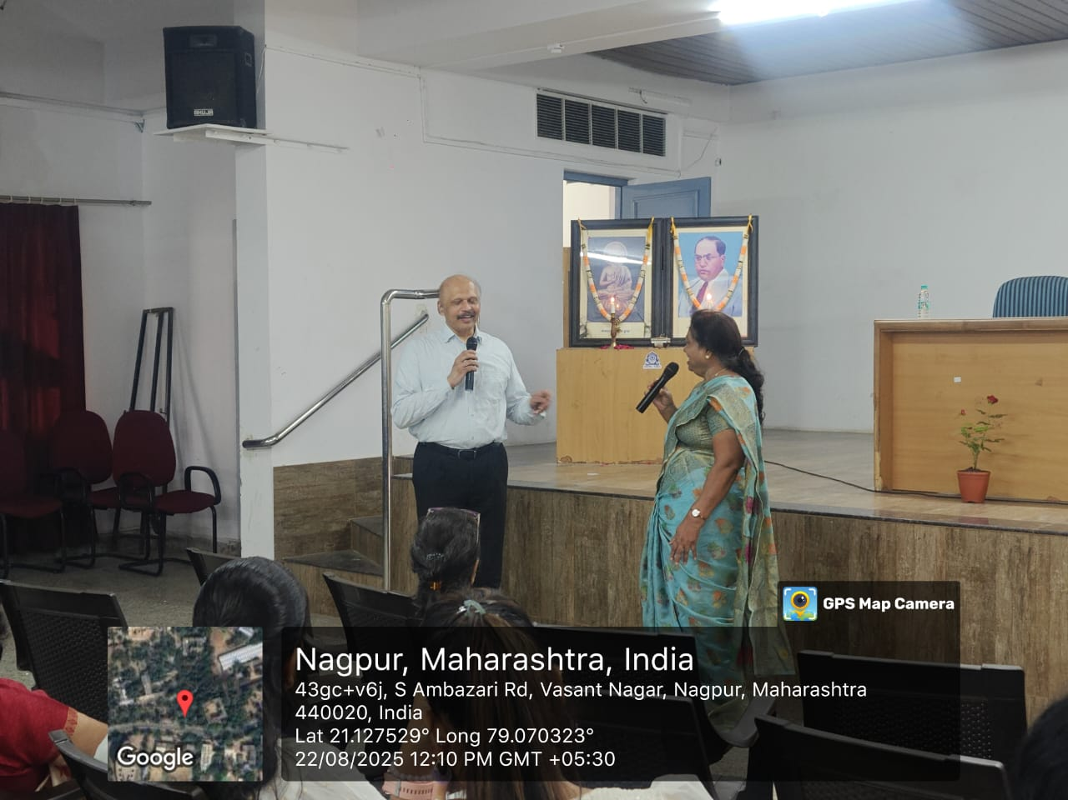

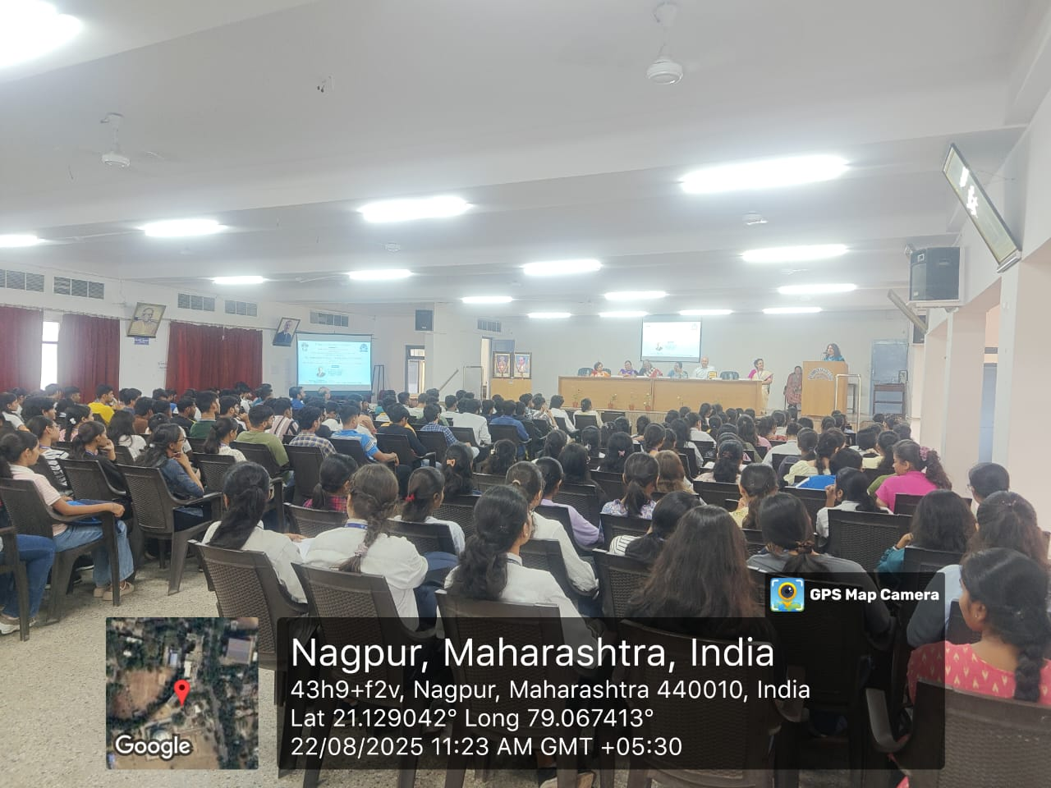

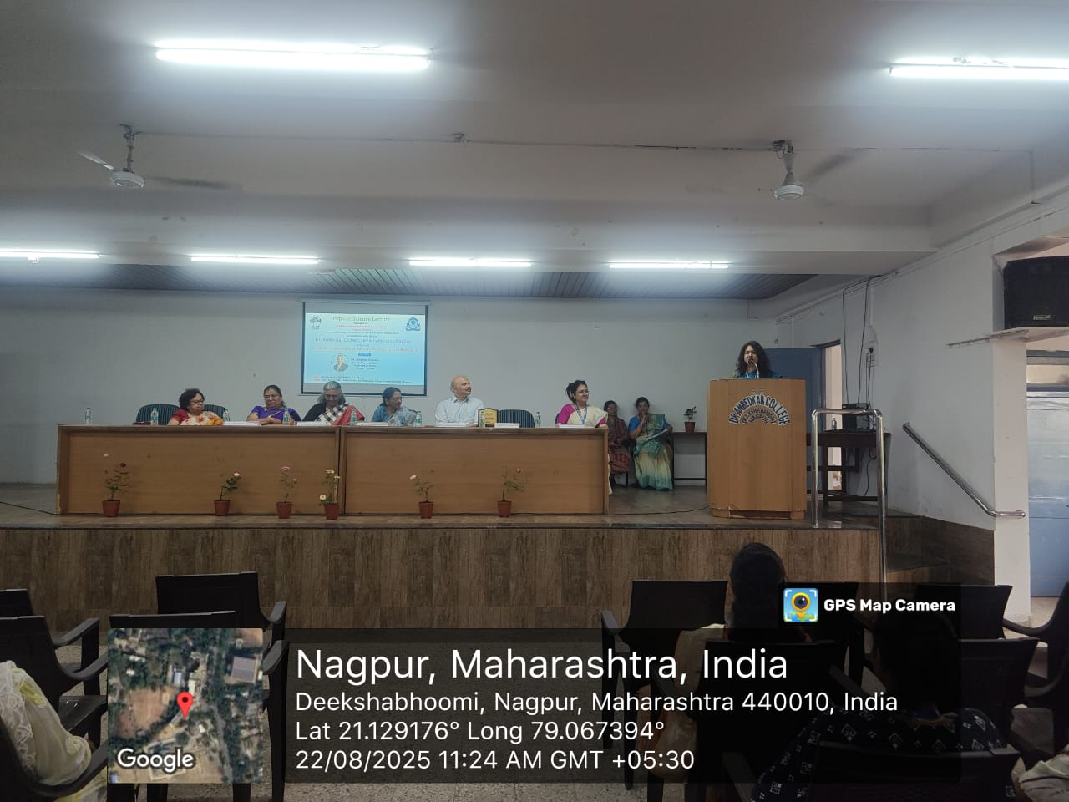

FEEDBACK

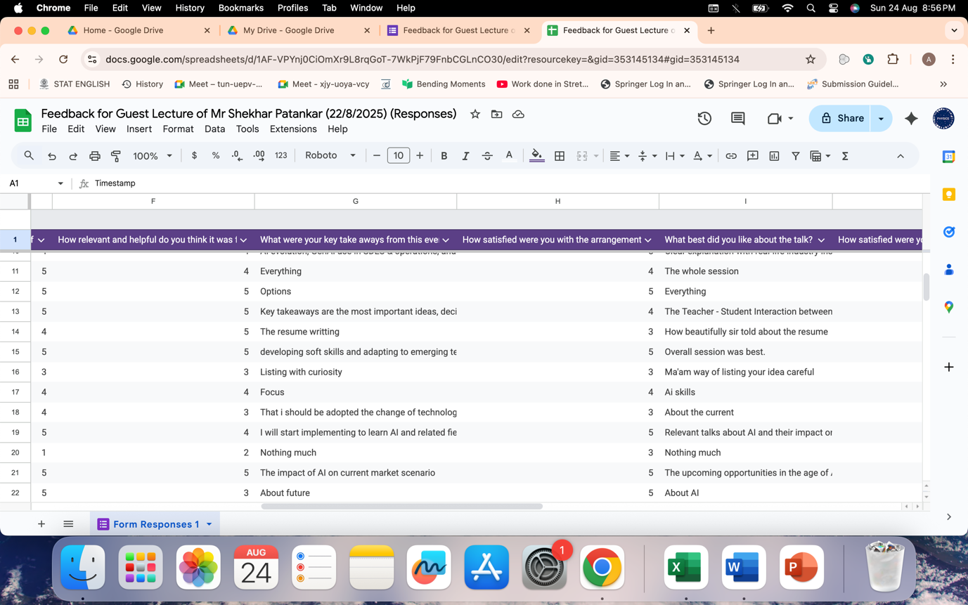

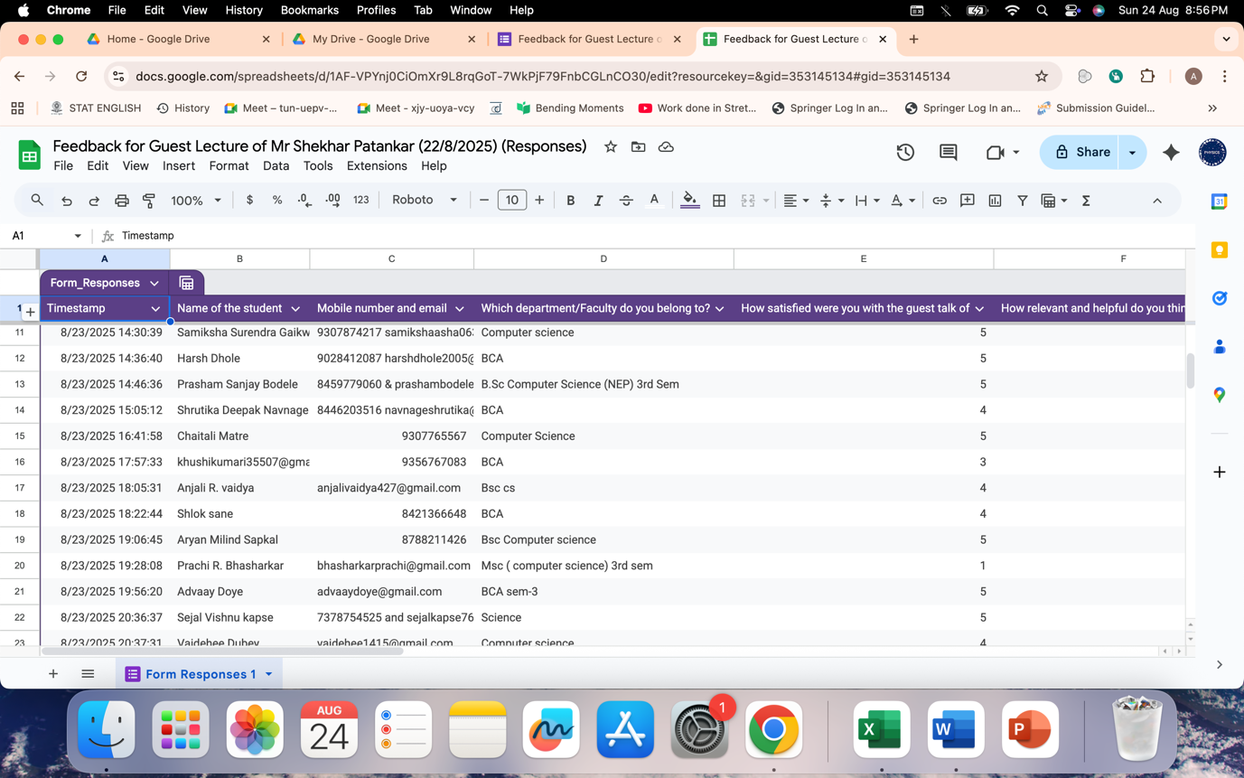

**Attendance**



