**Dr. Ambedkar College Deekshabhoomi, Nagpur**

**Department of Chemistry**

**Session: 2024-25**

**Report of Educational Visit to JNARDDC, Nagpur, Date: 17/4/2025**

**B.Sc. students of Chemistry Department** have planned Educational Visit to Jawaharlal Nehru Aluminium Research Design development Centre, Nagpur on dated 17/4/2025.

Director of the JNRDDC, Nagpur Dr. Anupam Agnihotri has permitted to our students. He has also explained about research activities of the institution & guided to our students. Dr. Upendra Sing Head of Analytical wing, has given guidance to our students. Mr. P. K . Meshram Personal officer& Coordinator (Training & Internship) welcome us and visited with students to various departments of the JNARDDC, Nagpur. **Dr. V. M. Shivankar** Professor Chemistry Department was **Coordinator and in charge** of this educational visit. **Dr. Mrs. D.M. Borikar** Professor Chemistry Department was **Coordinator** of this visit was present with students.

**First we have visited to XRF division**, Mrs. Priyanka Naiyyar, scientist explain about Fluorecence spectroscopy. sisty four samples can be analyzed at a time by XRF. Press pallet making machine is used in XRF., used basic powder which is easily available as a base and 24 tones pressure is applied planner surface is used for this. Mg ore binder is used. Mostly Bauxite sample is analyzed. In this Polyvinyl acetate is used as solvent. Whole process is carried out in vacuumed.

**Second visit given to Weight Chemical Lab**: Ms Sreedevi and Mrs. Janbandhu madam and Mr.A.S.gijare has explain to our students. Minerals analyzed is done in this lab by Spectrophotometer and Flame Photometer. Ca, Li, Na was determined by Flame Photometer. Samples evaporated by thermal energy. Energy absorb and then release. Energy is then directly proportional to the concentration of sample. Alumina & Bauxite is determined by Spectrophotometer. In this laboratory Lab in charge Mrs. Janbandhu explain function of Fume Wood & Muffle furnace. Solid form of sample is converted inti liquid form. First sample is treated with Con. HNO3, HCl with 1 gm sample with1:1 HCl to get transparent liquid and gel Silica. and the HF treatment is carried out. Weight sample is directly proportional to SI concentration. Back titration & Redox titration method is also used in this process.

**Third visit was given to ICP-MS & ICP-OES lab**. High voltage is induced in this method. Mass spectroscopy is used and sample is introduced in this ICP-MS instrument. First the solution is prepare and then it is injected into system, it is evaporated by nebulizer in high voltage. Atoms get ionized, ionized particles analyzed the mass of the elements. Elements get activated emission some radiation. Unit is used PPM or PPB level PPM is used for ICP-OES and PPBS is used for ICP-MS instrument.

**Fourth and last visit was given to Coal** Lab: Ms. Nawshin madam has explained very well to our students. In this laboratory Moisture content, Ash, Volatile matter and Fixed carbon were determine. Thermonuclear analyzer was used to determine the moisture in the sample. In Ash determination more the ash less the coal present in the sample. In volatile matter aliphatic compound heated to 9 degrees in presence of O2, burn for four hours. Fixed carbon determination is used for grading of different coal samples. Instrument Parn Calorimeter is used for heat calculation of Coal.

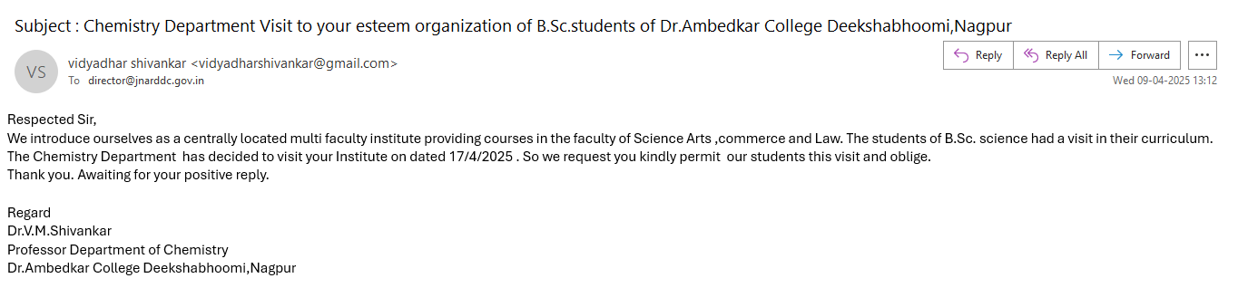

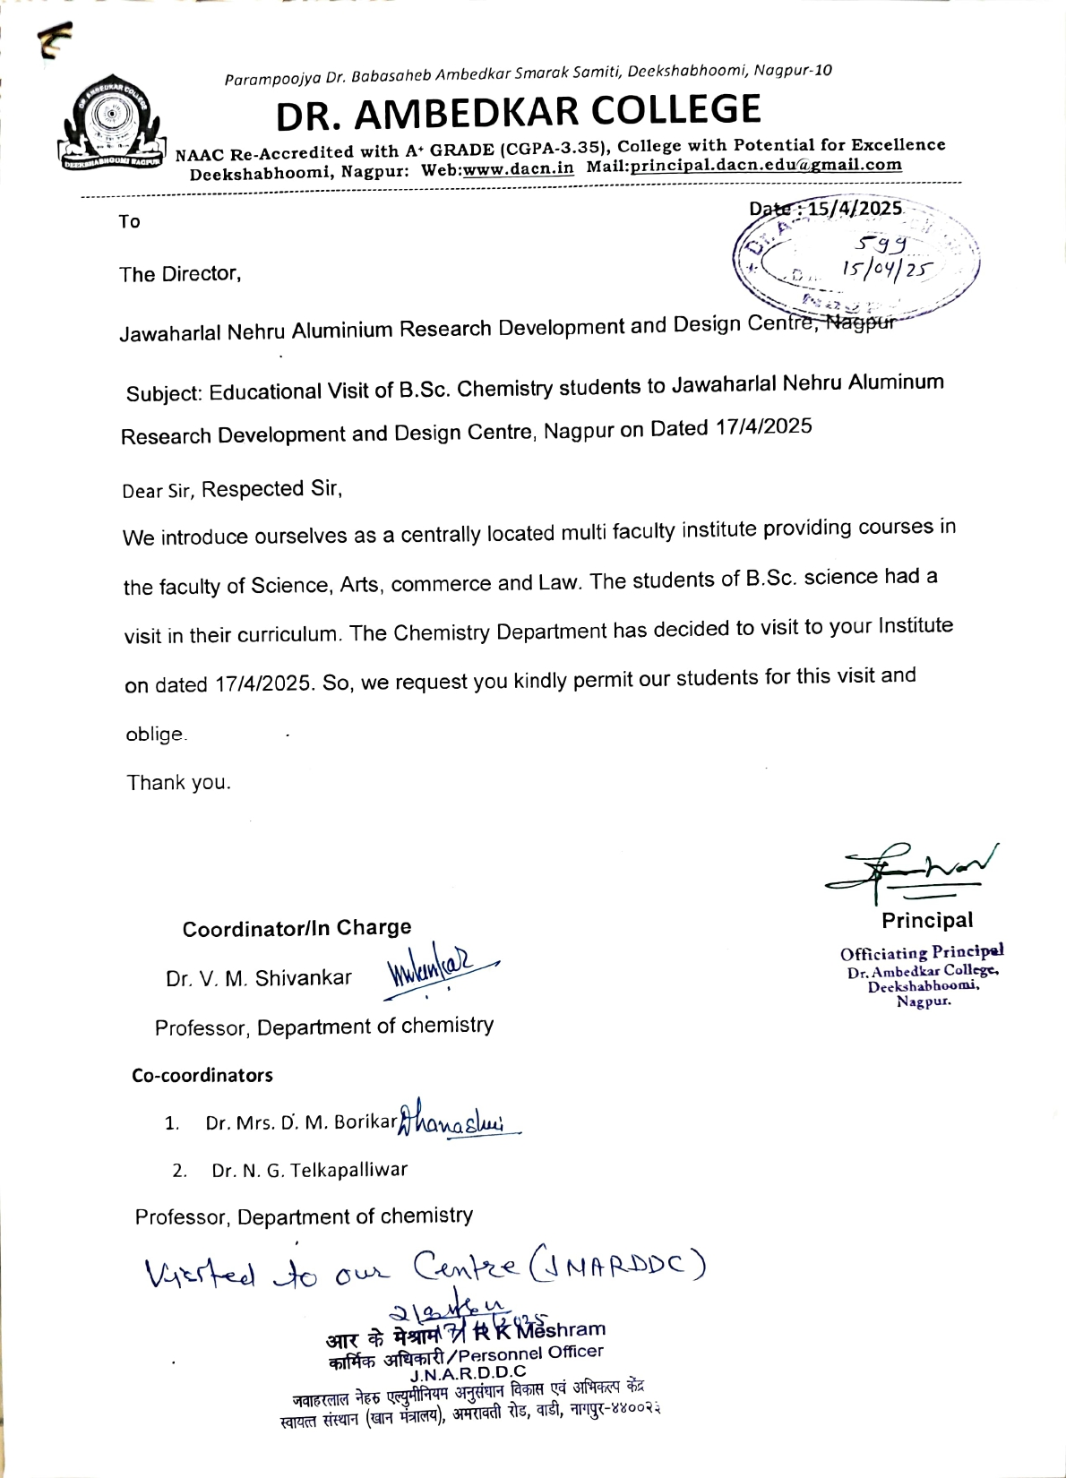

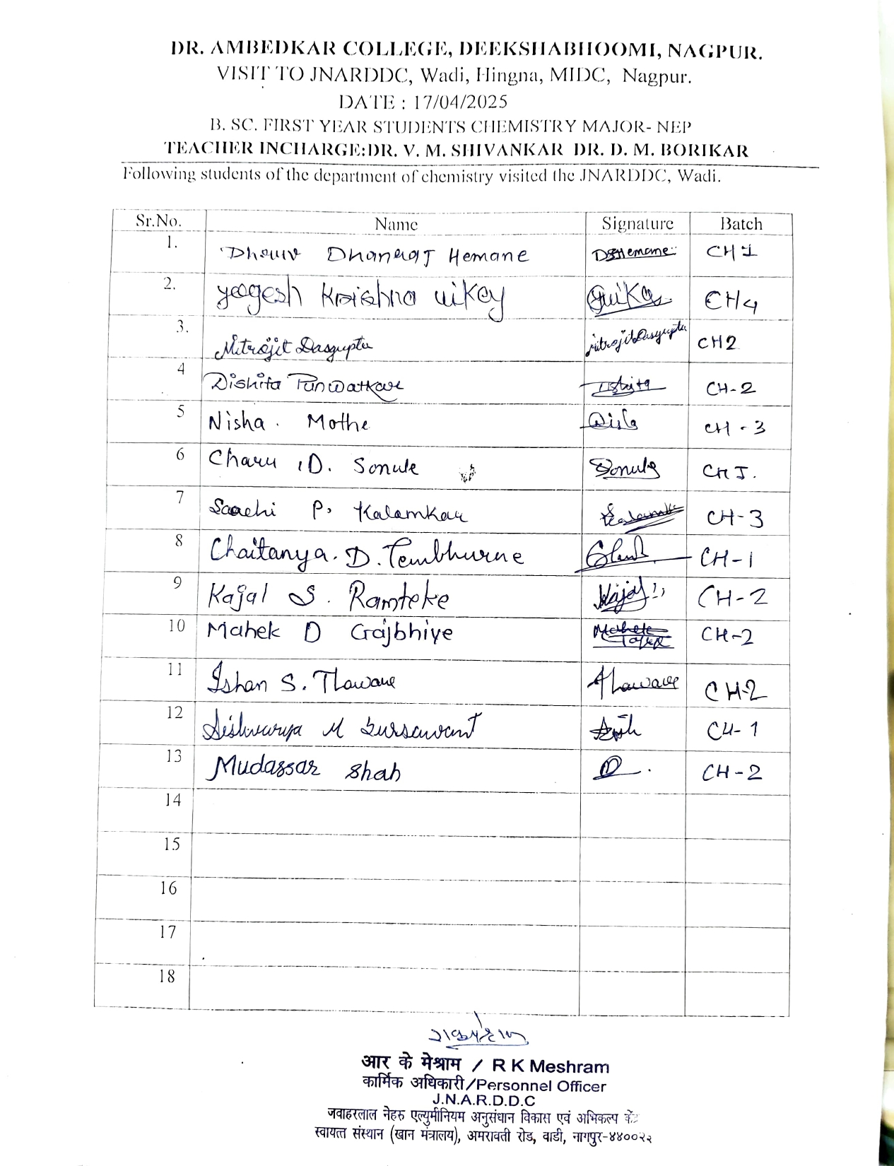

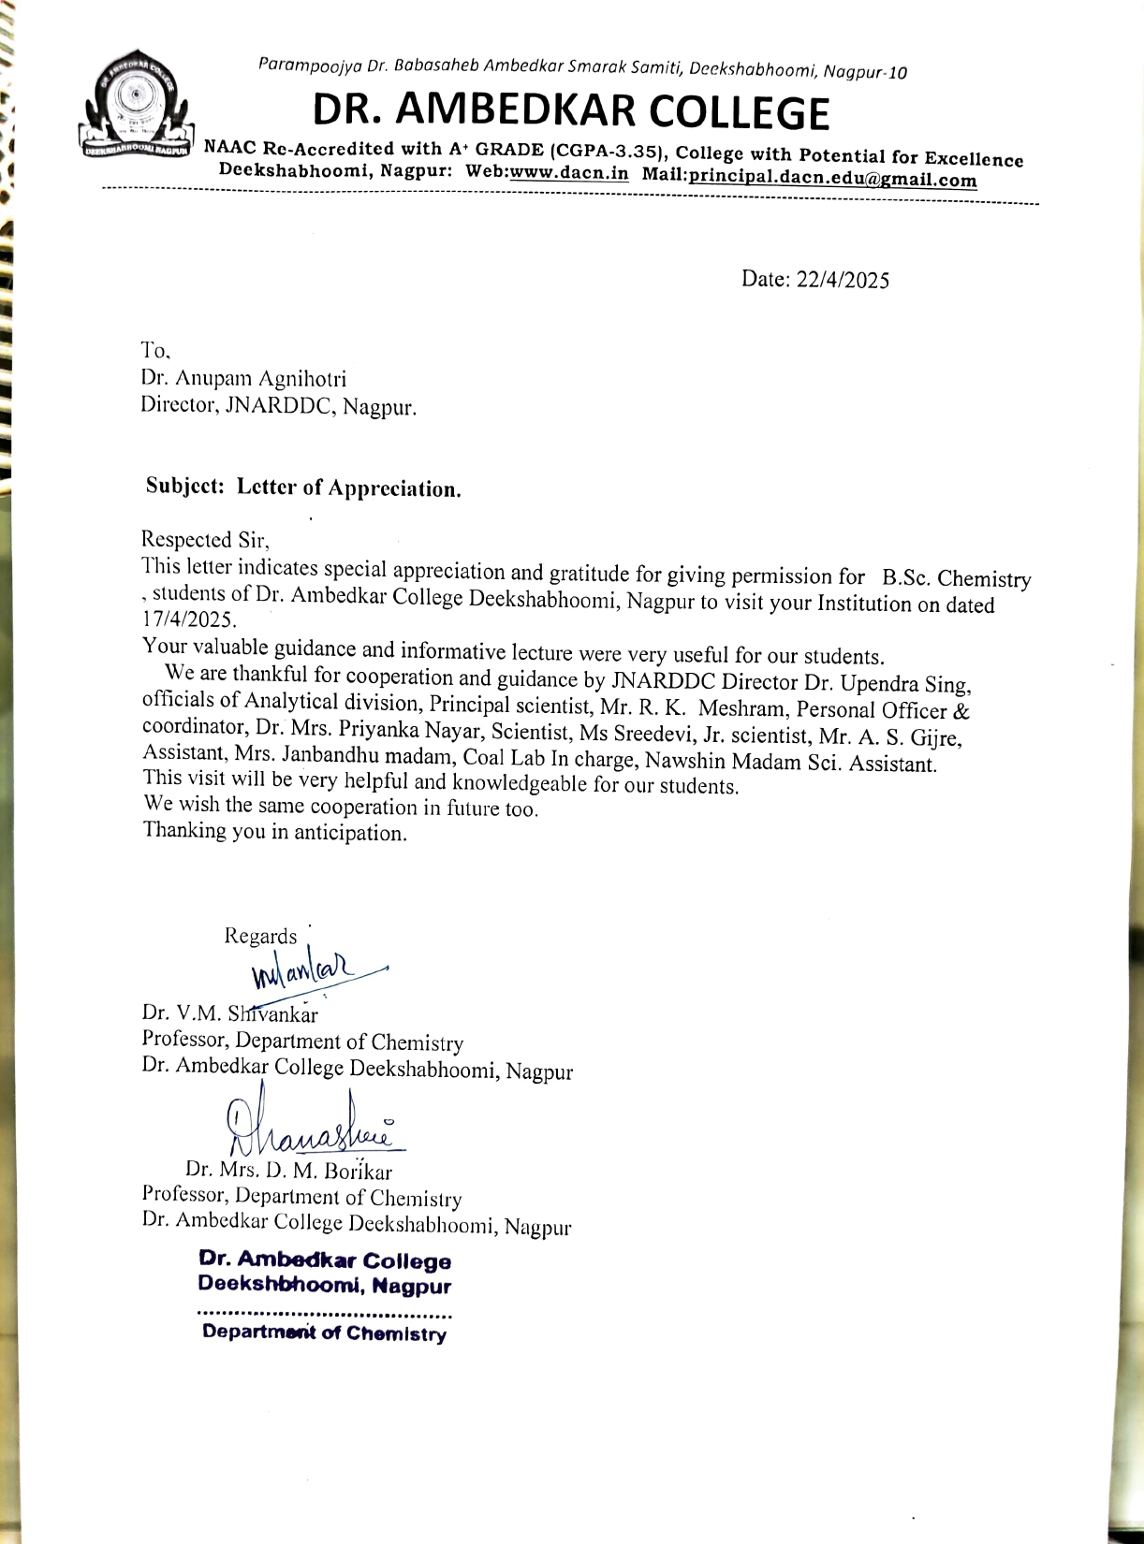

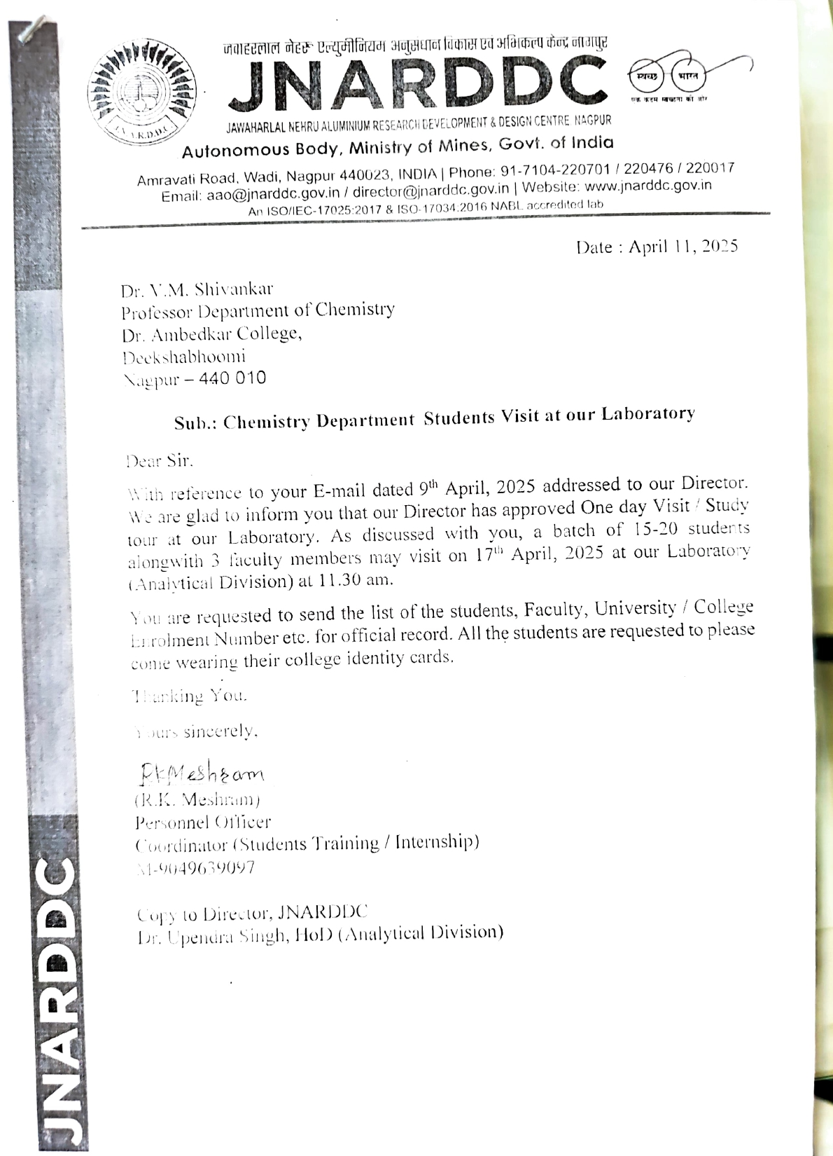

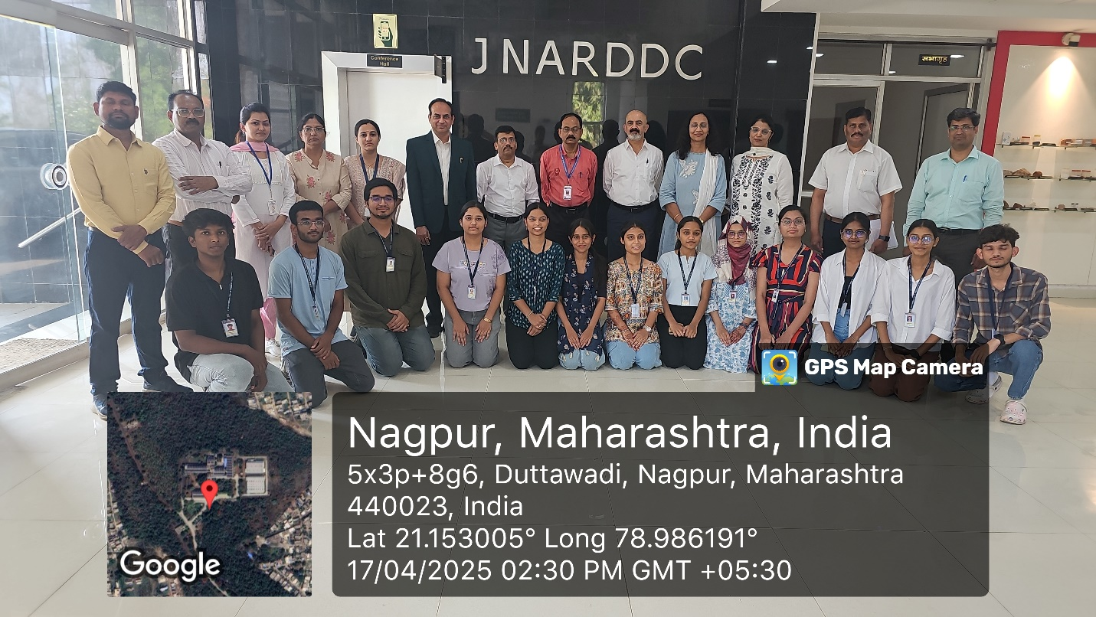

Photos of Educational Visit to JNARDDC, Nagpur

