

**Name of the Activity:** 2 Days’ Workshop on Artificial Intelligence - Unleashing New Era In Criminal Justice System

**Duration:** 31st August, 2024 – 1st September, 2024

**Name of the Co-ordinator: Prof. Dr. Sandhya Kalamdhad**

**Name of the Co-coordinator:** Ms. Shazia Bari, Assistant Professor

**Name of the Resource Persons:** i) Mr. Shreyas Muthye, Digital Forensics Professional (Technical session I)

ii) Mr. Syed Ahmed, In- House Legal Manager, Mumbai (Technical Session II)

**NOTICE:**

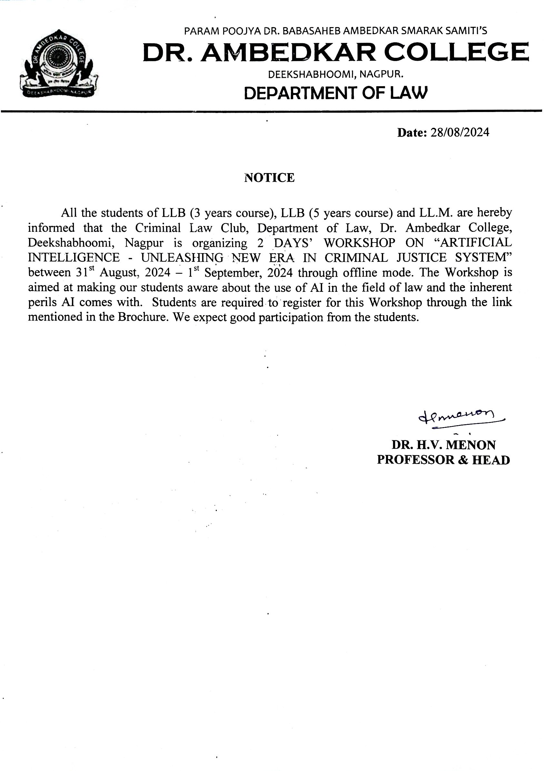

**Report:**

Dr. Ambedkar College, Department Of Law, Deekshabhoomi, Nagpur, through its Criminal Law Club had Organized “2 Days’ Workshop On Artificial Intelligence - Unleashing New Era In Criminal Justice System” between 31st August, 2024 – 1st September, 2024. The Workshop was aimed at creating basic understanding amongst our LL.B. and LL.M. students about the use of Artificial Intelligence in the field of Law and at the same time making our law students aware about the inherent perils with which AI comes. The Welcome address for the program was delivered by Prof. Dr. Sandhya Kalamdhad, Co-ordinator, Criminal Law Club. Mr. Shreyas Muthye, Digital Forensics Professional was the Resource person for Technical Session I. He spoke on the topic “Interface between AI and Criminal Justice System in India” in which he discussed about various AI tools, Cyber crimes and how AI can be used in crime investigation.

Mr. Syed Ahmed, In- House Legal Manager, Mumbai was the Resource Person for Technical Session II. He spoke on the topic “AI and Criminal Liability In India -Issues And Challenges”. He discussed about the concept of Criminal liability and the challenges present in the legal system due to AI. Both the Sessions were followed by Question- Answer Session. The Workshop was attended approximately by 60 participants. Final exam was conducted for assessing the students and result was declared. Certificates were presented to those students who successfully completed the Workshop.

**PHOTOS:**

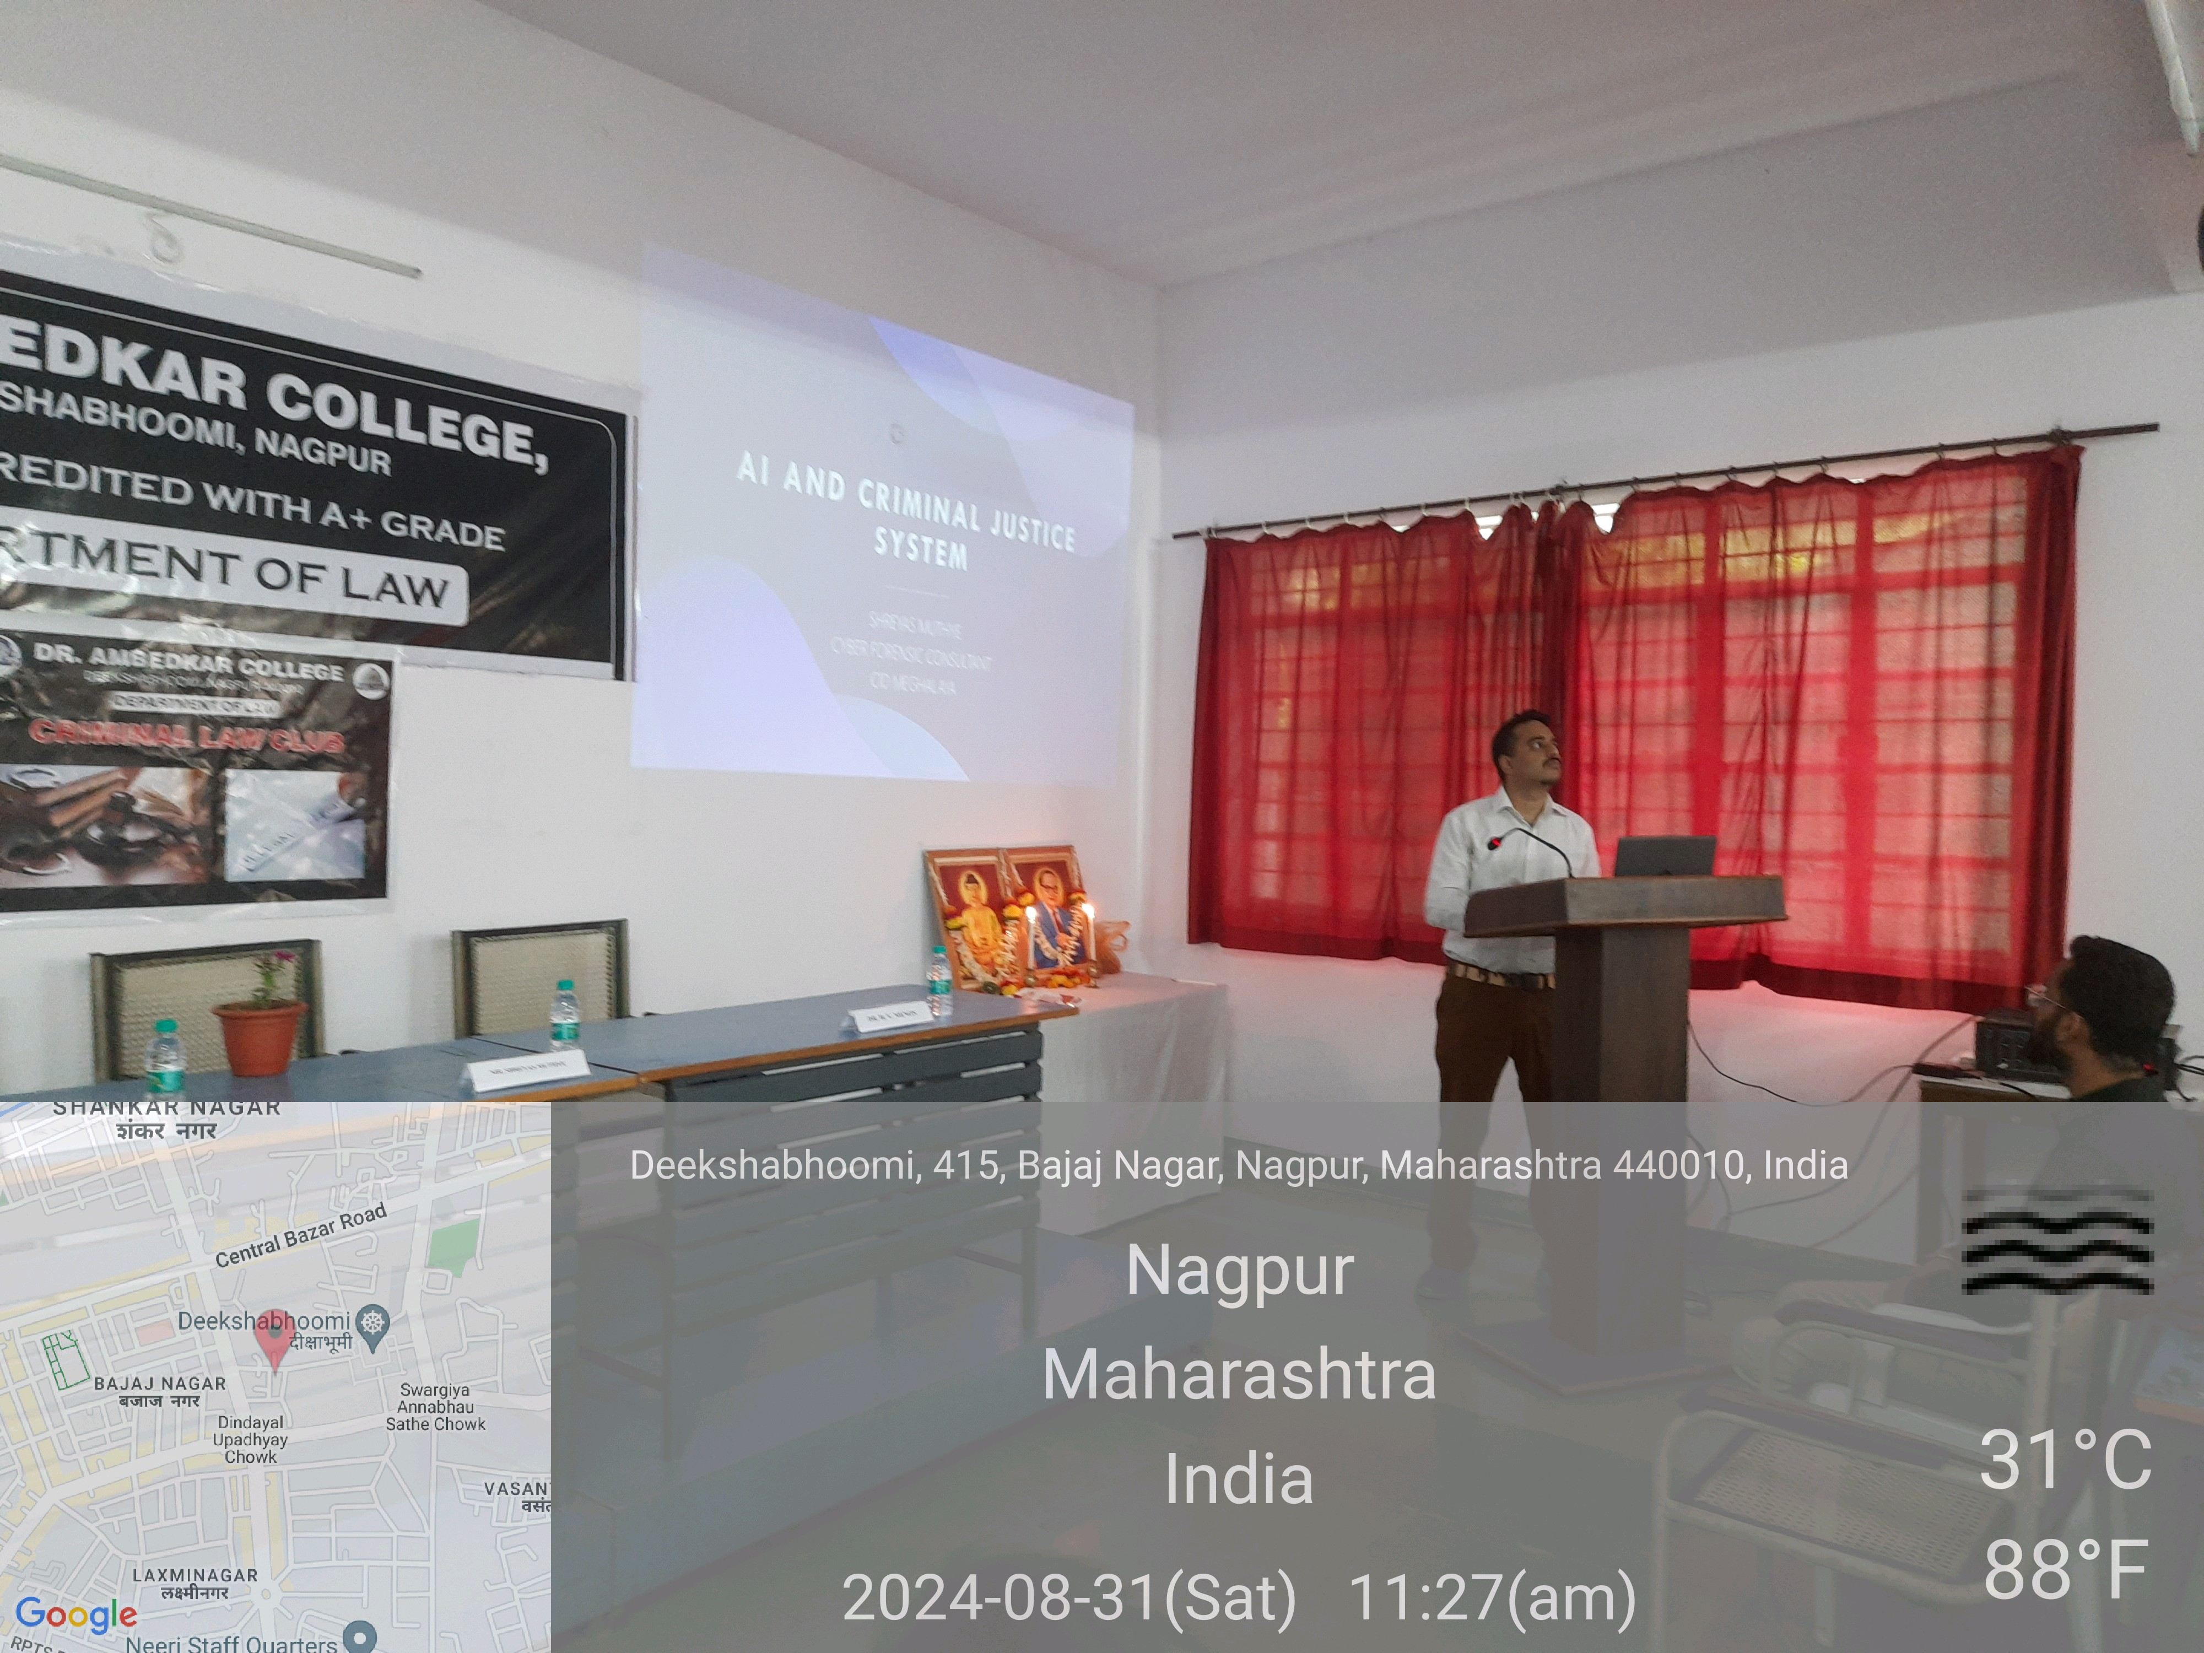

**TECHNICAL SESSION I**

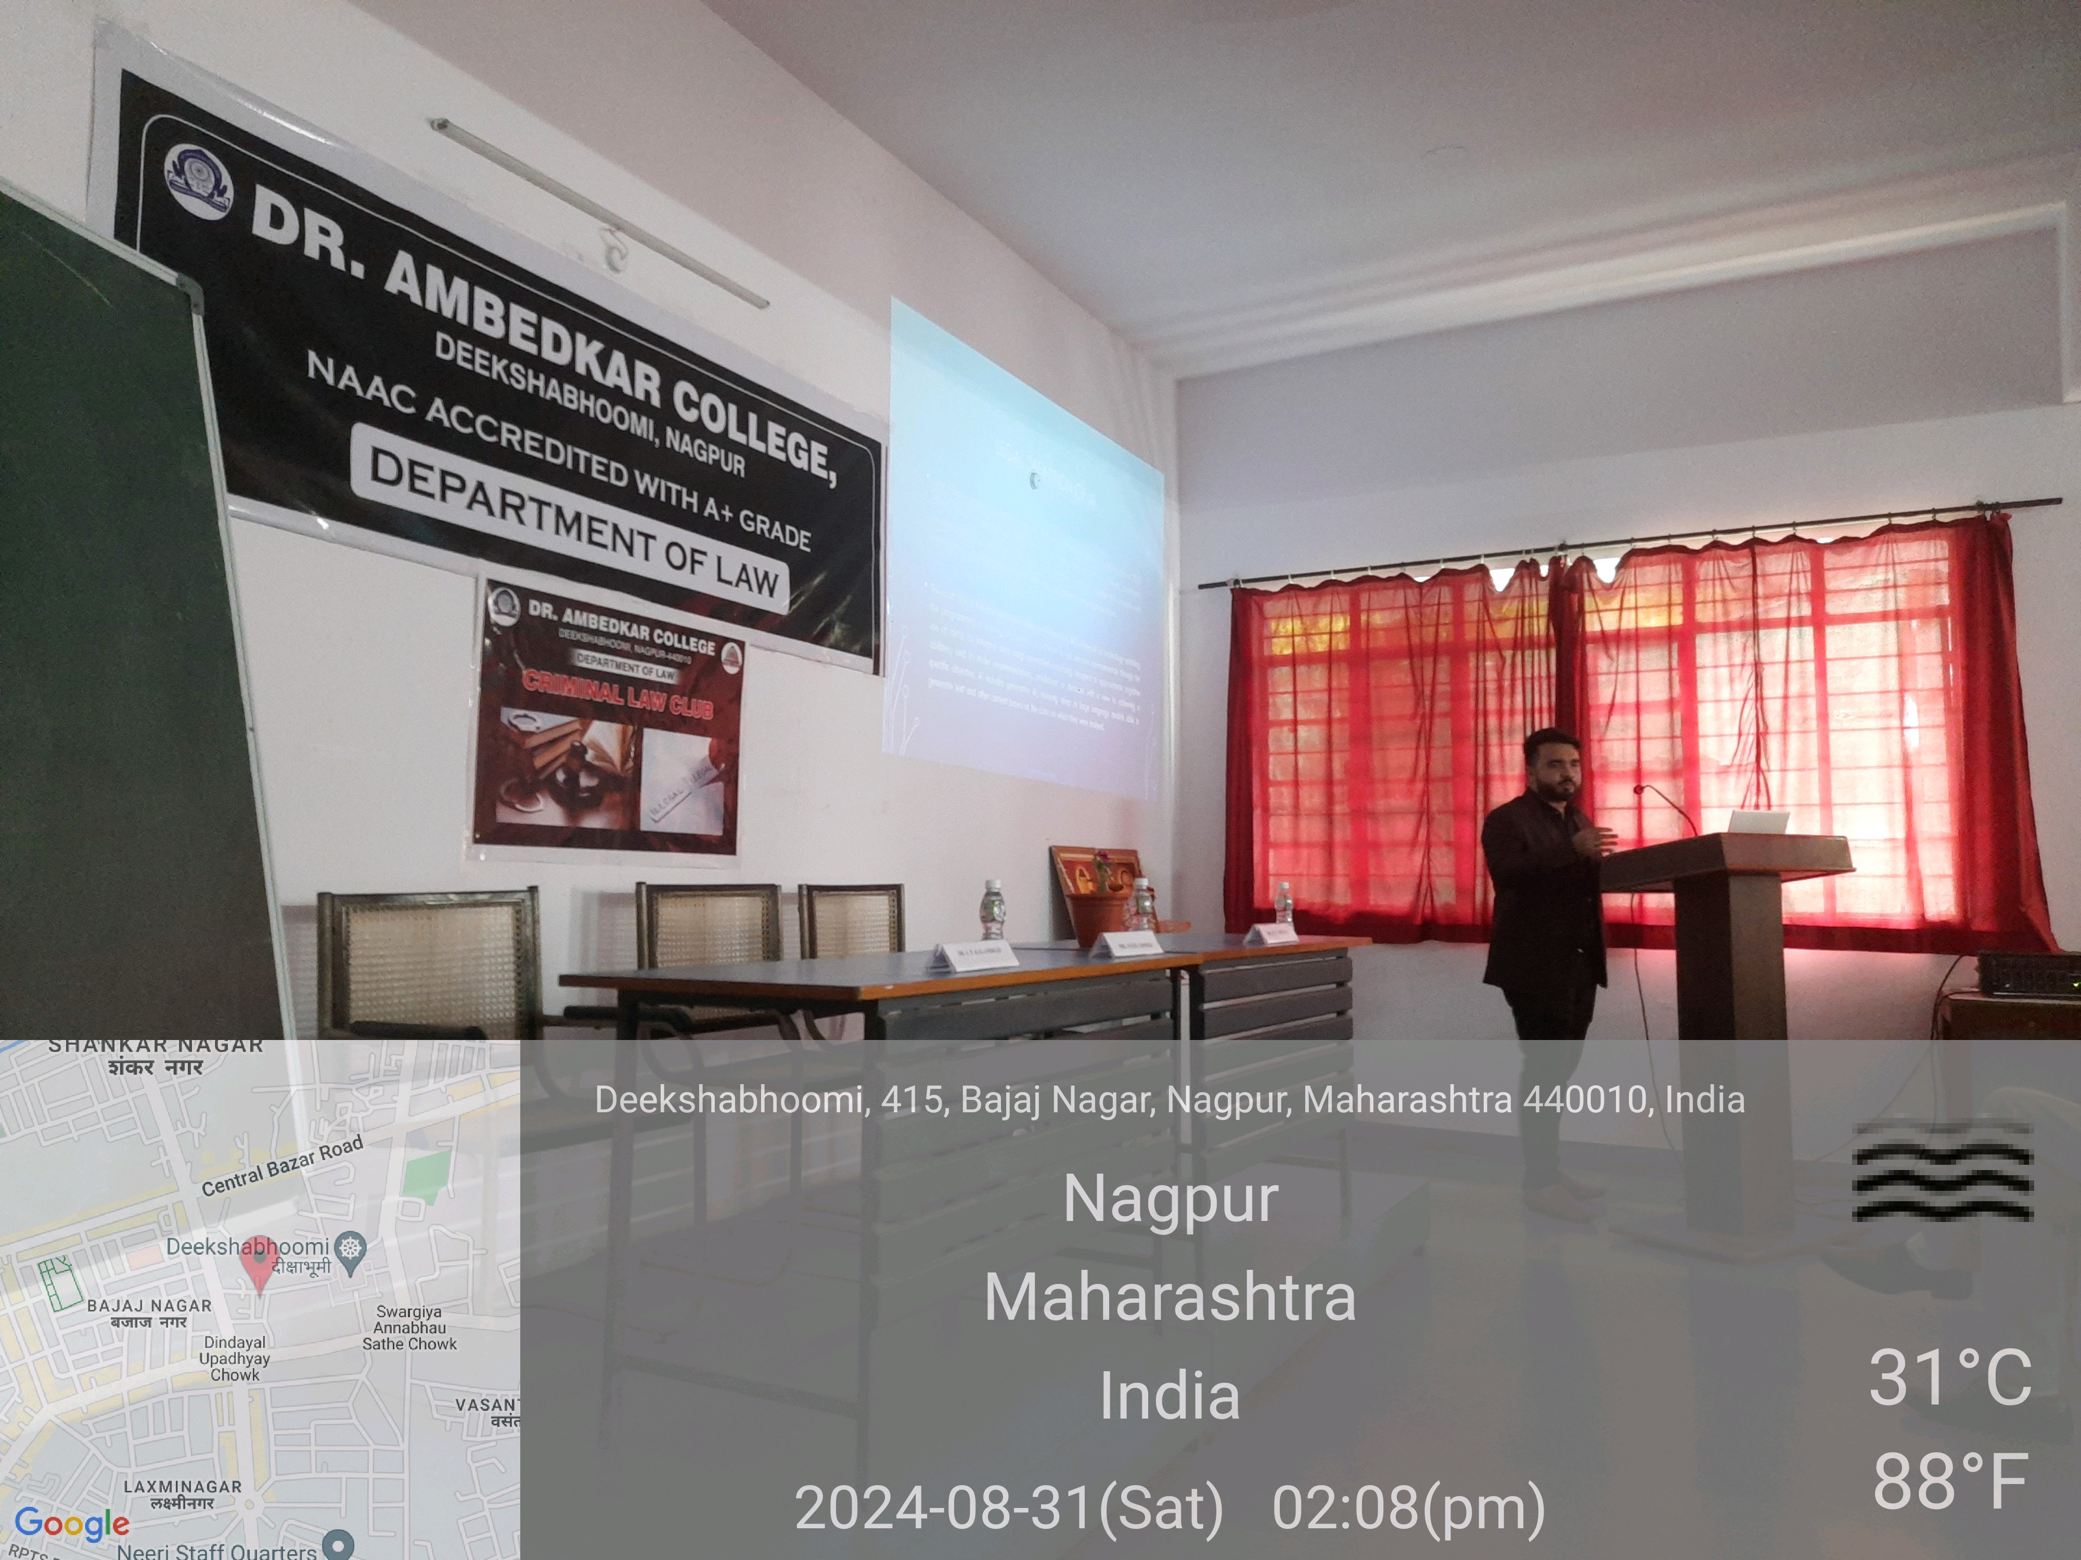

**TECHNICAL SESSION II**

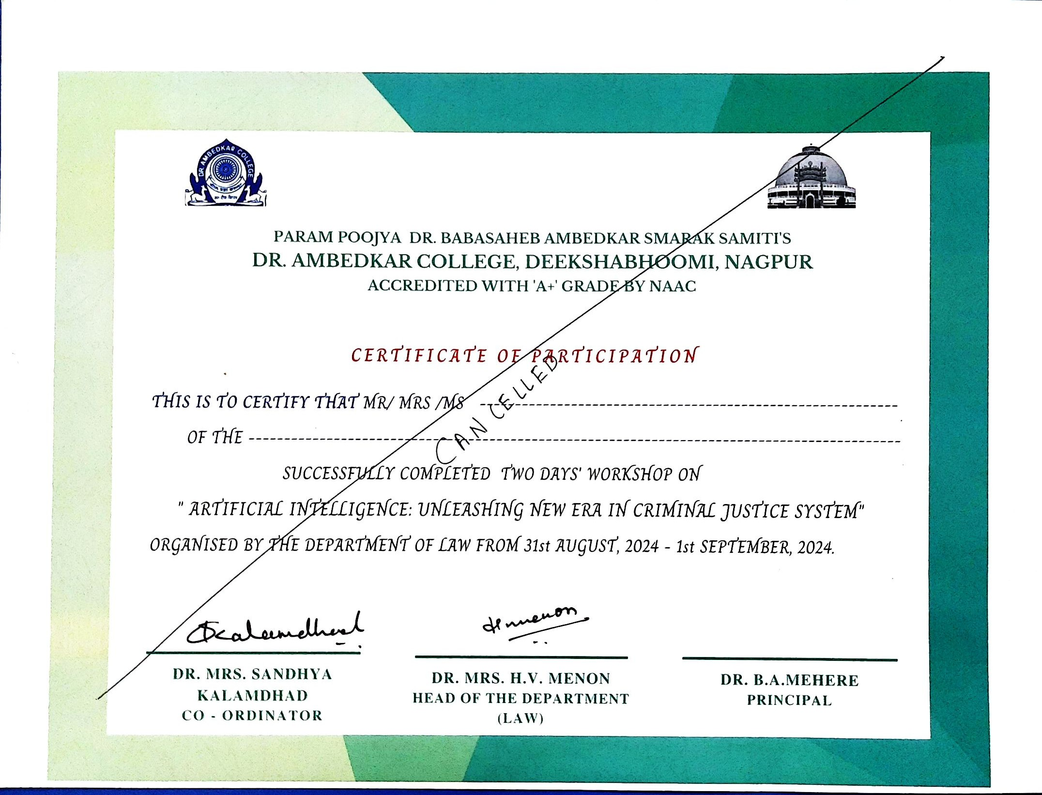

**SAMPLE CERTIFICATE**

**FEEDBACK FORM**

