**DR. AMBEDKAR COLLEGE, DEEKSHA BHOOMI, NAGPUR**

**INTERNAL COMPLAINTS COMMITTEE**

**Date: 19th Sept 2024**

**Name of the Programme: Lecture on “Prevention of Sexual Harassment at Higher Educational Institution: A Discourse”**

**Resource Persons: Dr. Shalini Lihitkar**

**Organised by: Internal Complaints Committee (ICC) Cell**

**Name of Program Co-ordinator: Dr. Sandhya Kalamdhad**

**Number of Attendees: Around 150**

**NOTICE**

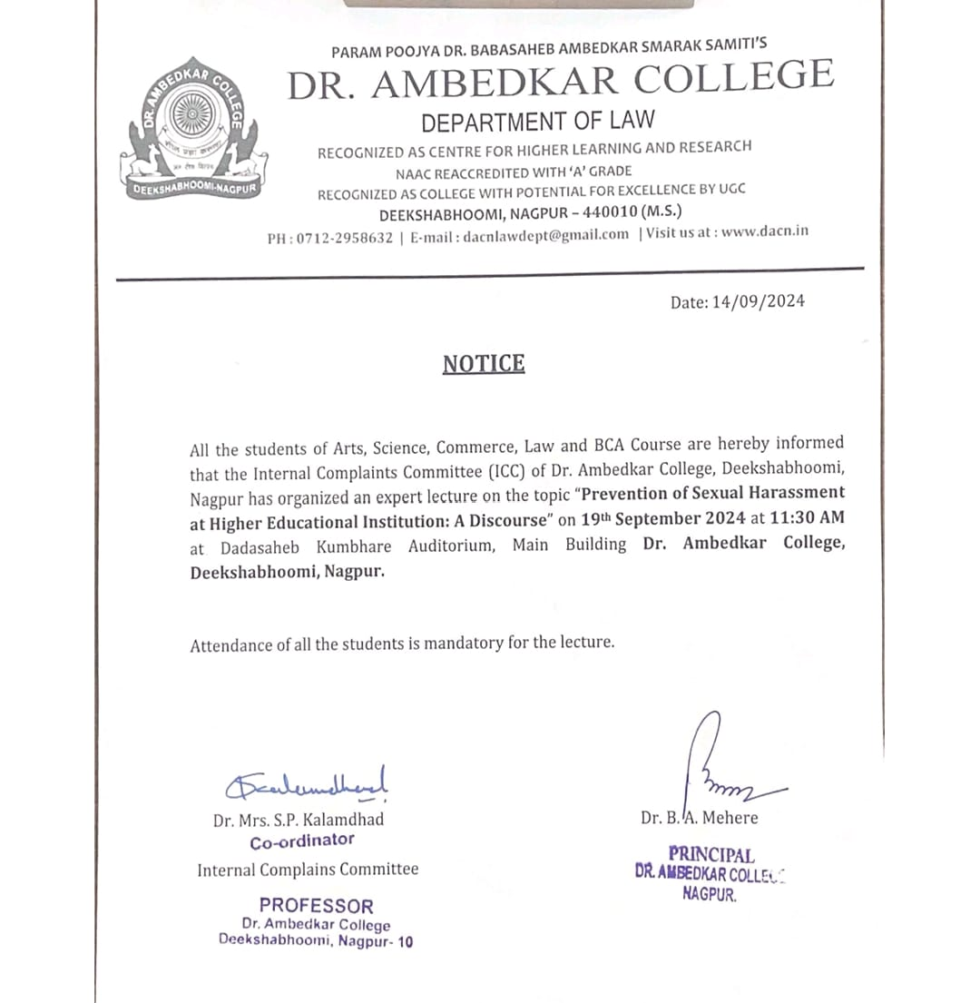

**REPORT ON GUEST LECTURE**

The**Internal Complaints Committee Cell** of Dr.Ambedkar College, Deekshabhoomi Nagpur, has organised a Guest Lecture on **19th Sept 2024** for the students of Arts, Science, Commerce, Law and BCA of the college on the topic “**Prevention of Sexual Harassment at Higher Educational Institution: A Discourse”**

Around **150** attendees were present in the program. **Dr. Shalini Lihitkar, Professor and Head, Department of Library, RTMNU Nagpur** invited as guest speaker in the program. **Dr.B.A. Mehere,** Principal of the college gave brief information regarding the topic of the lecture along with the welcome address.

**Dr. Shalini Lihitkar** commenced the lecture by Darwin’s Theory of Natural selection which is based on three Principals namely, Inheritance, Overproduction and Survival of Fittest. She emphasized that the roots of provision of sexual harassment lies in the constitution of India. She empathetically asked the audience about their relation with parents, who are the first one who address the issues faced by children.

Through her commendable talk she appealed the students to first understand that we need to respect the woman. In furtherance to this she vividly explained the student’s different forms of Sexual harassment and defined the same with different examples. She elaborately explained how the women are victimised and discriminated since long time. She further briefly narrated the significant and leading cases and the international convention on sexual harassment. He explained the real-life concerned cases, complaint mechanism, conciliation provisions almost all the provisions of 2013 Act on sexual Harassment.

The lecture is followed by the question-and-answer session wherein the different students asked the variety of questions which has been nicely answered by the guest speaker with full satisfaction of the students. She ended his talk by again appealing the students to be sensitive, respectful and be responsible towards the women.

The members of Internal Complaints Committee have graced the event by their presence. The Programme was conducted and concluded by Ms. Sanika Durugkar a student a Law 5 Year course.

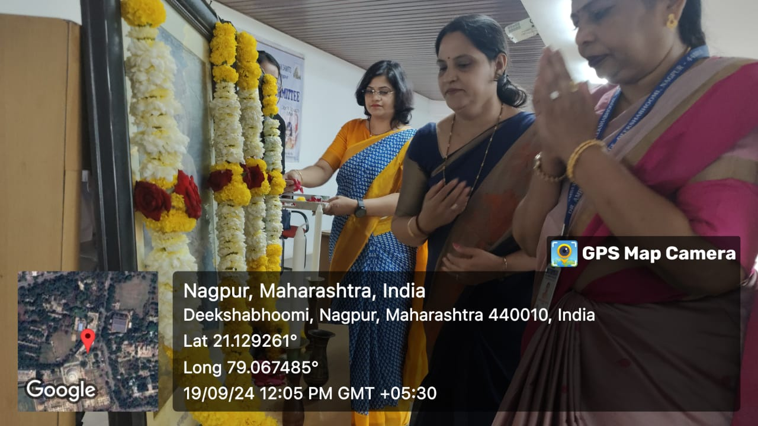

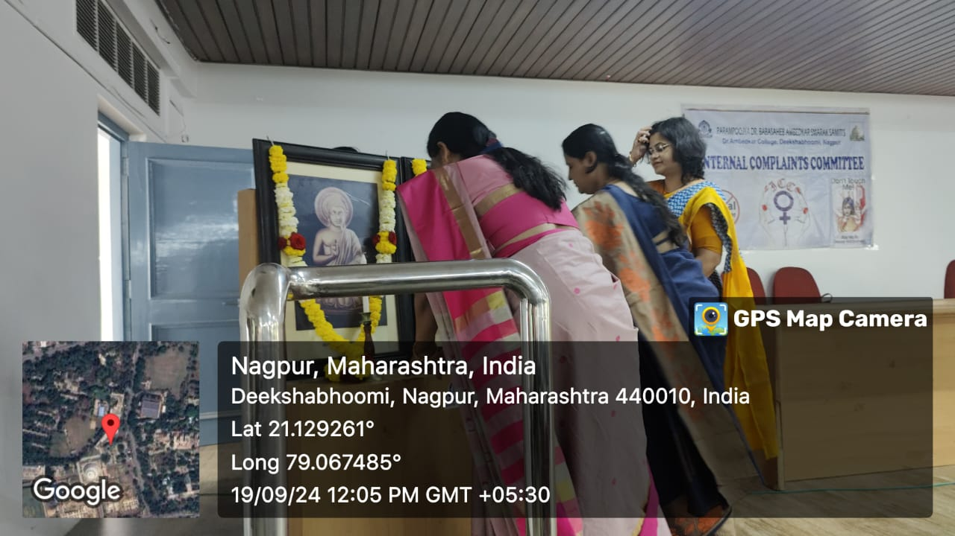

(Dignitaries seeking blessings of Tathagat Bhagwan Gautam Buddha and Dr. Babasaheb Ambedkar)

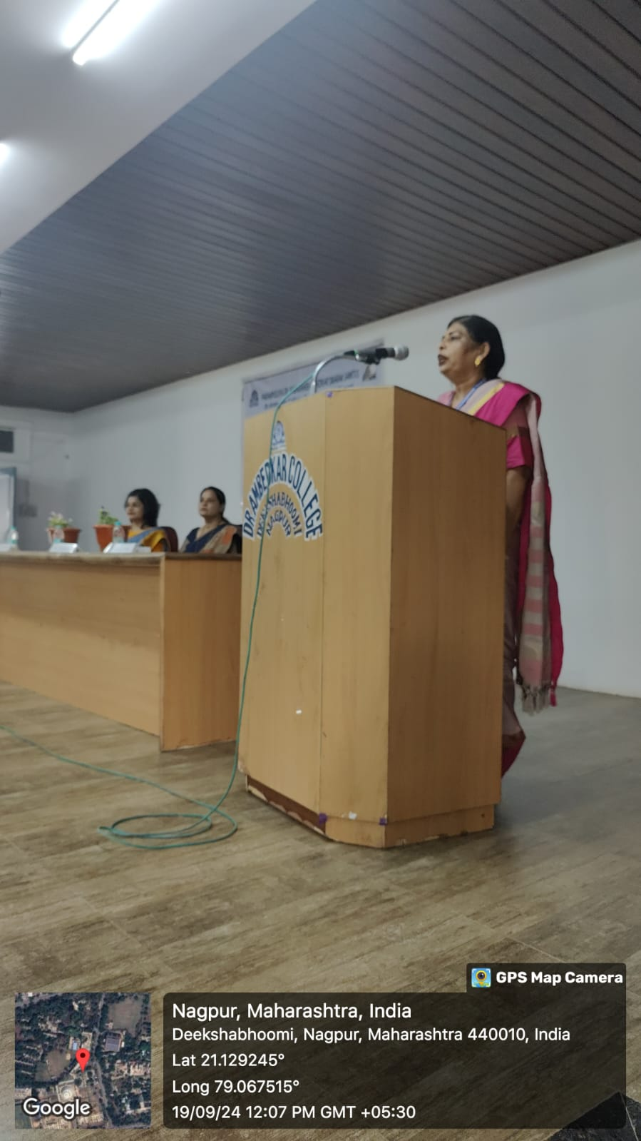

(Dr.B.A. Mehere, Principal of the college giving the introductory remark and welcome address)

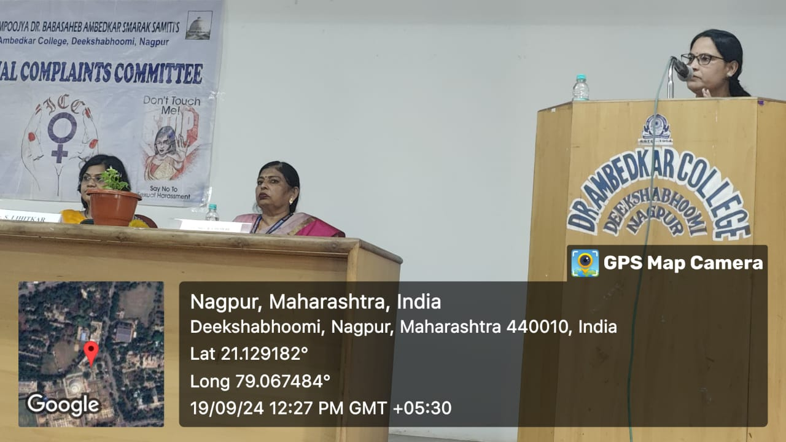

(**Dr. Shalini Lihitkar** delivering the lecture)

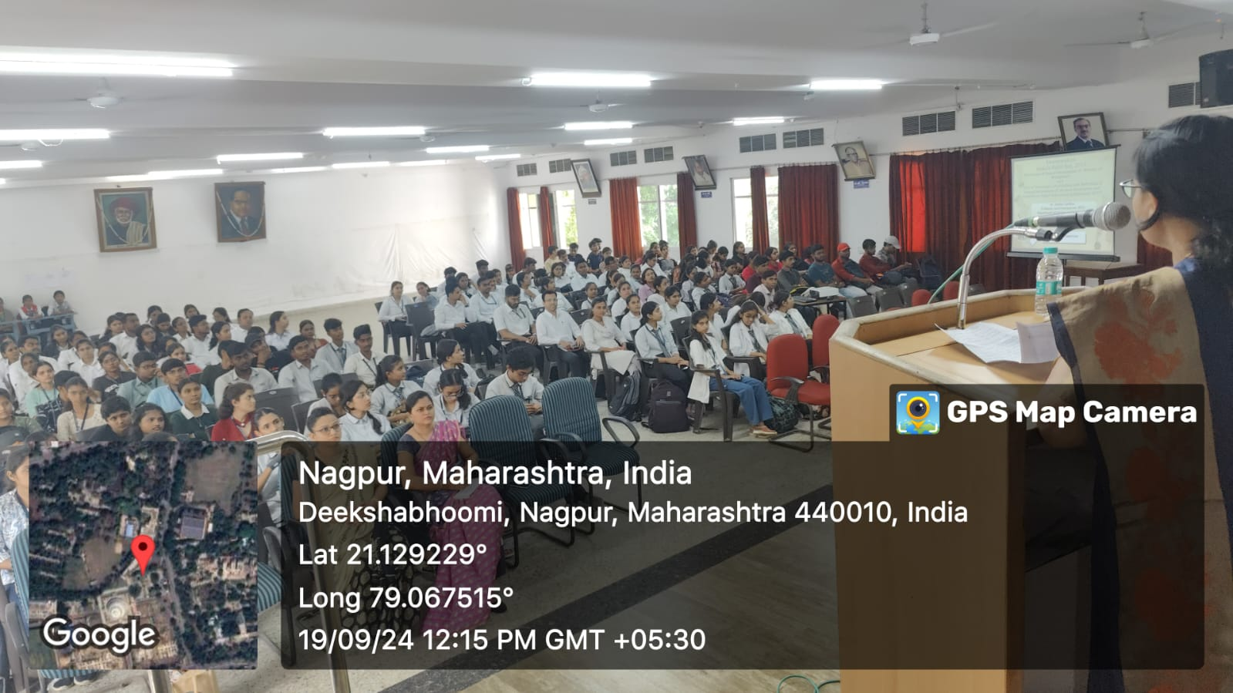

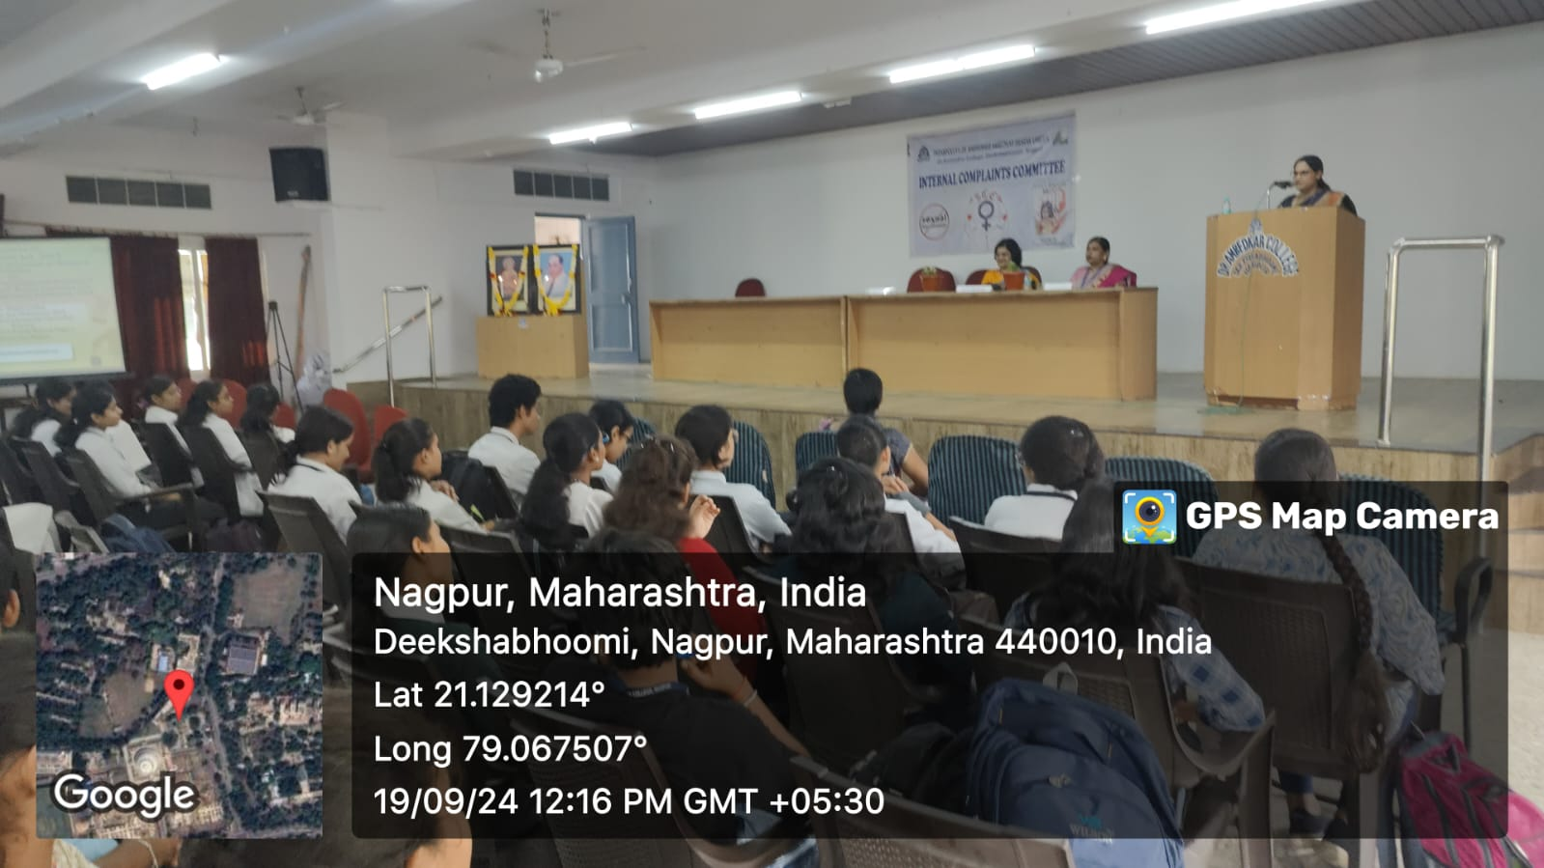

(Audience Present at the Programme)