**DR. AMBEDKAR COLLEGE, DEEKSHA BHOOMI, NAGPUR**

**INTERNAL COMPLAINTS COMMITTEE**

**Date: 30th August 2024**

**Name of the Programme: Lecture on “Prevention of sexual Harassment from the perspective of law and Society”**

**Resource Persons: Dr. Chinmayee Nimkhedkar**

**Organised by: Internal Complaints Committee (ICC) Cell**

**Name of Program Co-ordinator: Dr. Sandhya Kalamdhad**

**Number of Attendees: Around 100**

**Venue: Seminar hall, Department of Law, Dr. Ambedkar College, Deekshabhoomi, Nagpur**

**NOTICE**

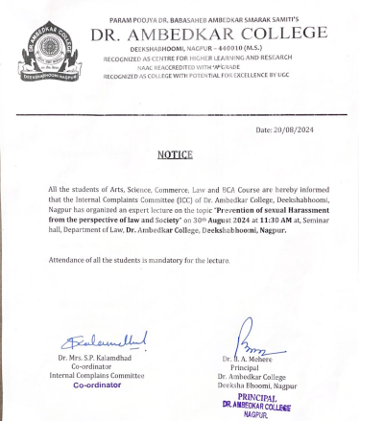

**REPORT ON GUEST LECTURE**

Sexual harassment is a serious manifestation of sex discrimination at the workplace and a violation of human rights as well as fundamental rights, enshrined in the Constitution of India. It is yet another form of violence against women reflecting patriarchal mind sets and gender based discrimination that women experience at work. It is also a manifestation of power relations, as women are much more likely to be the victims of sexual harassment because of their already existing vulnerability, insecurity, and social conditioning to accept discrimination in silence. Hence, there is a strong need to strengthen the Sexual Harassment Act. To make the legislation more effective, the need is to publicise this law to the people so that it would make its protection more comprehensive and effective. With this aim The Internal Complaints Committee on Sexual Harassment at the Workplace arranged oe lecture for the Gender Rights, titled, “topic “**Prevention of sexual Harassment from the perspective of law and Society**” on **30th August 2024** at **11:30 AM** at, Seminar hall, Department of Law, **Dr. Ambedkar College, Deekshabhoomi, Nagpur.**

The response to the workshop was overwhelming. **Around 100 students, 07 faculties and 05 non- teaching staff attended the lecture.** The aim of this lecture was to empower women faculty, non-teaching staff and students and provide protection against sexual harassment and offer the right to work with dignity and non-discrimination, based on the Human Rights treaties and the ratification of International Conventions by the Indian Government. Hence, with the ultimate object as, to strengthen the implementation of Sexual Harassment Act and to make its protection more comprehensive and effective.

**Dr. Chinmayee Nimkhedkar** in her address threw light on the patriarchal domination that is deeply rooted in the Indian Society. This Patriarchy, she said, emanates from the sex-based division of labour that relegated the woman’s role essentially within the four walls of the house, and the prerogative to work and earn money came to be considered the man’s world. This gave birth to hierarchy between man and woman and gave a subordinate position to women, who is subject to man’s power. This subordination has given birth, among others to the prevalence of sexual harassment of women.

She drew attention of the audience towards the role played by the Prevention of Sexual Harassment Act enacted by the State. The role played by such laws is immense, but she pointed out that law has its own limitations. She further explained all the provisions of Law along with latest case laws.

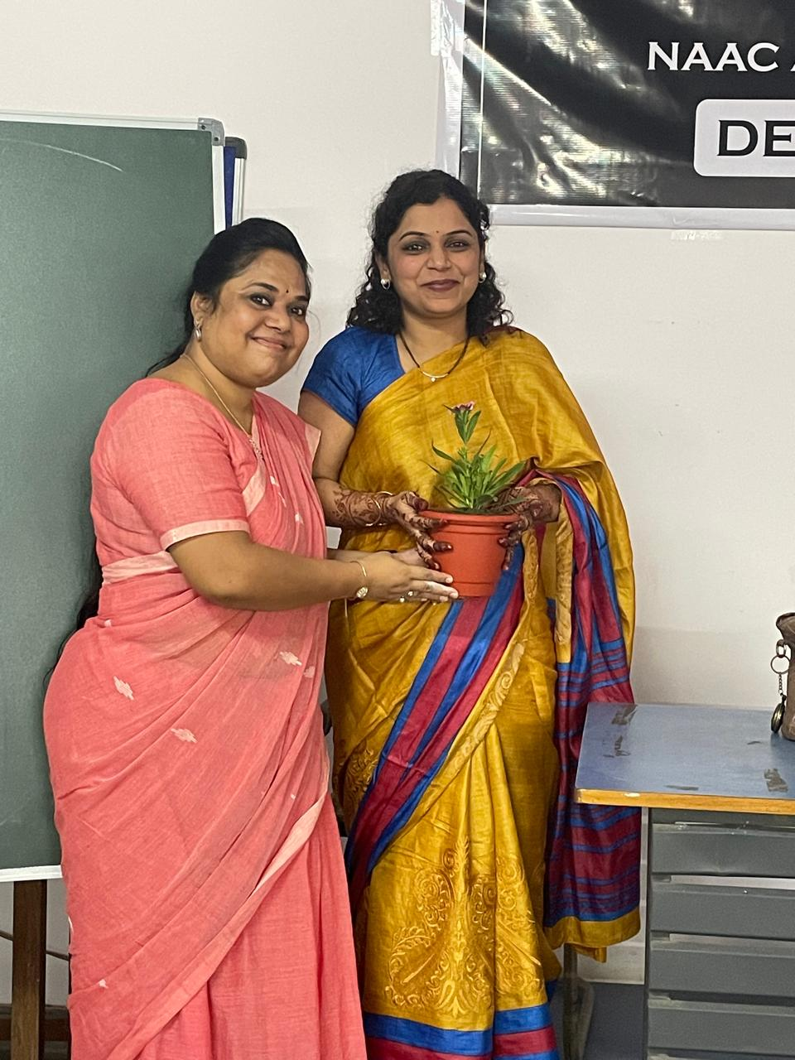

(Dr.P. R. Lokhande, Associate Professor of the college welcoming the guest speaker)

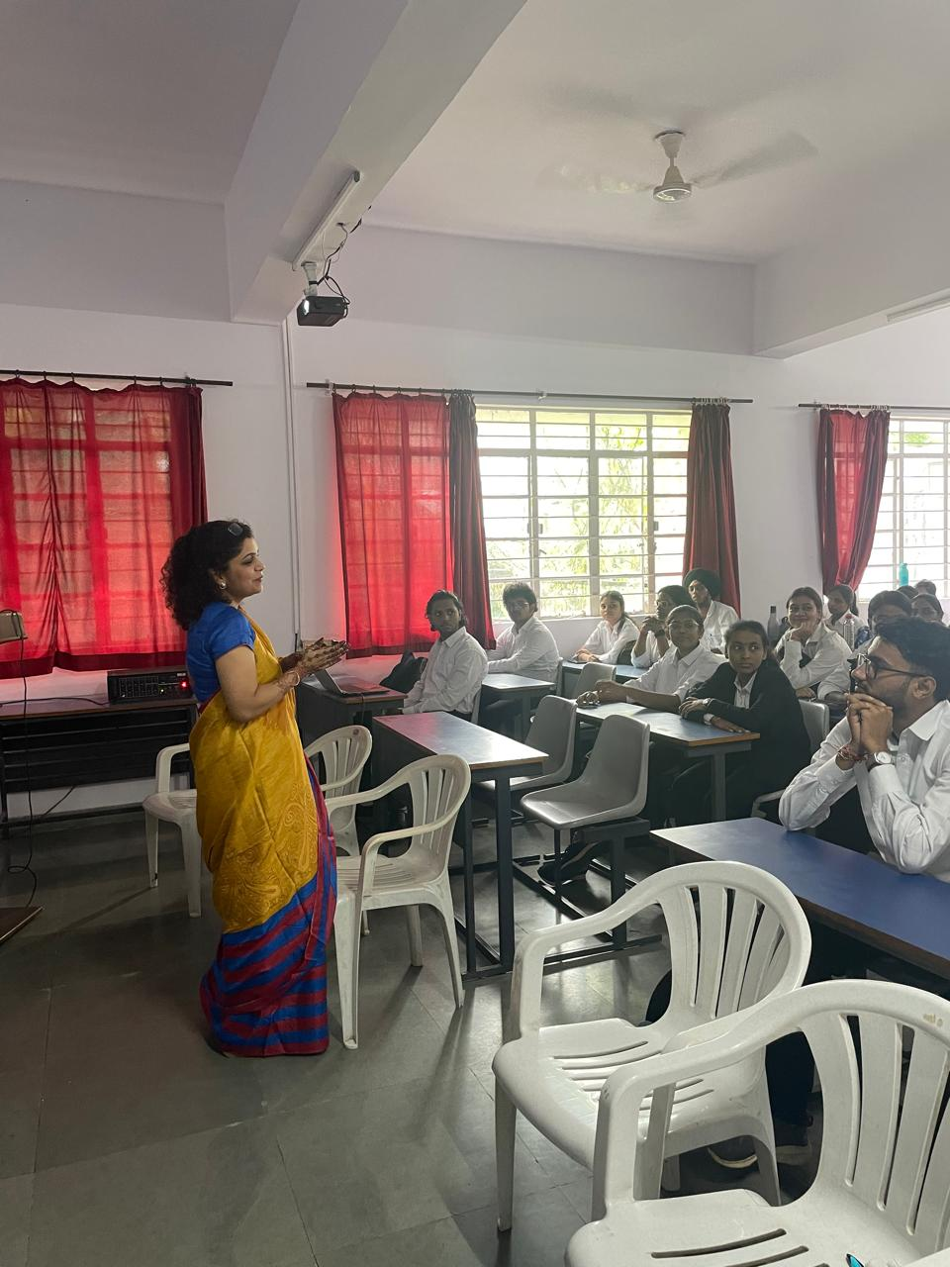

(**Dr. Chinmayee Nimkhedkar** delivering the lecture)

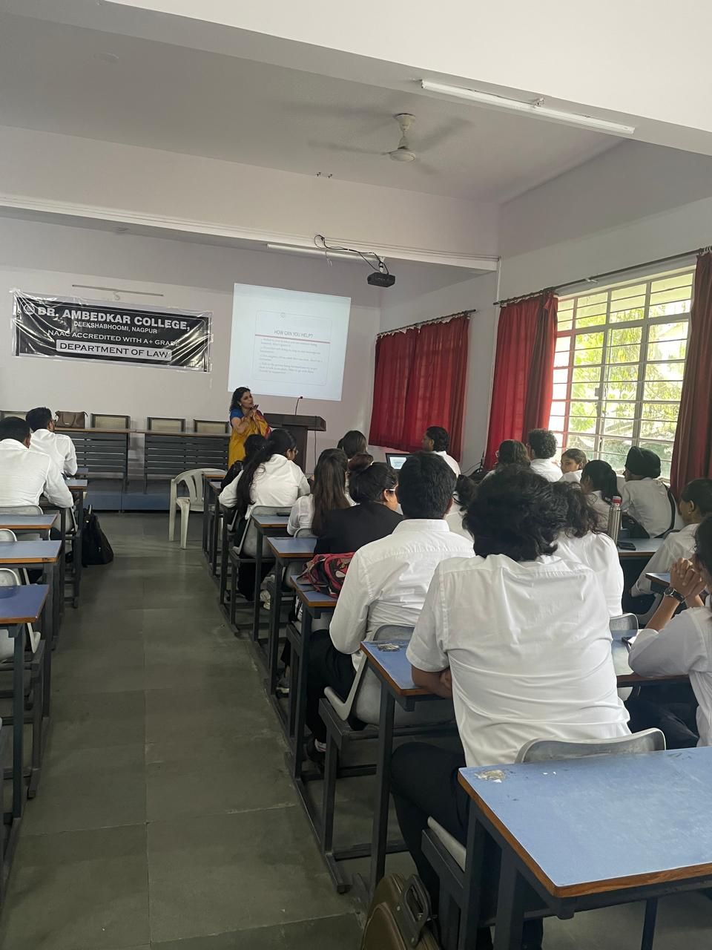

(Audience Present at the Programme)