DR. AMBEDKAR COLLEGE, DEEKSHA BHOOMI, NAGPUR INTERNAL COMPLAINTS COMMITTEE

**Date: 11th march 2025**

**Name of the Programme: Lecture on “Prevention of Sexual Harassment at Higher**

**Educational Institution: A Discourse”**

**Resource Persons: Dr. Sandhya kalamdhad**

**Organised by: Internal Complaints Committee (ICC) Name of Program Co-ordinator: Mr. Akash Mohurley Number**

**Number of Attendees: 60**

**NOTICE**

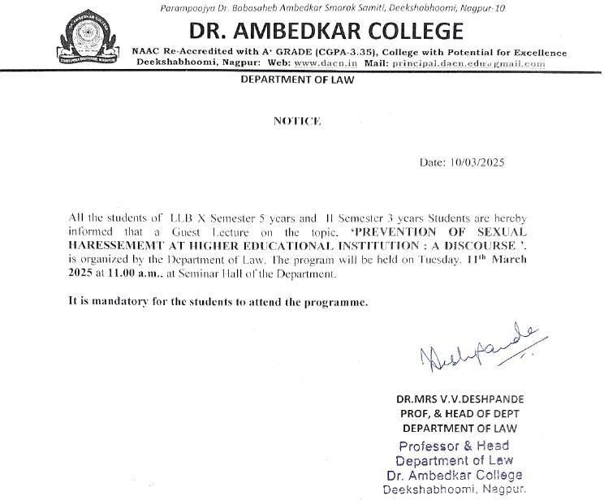

**REPORT ON GUEST LECTURE**

The **Internal Complaints Committee Cell** of Dr.Ambedkar College, Deekshabhoomi Nagpur, has organised a Guest Lecture on for the students of Law on the topic “**Prevention of Sexual Harassment at Higher Educational Institution: A Discourse”**

Around **60** attendees were present in the program. **Dr. Sandhya Kalamdhad , Professor Department of law ,** Dr.Ambedkar College, Deekshabhoomi Nagpur invited as a guest speaker in the program..

**Dr. Sandhya Kalamdhad** started the lecture on how women face discrimination on the basis of sex. She emphasized that the remedy also lies in the constitution of India that is article 19 which provides for right to work. She empathetically asked the students that once in a life every girl or woman has once faced harassment or not. She also told the story of Bhanwari Devi and her struggle which led to the Supreme court guidelines on sexual harassment.

Through her commendable talk she appealed the students to first understand that we need to respect the woman. In furtherance to this she explained different forms of Sexual harassment and cited different examples. She elaborately explained how the women are victimised and discriminated since long time. She further briefly narrated the significant and leading cases and the international convention on sexual harassment. She explained the real-life concerned cases, complaint mechanism, conciliation provisions almost all the provisions of 2013 Act on sexual Harassment.

The lecture is followed by the question-and-answer session wherein the different students asked the variety of questions which has been nicely answered by the guest speaker with full satisfaction of the students. She ended his talk by again appealing the students to be sensitive, respectful and be responsible towards the women.

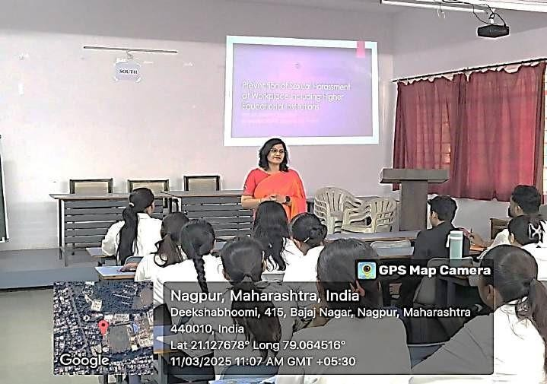

(**Dr. Sandhya Kalamdhad** delivering the lecture)

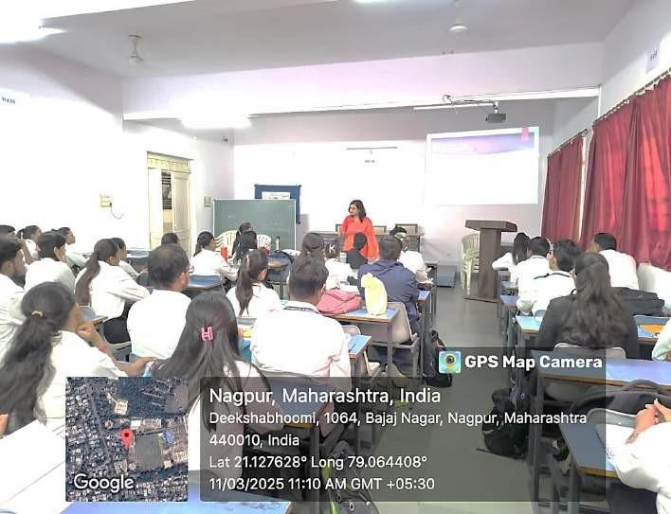

(Audience Present at the Programme)

