**National Level Quiz Competition on "Introduction to Indian Constitution" for UG and PG students organized by Competitive Examination Guidance Centre (CEGC), Dr. Ambedkar College, Deekshabhoomi, Nagpur**

**Report**

The Competitive Examination Guidance Centre (CEGC) at Dr. Ambedkar College, Deekshabhoomi, Nagpur, recently organized a National Level Quiz Competition for both undergraduate (UG) and postgraduate (PG) students on the topic "Introduction to Indian Constitution" as part of 2024-25 academic year activities. The event aimed to foster awareness and understanding of the Indian Constitution, its provisions, and its significance in shaping the nation.

**Event Details:**

* **Date**: 28/02/2025
* **Target Participants**: UG and PG students from various colleges.
* **Event Type**: National Level Quiz Competition
* **Organizing Department**: Competitive Examination Guidance Centre (CEGC)

**Objectives of the Quiz Competition:**

1. To enhance the knowledge of students regarding the Indian Constitution, its history, and its various provisions.
2. To provide a platform for students to test their understanding of constitutional law and current affairs related to constitutional matters.
3. To encourage healthy competition and critical thinking among students on the core principles that govern the Indian democratic system.
4. To celebrate the legacy of Dr. B.R. Ambedkar and his contribution to the drafting of the Indian Constitution.

**Structure of the Quiz:**

The quiz consisted of online mode exam including multiple choice question.

Total Marks: 50 Total Questions: 25

Quiz Link: <https://forms.gle/FofEeHGWDLD7K97s8>

The National Level Quiz Competition on "Introduction to Indian Constitution" was a successful initiative by the Competitive Examination Guidance Centre (CEGC) of Dr. Ambedkar College, Nagpur. It not only promoted awareness about the Constitution but also helped students develop a deeper understanding of their rights and duties as citizens of India. The event concluded with high regard for the participants' knowledge and enthusiasm, and the CEGC looks forward to organizing more such events to contribute to the academic growth of students.

**Participants Student list**

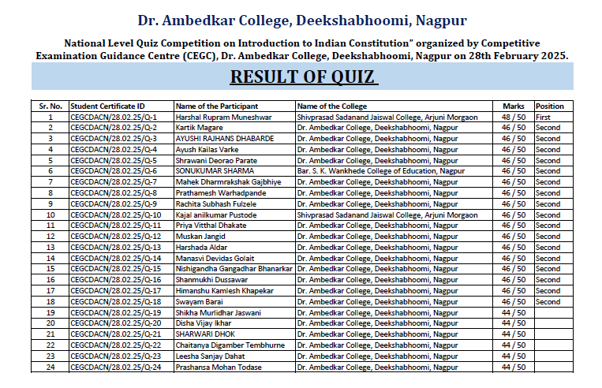

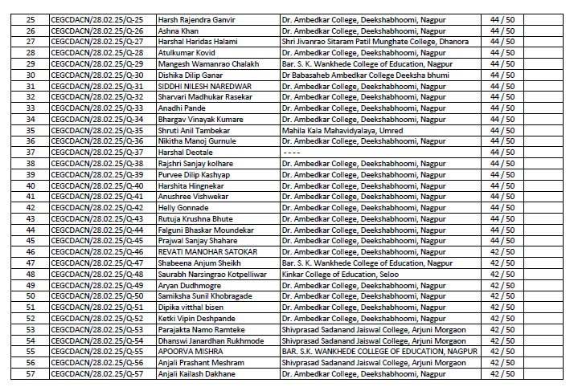

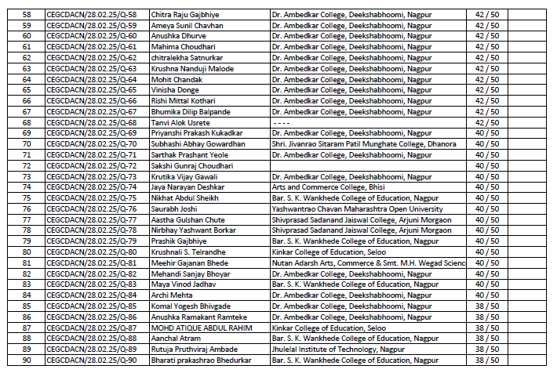

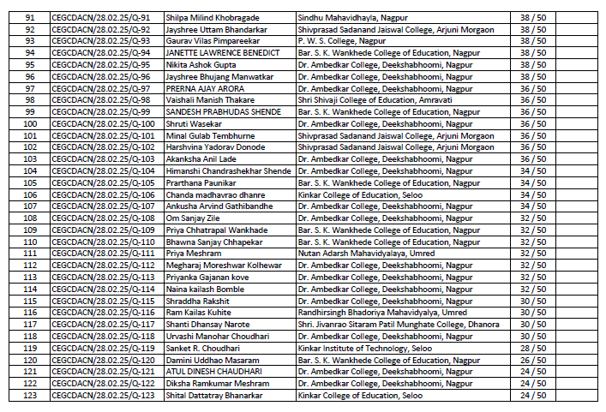

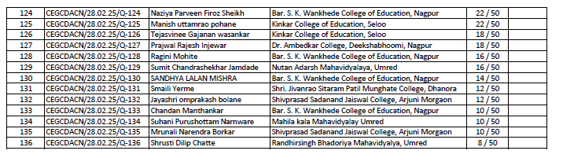

**Participation Certificate**

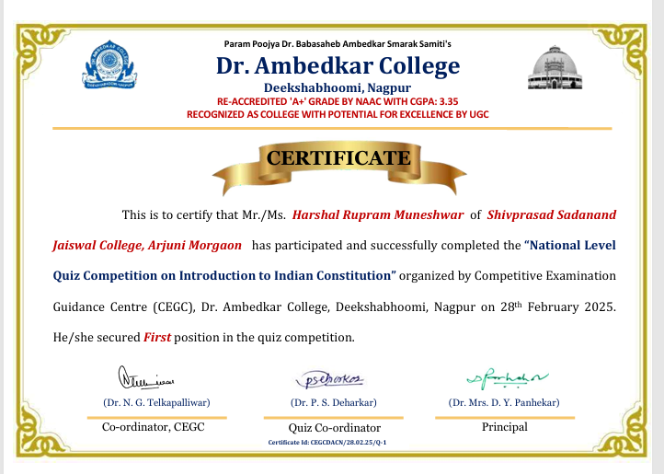

**Activity organized By:**  
1) Dr. P. S. Deharkar, Quiz Co-ordinator, Dr. Ambedkar College,

Deekshabhoomi, Nagpur

2) Dr. N. G. Telkapalliwar, Co-ordinator, Competitive Examination Guidance

Centre (CEGC) of Dr. Ambedkar College, Nagpur.



