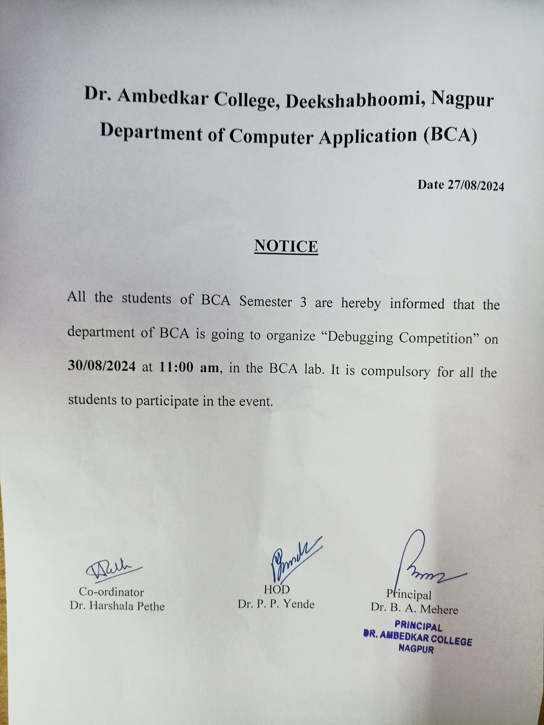

# DR. AMBEDKAR COLLEGE, DEEKSHABHOOMI, NAGPUR

# DEPARTMENT OF BCA

**DEBUGGING COMPETITION**

# Date: 30TH AUGUST 2024

**REPORT**

BCA department had organized debugging competition on 30th August 2024 for the students of BCA Semester 3 in BCA Lab at 11:00 am.

The objective of this competition was to improve students problem solving, algorithmic thinking and debugging skills.

The students were given the code in c++ with errors. The execution time of 5 minutes was allotted to students. After execution of code the time of execution was noted. The event was coordinated by Dr. Harshala Pethe

All the students participated with full enthusiasm and really enjoyed the Competition.

**Winners of the competition**

|  |  |  |
| --- | --- | --- |
| Sr. No | **Name of Student** | **Time (in min)** |
| **1** | **NANDINI KHAPEKAR** | **0.58** |
| **2** | **ANSHUL DHOBLE** | **1.06** |
| **3** | **ALFIYA AJAJ PATHAN** | **1.2** |
| 4 | POOJA BHOLA SONTAKKE | 1.3 |
| 5 | DIYA GIRDHARI SHARMA | 1.39 |
| 6 | AACHAL DIPAK HUMANE | 1.46 |
| 7 | SAKSHI YOGESH MESHRAM | 1.49 |
| 8 | PRAJWAL DILIP CHAUDHARI | 2.14 |
| 9 | GULAFSHA ANSARI | 2.29 |
| 10 | ABHA PRASHANT GHAROTE | 2.38 |
| 11 | LALIT KUMAR PANDIT | 2.4 |
| 12 | MAYUR VINAYAK BARVE | 4.3 |

**Glimpses of the event**

|  |  |
| --- | --- |
| E:\HBP\New folder\Debugging competition\Pics\1725427269508.jpg | E:\HBP\New folder\Debugging competition\Pics\1725427292767.jpg |
|  | |
| E:\HBP\New folder\Debugging competition\Pics\1725427312580.jpg | E:\HBP\New folder\Debugging competition\Pics\1725427330492.jpg |
|  | |
|  |  |
|  | |
|  |  |

**Attendance Sheet**

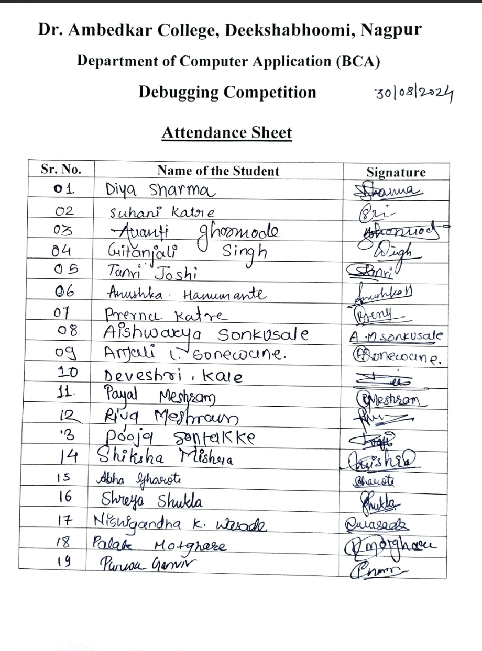

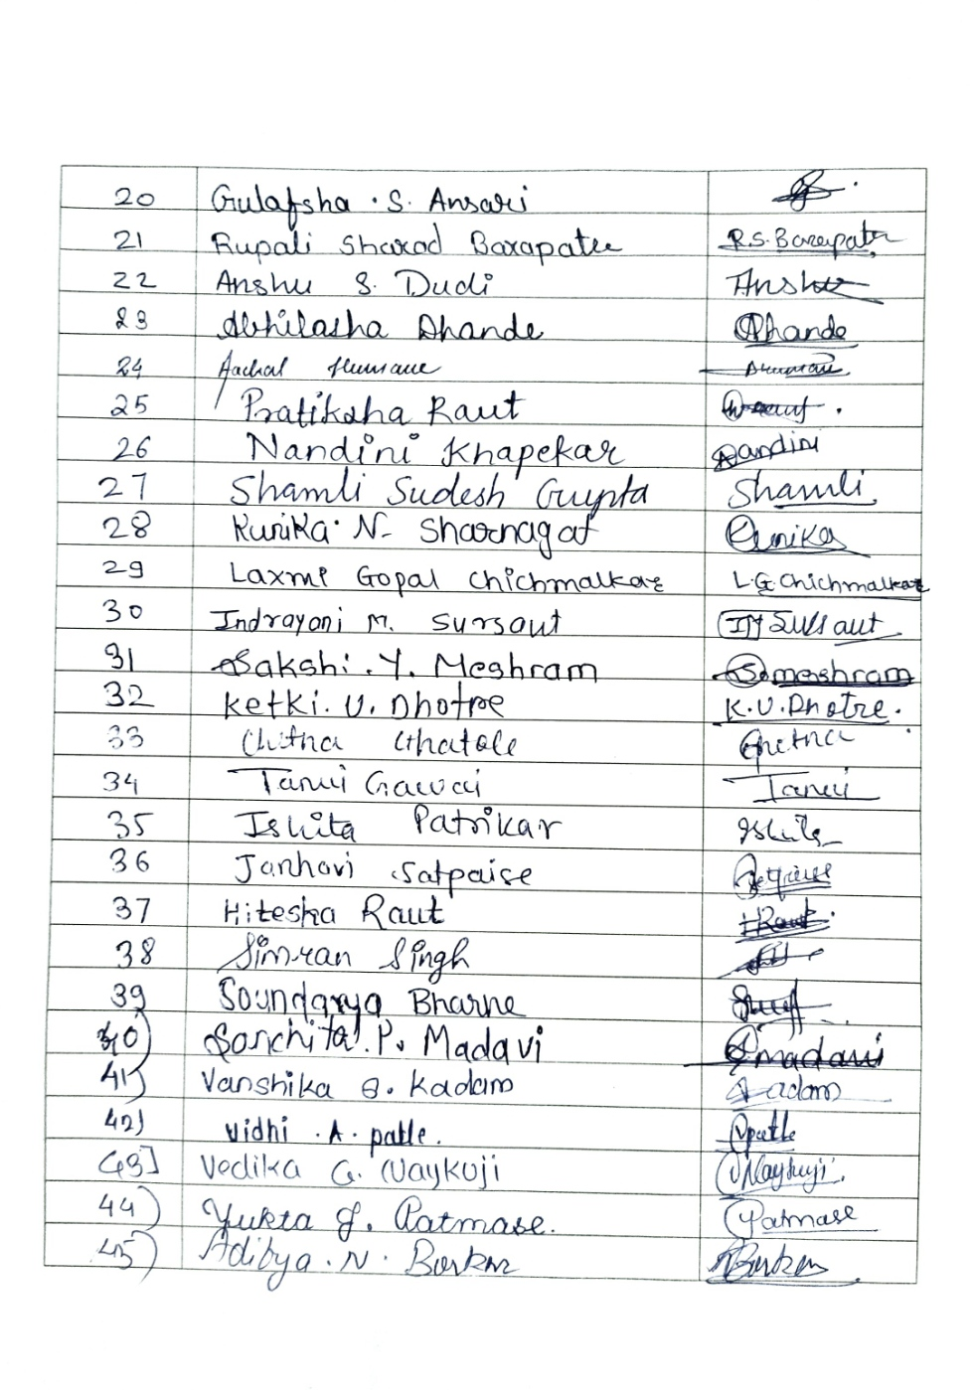

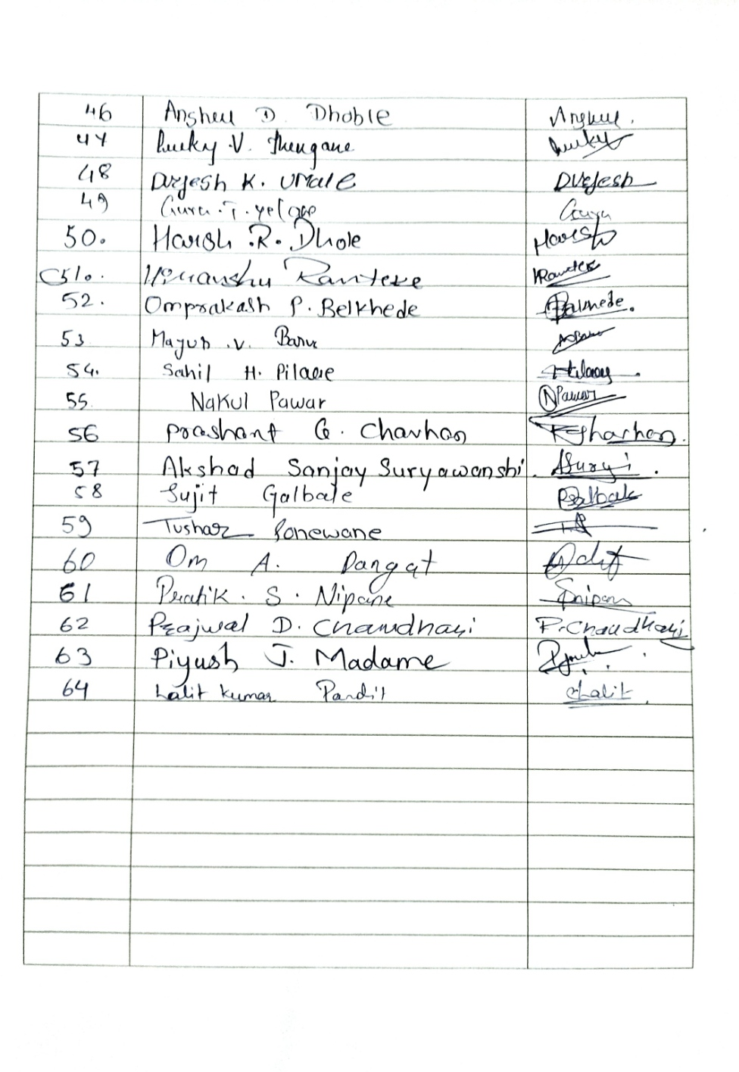

**Feedback Responses**

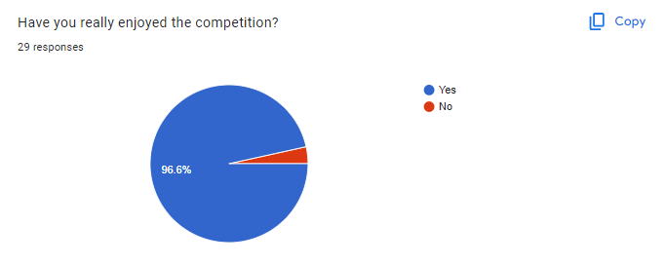

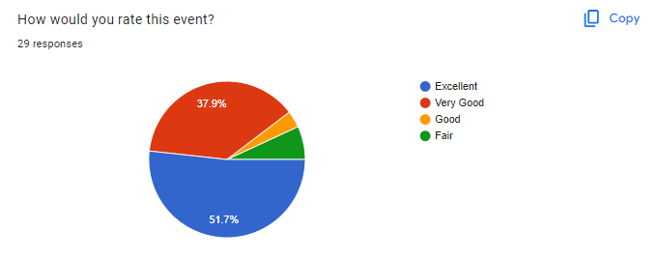

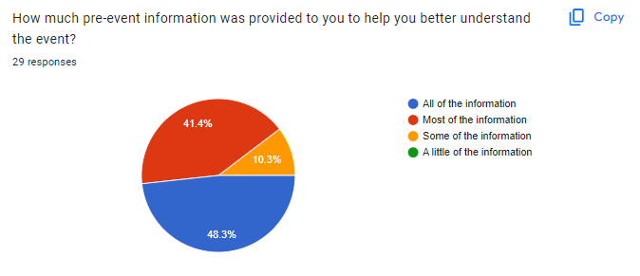

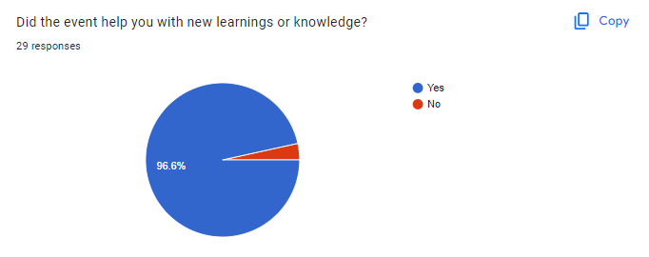

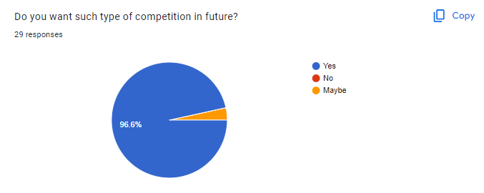

* Excellent
* Nice and well organised
* It was a great program and I am looking forward to see such events more.
* It was so good to experience it
* The overall competition was handled well by Harsha ma'am. I am looking forward to more such competition in the future.
* 10
* Please organized such types of competition in future too.
* Enjoyed it
* Very nice competition
* I toh enjoy a lot in that competition, it helps to improve my mistakes..👀🫠
* It is helpful to increase a knowledge
* Thank you!
* Yes
* Best
* I enjoyed it!!
* I enjoyed the competition
* Enjoyed the competition
* Maja aaya !
* Great competition I can learn many things
* Giving chance to know about how much knowledge we gain and it is important for us
* It's amazing competition Such competitions should be organized again
* It was a good competition
* This type of competition is very useful for us
* Best activity done till today by teacher!
* Nothing
* These competition teach each and every mistake in the program and we have got a chance to learn it
* Competition was too good