**DR.AMBEDKAR COLLEGE, DEEKSHABHOOMI, NAGPUR**

**DEPARTMENT OF LAW**

**ACADEMIC SESSION 2023-24**

**INDUCTION PROGRAMME (DEEKSHARAMBH)**

NAME OF THE PROGRAMME: **INDUCTION PROGRAMME (DEEKSHARAMBH)**

DATE AND DAY**: 29/8/2024 TO 1/9/2024**

TIME: **11.30 AM Till Evening**

VENUE: DEPARTMENT OF LAW

PROGRAMME SUPERVISOR: **Dr. Hema Menon, HOD & Prof.**

PROGRAMME CO-COORDINATORS: **Dr. Sandhya P. Kalamdhad**

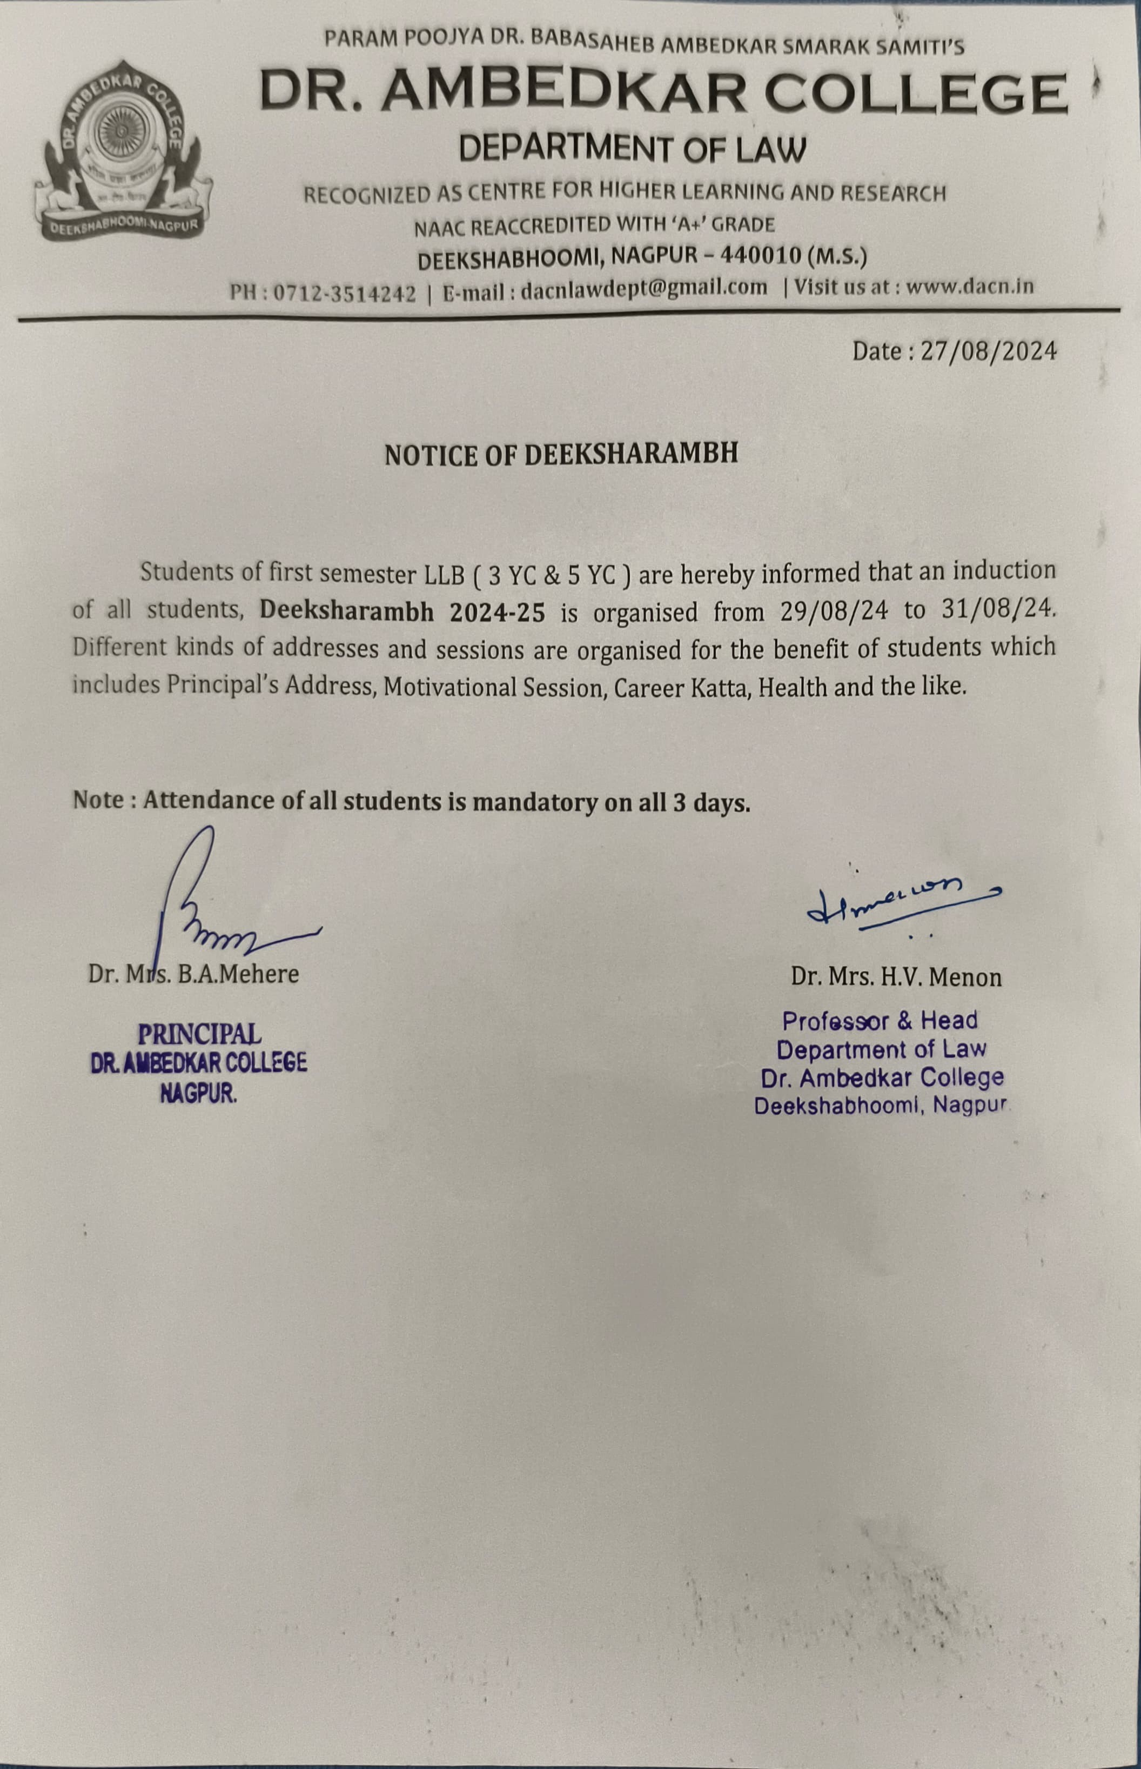

REPORT ON DEEKSHARAMBHA

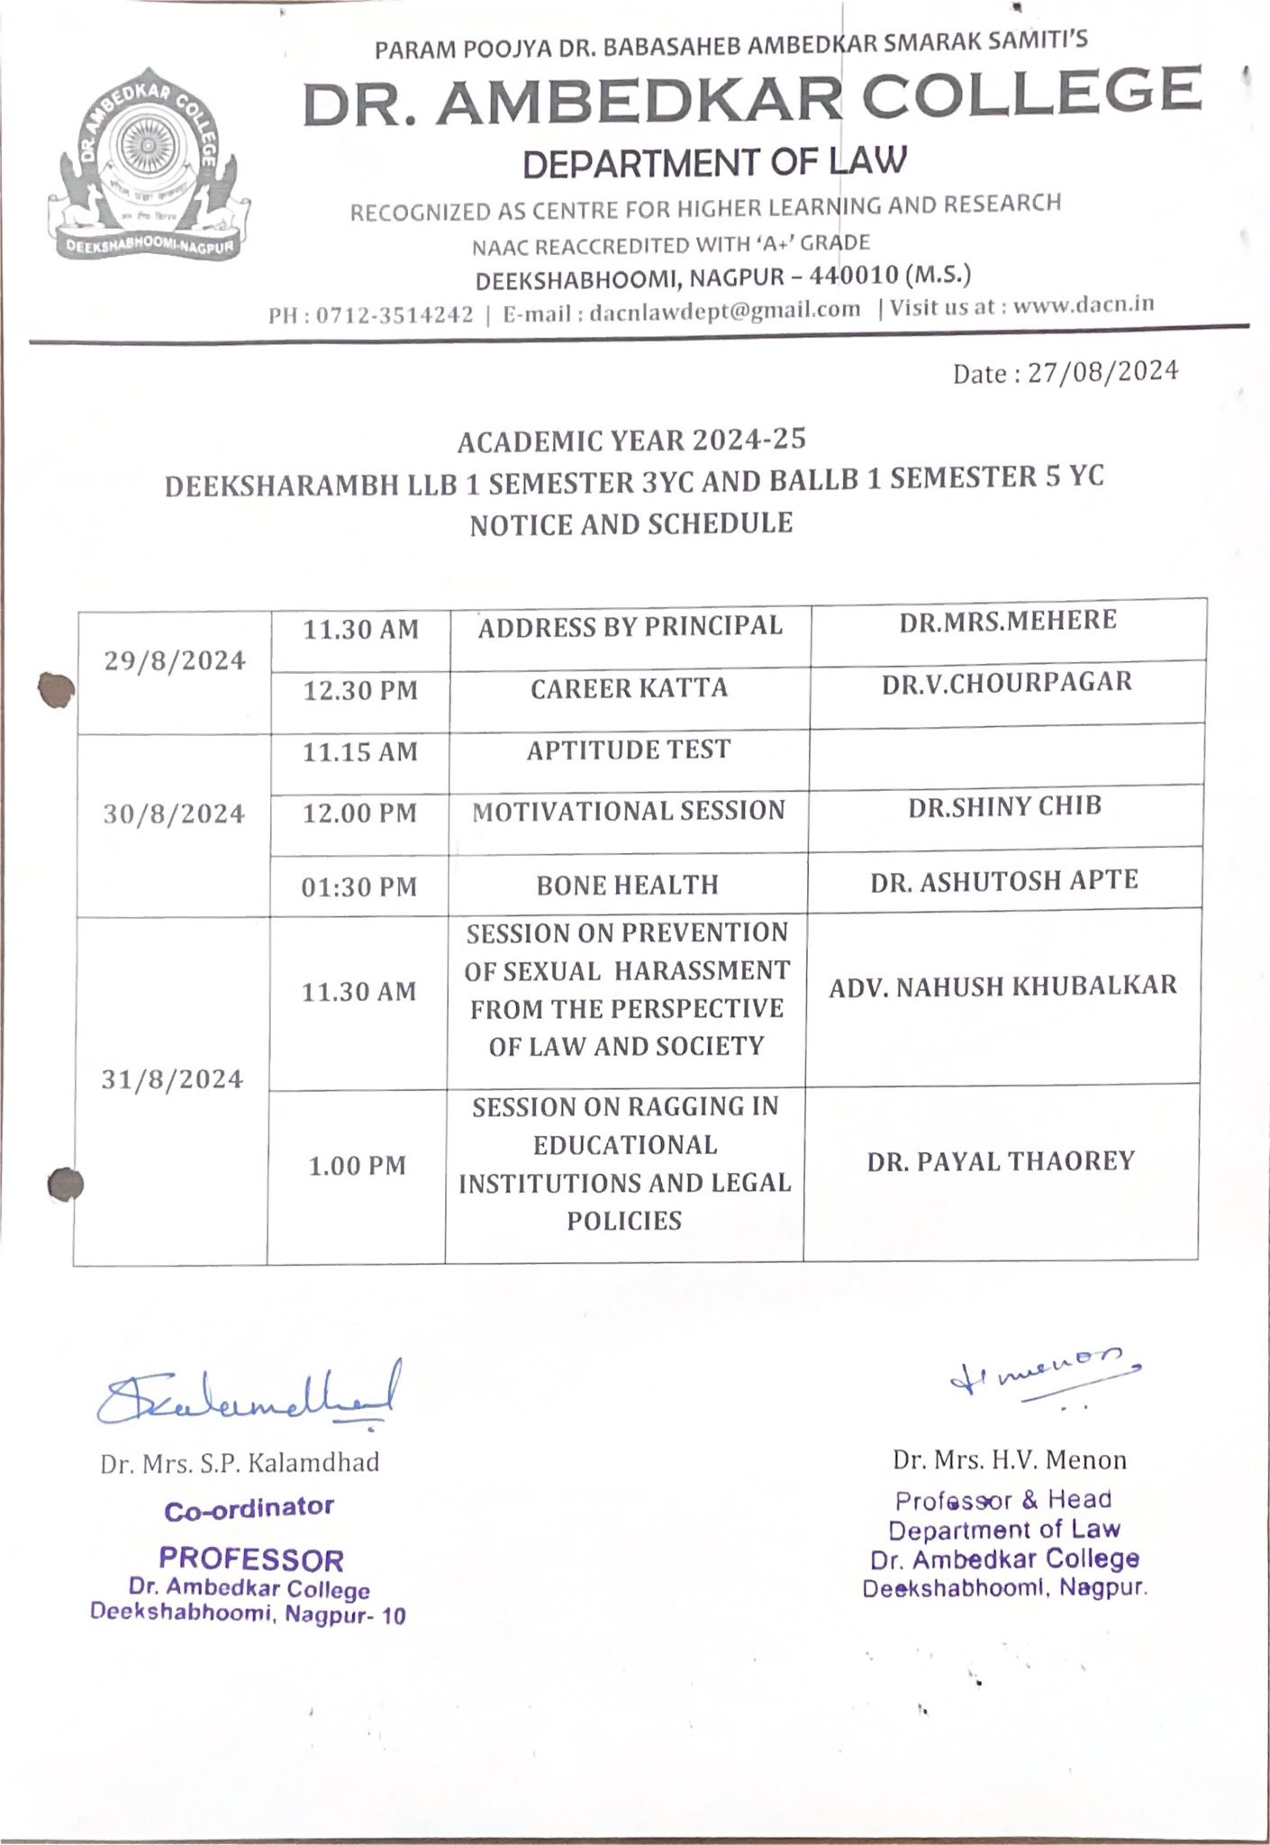

The Department of Law, Dr. Ambedkar College, Deekshabhoomi have organised Four days Induction Programme (DEEKSHARAMBHA) for the fresher students of the department i.e. BA LLB 5 Years Course and LLB 3 Years Course.

This programme was organised with the aim to provide support to the new students so that they can develop a sense of belongingness towards institution. Also to create an awareness of their rights as well as responsibilities.

There is a transition of students from secondary to higher education and/or from undergraduate to postgraduate programme, therefore this is the most appropriate time to organise different talks and events with a purpose to help students acclimatize with the new surroundings, develop bond with fellow students and teachers, sensibility towards various issues of social relevance and imbibe human values in them, so as to become responsible citizen. Therefore, with this realization we understood how important task it is to welcome new students to higher educational Institution and prepare them for their new role. This Induction programme was designed to help the students in the whole process.

We inaugurated this programme with the auspicious presence of our beloved Principal, Prof. Dr. Bhumi Mehere. When new students enter an institution they come with diverse thought, backgrounds and preparations. They come into a new unfamiliar environment and most of them have little knowledge of a University/ college culture. Therefore Ho’ble principal Madam introduced them with the culture of the college. She informed them about the different committees which we have for the welfare and protection of the students. Apart from this, she had introduced to the students, the different schemes and facilities in the college. She welcomed the students and ensured them that they are in safe hands and they will get here a good platform to showcase their talents.

Head of the Department, Dr. Hema Menon while addressing the students, welcomed them and informed them about different clubs which we have in the department and talked about the various academic, cultural as well sports activities conducted through various clubs in the department. She said discipline is must in the department and informed them about the different rules of the department of Law. She introduced all the faculties to the students.

Co-ordinator of the programme, Prof. Dr. Sandhya Kalamdhad also welcomed the students on behalf of the whole teaching and non-teaching faculties and assured them all co-operation. She further elaborated the importance of Induction programme and appealed them to attend the programme. She talked about the whole schedule as well as about the teachers who will be teaching them in this semester. She emphasised on the importance of participating in different curricular and extra-curricular activities.

After inaugural session, Dr. V. Chourpagar delivered a lecture on “Career Katta”, which is recently introduced programme by the Government of Maharashtra. She gave detailed account of the programme and encouraged the students to register themselves. After this lecture we received an overwhelming response from the students. Immediately students registered themselves for the programme.

On the second day of the Programme we took ‘Aptitude Test’, so that we can identify the week and good students and accordingly plan our action. Thereafter we had an awareness session by Dr. Chinmayee Nimkhedkar, on the topic, “Prevention of sexual Harassment at Higher educational Institution”. One of the purposes of Deeksharambha is to help the new students to adjust and feel comfortable to the new environment, inculcate into them the ethos and culture of the institution, help them build bonds with other students and faculty members and expose them to a sense of larger purpose and self exploration. With this aim we organised this lecture to sensitize them towards the zero tolerance policy of the college towards sexual harassment. Very aptly and elaborately by citing live examples madam had explained the policy against sexual harassment. Thereafter, we had a session on health, Dr. Ashitosh Apte who is also an alumnus of the department explained the importance of bone health in today’s world.

On the third day we had a motivational speech by Ms. Khushi Bajaj, who is an International Trainer in this field. She trained the students on the topic, ‘Importance of Communication in Legal Field’. She took three hours’ workshop whereby she not only explained the importance but also trained the student’s through different small group activities. Thereafter we had a session on “Anti Ragging” by Dr. Payal Thaore, HOD, PGTD, RTMNU, who very elaborately explained all the provisions of Anti Ragging Law as well as Anti Ragging Policy by UGC. By citing very live examples she tried to sensitize the students on the subject of ragging.

Then on the Fourth day we took the students for visit at Deekshabhoomi, where senior students explained the importance of place and visited all auspicious places at Holi Deekshabhoomi. Then our teachers also took the students to the library and informed and trained them about various software’s which we have in the library and introduced them with books. They specifically told them the importance of books in Lawyer’s life and also taught them how to read and refer different journals available in the library.

