DR. AMBEDKAR COLLEGE, DEEKSHABHOOMI, NAGPUR
DEPARTMENT OF LAW
Academic Session- 2023-24

NAME OF THE PROGRAMME: | MOOT COURT WORKSHOP 2024-25 BY SMCA.
NAME OF THE GUEST SPEAKER: | ADV. CHETAN DHORE  ADV. RAHUL DHANDE
NAME OF THE PROGRAMME  SUPERVISOR: | DR. VARSHA DESHPANDE
NAME OF THE PROGRAMME CO-ORDINATOR: | DR. VAISHALI A. SUKHDEVE
DATE AND DAY: | 19th October 2024, SATURDAY.
TIME: | 2 P.M
TOTAL NUMBER OF PARTICIPANTS | 90
VENUE: | ROOM NO. 6 AND SEMINAR HALL,  DEPARTMENT OF LAW
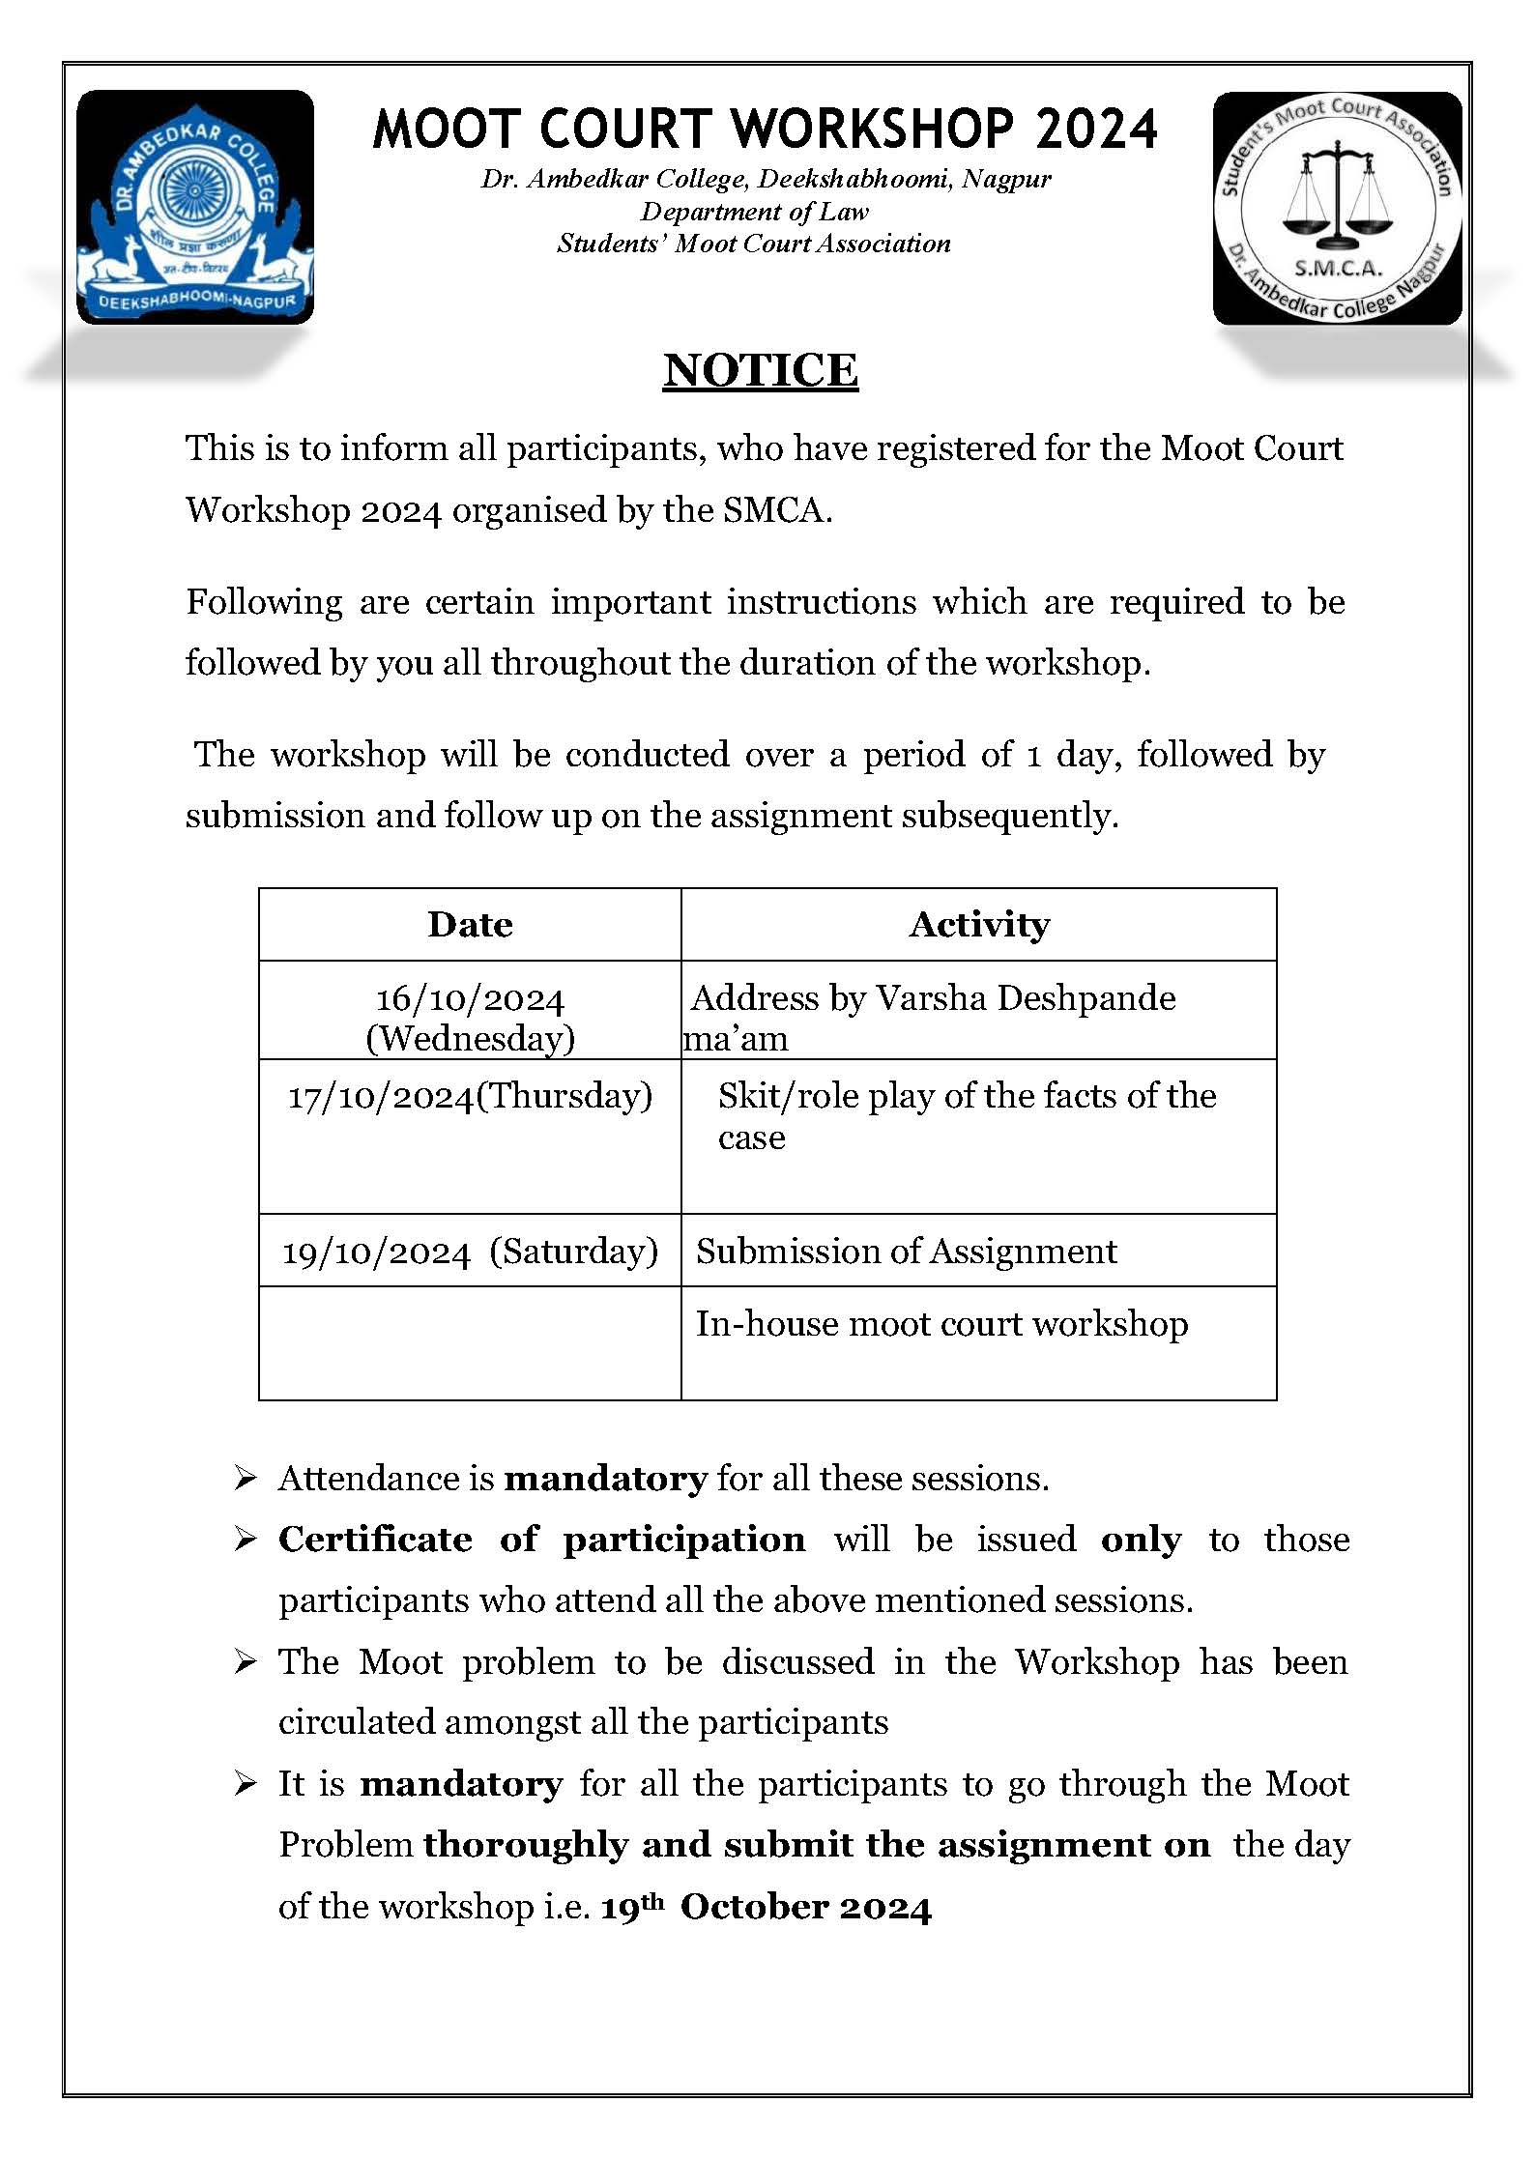

Moot Courts are vital for law students as they offer practical legal skills, courtroom experience, and opportunities for honing research, oral advocacy and writing abilities. Thus, it is extremely important that they receive proper and adequate guidance in the same. With this thought in mind, The Students Moot Court Association of the Department of Law, Dr. Ambedkar College, Deekshabhoomi, Nagpur organized Workshop on Moot Court on the 19th October 2024 for the students of 1st Semester and final semester of B.A LLB 5Years and LLB 3 Years, under the guidance of Adv. Chetan Dhore, Practicing Advocate Bombay High Court, Nagpur Bench, Nagpur And Adv. Rahul Dhande, Practicing Advocate, Bombay High Court, Nagpur Bench, Nagpur.
Through this workshop the participants were taught the basics of mooting which start right from reading a proposition to drafting a memorial. To make the whole learning process more effective the moot preposition was circulated to the students one week before the actual workshop.
Adv. Rahul Dhande addressed one group of participants, and the other group was guided by Adv. Chetan Dhore. The workshop revolved around the case of Rajesh Sharma vs ABC College based on a moot court proposition involving a student’s right to financial aid and transparency of institutional financial records. The central theme examined the conflict between Rajesh Sharma, a student admitted under the EWS (Economically Weaker Sections) quota, and the college’s denial of a fee waiver during a financial emergency. This proposition opened discussions on the rights of students in government-aided institutions and the responsibilities of such institutions under the RTI Act.
Adv. Chetan Dhore discussed the problems faced by students while mooting and how to tackle them. He told the importance and significance of moot court competitions, and he encouraged the students to participate in the same. He discussed the techniques of mooting, and he shared his personal experiences of moot court competitions. With respect to moot proposition, Adv. Dhore introduced the legal framework of the RTI Act, explaining its purpose in ensuring transparency in public institutions, including those receiving government aid. He discussed the specific case of Rajesh Sharma, focusing on the denial of access to education due to financial constraints and the subsequent filing of an RTI application. Adv. Dhore underscored the student's right to seek transparency on fund utilization and fee structures in a government-aided institution.

While guiding other group of students, Adv. Rahul Dhande, went into detailed purpose of moot court competitions. He clarified the proper format of writing a memorial and highlighted the value of conducting research before drafting. Adv. Rahul Dhande, in his address with regard to given moot proposition, provided insights into the judicial recourse available in such cases, elaborating on Rajesh’s writ petition before the High Court. He emphasized the obligation of educational institutions to provide accurate financial information under the RTI Act and their role in ensuring equal opportunities for EWS category students.

The resource persons were kind enough to explain all the nitty gritty of it. They also explained the method of researching for a moot. The interactive session following the workshop was particularly enriching, with students posing relevant questions. Adv. Dhore and Adv. Dhande also encouraged students to actively utilize the RTI Act to hold institutions accountable for their policies and financial management.

The workshop concluded with a vote of thanks by the SMCA Executive Member Sanskruti Pakhide and Shraddha Mishra, who expressed gratitude to the esteemed advocates for shedding light on the drafting, researching and argument skills required in moot courts. The event was well-received by the participants marking a significant step in fostering a deeper understanding of intricacies involved in mooting.
The participants as well as the organizers were indebted for the patient demeanour and teaching style of the speakers. The participants left with a feeling of confidence and eagerness to learn more while the speakers parted with having taught probably the most enthusiastic participants ever.

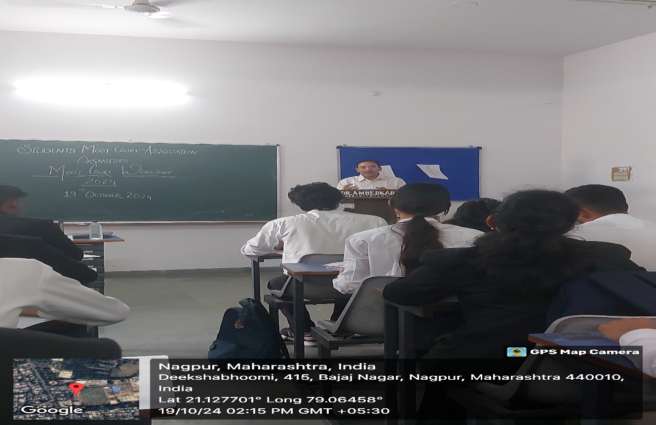

Adv. Rahul Dhande addressing the participants about nitty gritty of researching and drafting moot memorials
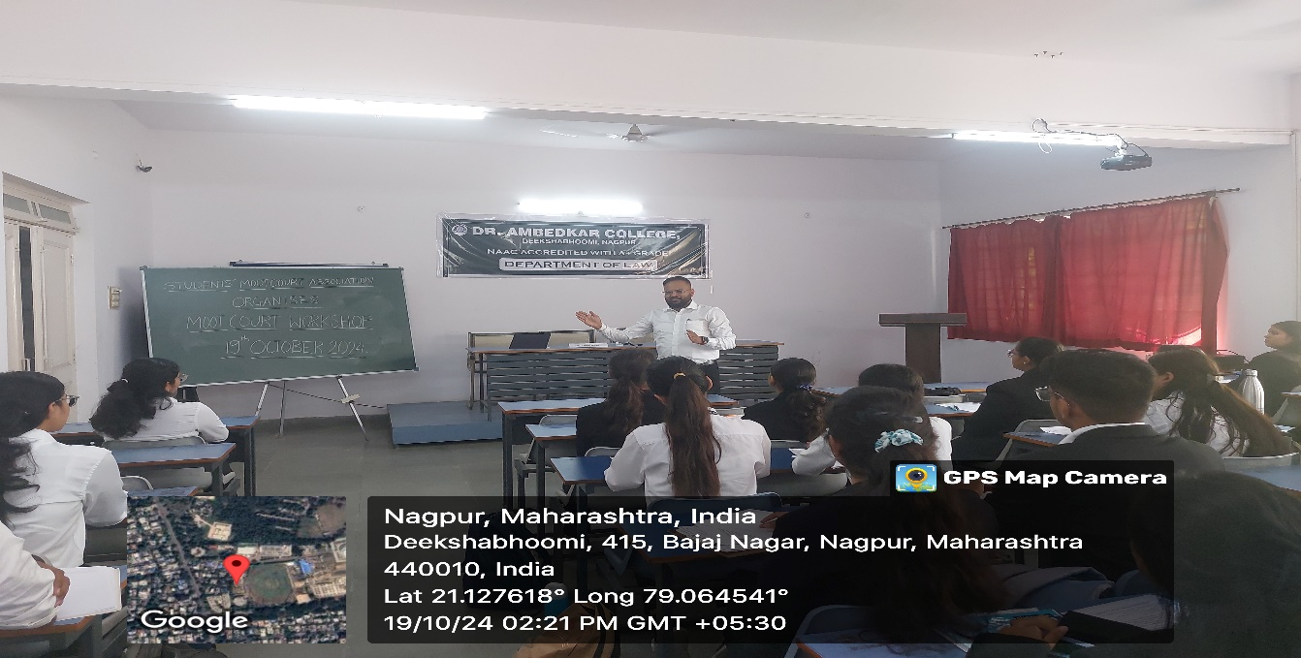
Adv. Chetan Dhore explaining the mooting skills to the participants.
