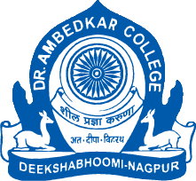

**PARAM POOJYA DR. BABASAHEB AMBEDKAR SMARAK SAMITI’S**

**DEPARTMENT OF LAW**

**NAAC REACCREDITED WITH ‘A’ GRADE**

**DEEKSHABHOOMI, NAGPUR** – 440010 **(M.S.)**

|  |  |
| --- | --- |
| **NAME OF THE PROGRAM** | **LECTURE ON HIGHER EDUCATION IN EUROPE** |
| **ORGANISING DEPARTMENT/ NAME THE CELL** | **NOUVEAU CORPORATE CLUB OF DEPARTMENT OF LAW** |
| **PROGRAM CO-ORDINATOR** | **DR. H.V. MENON**  **HOD OF LAW AND COMMITTEE CHAIR**  **DR. PRATIMA LOKHANDE**  **VICE CHAIR OF NC CLUB** |
| **DATE** | **10TH AUGUST 2024** |
| **RESOURCE PERSON** | **MRS. MADHAVI MAUSKAR KHARSHIKAR**  **DIRECTOR OF SOUTH WESTERN EUROPEAN CORRIDOR** |
| **NUMBER OF STUDENTS** | **52** |

**NOTICE**

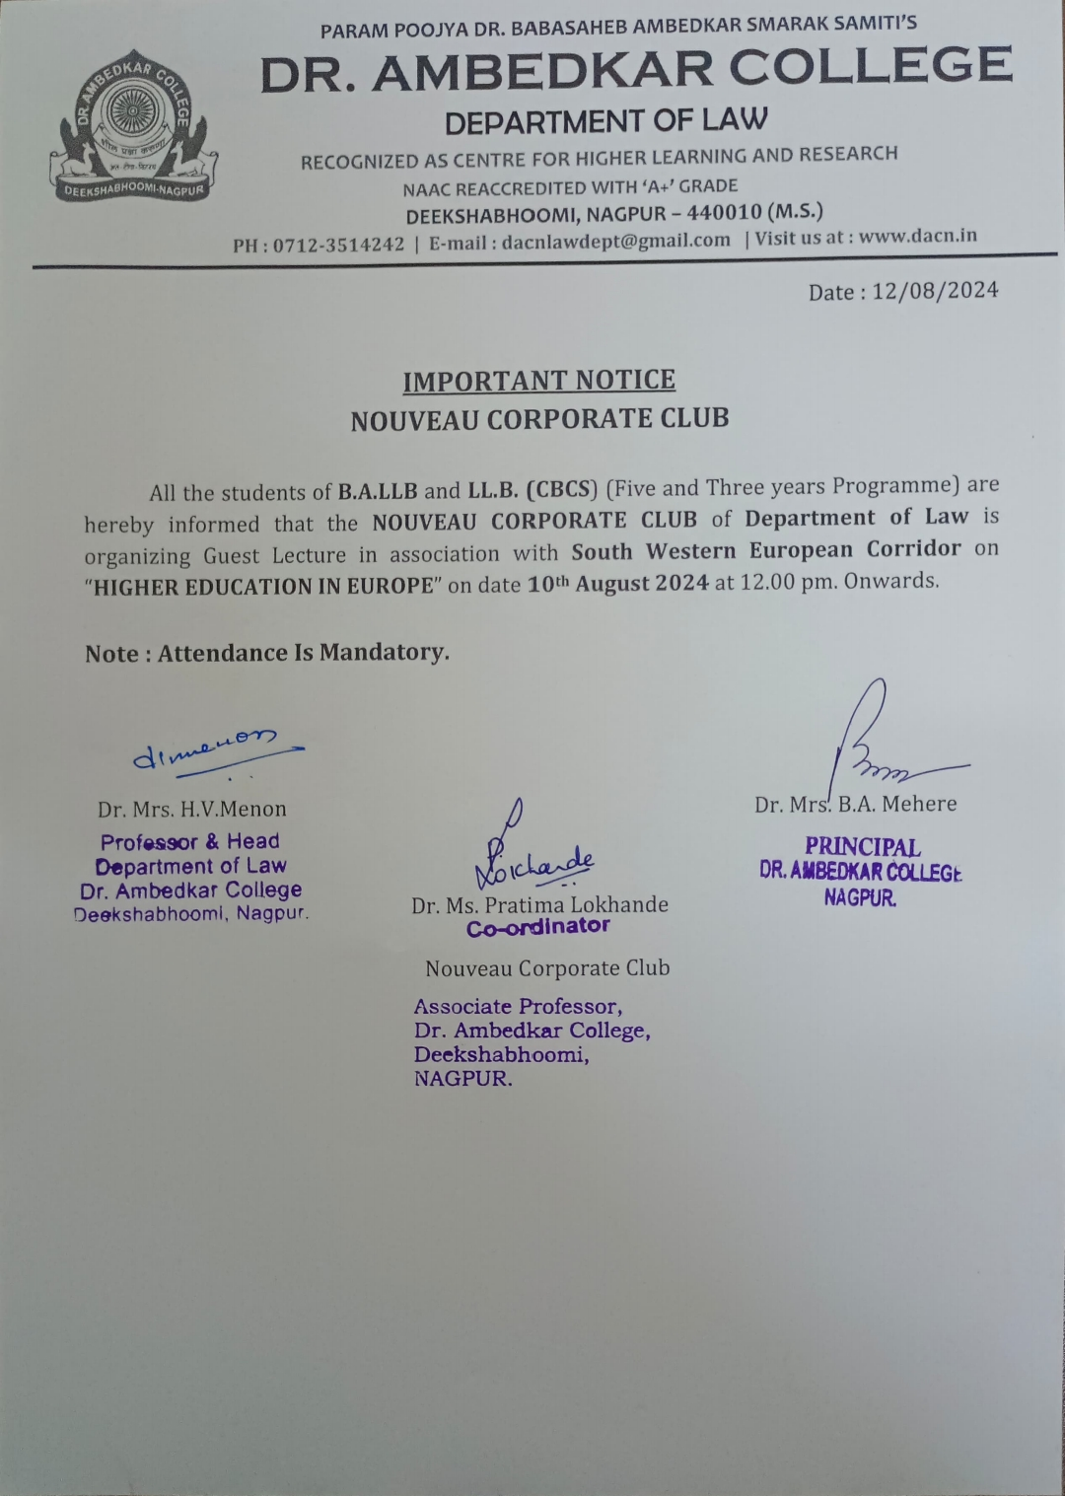

**REPORT**

**Nouveau Corporates Club** of Department of Law has organized One day Seminar on “HIGHER EDUCATION IN EUROPE” on **10TH AUGUST 2024**. The need of today for Law students is how to prepare for the job and which sector is important for them. Nouveau Corporates Club conducts such programme every year. One of which is recently organised in the Department of Law. This seminar was conducted by Madhavi Mauskar Kharshikar, Director of South Western European Corridor, Higher Education in Europe for Bachelors, Masters and Ph.D. aspirants. She has advised the student to learn German and stated that Germany has the world’s fourth largest economy, behind the United States, China, and Japan. Thus, German is very important language for people working in the sectors as it not only supports the German economy but also employ large numbers of people. She has given information to the students to provide assistance in getting jobs and internship. She has also covered the assistance provided by ESEC in shortlisting the universities across all 12 countries in Europe. She has also provided the information about SWEC MIRAM scholarships for the students. The seminar also touched upon key facets including the Do’s and Don’ts of seeking higher education in Europe.

The lecture was indeed very informative and equipped the students to understand job opportunities available in Europe. 52 Law students participated in the seminar and they got the knowledge regarding higher education in European countries. Students have made a lot of efforts to make the success of the day. The programme was conceptualized under the able guidance of Dr. H.V. Menon, Professor and Head of the Department of Law. Dr. Pratima Lokhande, Associate Professor and Vice Chair of the Nouveau Corporates Club, Department of Law has executed the seminar.

The program was conducted by student member of NC Club Ms. Stuti Salodkar. The Program came to an end with formal vote of thanks. The lecture was an altogether interactive session.

**GLIMPSES OF THE EVENT**

