**DR. AMBEDKAR COLLEGE, DEEKSHABHOOMI, NAGPUR**

**DEPARTMENT OF LAW**

**Academic Session - 2024-2025**

**CRIMINAL LAW CLUB**

|  |  |
| --- | --- |
| **NAME OF THE PROGRAMME:** | Group discussion, on the topic “Reforms in Entrance Examination in India: A call to protect students and Education system” |
| **NAME OF THE PROGRAMME CO-ORDINATOR:** | Prof. Dr. Sandhya Kalamdhad  Dr. Vaishali A. Sukhdeve |
| **DATE AND DAY:** | 29th July 2024, 11.30 a.m. |
| **TOTAL NUMBER OF PARTICIPANTS:** | 18 |
| **VENUE:** | Seminar Hall of the Department |

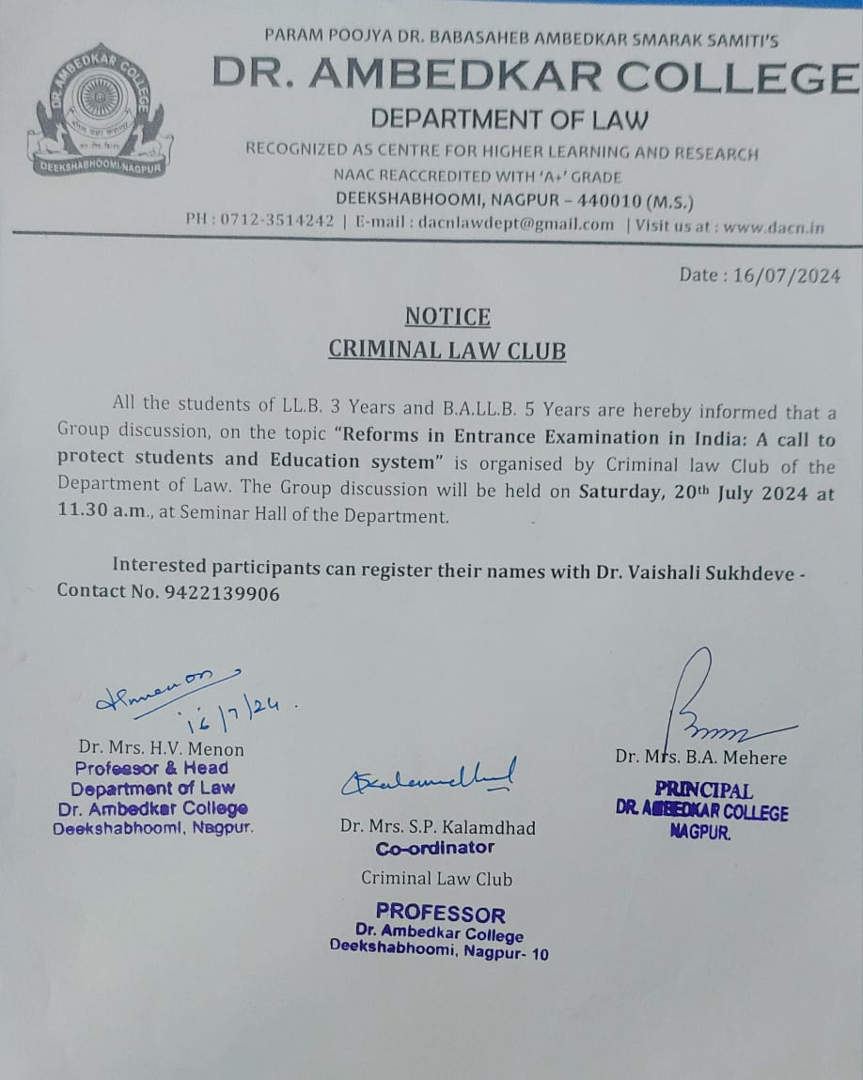

Criminal Law Club of the Department of Law, organized Group Discussion on the topic “Reforms in Entrance Examination in India: A call to protect students and Education system”. The Group discussion was held on Monday, 29th July 2024 at 11.30 a.m., at Seminar Hall of the Department. Total 18 students participated in the discussion.

The object of undertaking this topic for Group discussion was because of the fiasco which happened this year in the conduct of the NEET-UG that has created dismay and complete loss of trust in the NTA’s ability to conduct fair examination. The participants for Group discussion were divided into two groups. Both the groups put up their points of argument and counter arguments through meaningful inputs. All the participants confidently put their perspectives on the opening statement made by Prof. Dr. Sandhya Kalamdhad.

The group discussion was very fruitful and meaningful in which majority of the students concluded their discussion on the point that, decentralising the entrance examination processes to states and different governing entities could reduce the element of risk. Another point of discussion was the rejuvenation of schooling system as the growth of coaching industry has damaged the schooling system. Thus, the objective of Group discussion was achieved with the brainstorming ideas from the students which will definitely be helpful for them to develop communication and leadership skills.

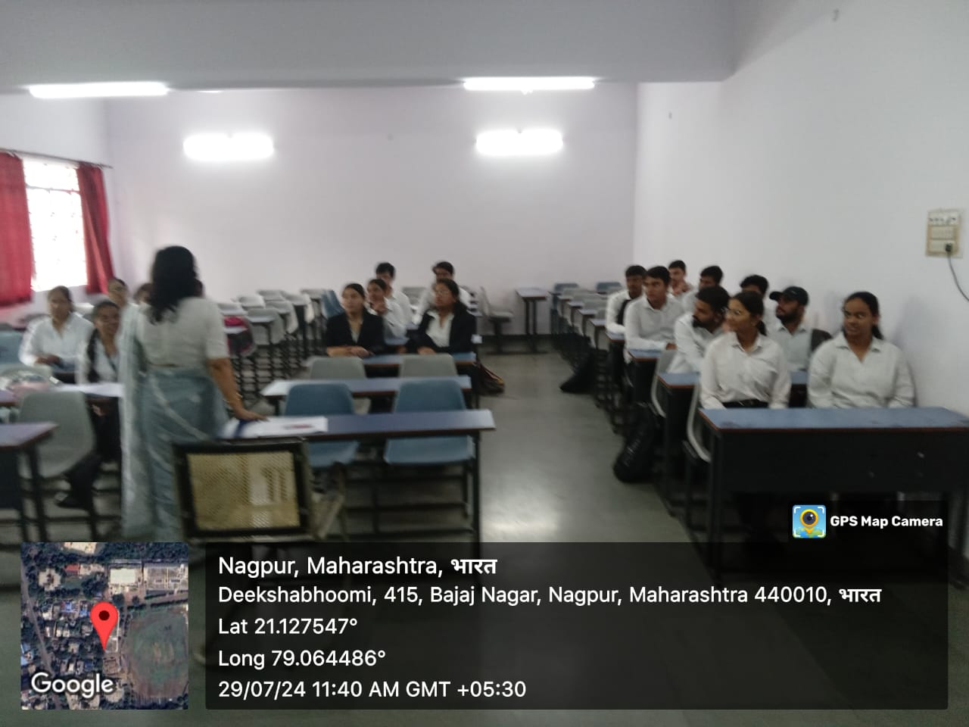

**Dr. Sandhya Kalamdhad, the supervisor of Criminal Law Club giving an opening statement of Group discussion.**

