**DR. AMBEDKAR COLLEGE, DEEKSHA BHOOMI, NAGPUR**

**REPORT ON GUEST LECTURE**

**Name of the Programme: Lecture on “Limitation And Civil Procedure Code”**

**Resource Persons: Adv. Rabi Ghosh**

**Organised by: Mr. Akash Mohurley**

**Number of Attendees: Around 45**

**Venue: Seminar Hall, Department of Law, Dr. Ambedkar College, Deekshabhoomi, Nagpur**

**Date: 30th August 2024**

**NOTICE**

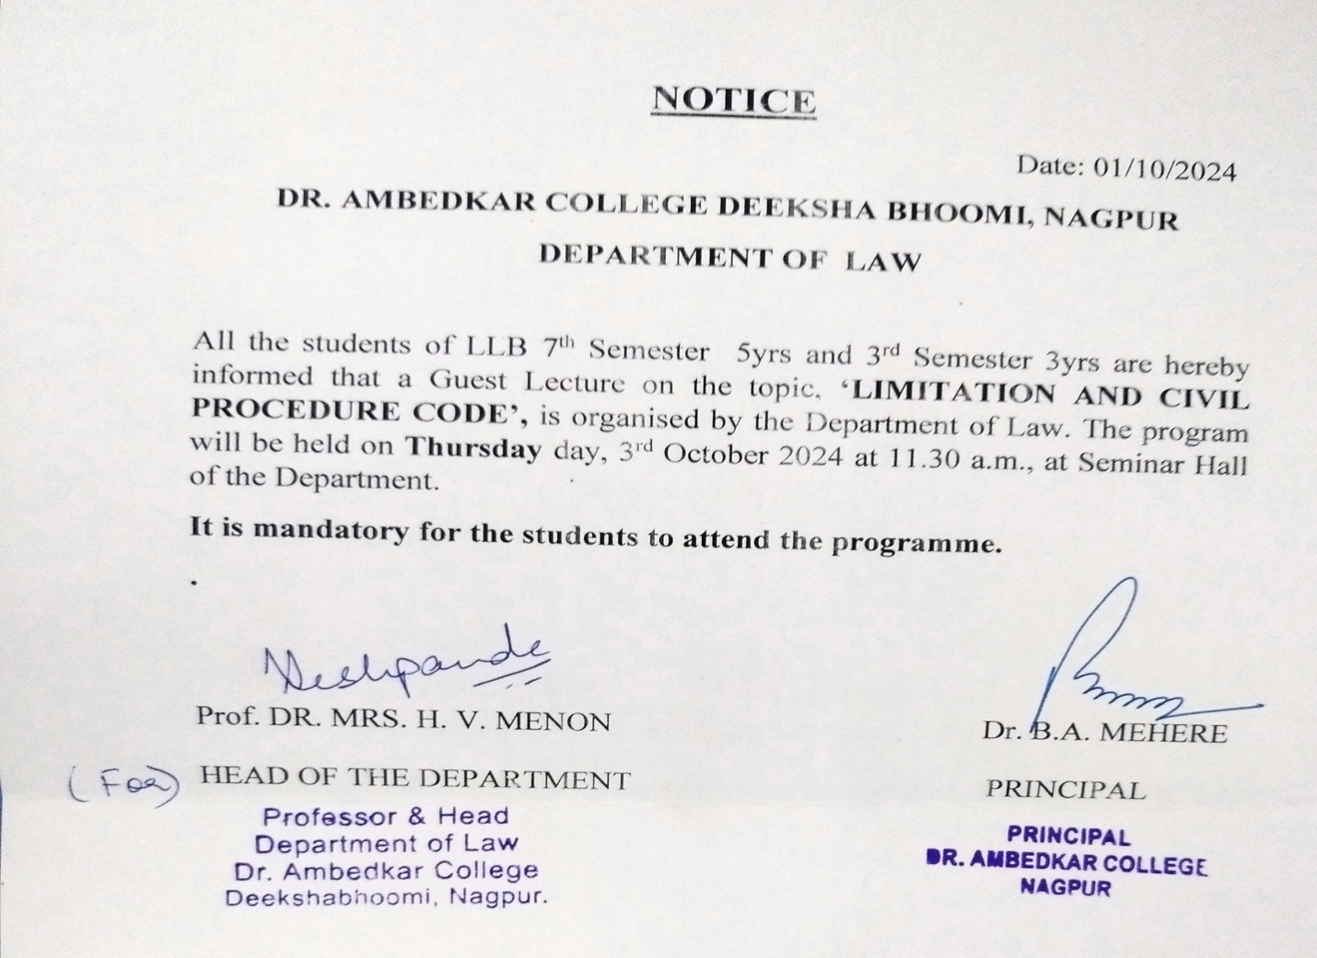

**REPORT ON GUEST LECTURE**

On 3rd October 2024, an Offline guest lecture was conducted by Dr. Ambedkar College, Department of Law, Deekshabhoomi, Nagpur for the students of LLB 3rd SEM(3years), 7th Sem (5 yrs) . Total 45 students attended the program. The Program was conducted under the guidance of Prof. Dr. H.V.Menon Head of the Department of Law and Dr. Vaishali Sukhdeve, in seminar room at 12.00 P.M.

Course content delivered in the offline is as follows

The speaker of the session Adv.Rabi Ghosh, Alumni of the Department of Law presented the keynote address on “Limitation and civil procedure code ’ with a practical aspect.

This lecture was arranged with the motive of sharing the knowledge and practical experience of Adv.Rabi Ghosh who is an expert in his field. Adv. Shubham Sahu started lecture by telling the student how limitation act 1963 impacts civil suits etc. He emphatically explained the need of such legislations.

He discussed different aspect and application of limitation act on civil procedure mainly on the civil side during civil procedure as governed by legal standards of admissible evidences. Provision like section 5, 9, 24, to other sections of CPC with practical example, and how law of limitation is a critical element of civil litigation. He also discussed remedies available to the parties if there applications are barred by law of limitation, and how lawyers should navigate through it with an idea to format and essentials of the application . At the end question answer session was held which were satisfactorily answered by the guest speaker.

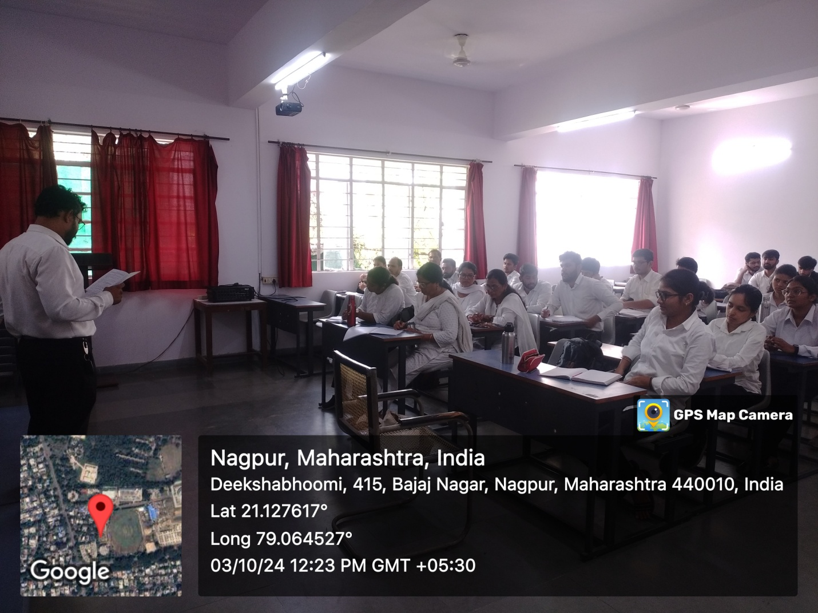

( Audience Present at the Programme)

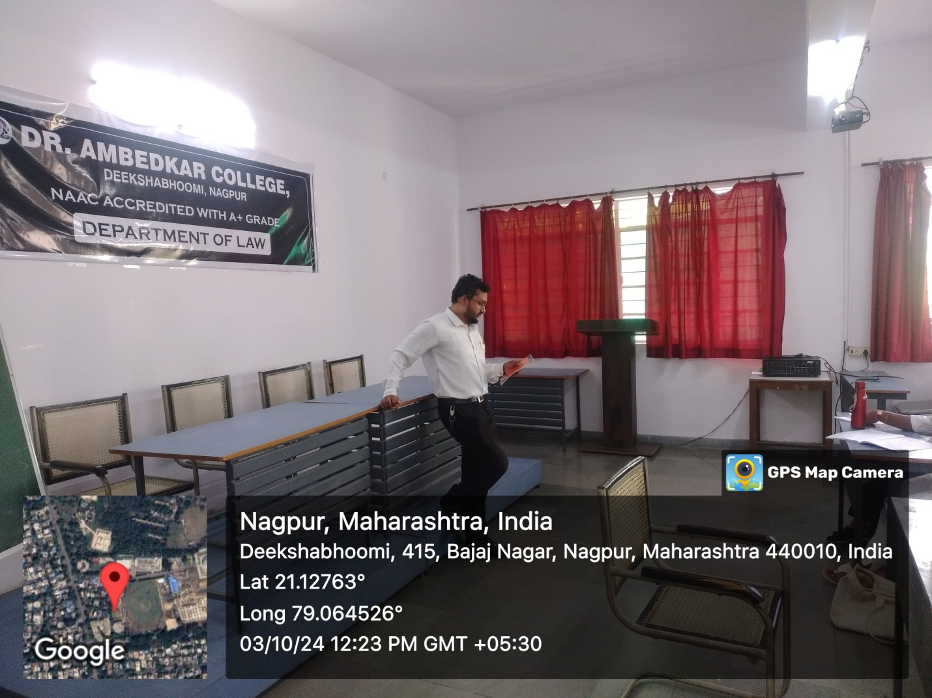

(**Adv. Rabi Ghosh** delivering the lecture)

