DR.AMBEDKAR COLLEGE,DEEKSHABHOOMI, NAGPUR
Department of Computer Application(BCA)
INSTALLATION OF
“SOCIETY OF COMPUTER APPLICATION”
“ARENA 15.0”
Date:13th February 2024 Time : 11:00 AM–12:00 AM
REPORT
BCA Department has Installed “Society of Computer Application” and Inaugurated Arena 15.0 in November 2024. The program started with welcoming the Guest. Installation of society was done by the hands of chief guest Dr. Shweta Barhate (Department of Electronics and Computer science, RTM Nagpur University ) ,Principal Dr. Mrs. B. A. Mehere, Dr. Ambedkar College,Nagpur, Dr. Prashant Yende HOD, ( BCA Dept.) also briefed about the Aims and Objectives of the society followed by Investiture and Oath Ceremony for the Society Members.

Members of the Society as follows:
NAME | POST | CLASS
Srijon Mitra | President | BCA- Final
Mitali Neware | Vice-President | BCA- Final
Piyush Bhagwat | Secretary | BCA- Final
Naina Titarmare | Joint Secretary | BCA- Final
Sayee Warwatkar  Yash Hadke | Treasurer | BCA- Final
Sujata Prasad  Parag Borkar  Ankit Meshram,  Piyush Bhagwat,  Lukeshdas Sahu | Technical | BCA- Final  BCA- Final  BCA- II  BCA- I
Ashwini Patil,  Prabhat Ramteke,  Srijon Mitra,  Rupal Maurya,  Akansha Mokharwate,  Chaitanya Gathbande | Academic | BCA- Final  BCA- Final  BCA- II  BCA- II  BCA- I  BCA- I
Yash Khubele  Kaustubh Gautam  Sakshi Bajare | Sports | BCA- Final  BCA- Final  BCA- Final  BCA- II  BCA- II  BCA- I  BCA- I
Parth Thacker  Sakshi Patel | Cultural | BCA- Final  BCA- Final  BCA- II  BCA- II  BCA- II  BCA- I  BCA- I
Sarthak Sahu,  Divya Pardhi,  Yash Hadge,  Harshit Tiwari,  Prasad Fulkondewar,  Manasi Manmode | Discipline | BCA- Final  BCA- Final  BCA- II  BCA- II  BCA- I  BCA- I
Aboli Faye  Tanmay Waghmare | Organizing | BCA- Final  BCA- Final  BCA- Final  BCA- Final  BCA- II  BCA- II  BCA- I  BCA- I
Vishal Sahu  Riya Agase | Social | BCA - Final

Dr. Barhate mam is a visionary behind the organizations and is charismatic and multi-dimensional personality. He has till date delivered 200 plus talks/speeches ranging from motivational, social –change, teacher training, staff training and transforming education etc.

Program was followed by the chief guest Address on Opportunities and Recent trend in IT Sector. In his speech he mentioned current Scenario of Corporate & IT world, Requirement of creative thinking, out of box Quest of building IT software for everyday problems.

The Program was followed by Principal’s Heart Touching Address in which he mentioned that “We often react to Situations Rather than response”. The program Concluded by Vote of thanks by Mital Neware . This event was made a great success through the commitment and team efforts of the co-ordinator, Mrs.Priyanka Soitkar under the guidance of Dr. Prashant Yende (HOD, BCA) and other staff members Mrs. Shama Khan, Dr. Harshala Pethe ,Mr. Javed Shah, were also present. The students attended the program with full enthusiasm. The Event was successful and it rightly benefited all those who attended it.

GLIMPSES OF INSTALLATION OF SOCIETY OF COMPUTER APPLICATION
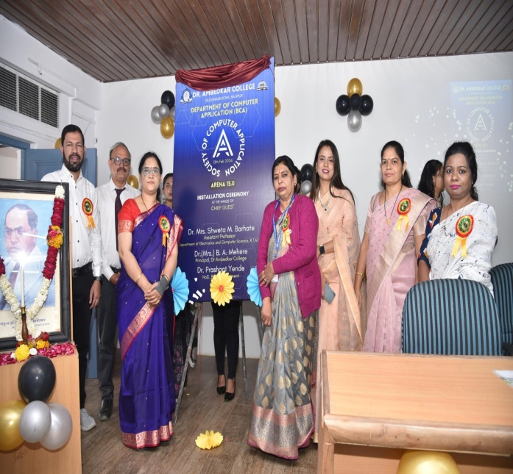  Inauguration of ARENA 15.0 at the hands of Chief Guest Dr. Barhate | 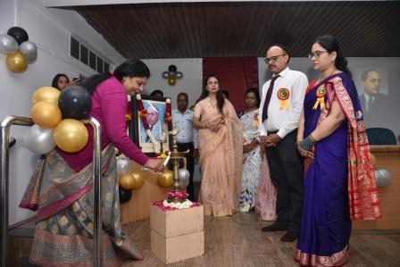  Traditional Lighting at the Hands of the Guest and Principal
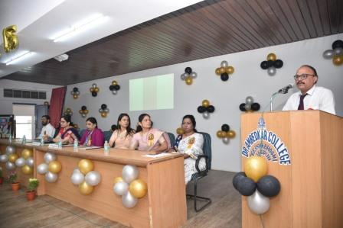  Address by Dr.Prashant Yende(HOD,BCA) | 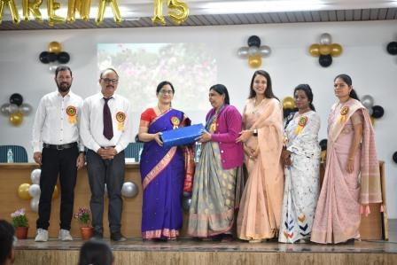 Token of Love to guest by Principal
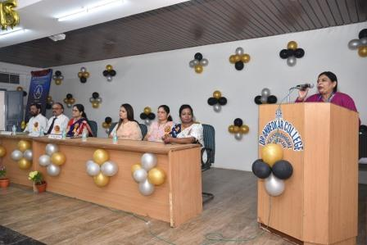  Addressed by Principal Mam | 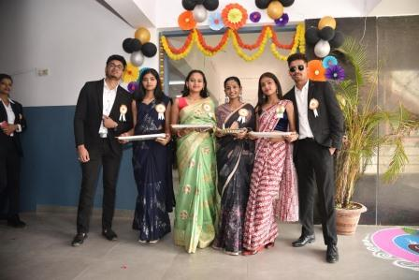  Welcome of the Guest by Students
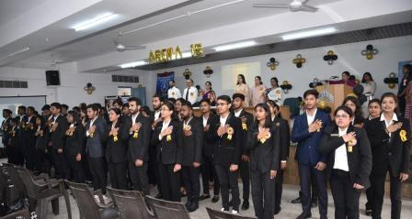Oath Ceremony undertaken by Students of  Computer Application Society | 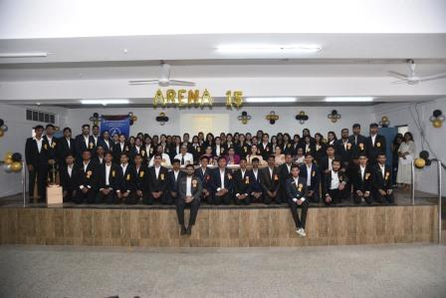Core Committee Members with Principal and BCA Staff

