**DR. AMBEDKAR COLLEGE, DEEKSHABHOOMI, NAGPUR,**

**DEPARTMENT OF LAW ACADEMIC SESSION 2021-22**

|  |  |
| --- | --- |
| **NAME OF PROGRAMME** | Poster Making Competition |
| **DATE AND DAY:** | 10th December, 2021 |
| **TIME:** | 11.30 Am |
| **VENUE:** | Department of Law |
| **PROGRAMME SUPERVISOR:** | Dr. Pratima Lokhande |

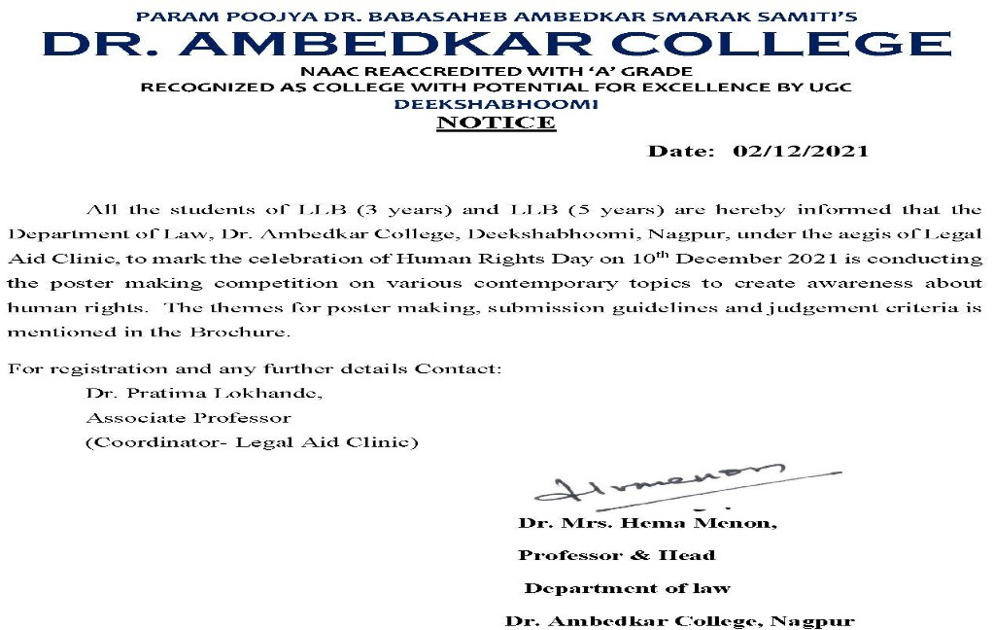

Dr. Ambedkar College, Deekshabhoomi, Nagpur, under the aegis of Legal Aid Clinic, to mark the celebration of Human Rights Day on 10th December 2021, the poster making competition was conducted on the various contemporary topics to create awareness about human rights, and to

create interest and promote the idea of Human rights. The competition was based on various themes like Women and Human Rights, Free Legal Aid, Female Foeticide, Environment Protection, Human Rights and Climate Change, Children, Detention and Imprisonment, Discrimination, right to health during Pandemic, Education – Online and off-line, Sexual Orientation and Gender Identity, Artificial intelligence and Human rights, Human rights and Cyber Crimes, Human rights of Migrant workers, Human Rights and Scientific tests in criminal Investigation. This competition was for the students of LLB 3 years course and 5 Years course students. Detailed rules of the competition regarding poster making and submission format were stated along with the judgment criteria. Total 10 students participated in the same. Best three Posters were awarded with certificate and prizes.

The Winners were as follows-

Winner was Anupama Lohakare from BA.LB 9th sem (5 years course)

First Runner up was Stuti Salodkar from BALLB 3rd sem (5 years course) and Second Runner up was Anjali Wanjari from LLB 3rd sem (3 years course)

All the participants shown enthusiastic participation and tried to portray different human rights issues in a colourful as well as sensitive manner through their creative imagination. The programme was co-ordinated and supervised by Dr. Pratima Lokhande, the Co-ordinator of Legal Aid clinic and assisted by Mrs. Vaishali A. Sukhdeve, the member of the clinic.

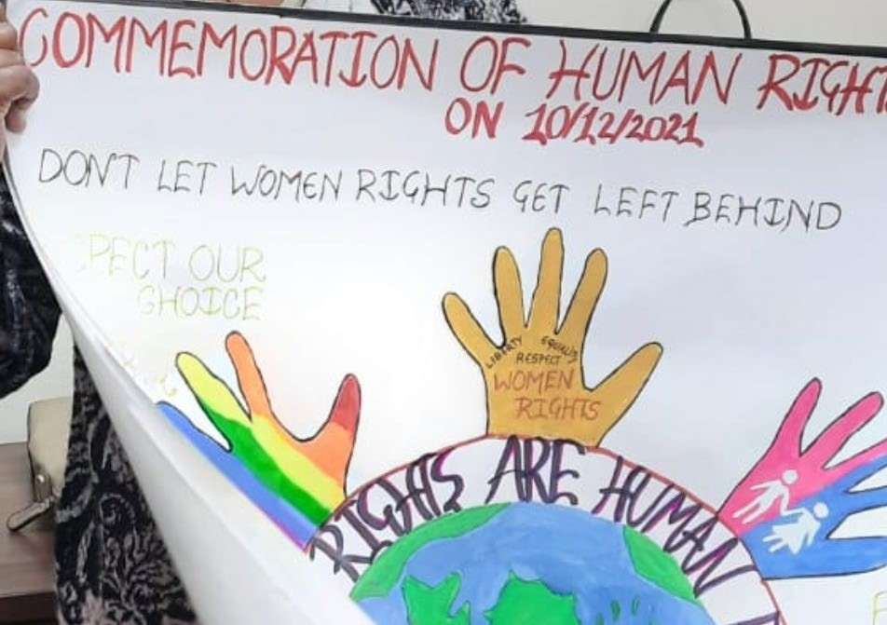

**DEPARTMENT OF LAW**

**DR. AMBEDKAR COLLEGE, DEEKSHABHOOMI, NAGPUR**

**LEGAL AID CLINIC**

|  |  |
| --- | --- |
| **NAME OF THE PROGRAM:** | **LEGAL AID CAMP (PAN-INDIA AWARENESS AND OUTREACH CAMPAIGN)** |
|  |  |
| **DAY:** | **19th October 2021** |
| **TIME:** | **11.00 AM –05.30 AM** |

**NAME OF CELL: LEGAL AID CLINIC**

**PROGRAM COORDINATOR: DR. PRATIMA LOKHANDE**

**MEMEBERS: SHILPA RATHOD**

**SARIKA KAMDI**

**STUDENTS: 07 (Male -11 and Female 8)**

**Only 19 Students were allowed**

**Due to Covid Guidelines**

**REPORT ON**

**LEGAL GUIDANCE AND COUNSELING CAMP AT DEOLAPAR**, **KATTA AND NIMTOLA**

Access to justice is not confined to code base legal services it extends to making people aware about their entitlement under various enactments and welfare schemes and programmes and strengthening their access to the same. Therefore, there is a need to shift from Awareness to empowerment. For this to happen legal services camp is required which would not only make people aware about their entitlements and procedural aspects relating to the same but also to connect them to the welfare scheme meant for them.

NALSA has conceptualized a **Pan India Legal Awareness and Outreach Campaign** from 2nd October to 14 November 2021. **The** **Legal Aid Clinic of Department of Law, Dr. Ambedkar College, Deekshabhoomi, Nagpur** is a taking part in this noble campaign with an objective to create legal awareness in villages.

Dr. Pratima Lokhande, Coordinator of Legal Aid Clinic, Shilpa Rathod and Sarika Kamdi members legal aid clinic along with Students from Department of Law, Dr. Ambedkar College, Deekshabhhomi, Nagpur on 19th October 2021 organised a Legal Aid Camp in Ramtek Taluka a tribal-dominated area adopted by Dr Ambedkar College Deekshabhoomi Nagpur as a part of the Pan India awareness and Outreach Campaign.

The program was conducted in different sections/phases/ part in the first section of the program banners having information regarding free Legal Aid service, women’s right, children’s right were pasted at conspicuous places in the village, Samaj bhavan, gram panchayat office.

In the second section of the program keynote address and the outline of the program was given by Dr Pratima Lokhande, Coordinator of legal Aid Clinic. She also explained the villagers the legal rights available to the poor and backward section of the society and how they can access free legal aid.

In the third phase a survey was conducted. The college students went door to door in Deolapar, Katta and Nimtola to inform the general public about their rights and schemes available, free legal aid service available to the weaker sections of the society, and also conducted survey regarding the same. Information was provided regarding Children’s right, Women’s right, Child abuse (POSCO), E-frauds, misuse of social media to the villagers by the students.

Newly elected Zilla Parishad member Harish Uikey, who was present at the camp, expressed his happiness over the camp organized by the college. Zilla parisad member Shanta Kumare, Durgavati Sariyam, Ram Ratan Gajbiye, Pramod kumara, Gram Sevika Devkar and Devlapar up-sarpanch Masram attended the program.

Students of Law College named, Rituja Sariyam, Abdul Shafiq, Akshay Khobragade, Tanmay Makad, Kamlesh umale, Sumeet tarudkar, Shivam Lokar, Shubham Gawli, Suraj Bagde, Swapnal wagh, Nirmisha Bansod, Neelima palliwal, Manali Nirbate, Gayatri khaire, Shruti Tighare,actively participate in the camp. Ragini Nachpande and Rushabh Bangre hosted in the inauguration ceremony.The legal aid camp was conducted under the Guidance and support of Head of the department Professor Dr. H.V.Menon. Special technical help was provided by Assist. Prof Vaishali Sukhdeve.

**Inauguration of the** **Legal guidance and counseling camp at Deolapar**

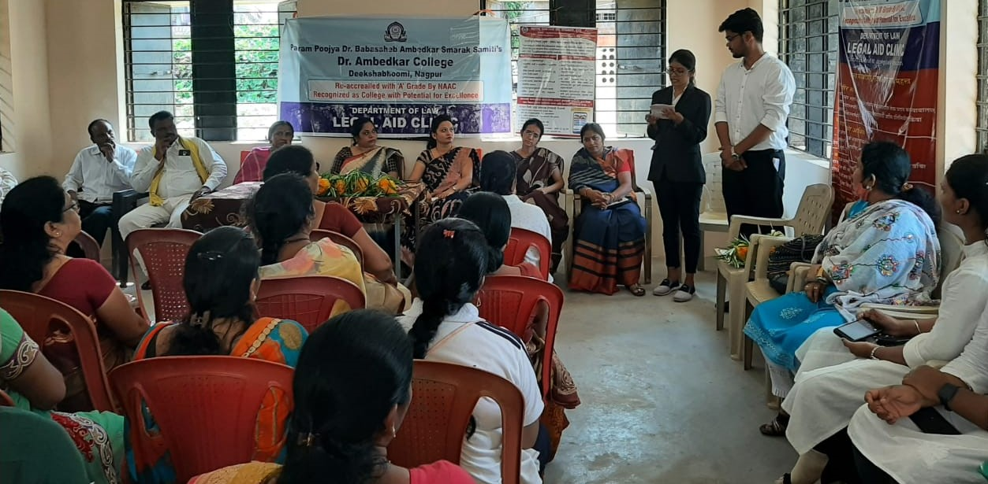

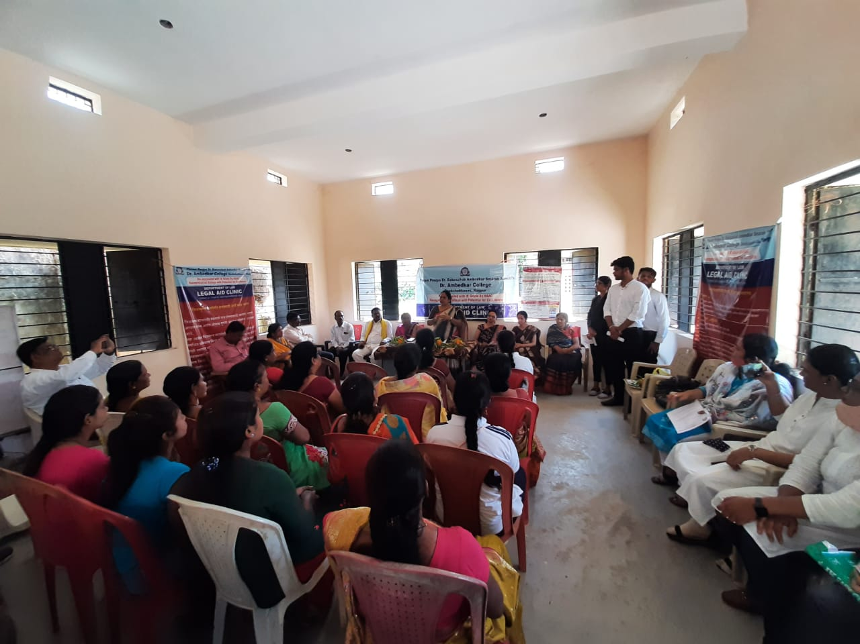

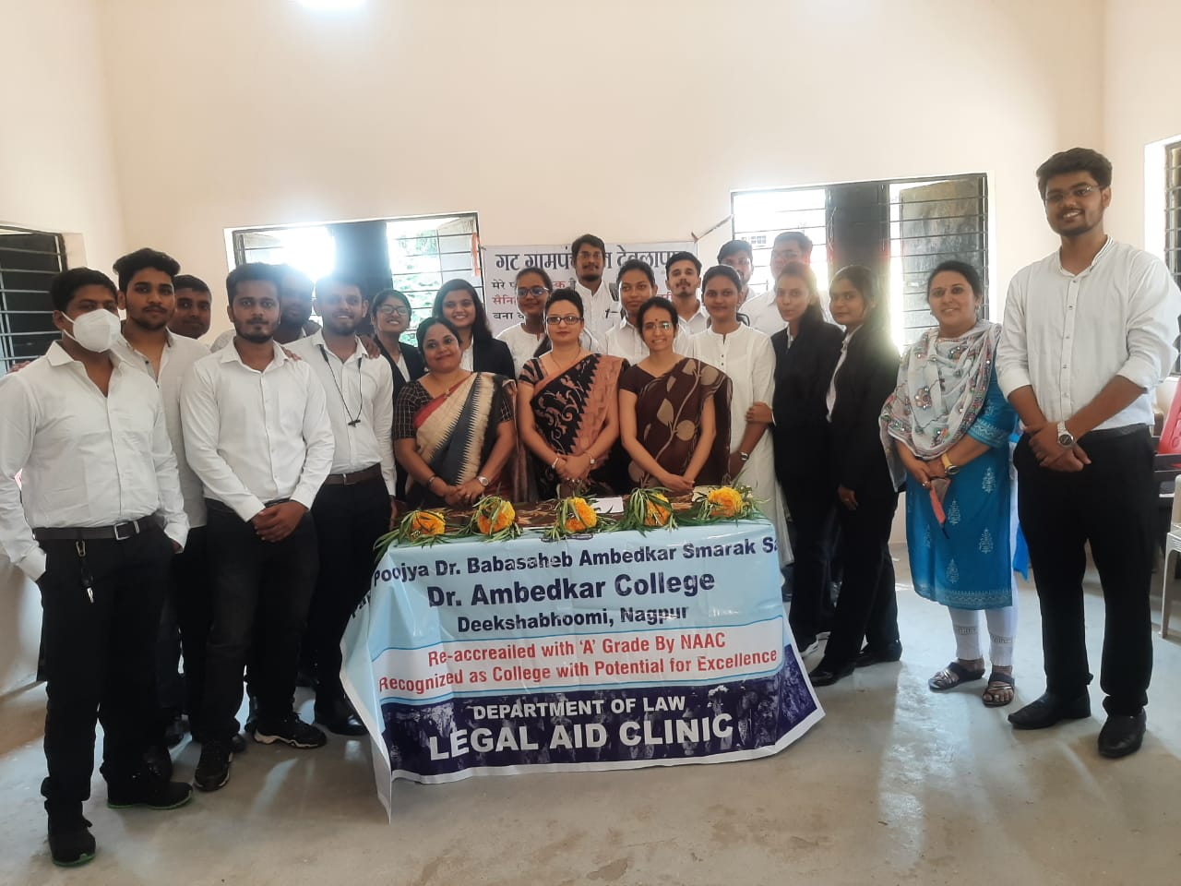

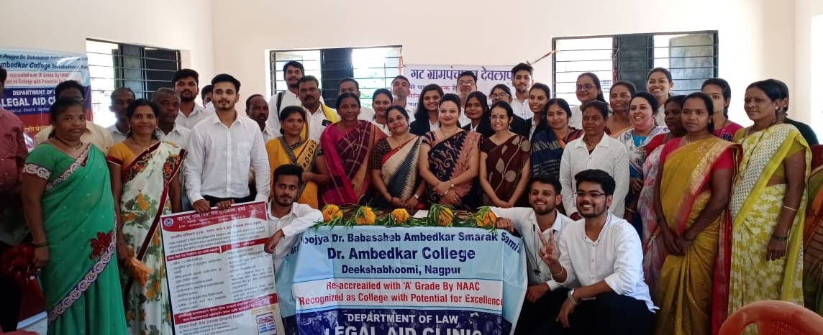

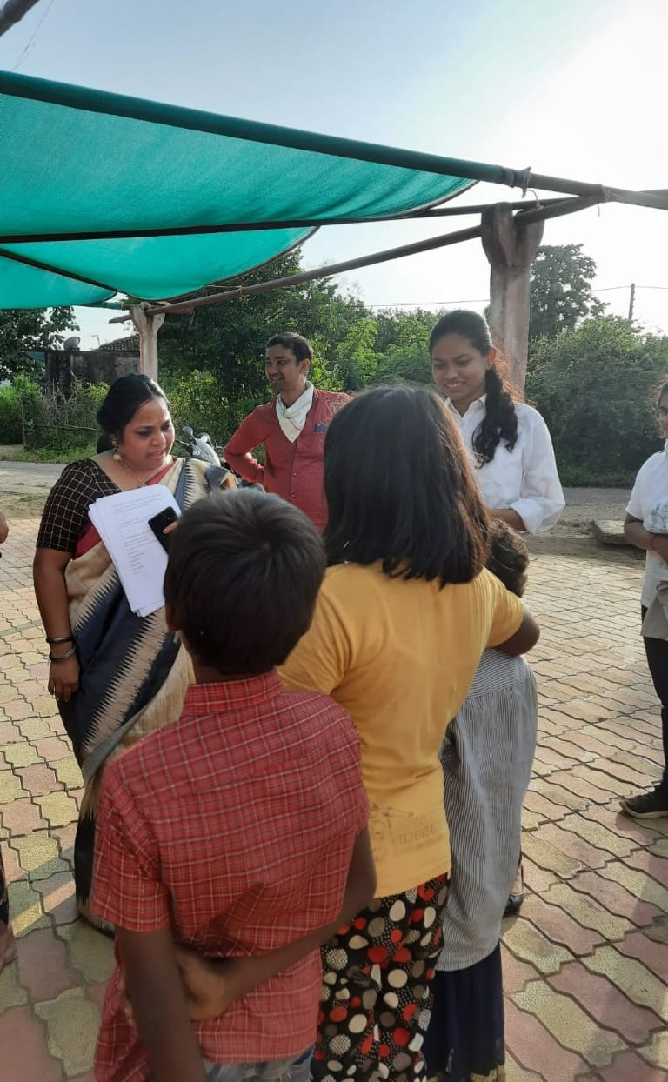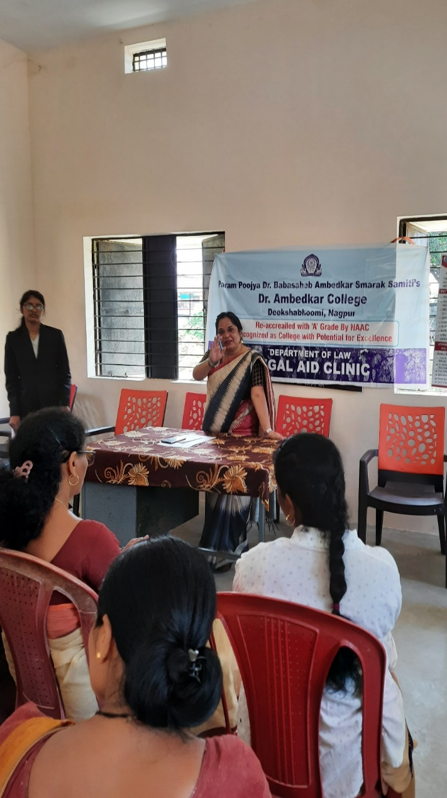

**Dr. Pratima Lokhande Coordinator of Legal Aid Clinic along with members addressing villagers and interacting with children.**

**STUDENTS CONDUCTING SURVEY IN VILLAGE**

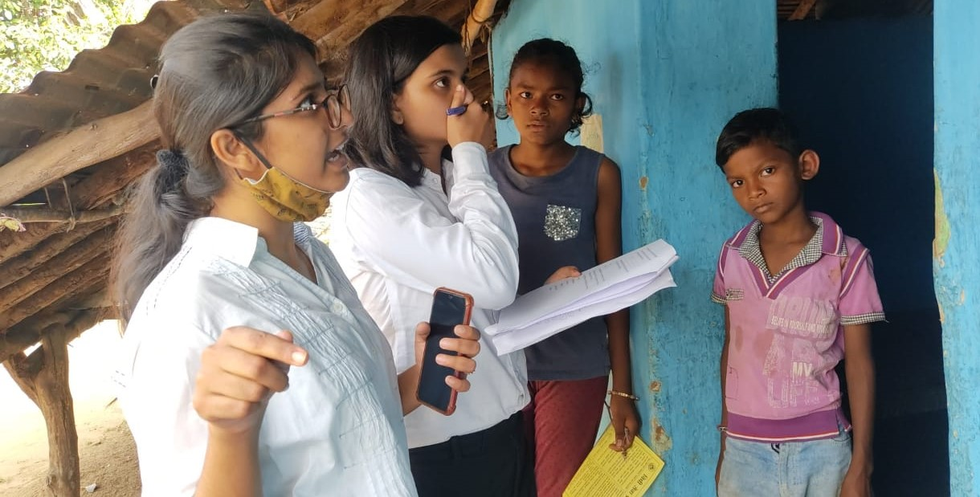

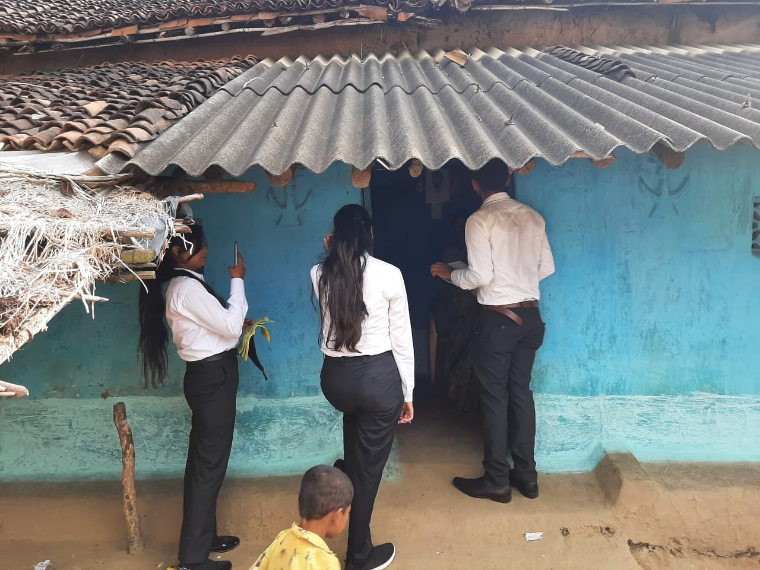

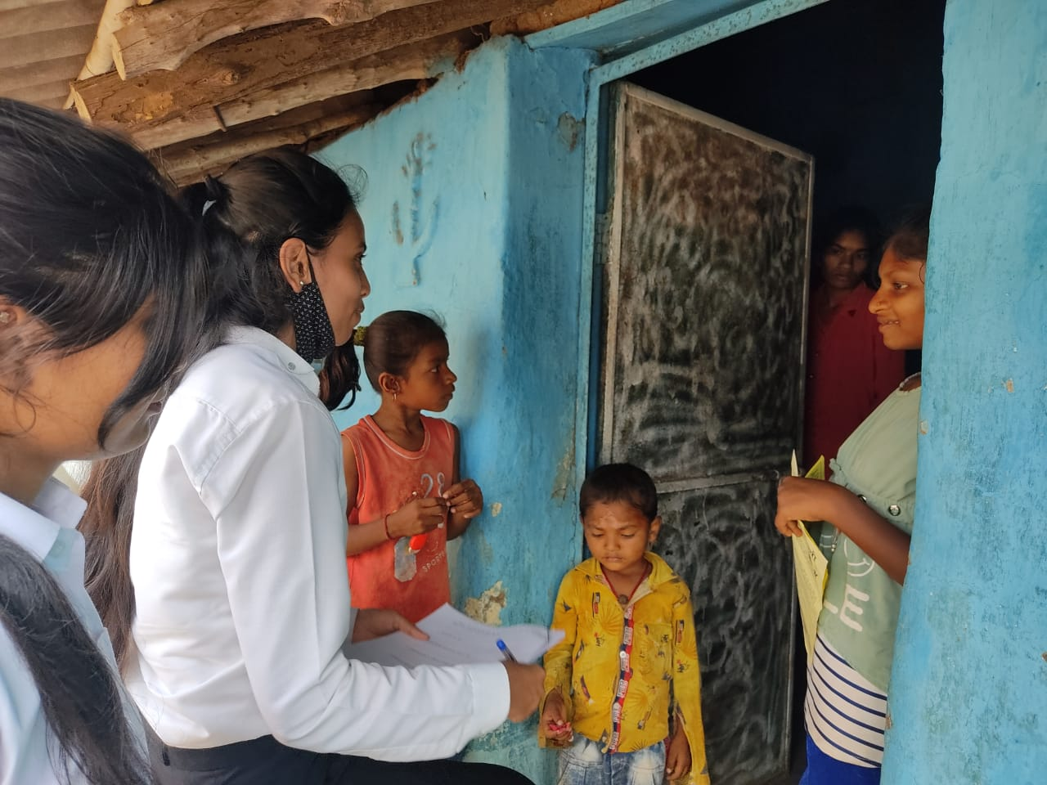

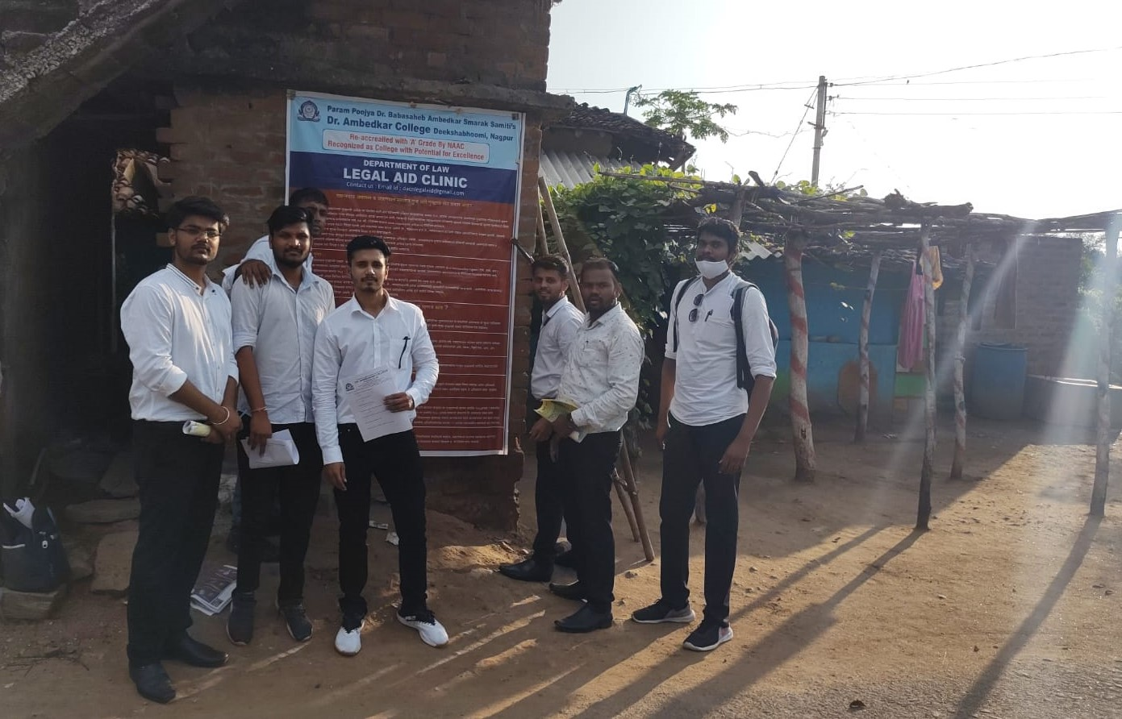

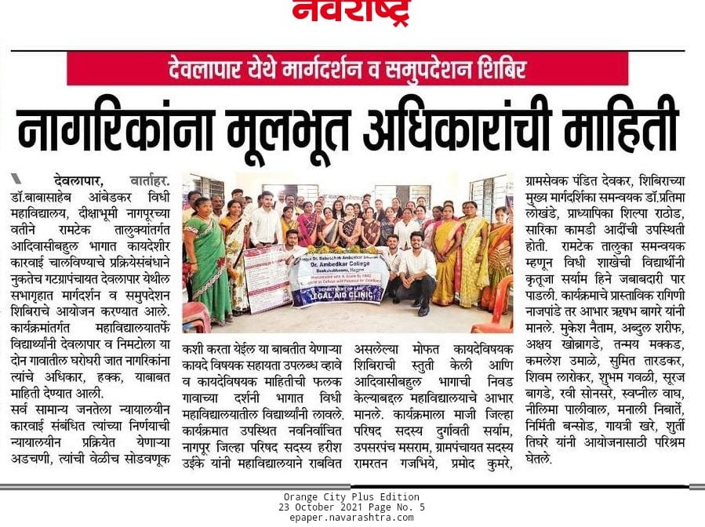

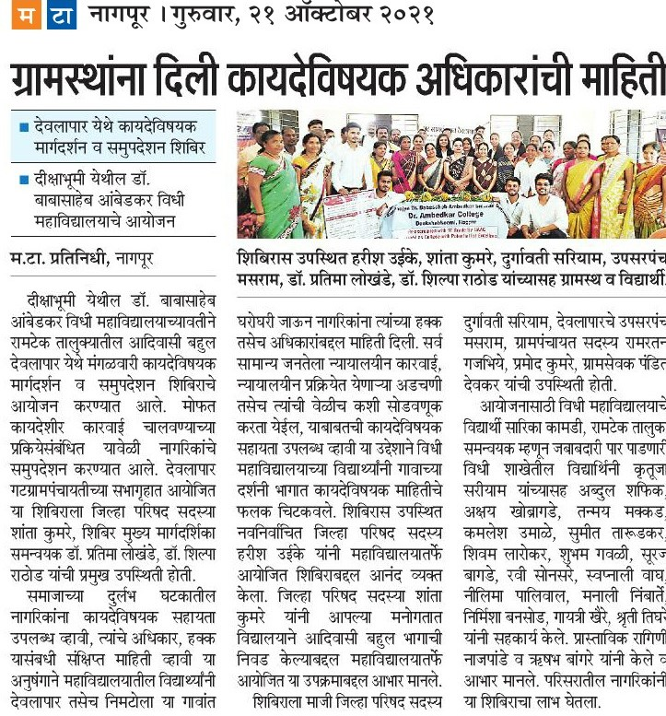

**DEPARTMENT OF LAW**

**DR. AMBEDKAR COLLEGE, DEEKSHABHOOMI, NAGPUR**

**LEGAL AID CLINIC**

|  |  |
| --- | --- |
| **NAME OF THE PROGRAM:** | **LEGAL AID CAMP (PAN-INDIA AWARENESS AND OUTREACH CAMPAIGN)** |
|  |  |
| **DAY:** | **12th Novmeber 2021** |
| **TIME:** | **11.00 AM –05.30 AM** |

**NAME OF CELL: LEGAL AID CLINIC**

**PROGRAM COORDINATOR: DR. PRATIMA LOKHANDE**

**MEMEBERS: SHILPA RATHOD**

**SARIKA KAMDI**

**STUDENTS: 40 (Male -25 and Female 15)**

**Only 40 Students were allowed**

**Due to Covid Guidelines**

**REPORT ON**

**Legal Guidance and Counseling Camp at Pimpalgoan and Mogra**

“***The soul of India breathes in rural areas or villages***”. The Constitution of India makes its obligatory to ensure equality before law and a legal system which protects justice on the basis of equal opportunity to all. It is the duty of legal services institutions to ensure that easier access to justice is made available to the poor and downtrodden.to achieve these goals there is a need to shift from Awareness to empowerment. For this to happen legal services camp is required which would not only make people aware about their entitlements and procedural aspects relating to the same but also to connect them to the welfare scheme meant for them.

NALSA has conceptualized a **Pan India Legal Awareness and Outreach Campaign** from 2nd October to 14 November 2021. The **Legal Aid Clinic of Department of Law, Dr. Ambedkar College, Deekshabhoomi, Nagpur** is a taking part in this noble campaign with an objective to create legal awareness in villages.

Dr. Pratima Lokhande, Coordinator of Legal Aid Clinic, Shilpa Rathod and Sarika Kamdi members legal aid clinic along with Students from Department of Law, Dr. Ambedkar College, Deekshabhhomi, Nagpur on 12th November 2021 Legal Aid camp organised a Legal Aid Camp in Pimpalgaon and Mogra Narkhed Taluka an area adopted by Dr Ambedkar College Deekshabhoomi Nagpur as a part of the Pan India awareness and Outreach Campaign.

The program was conducted in different part in the first section of the program banners having information regarding free Legal Aid service, women’s right, children’s right were pasted at conspicuous places in the village, School hall, gram panchayat office.

In the second section of the program keynote address and the outline of the program was given by Dr Pratima Lokhande coordinator of legal Aid Clinic. She also explained the villagers the legal rights available to the poor and backward section of the society and how they can access free legal aid.

In the third phase the students were divide into two groups to conduct the survey. The college students went door to door in Pimpalgoan and Mogra to inform the general public about their rights and schemes available, free legal aid service available to the weaker sections of the society, and also conducted survey regarding the same. Information was provided regarding Children’s right, Women’s right, Child abuse (POSCO), E-frauds, misuse of social media to the villagers by the students.

Sarpanch of Pimpalgaon Shrimati Chayya Thakre, who was present at the camp, expressed his happiness over the camp organized by the college. Police patil Mr. Chetan, attended the program.

Adv. Bagde and Adv. Manker from Taluka legal Service Narkhed also guided the villagers and made them aware of various provision of laws benficial to the public at large.

Students of Law College named, Akshay Khobragade, Anjali wanjari, Balkrishna kapalavar, burhan Sheikh, Devyani Warade, Dr Subhash bhongade gaytri khaire, Ishwar barapatre,Nisha Agarwal, kartiki Govardipe, Manali Nimbarte, Manish gotmare,Nehanahu Patil Nirmisha Bansod,Pankaj khapekar  Puja Aale, Praful Askar, Pratima telang, Ragini nagpande, Ratan Singh, Sakshi Wankhede, Sameer gargeya Shayli Narsapurkar  Shayli Purohit  Shivam lorkar, Srikanth Chari  Shruti Tigare,Shubham gavali, Sphoorti tigare,  Sumit gadling,Sumita Tarudkar  Suraj Bagde, Swapnil Wagh, Tanmay Chopde, Unnati Bobde, Vasundhara Thackeray, Viki Baba Patil. Sameer gargeya Shayli Narsapurkar  Shayli Purohit  Shivam lorkar, Srikanth Chari  Shruti Tigare,Shubham gavali, Sphoorti tigare,  Sumit gadling,Sumita Tarudkar  Suraj Bagde, Swapnil Wagh, Tanmay Chopde, Unnati Bobde, Vasundhara Thackeray, Viki Baba Patil. Participated in the camp. **The legal aid camp was conducted under the Guidance and support of Head of the department Professor Dr. H.V.Menon**

**Special technical help was provided by Assist. Prof Vaishali Sukhdeve .**

**Inauguration of the** **Legal guidance and counseling camp at Pimpalgoan and Mogra**

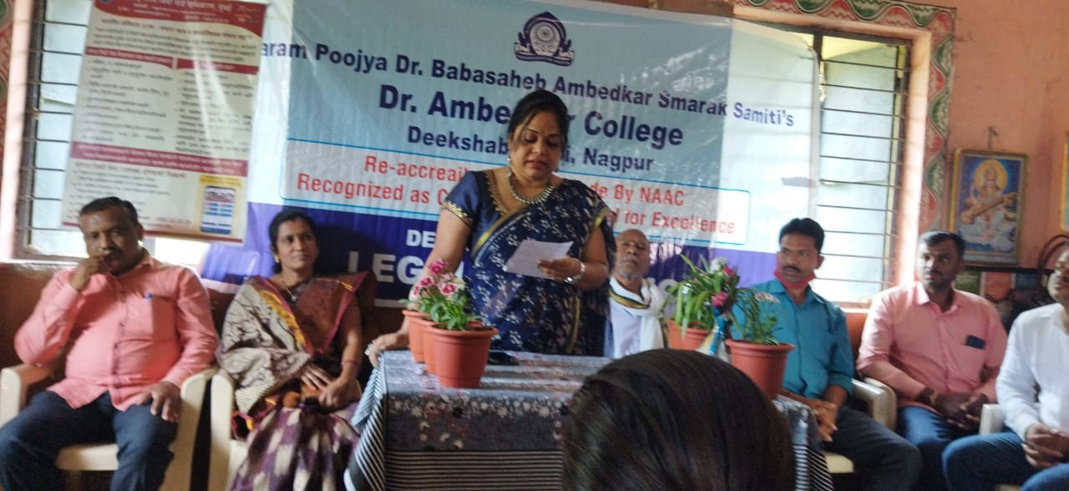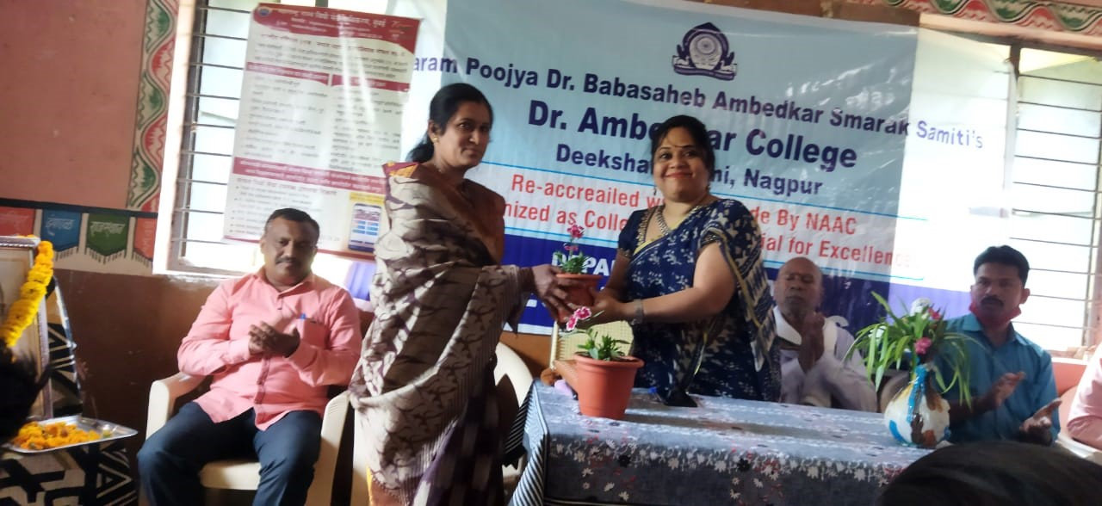

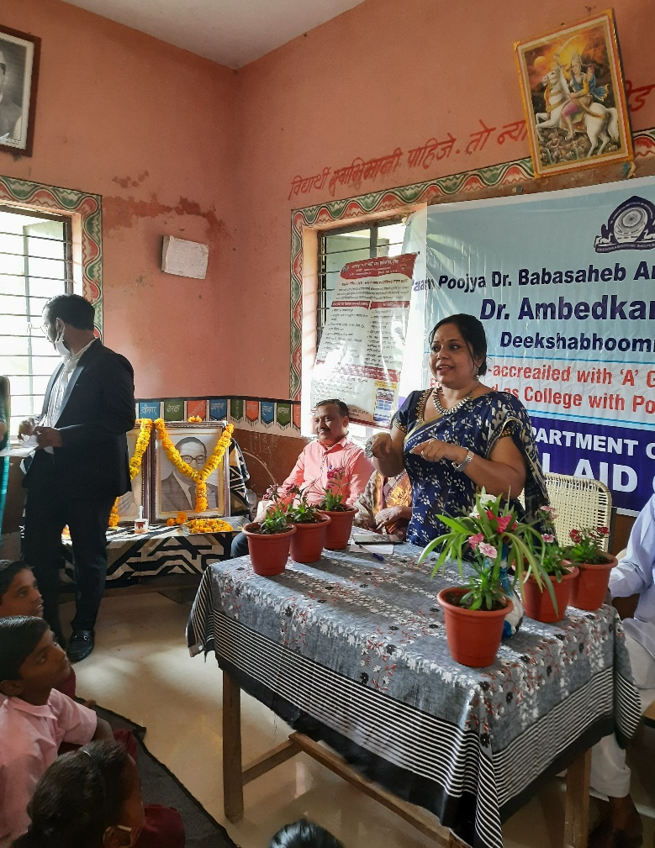**Dr. Pratima lokhande Coordinator of Legal Aid Clinic addressing villagers and interacting with children.**

Adv. Bagde and Adv. Mankar from Taluka legal services of Narkhede addressing the villagers

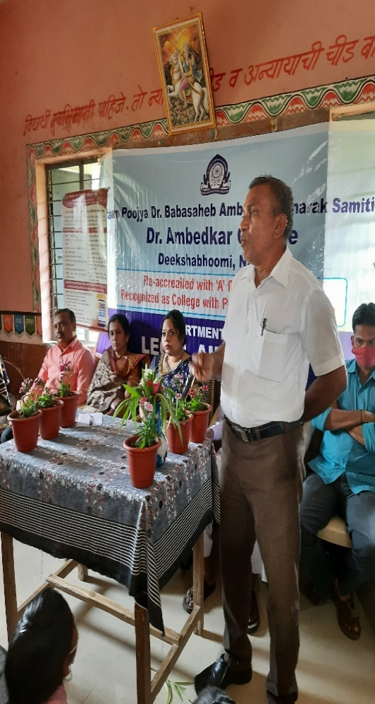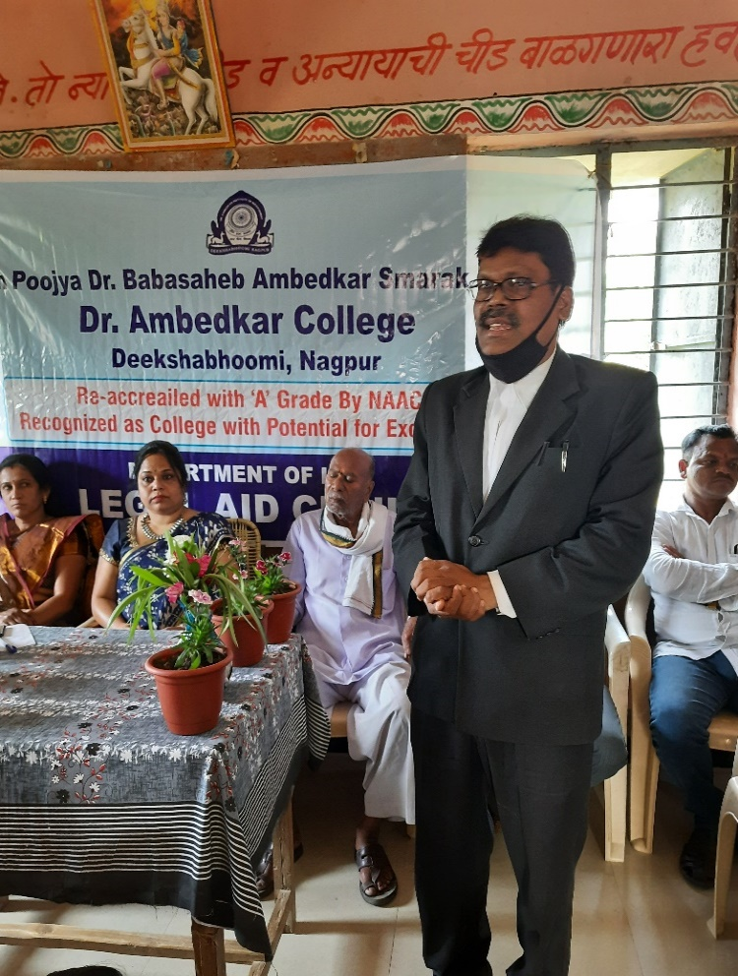

**Press Note**

